For questions 29 to 41, write your answers in this booklet. :  
The number of marks avallable is shown in the brackets [ ] at the end of each question  
or part question. | (44 marks)

l , .  
29. Mary carried. out an experiment to find out whether light is needed for  
photosynthesis. :

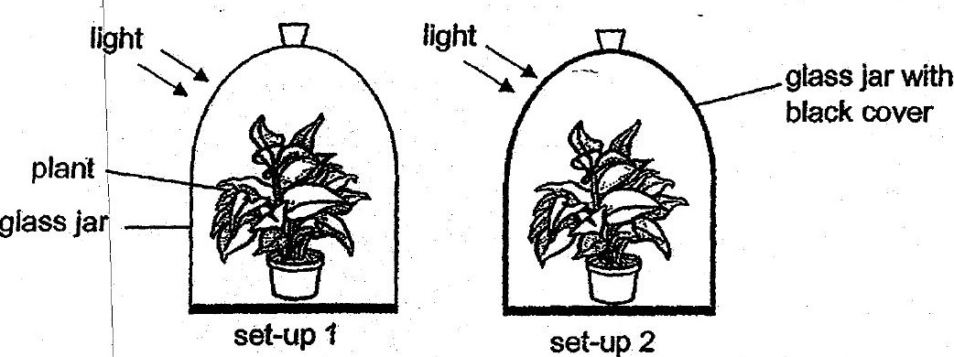

a (a) What is the purpose of set-up 1?

(b) Based on her experiment, how can Mary confirm that light is needed for  
photosynthesis? : (2]

