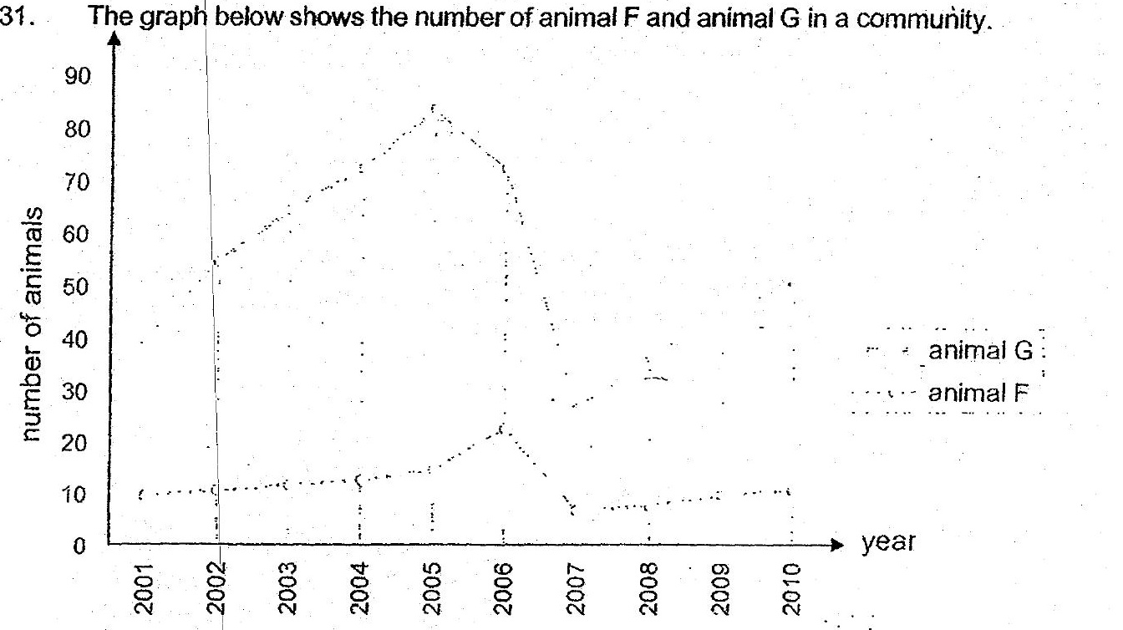

{a} Animal F and G have a prey-predator relationship. Based on the graph  
above} which animal is a prey and which is a predator? oe [1]  
| -

Prey: |

(b) Based on the graph given above, there was a period with very little  
rainfall So

This most likely happened from Z fo! . 7]

(c) Other than lack of water for the predator, Give another possible reason. |  
why with very little. rainfall would cause a decrease in the population of  
the predator. = {1]

