32. -Halim wanted to conduct: an experiment to find out if plastic is harmful to the  
environment. He buried a plastic box and a paper box for a month. Every week,  
Halim dug out the boxes to observe them.

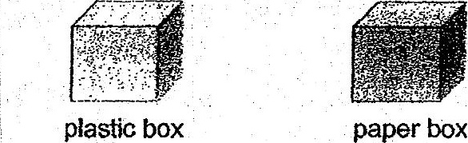

(a) © Besides the size of the boxes, state two other variables that he should  
keep the same in order for it to be a fair test> {1]

(b) The results of Halim’s experiment showed that the plastic box remained  
the ‘same condition while the paper box had broken down into smaller  
pieces. Which of the following statements is supported by. the results of  
Halim’s experiment? Put a tick in the box next to the correct statement.  
  
ft}

ee  
Pasi cae aebavamne |  
Pasi nahn as vess nouroniwomeee |  
Past lows arf goss wien beakaowm |_|

Bho _. (c) State one way that we can help to reduce plastic waste in our  
. environment. a . (1)