33. The diagram below shows organism B usirig its long proboscis.to obtain nectar  
from a flower. It will curl up its proboscis when it flies from flower to flower.  
Other than nectar, organism B also feeds on honey. It will mimic the scent of  
the bees in order to enter the beehives to consume the honey: It has clawed  
feet that help it to climb around the beehives easily. When met with predators,  
organism B will flash its brightly coloured abdomen to frighten them away.

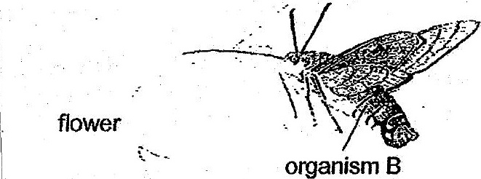

(a) Based on the information above, state one. structural and one  
behavioural adaptation of organism B that allow it to obtain food. [1]

|  
Structural adaptation:  
|

\

| - oo  
(b) Organism B usually feeds at night. How will feeding at night benefit  
organism 8? {1}

I 7 7 \*  
———

(c) State one reason why organism B mimics the scent ofthe bees when  
entering the beehives. [1]  
| .

