36. Lennard. used.an. open-top cardboard box and a balloon: to make a-toy as. shown  
below. He then used it to investigate if the size of the balloon would affect the  
distance moved by the foy. ~~~

_. Side view of toy , Top view of toy  
spenendot <i | pen ond  
balloon cardboard box. balloon cardboard box

He inflated the balloon with some air before twisting the open.end of the balloon  
and holding it between his fingers. He then placed the toy on the. floor and  
released his grip on the balloon. Immediately, the toy moved a distance away  
from him. He then measured the distance moved by the toy.  
distarice moved by toy (cm)  
oOo  
as '  
. 1 1  
at. = .  
‘outline of balloon in box floor

Lennard then inflated. the balloon with more: air and répeated the experiment.  
He noted that the toy moved:a greater distance.

Lennard made some modifications to his. experiment as shown in the diagram  
heiow. - : uo . tos TO, Bm

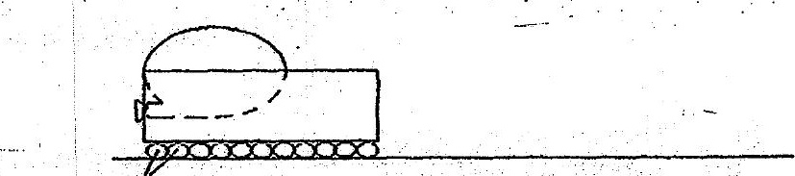

(b)' Would. the toy move-a shorter or longer distance than before? Explain

eT