37. Study the set-up below.

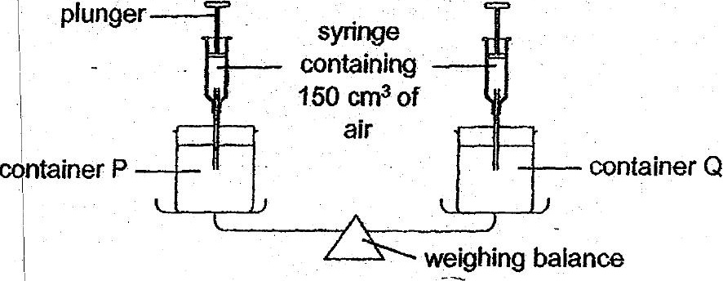

(a) What would be observed wien 150 cm? of air was pumped into container  
Q? | ff}

i a

je  
| \

I \*  
7 l  
Thomas set up an experiment as shown below.

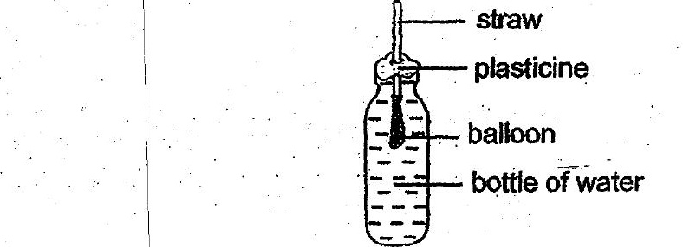

(c) Thomas tried to inflate the balloon by. blowing through the straw. Would  
the balloon inflafe? Give a reason for your answer. {]

