SCHOOL: ': CHIJ PRIMARY SCHOOL  
LEVEL: PRIMARY 6  
  
SUBJECT : . SCIENCE  
  
TERM : 2019: PERLIM © ‘

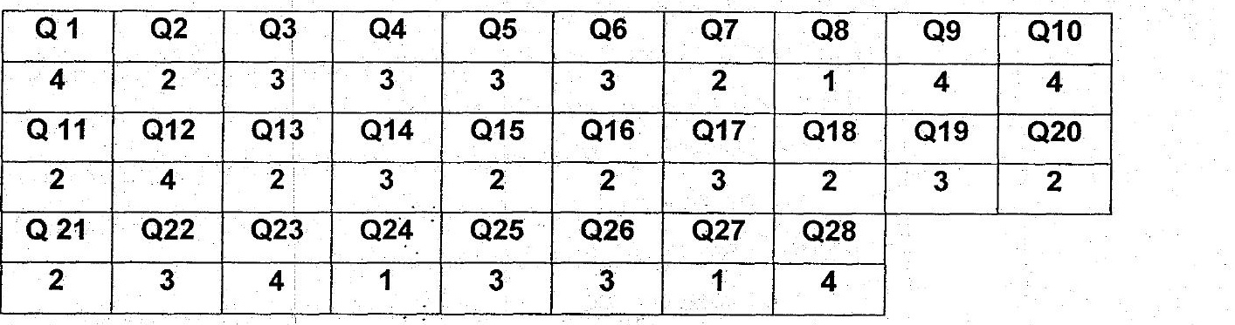

a}To act as a control set-up to show that light is needed for  
  
. photosynthesis to take place.  
  
: b)Take a leaf from each set-up and when photosynthesis takes place,  
  
: starch will be present in the leaf. Test the presence of starch by lodine  
  
. test. The leaf in. set-up 1 will. turn blue-black which shows the . ;  
| : be presence of starch while the leaf in set-up 2 turn yellowish-brown  
rn which means there is no starch in set-up 2. Therefore, light is needed .  
: for photosynthesis to take place. ~  
  
. c)Glucose and oxygen: an oom  
  
Q30). | insect M will feed on Insect A. The population.of insect A will decrease :  
  
and population of K will increase. Insect M will also help to pollinate = |[__  
  
| plant K, causing plant K to grow without the use of pesticides. |  
  
| Q31) | a)Prey:G -. en Cw  
  
/ . Predator : F mo . .  
  
a . b)2006t0 2007, oe ae