8. Study the food. chain shown below.  
|

|  
| 7 >

What is the me source of energy for the food chain?

(1) Sun |  
(2) Plant |  
  
(3) Water |  
  
(4) Carbon dioxide

9. The graph below shows the population of bees in a community over a périod of time.

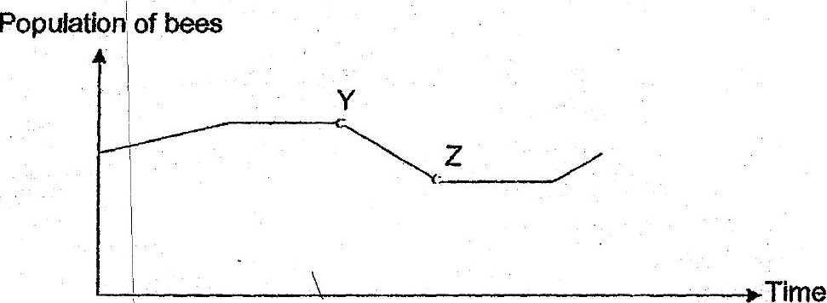

_. Which of the following explains the change in the population of bees shown by YZ in  
the graph? | .

ae OA There wasadrought, =  
-.... |B, Butterflies were Intradiiced to the habitat. =  
ge More land was used for building of hotses. oo  
D A disease had infected on some of the flowering plants.

(1) Aand B only  
(2) Cand Donly  
(3) BandD only  
(4) A,B, CandD