12. Study the diagram below.

carbon dioxide , mineral salts from  
and water vapour. « animal waste  
breathed out Ny Pe  
| x  
| iowt&

| : .  
Which of the following substances will be retumed fo the environment and be  
recycled? | _

(1) Mineral salts only.  
  
(2). Minerat salts and water only.  
  
(3) Carbon bioxide and mineral salts only.  
(4). Carbon dioxide, mineral salis and water.

13. Jody poured 200 mi of water into container P as shown in the diagram below. She  
then poured all the water from container P to container Q. All the water was then  
poured out from container Q to container R.

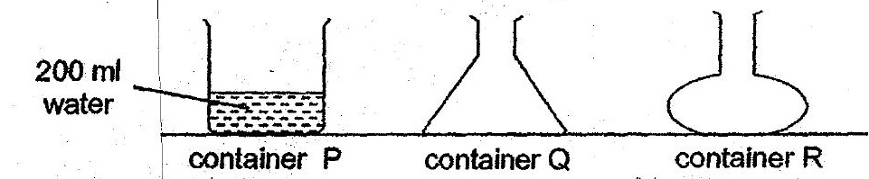

(1). She was frying to find out if water nas definite mass. .  
.@) ° She was tying to find out if water has a definite shape. ,  
  
(3) . She was trying to find out if water has a definite. volume.  
  
(4) She was trying to find out if water has definite mass and shape.