14. The diagram Detow shows. three identical beakers X, Y and Z. Three pieces of  
plasticine of different sizes were placed into the beakers. The-beakers were then filled  
to the brim with water. -

vate.  
plasticine ~ Se f= [ } ers  
+ beaker X beaker Y beaker Z

Which one of the following shows the most likely amount of water added into each  
heaker? — i

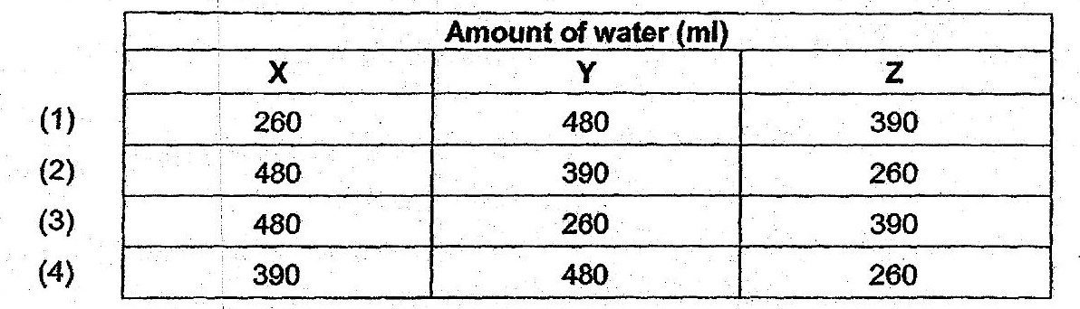

15. . Mei Ling wanted to investigate whether the size of a magnet affects the greatest  
distance. it can attract a paper clip.

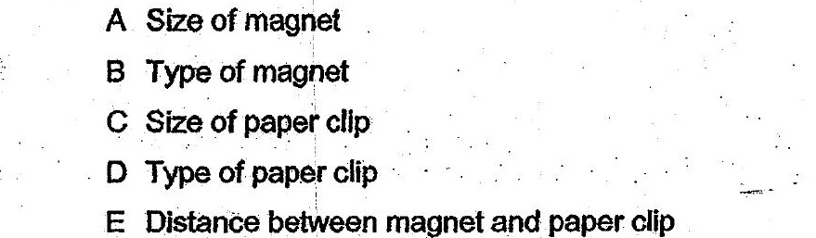

(1) Aonly  
  
(2) B, Cand D only,  
(3) A,B, D-and & only  
(4) B,C, DandE only