

When the torch was switched on, she noted a Square. patch of light on the

screen. She then repeated the same experiment witir blue and green filters.

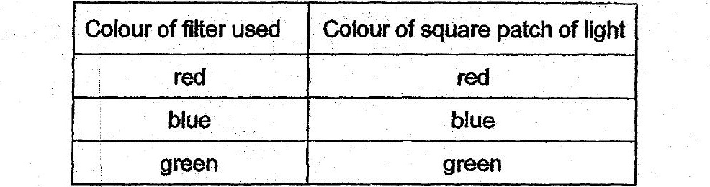



(a) What was the aim of Alisha's experiment?

Alisha then placed a can of drink behind a red fitter as shown in diagram 2.

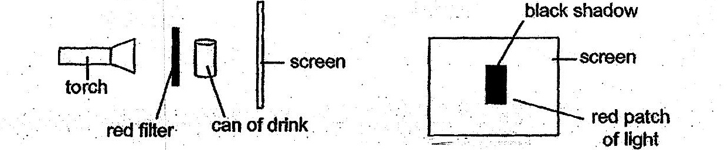

(b). . Dlagram 3. shows: what.she saw on the screen-whén the torch was

