between the five organisms are stated below:

\* Organism K feeds on Organism J.

«| Organism F and J feed on Organism HH.

«| Organism G feeds on Organisms F and H.

Which one of the following is correct? —

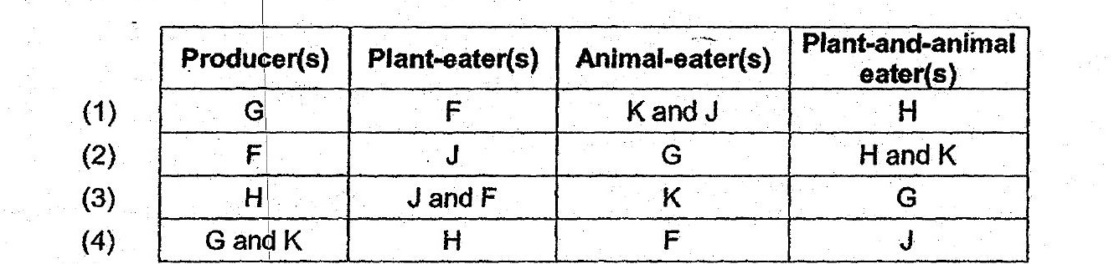

6. . “Fhe picture below shows the structural adaptations of two plants.

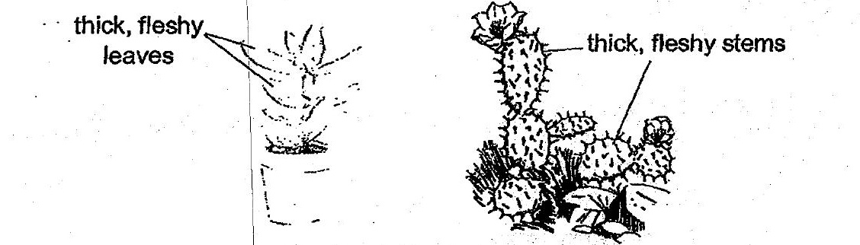



Which one of the following best explains the function of these adaptations?

(2). Adaptation|for reproduction.

(3) . Adaptation'for water retention.

(4) Adaptation for getting suniight.