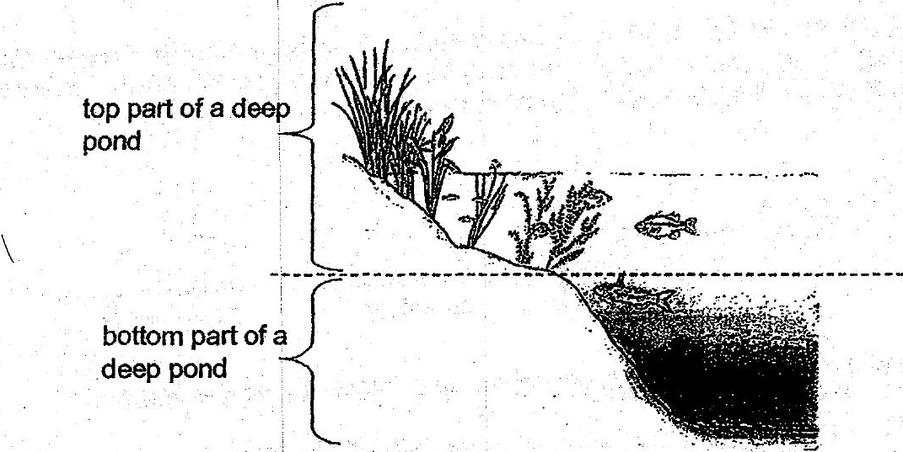

There are more aquatic plants found-at the top part of the deep pond. What is the main

reason for such an observation?. —

(4) |The aquatic plants can get sufficient nutrients to grow well.

(2) . The aquatic plants can:absorb more sunlight for photosynthesis. :

(3) The aquatic plants can take in oxygen fromthe air above the water. .

(4) . The aquatic plants can provide shade and shelter for the aquatic animals tiving