plasticine of different sizes were placed into the. beakers. The beakers were then filled

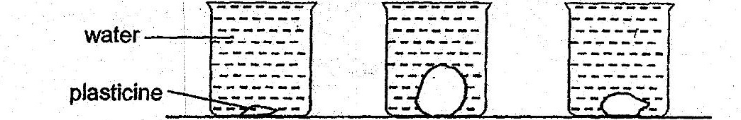

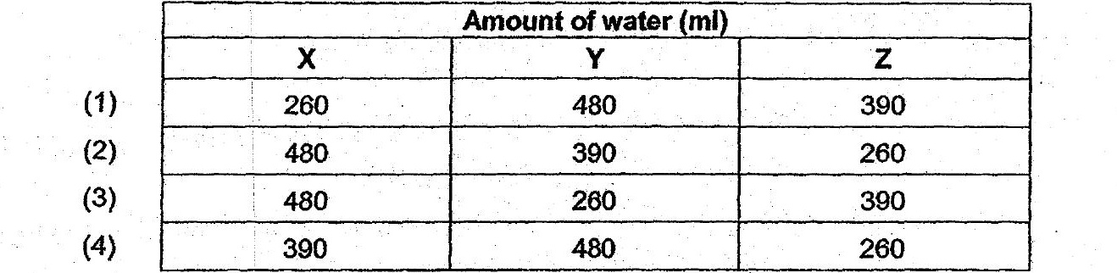

15. . Mei Ling wanted to investigate whether the size of a magnet affects the greatest



E Distance between magnet and paper clip

(1) Aony

(2) 6B, Cand D only:

(3) A,B, Dand & only

(4) B,C, Dand€ only