727721EUIT061_D3_CE1

Day 03: Class Exercise Lab

Task 01: Create and Replay

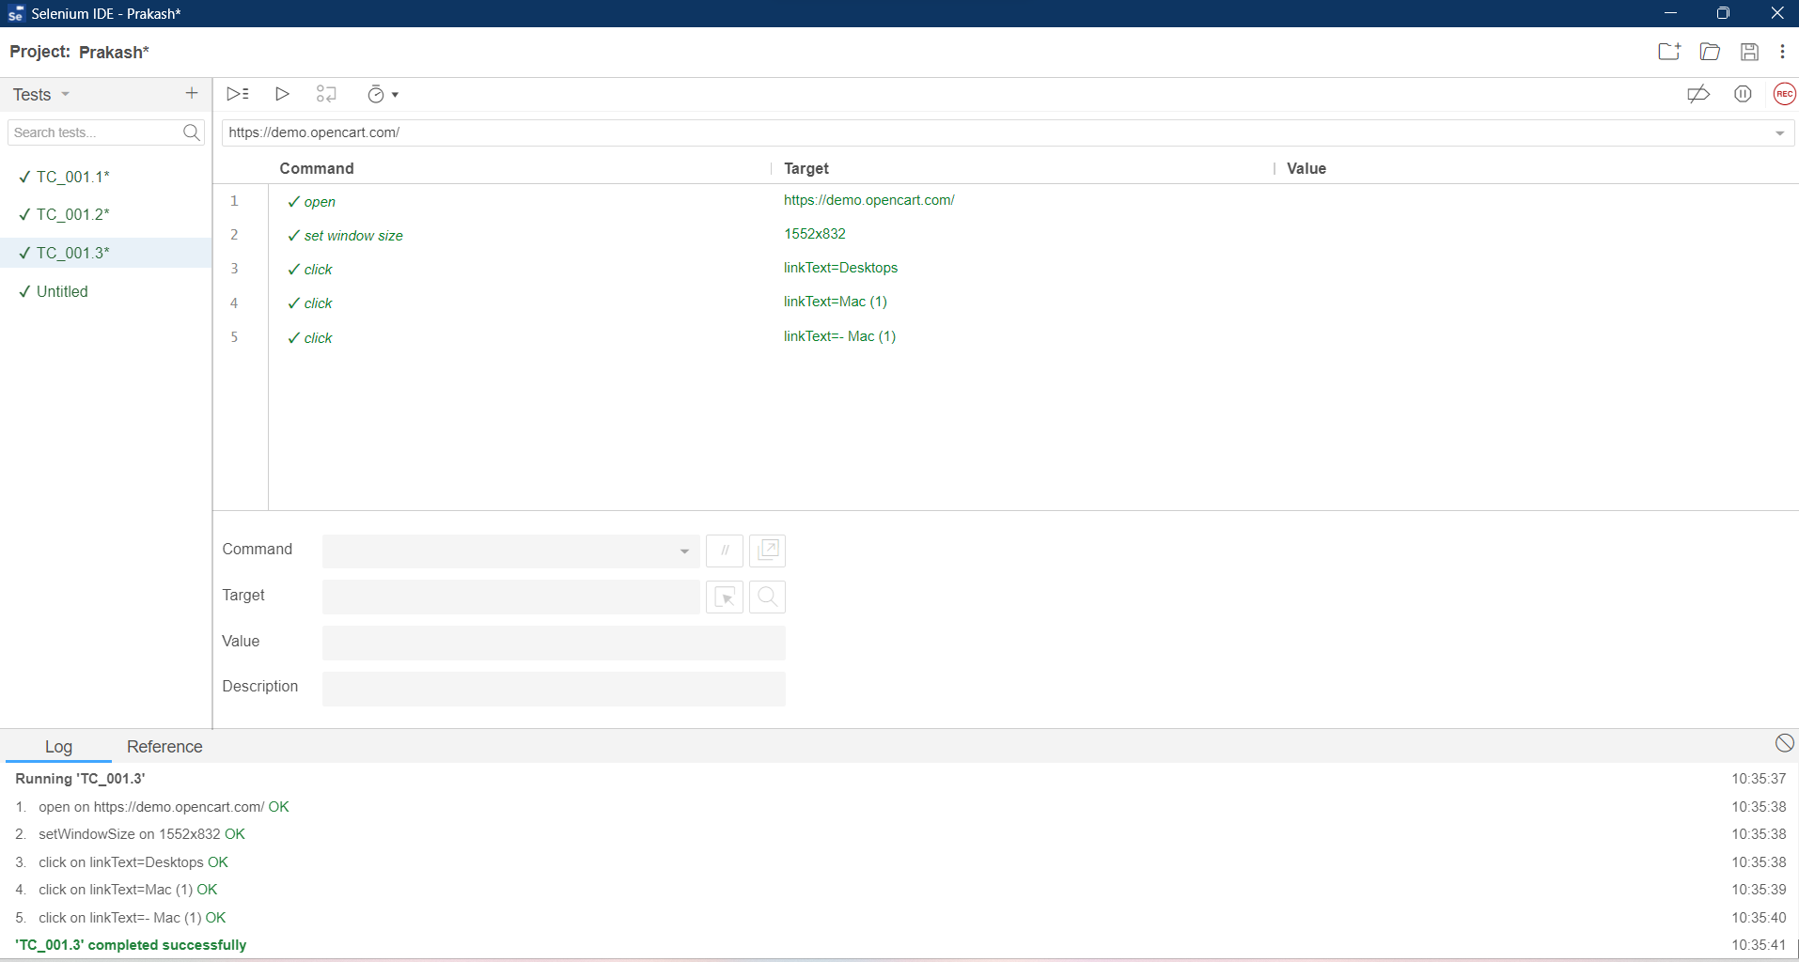

Task 02: Selenese Commands

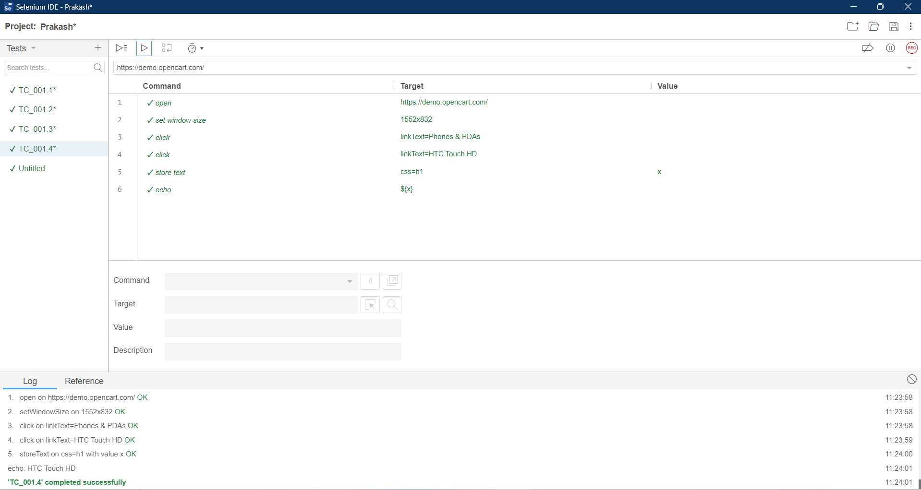

Task 03: Selenese Commands

Task 04: Selenese Commands

Task 05: Selenese Commands

