
System Design Document

Cardzo - Document Scanner

Submitted By

Sidarth CS
Praveen Kumar T Krishnendu Suresh
Jyothis KS
Jabirhusain KP

On

10 - October - 2020
Table Of Contents

1. Introduction
1. Purpose
2. Scope
3. Overview

2. System Overview

3. Design Considerations
1. Goals
2. Development Methods

4. System Design
1. Use Case Diagram
2. Use Case Description
3. Dataflow Diagram
4. Transition Diagram

5. Graphical User Interface Design
1. Overview
2. Gui Models
1. INTRODUCTION

1.1. Purpose
This purpose of this document is to outline in detail the system
design of Cardzo - Document Scanner App. This document will provide the use case diagram, data flow diagram,state transition diagram and table design of Cardzo to give a better understanding of how information will be processed with regards to the application. In addition, images will be provided that show the GUI model to give a better idea of the system's user interface design.

1.2. Scope
This document provides the design of Cardzo. It will show how the
application's functionalities work by explaining each of the system's components.

1.3. Overview
This document will cover the basic functionality of the application,
its context and its design. It will cover how data flows within and out of the system. The system architecture will cover each of the components of the application and its relation to system functionality.
2. System Overview

The Cardzo app will ensure all the documents and user details are
stored in the local database, and makes the retreival of information or any documents possible. Even though there are some applications in the market with same functionalities, the complex user interface and non essential features makes the apps pretty useless for ordinary people. Here, through Cardzo app, the simplest user interface and essential features will make user's life easier.

3. Design Considerations
3.1. Goals
• Ease of usability is top priority for the development process.
• The application will have buttons with labels that explain the

functionality of that button.

3.2. Development Methods
This project was initially conducted using the waterfall model
method. As time progressed we switched to agile development due to new features addition and modification of existing features.
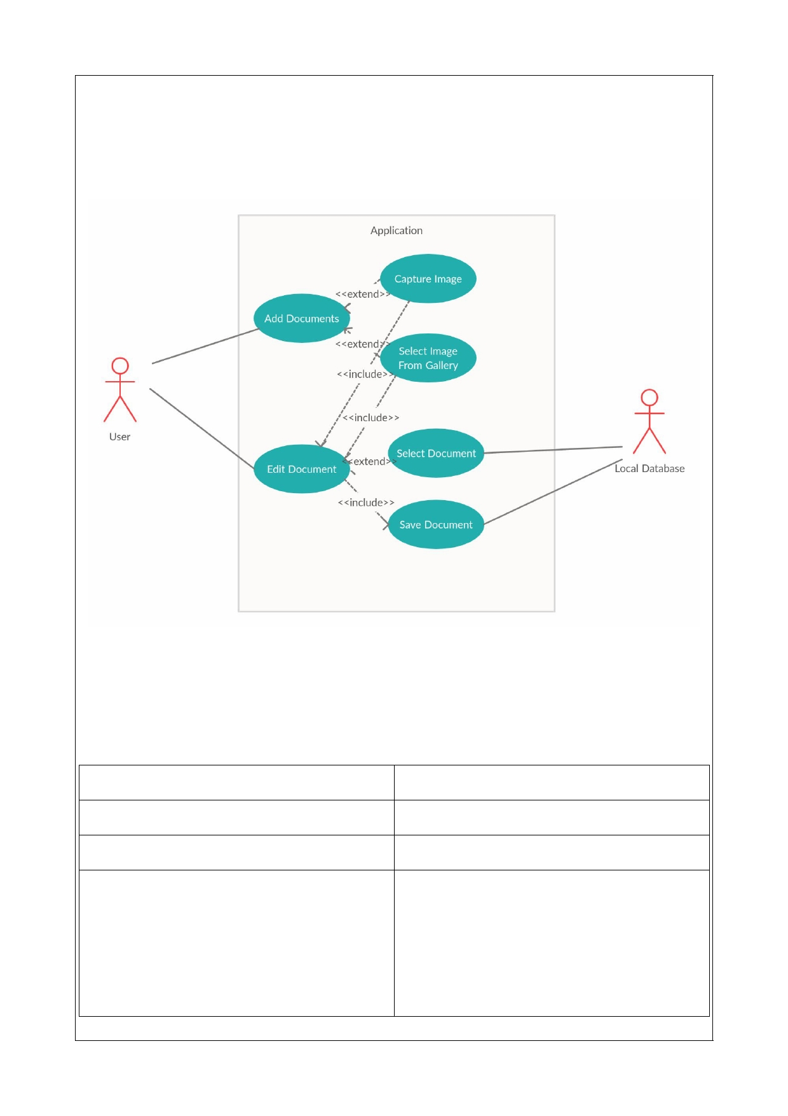
4. System Design

4.1 Use Case Diagram

4.2 Use Case Description

Use Case 1 :
Name

Description

Actor

Scenario

Add Document

Add A Scanned Formated

User

1. Click On Scan Button
2. Chooses Camera/Gallery
3. Captures The Image
4. Process The Image And Edits
5. Save The Document

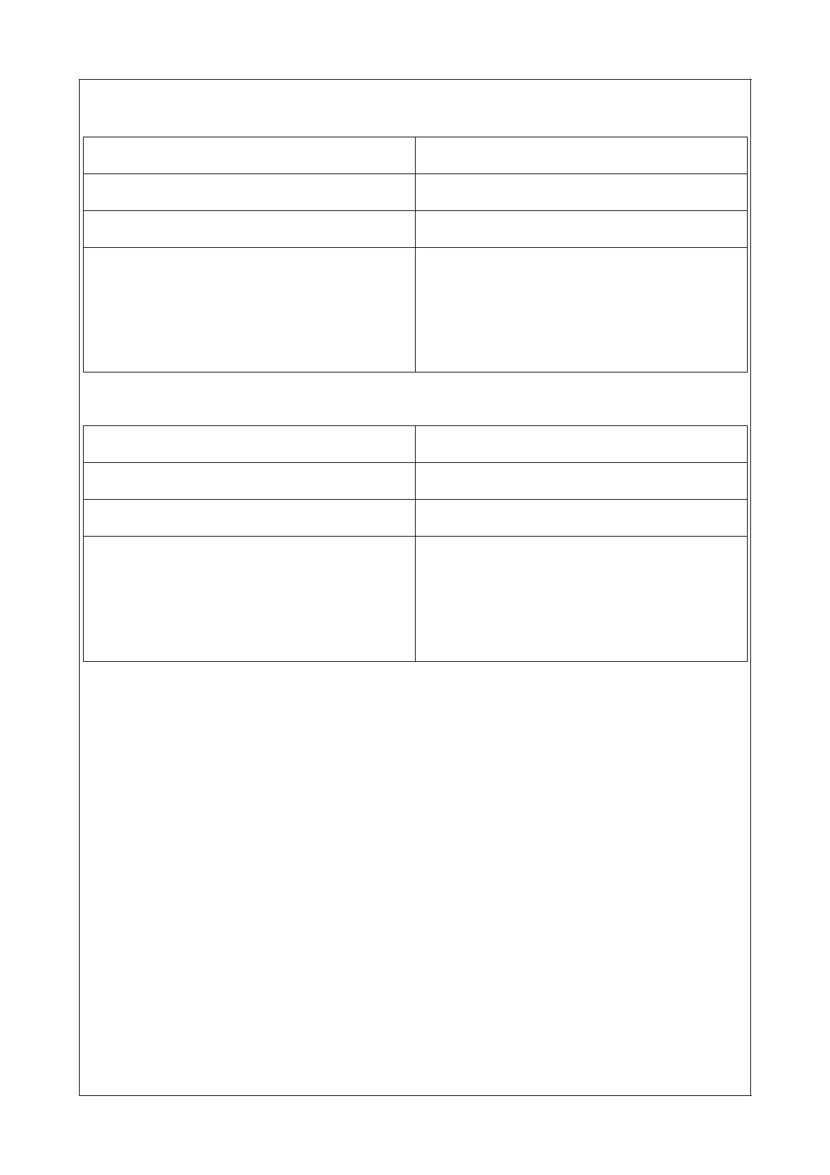
Use Case 2 :
Name

Description

Actor

Scenario

Use Case 3 :
Name

Description

Actor

Scenario

Edit Document

Editing A Existing Document In App.

User

1. Selects Document
2. Click On Edit Button
3. Editing The Document
4. Saves The Edits

Share Document

Share A Document From The App

User

1. Selects The Document
2. Views The Document 3. Click On Share Button 4. Shares The Document

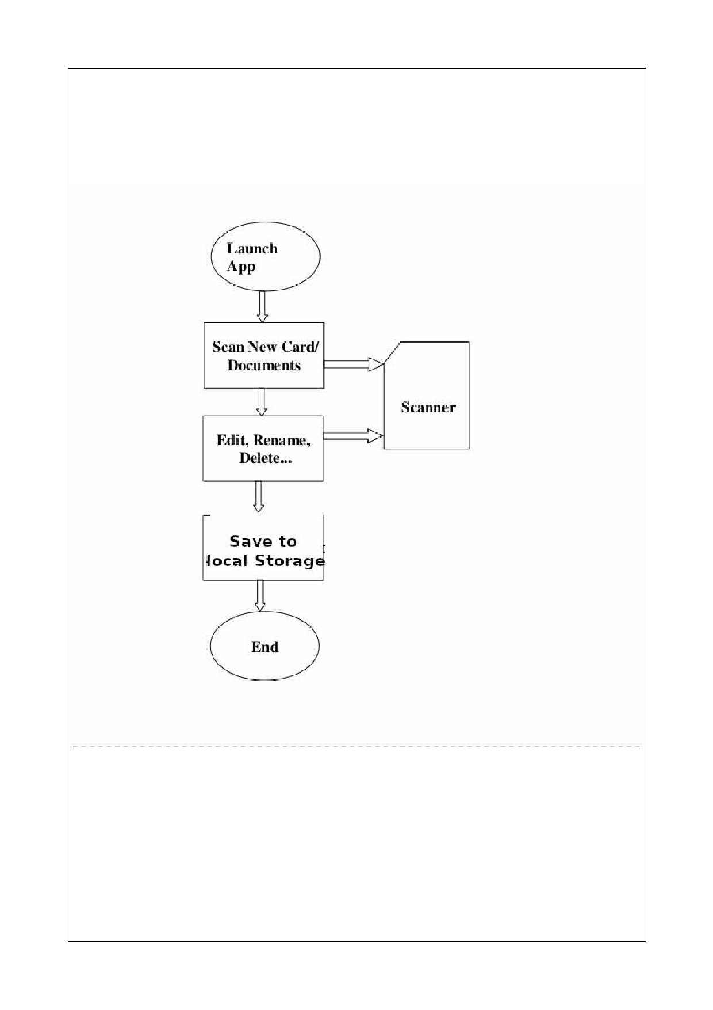
4.3 Data Flow Diagram
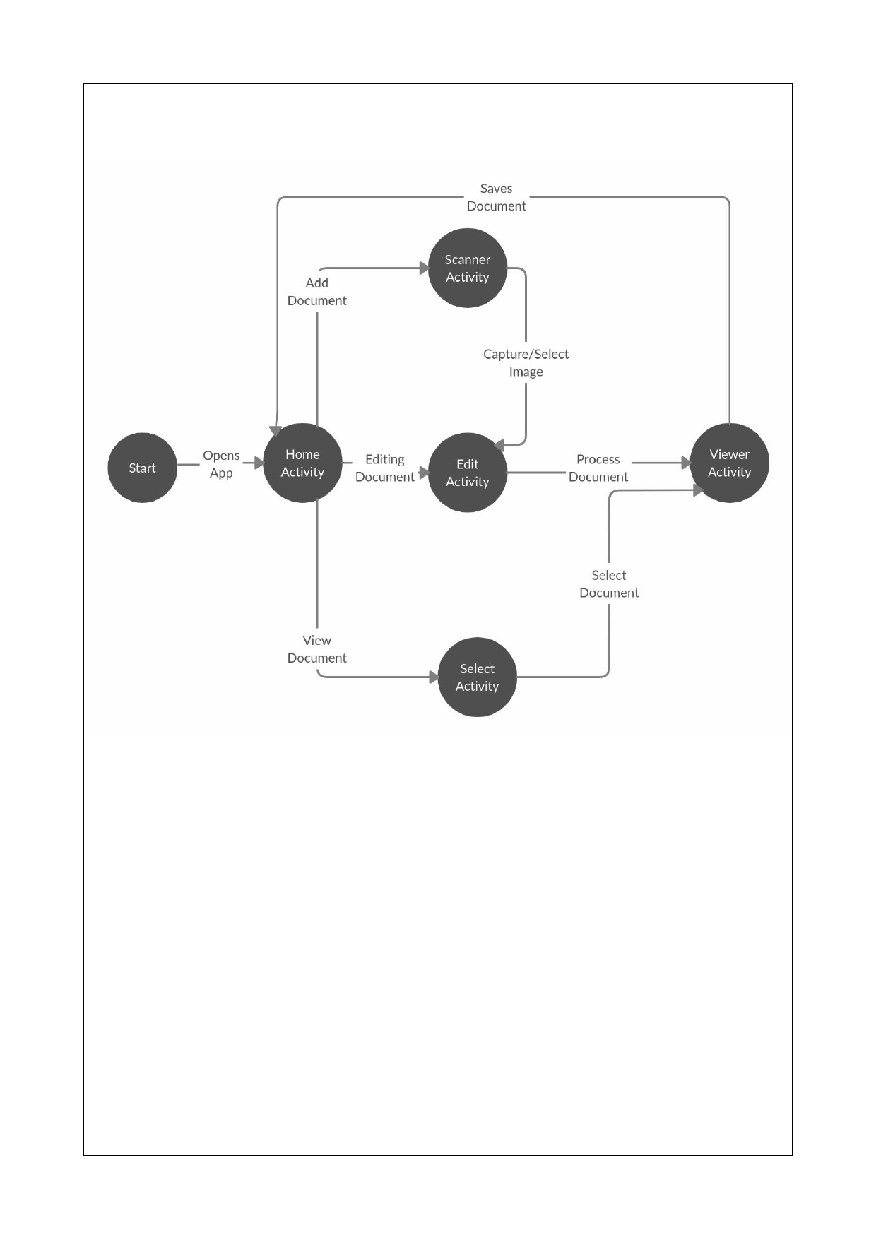
4.4 State Transition Diagram
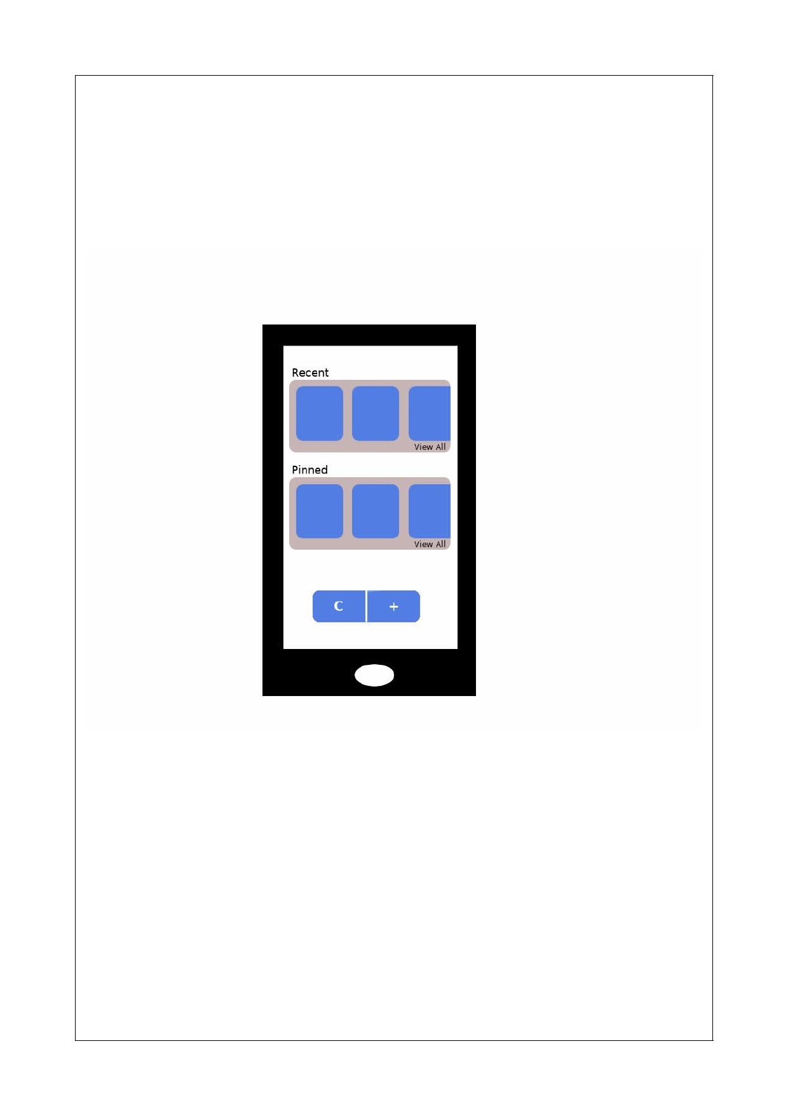
5. Graphical User Interface Design

5.1 GUI Models

Homepage
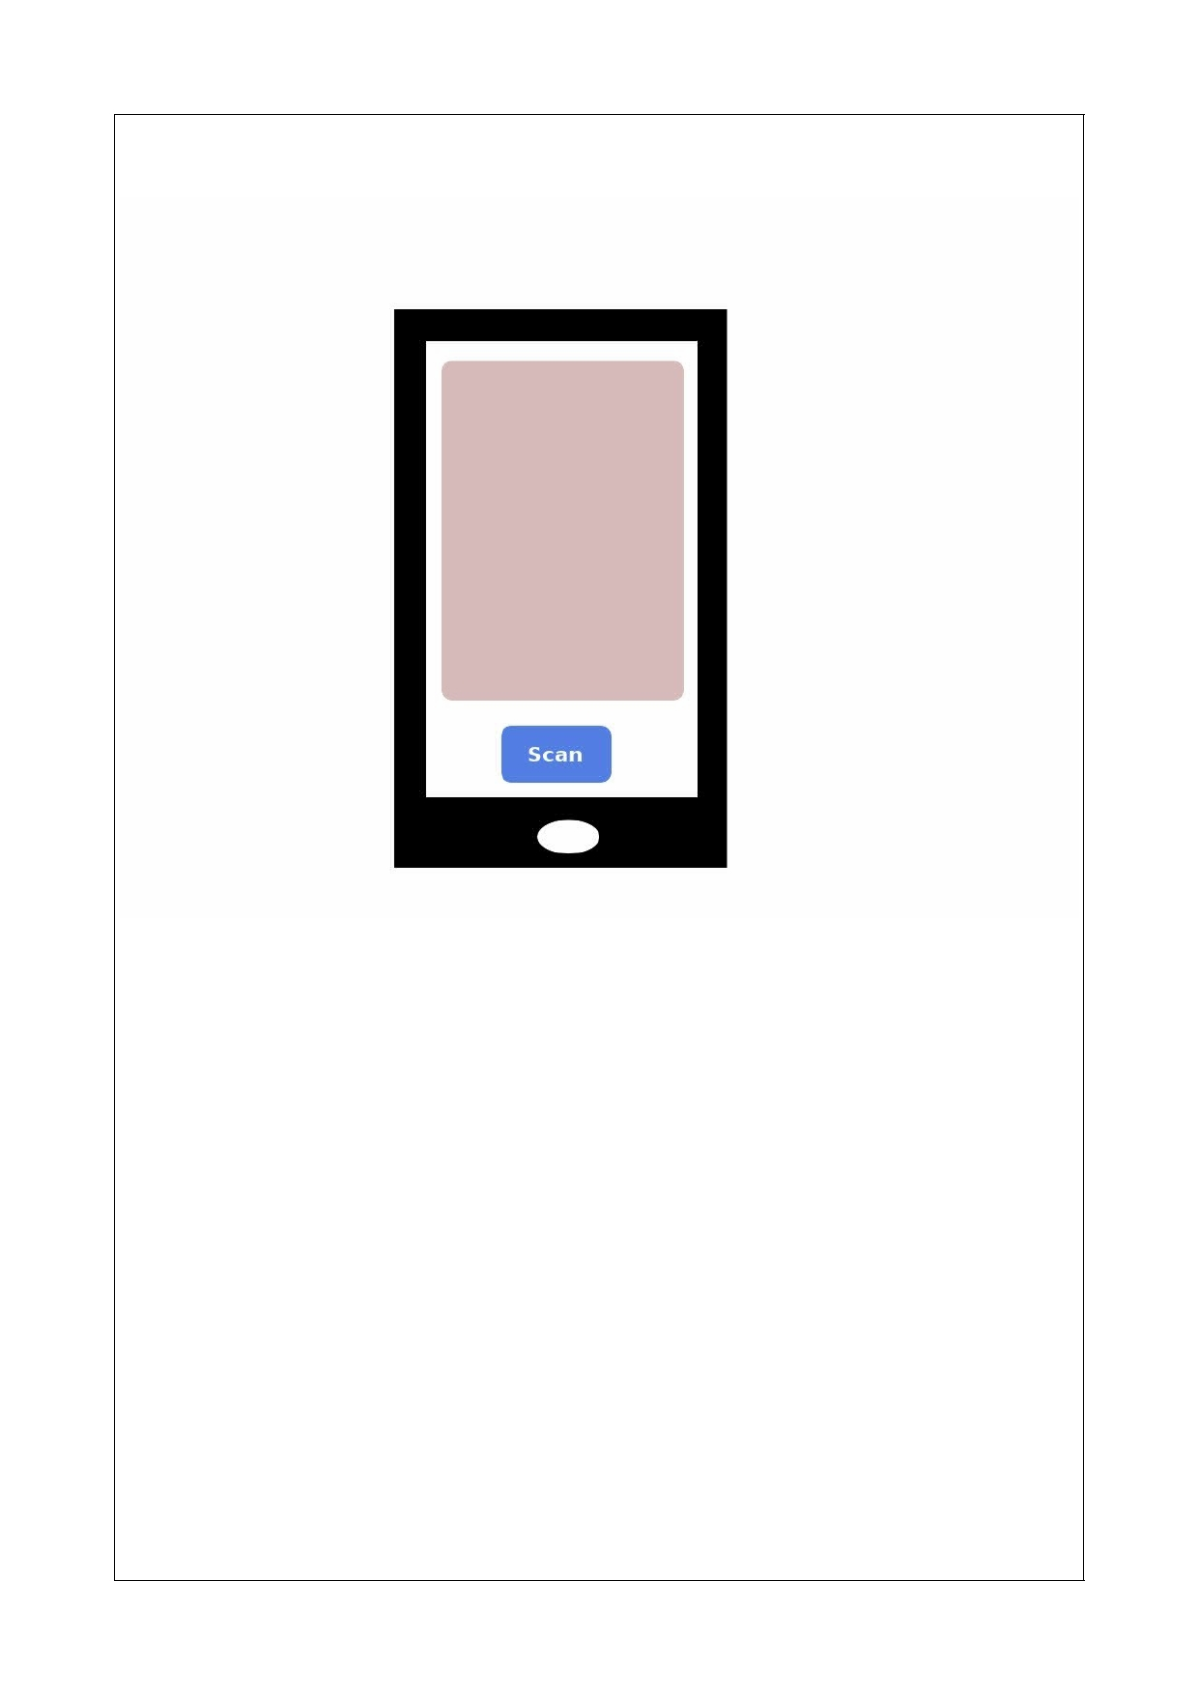
Scanner
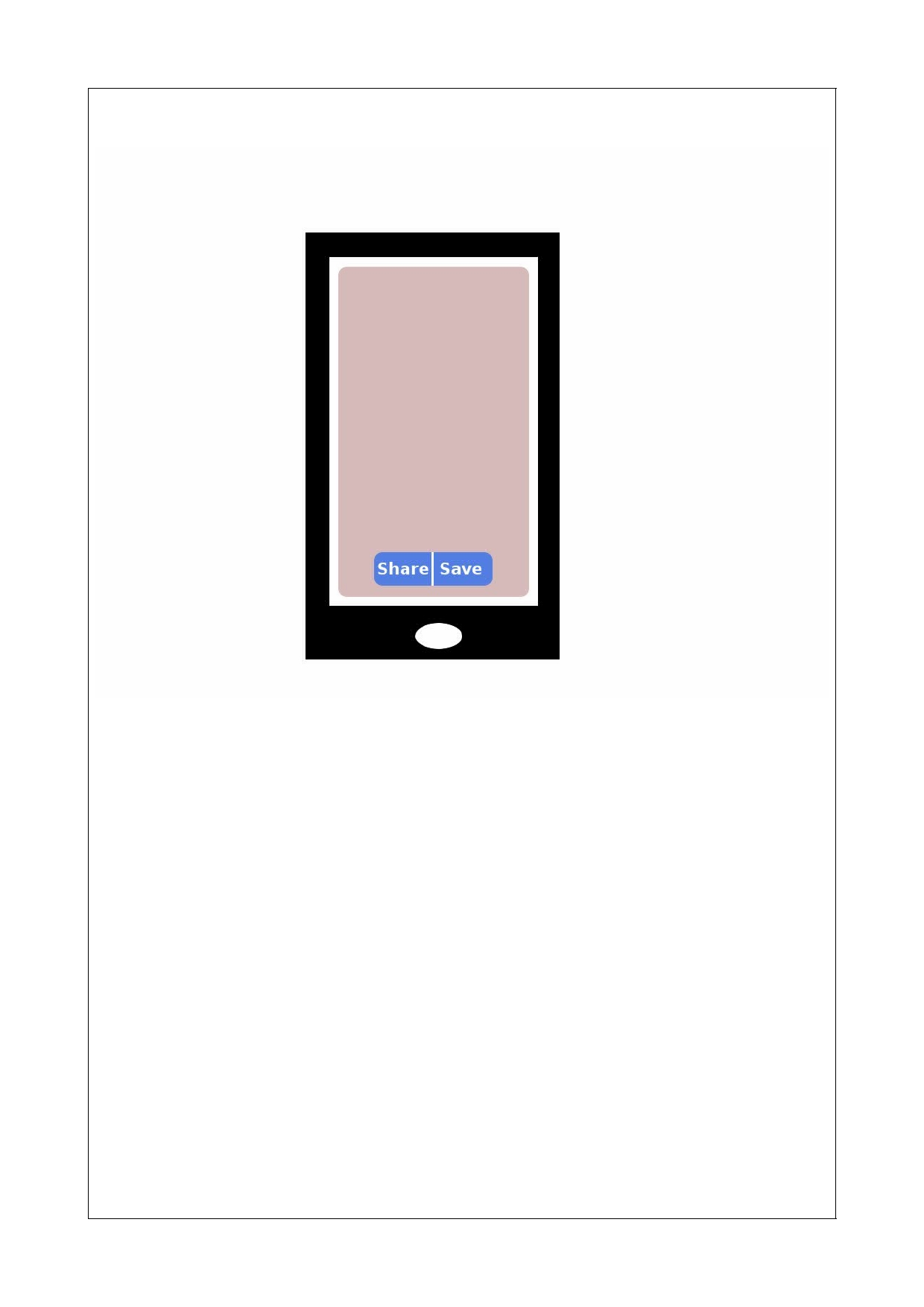
Document Viewer
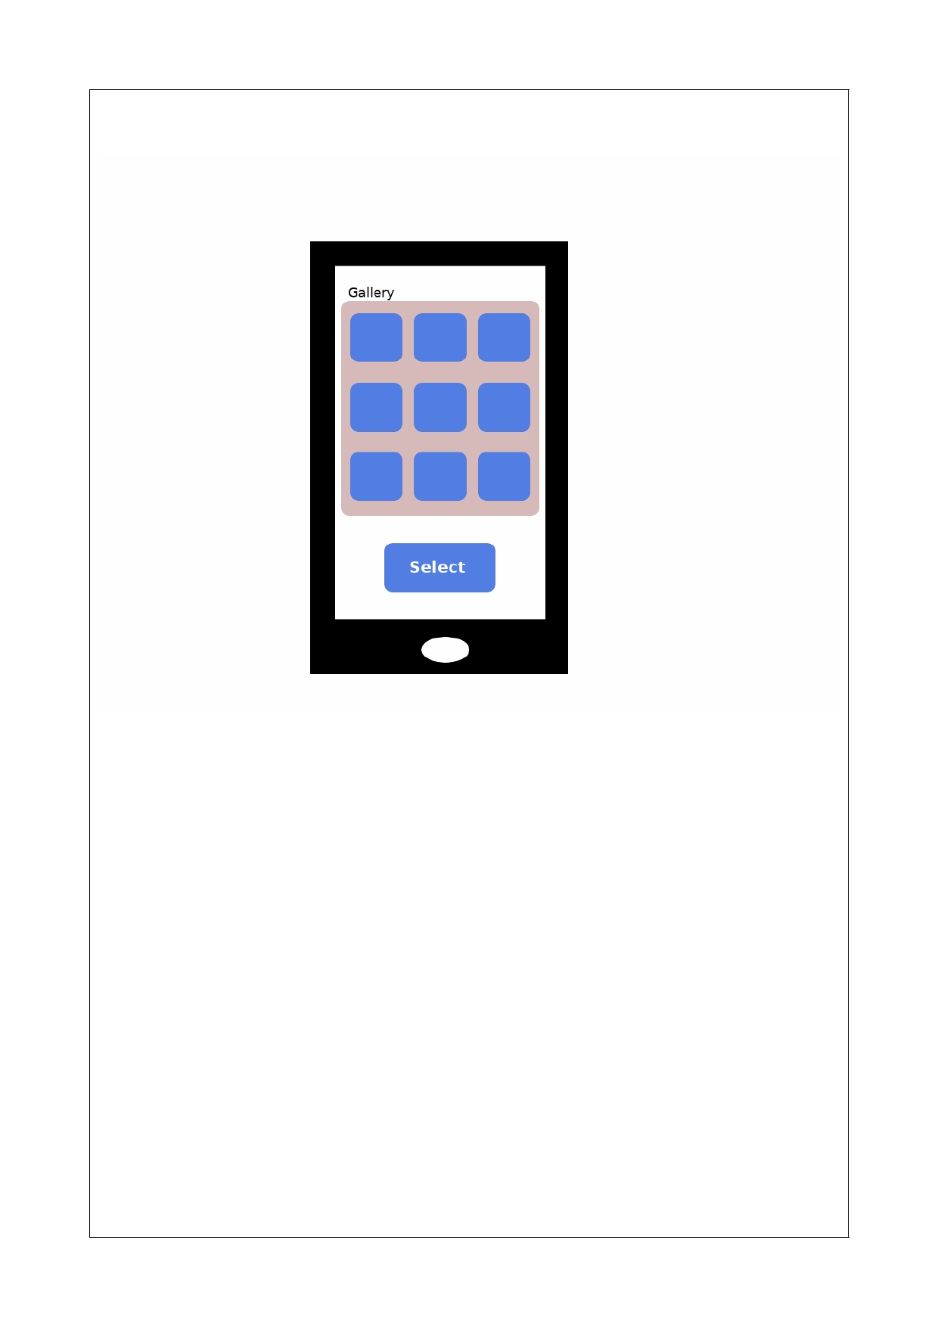
Select Image Screen
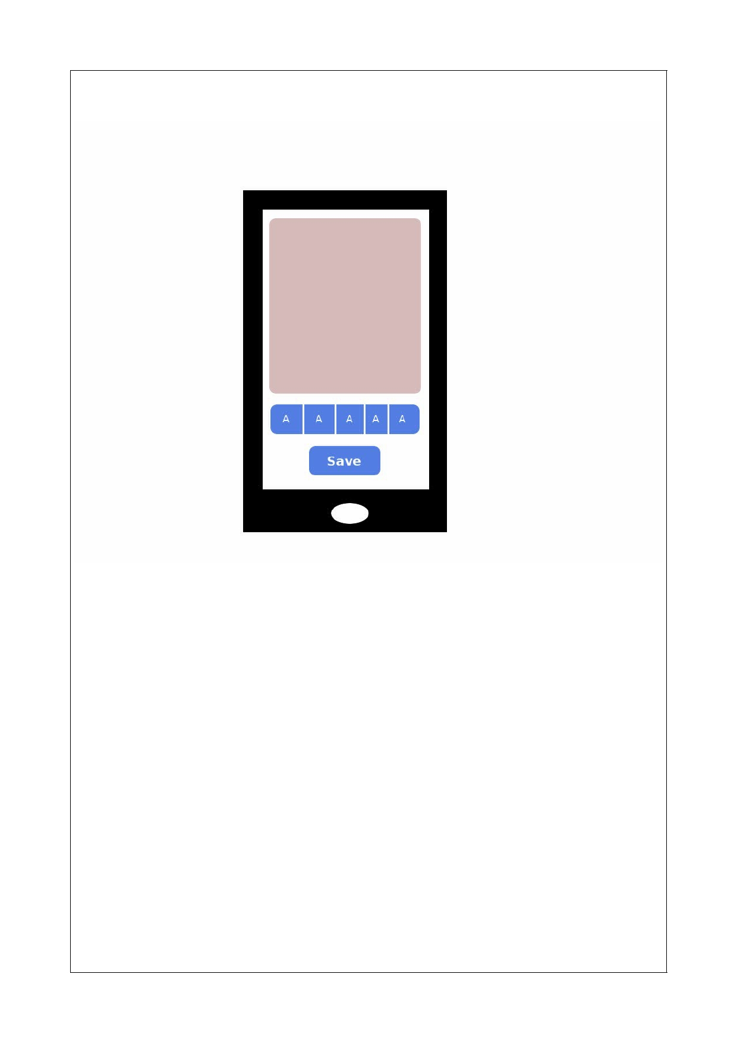
Edit Document Screen

