A Project Report on
SkillNect – Smart Career Guidance and Development App
Submitted in partial fulfillment of the requirements for the award of the degree of

BACHELOR OF TECHNOLOGY
in

COMPUTER SCIENCE & ENGINEERING

Submitted by
KUDIPUDI JYOTHI 22MH1A05B5
BIKASH PRASAD YADAV 22MH1A0589
SHIVANAND PRASAD KUSHWAHA 22MH1A05E3
DASI KARTHEEK 22MH1A0597

Under the esteemed supervision of

Mr. D. Venkata Ravi Kumar, M.Tech, (Ph.D),


Assistant Professor

Department of Computer Science & Engineering

ADITYA COLLEGE OF ENGINEERING & TECHNOLOGY

An AUTONOMOUS Institution
Approved by AICTE, Permanently Affiliated to JNTUK, Accredited by NBA & NAAC with A+ Grade Recognized by UGC under Sections 2(f) and 12(B) of UGC Act, 1956
(2022-2026)

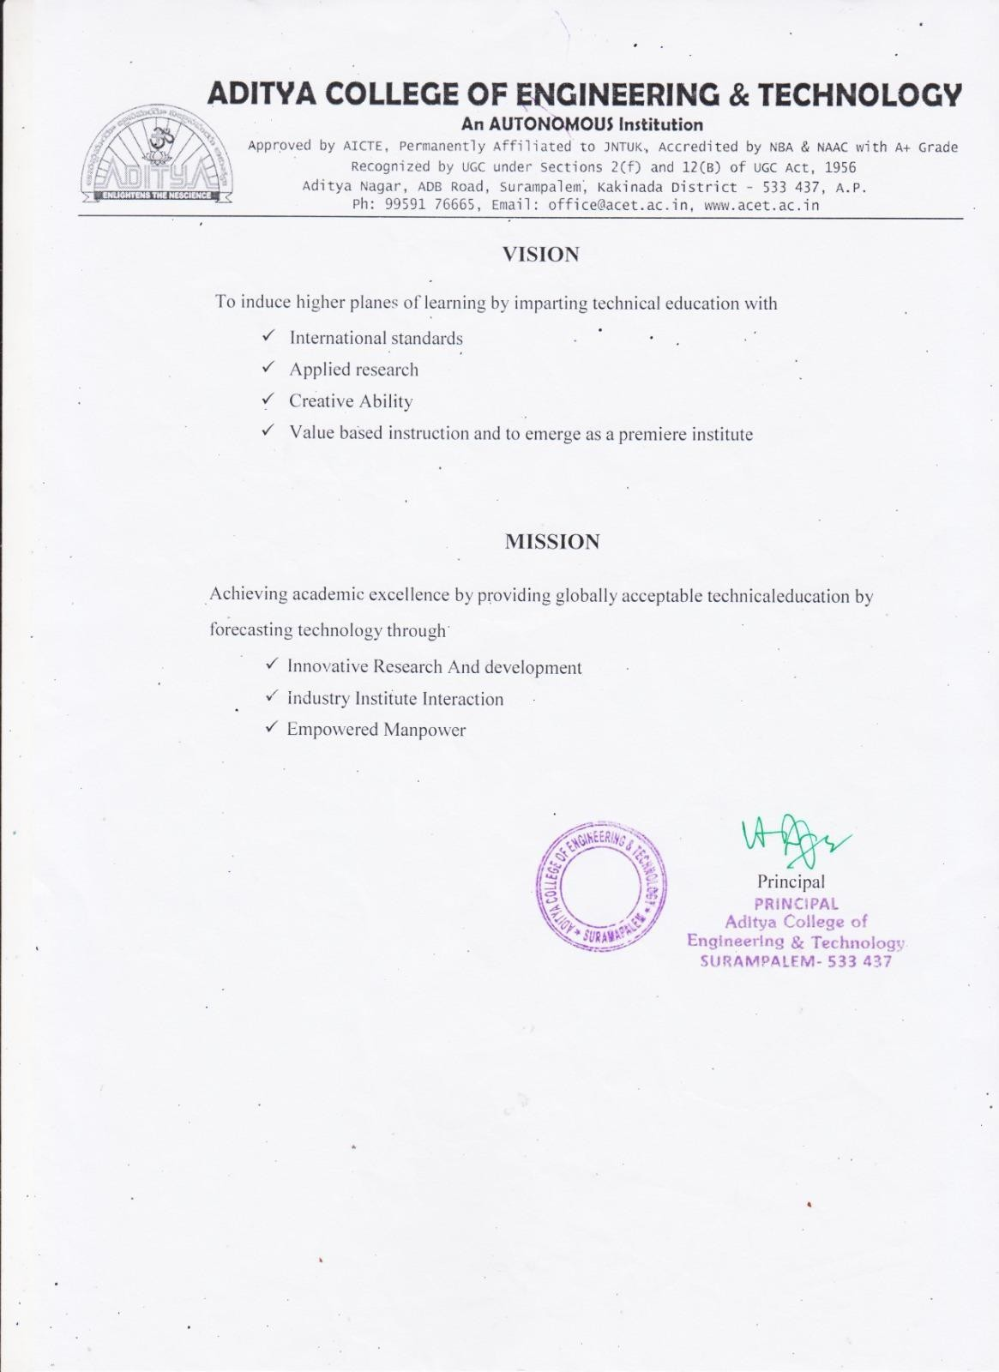

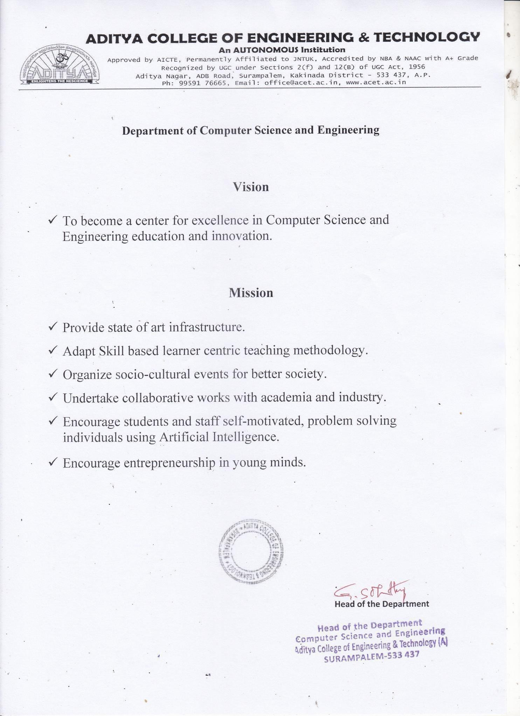

ADITYA COLLEGE OF ENGINEERING & TECHNOLOGY

An AUTONOMOUS Institution
Approved by AICTE, Permanently Affiliated to JNTUK, Accredited by NBA & NAAC with A+ Grade Recognized by UGC under Sections 2(f) and 12(B) of UGC Act, 1956

Department of Computer Science & Engineering


CERTIFICATE

This is to certify the project report entitled SKILLNECT – SMART CAREER GUIDANCE AND DEVELOPMENT APP is a bonified work carried out by Kudipudi Jyothi bearing with Regd No: 22MH1A05B5, Bikash Prasad Yadav bearing with Regd No: 22MH1A0589, Shivanand Prasad Kushwaha bearing with Regd No: 22MH1A05E3, Dasi Kartheek bearing with Regd No: 22MH1A0597 at the college for the award of Bachelor of Technology in COMPUTER SCIENCE & ENGINEERING from ADITYA COLLEGE OF ENGINEERING & TECHNOLOGY(A) during the academic year of 2022- 2026.

Project Guide Head of the Department
Mr. D.Venkata Ravi Kumar ,M.Tech,(Ph.D) Dr. G. S. N. Murthy ,M.Tech,Ph.D
Dept. Of CSE Dept. Of CSE
Assistant Professor Professor

EXTERNAL EXAMINER

DECLARATION

We hereby declare that this project entitled "SKILLNECT – SMART CAREER GUIDANCE AND DEVELOPMENT APP " has been undertaken by us and this work has been submitted to ADITYA COLLEGE OF ENGINEERING & TECHNOLOGY (A), Surampalem affiliated to JNTUK, Kakinada, in partial fulfillment of the requirements for the award of the degree of BACHELOR OF TECHNOLOGY in COMPUTER SCIENCE & ENGINEERING.
We further declare that this project work has not been submitted in full or part to any other University or educational institute for the award of any degree or diploma.

PROJECT ASSOCIATES

Kudipudi Jyothi 22MH1A05B5
Bikash Prasad Yadav 22MH1A0589
Shivanand Pd Kushwaha 22MH1A05E3
Dasi Kartheek 22MH1A0597

ACKNOWLEDGEMENT

It is with immense pleasure that we would like to express our indebted gratitude to my Project Supervisor, Mr. D. VENKATA RAVI KUMAR, who has guided us a lot and encouraged us in every step of project work, her valuable moral support and guidance have been helpful in successful completion of this Project.
We wish to express our sincere thanks to Dr. G S N Murthy, Head of the Department of CSE, for his valuable guidance given to us throughout the period of the project work.
We feel elated to thank Dr A. Ramesh, Principal of Aditya College of Engineering & Technology for his cooperation in completion of our project and throughout our course.
We feel elated to thank Dr. P.S.V.V.S. Ravi Kumar, Dean (Academics) of Aditya College of Engineering & Technology for his cooperation in completion of our project work.
We wish to express our sincere thanks to all faculty members, and lab programmers for their valuable guidance given to us throughout the period of the project.
We avail this opportunity to express our deep sense and heart full thanks to the Management of Aditya College of Engineering & Technology for providing a great support for us by arranging the trainees, and facilities needed to complete our project and for giving us the opportunity for doing this work.

PROJECT ASSOCIATES
Kudipudi Jyothi 22MH1A05B5
Bikash Prasad Yadav 22MH1A0589
Shivanand Pd Kushwaha 22MH1A05E3
Dasi Kartheek 22MH1A0597

ABSTRACT

The career development process for students and fresh graduates often lacks personalized guidance, structured planning, and continuous skill assessment. Many individuals struggle with resume quality, unclear career paths, poor communication skills, and limited interview preparedness, which reduces their employability. Existing platforms are often fragmented, manual, or fail to provide end-to-end career support.

To address these challenges, this project proposes SkillNect – a Smart Career Guidance and Development Application. The system provides an integrated platform that offers resume analysis with ATS scoring, personalized career roadmaps, communication and personality development modules, mock interview simulations, and progress tracking. Users can upload resumes, receive actionable feedback, select target career paths, and monitor their improvement through visual analytics.

The application is developed using modern web technologies with a secure backend and an interactive frontend, ensuring scalability and usability. By providing structured guidance, skill assessment, and continuous progress monitoring in a single platform, SkillNect enhances career readiness, confidence, and employability of users in a practical and efficient manner.

KEYWORDS: Career Guidance, Resume Analysis, ATS Score, Skill Development, Mock Interview, Communication Skills, Progress Tracking, Employability, Web Application.

INDEX  CHAPTER | PAGE NO
ABSTRACT | i
- INTRODUCTION | 1
1.1 Introduction to Project | 1-2
1.2 Literature Survey | 2-5
1.3 Existing System | 5-6
1.4 Scope of the Existing System | 6-7
1.5 Proposed System | 7-8
- Novelty of the Proposed System | 8-9
- LITERATURE SURVEY | 10
2.1 Introduction to literature survey | 10-11
2.2 Theoretical background / key concepts | 11-12
2.3 Review of existing methods / systems | 12-13
2.4 Critical analysis and research gaps | 13
2.5 Summary and link to proposed work | 14
- REQUIREMENT ANALYSIS | 15
3.1 Functional Requirements | 15-16
3.2 Non -Functional Requirements | 16-17
- SYSTEM DESIGN | 18
4.1 Overview of System Architecture | 18-20
4.2 Module Description/ Decomposition | 20-21
4.3 Database Design (ER-Diagram) | 21
4.4 Data flow Diagrams | 21
4.5 UML Diagram | 22
4.5.1 Use Case Diagram | 22-23
4.5.2 Class Diagram | 24
4.5.3 Sequence Diagram | 25
4.5.4 Activity Diagram  4.5.5 State Diagram | 26  27
4.5.6 Component Diagram | 28
4.5.7 Deployment Diagram | 29
4.5.8 Composite Diagram | 30
4.5.9 Package Diagram | 31
4.5.10 Object Diagram | 32
4.5.11 Timing Diagram | 33
4.5.12 Communication Diagram | 34
4.5.13 Profile Diagram | 35
4.5.14 Interaction Overview Diagram | 36
4.6 Design decision and constraints | 37
- SYSTEM IMPLEMENTATION | 38
5.1 Implementation Environment | 38-39
5.2 Module-wise Implementation | 39-42
5.3 Algorithm / Pseudo Code | 43-44
5.4 Screenshots Explanation | 44-50
- TESTING AND VALIDATION | 51
6.1 Testing Strategy | 51
6.2 Test Cases | 52
6.3 Test Results | 52
6.4 Validation | 52
- RESULTS AND PERFOMANCE ANALYSIS | 53
7.1 Output Analysis | 53
7.2 Performance Metrics | 54
7.3 Comparative Analysis | 55
- CONCLUSION & FUTURE ENHANCEMENTS | 56
8.1 Conclusion | 56-57
8.2 Limitations | 57
8.3 Future Scope | 57
- REFERENCES | 58
- APPENDIX | 59
10.1 Source Code | 59-61
10.2 User Manual | 62
10.3 Abbreviations | 63
10.4 Publication Paper Copy  10.5 Publication Certificates | 64-73  74-78

LIST OF FIGURES

CHAPTER | NAME OF FIGURE | PAGE NO
4.1 | Layered Architecture Diagram | 18
4.5.1 | Use Case Diagram | 22-23
4.5.2 | Class Diagram | 24
4.5.3 | Sequence Diagram | 25
4.5.4 | Activity Diagram | 26
4.5.5 | State Diagram | 27
4.5.6 | State machine Diagram | 28
4.5.7 | Composite Diagram | 29
4.5.8 | Profile Diagram | 30
4.5.9 | Timing Diagram | 31
4.5.10 | Interactive overview Diagram | 32
4.5.11 | Deployment Diagram | 33
4.5.12 | Package Diagram | 34
4.5.13 | Object Diagram | 35
4.5.14 | Communication Diagram | 36
5.3.1 | Resume ATS Score Algorithm | 43
5.3.2 | Career Roadmap Generation Module | 43
5.3.3 | AI Mock Interview Module | 44
5.3.4 | Landing Page | 44
5.3.5 | Sign-in Page | 45
5.3.6 | Dashboard | 45
5.3.7 | Roadmap Page | 46
5.3.8 | Roadmap | 46

5.3.9 | Roadmap | 47
5.3.10 | Resume Builder Page | 47
5.3.11 | Interview Page | 48
5.3.12 | Interview Page | 48
5.3.13 | Interview Page | 49
5.3.14 | Admin Dashboard | 49
5.3.15 | Admin-User Management | 50
7.1.1 | API response Time Observation | 53
7.2.1 | Database Operation Time | 54
7.3.1 | Conceptual Comparison Between Existing and Proposed | 55
10.1.1 | Backend - Server Configuration | 59
10.1.2 | Backend - User Login Route | 60
10.1.3 | Frontend - React Component | 61

LIST OF TABLES

CHAPTER | NAME OF TABLE | PAGE NO
6.1 | Test Cases | 51
7.1 | Existing Versus Proposed System | 53
10.3 | Abbreviations | 63

INTRODUCTION
This project proposes an intelligent career development platform, SkillNect, designed to address the challenges faced by students and job seekers during the preparation process. The system integrates multiple functionalities such as mock interview simulations, personalized career roadmap generation, and curated learning resource recommendations into a single unified platform. By analyzing user inputs like career interests, skill levels, and performance metrics, the platform provides structured and targeted guidance to enhance employability.
This project proposes a data-driven approach for continuous learning and performance tracking through an interactive dashboard. The system records user activities, including interview attempts and scores, and presents them in an analytical format to monitor progress over time. Additionally, it recommends relevant learning resources, such as video-based content, to help users improve identified skill gaps. The use of modern web technologies and cloud infrastructure ensures scalability, real-time interaction, and efficient user experience.

Introduction to Project:
Career preparation has evolved into a continuous and structured process in today’s competitive environment. Students and job seekers are expected to develop strong technical skills, build effective resumes, improve communication abilities, and prepare for interviews simultaneously. With rapid advancements in technology and increasing competition, individuals must adopt a strategic approach to achieve their career goals.

However, most individuals rely on multiple disconnected platforms such as learning websites, resume tools, and interview preparation resources. This fragmented approach often leads to confusion, lack of direction, and inefficient utilization of time. Users struggle to identify which skills to prioritize and how to effectively plan their preparation journey.

Traditional career guidance methods, including counseling sessions and generic training programs, are often not personalized and fail to adapt to individual needs. These methods do not consider the user’s current skill level, career interests, or performance progression. As a result, many job seekers face difficulties such as poorly structured resumes, lack of confidence, and inadequate interview readiness.

Another major challenge is the absence of a proper system to track progress and evaluate performance over time. Without continuous monitoring and feedback, users are unable to identify their strengths and weaknesses. This lack of insight leads to ineffective preparation and reduced chances of success in competitive job environments.

To overcome these challenges, there is a need for a centralized platform that integrates multiple career development functionalities into a single system. Such a platform should provide personalized guidance, continuous performance tracking, and adaptive learning recommendations to ensure efficient and goal-oriented preparation.

The proposed system, SkillNect, aims to bridge this gap by offering an all-in-one solution for career development. It enables users to practice mock interviews, receive performance-based feedback, and generate personalized career roadmaps based on their interests and skill levels. The system also recommends relevant learning resources to support continuous improvement.

Literature Survey
Career development platforms have become essential in addressing the challenges faced by students during job preparation. Modern systems aim to combine skill development, interview preparation, and career planning into a structured workflow. With increasing competition, users require platforms that provide continuous guidance rather than one-time support. Digital solutions offer flexibility and accessibility, enabling users to learn and prepare at their own pace. However, many existing systems lack integration of multiple features in a single platform. This creates gaps in user experience and reduces overall efficiency. Therefore, research focuses on building unified and intelligent career systems.
Nandakumar et al. [1] emphasized the need for structured career planning systems that guide users based on their interests and skill levels. Their study highlighted that generic career advice does not effectively support individual growth. Instead, personalized guidance frameworks help users make better career decisions. The research also showed that users benefit from systems that adapt to their progress over time. This concept is directly relevant to platforms like SkillNect, which focus on customized career roadmaps. By aligning user goals with system recommendations, better outcomes can be achieved. Structured guidance is therefore a key requirement in modern career platforms.
Reddy and Varma [2] analyzed digital career guidance platforms and their role in providing step-by-step learning paths. Their findings suggest that users perform better when guided through a structured roadmap rather than random learning resources. These platforms help users identify required skills and plan their learning journey effectively. The study also highlighted the importance of interactive systems in improving user engagement. This directly relates to SkillNect roadmap generation feature. By providing a clear path, users can focus on goal-oriented preparation. This reduces confusion and improves learning efficiency.
Kumar and Sharma [3] studied Applicant Tracking Systems (ATS) and their impact on resume selection during recruitment. Their research explained how resumes are filtered based on keywords, formatting, and relevance. Candidates who optimize their resumes according to ATS requirements have higher chances of shortlisting. The study emphasized the importance of intelligent resume analysis tools. This is relevant to SkillNect resume improvement feature. By guiding users to create ATS-friendly resumes, platforms can significantly increase job opportunities. Understanding ATS behavior is essential in modern recruitment processes.
Patel and Mehta [4] further explored automated resume screening systems and identified key challenges faced by job seekers. Many candidates fail to meet system requirements due to lack of awareness about resume optimization techniques. The study suggested integrating intelligent feedback mechanisms into career platforms. Such systems can analyze resumes and provide suggestions for improvement. This approach enhances the effectiveness of resume preparation. It also reduces rejection rates during initial screening. These findings support the need for advanced resume tools in platforms like SkillNect.
Zhao et al. [5] focused on mock interview systems and communication training platforms. Their research showed that simulated interview environments help users improve confidence and communication skills. Continuous practice and feedback play a major role in enhancing performance. However, the study identified a limitation in long-term performance tracking. Most systems do not store or analyze past performance effectively. This gap highlights the importance of features like SkillNect’s progress dashboard. Tracking interview scores over time helps users understand their improvement. This leads to better preparation outcomes.
Singh and Kaur [6] examined online interview preparation tools and identified the lack of performance analytics as a major drawback. Users often practice interviews but do not receive structured feedback or progress insights. Without tracking, it becomes difficult to measure improvement. The study emphasized the need for dashboards that display performance metrics clearly. This directly aligns with SkillNect’s dashboard feature. By showing interview attempts and scores, users can evaluate their strengths and weaknesses. This supports continuous learning and improvement.
Behl and Kaur [7] analyzed web-based career platforms and highlighted the issue of fragmented services. Most systems offer individual features such as resume building or learning resources, but lack integration. Users are forced to switch between multiple platforms, which reduces efficiency. The study suggested developing unified systems that combine all essential features. This concept is implemented in SkillNect by integrating multiple tools into one platform. A centralized system improves usability and saves time. Integration is therefore a critical factor in modern career solutions.
Sharma et al. [8] studied recommendation systems and their role in personalized learning. Their research showed that recommending relevant content based on user behavior improves engagement. Systems that suggest videos and learning materials help users focus on important topics. This is directly related to SkillNect’s YouTube recommendation feature. Personalized suggestions reduce unnecessary effort and improve learning outcomes. The study also highlighted the importance of adaptive systems in modern education. Intelligent recommendations enhance overall user experience.
Gupta and Rao [9] concluded that future career development systems must integrate multiple functionalities into a single platform. Their research emphasized combining interview preparation, resume optimization, skill development, and performance tracking. Integrated systems provide better results compared to standalone tools. This forms the core idea behind SkillNect. By using modern technologies like React, Node.js, and cloud databases, such platforms can deliver scalable and efficient solutions. A unified and intelligent system is essential to meet current industry demands. SkillNect is designed to address these requirements effectively.

1.3 Existing System

The existing career guidance ecosystem consists of multiple independent platforms that assist users in different aspects of career preparation, such as resume building, online learning, communication skill development, and interview practice. These platforms are designed to address specific problems individually, but they operate in isolation without any form of integration. As a result, users are required to switch between multiple applications to complete their preparation process. This fragmented approach increases complexity and reduces overall efficiency, making career planning unstructured and difficult to manage.

Most existing systems provide generalized information and static suggestions that are not tailored to individual user needs. Resume evaluation tools often rely on basic keyword matching and fail to provide meaningful, job-specific feedback. Similarly, learning platforms recommend generic content without considering the user’s current skill level or career goals. Communication training applications lack proper evaluation mechanisms, and mock interview systems do not offer continuous feedback or performance tracking. Due to the absence of personalization, users are unable to receive targeted guidance for improvement.

Another major limitation of existing systems is the lack of performance monitoring and analytics. Users can practice interviews or learn new skills, but there is no centralized mechanism to track their progress over time. Without proper feedback and data analysis, it becomes difficult for users to identify their strengths and weaknesses. This absence of structured evaluation leads to inefficient preparation and reduces confidence during actual job interviews.

Challenges in Existing System

Lack of integration between resume tools, learning platforms, and interview systems

Absence of personalized recommendations based on user profile and performance

Limited or no real-time feedback in mock interview and communication systems

No centralized dashboard to track user progress and performance

Dependence on generic content instead of adaptive learning

Inefficient workflow due to use of multiple disconnected platforms

1.4 Scope of the Existing System

The scope of existing career guidance systems is limited to providing isolated functionalities such as resume building, online learning, or interview preparation. These systems are designed to solve specific problems independently but do not offer a complete solution for career development. As a result, users are required to rely on multiple platforms to manage different aspects of their preparation. This lack of integration makes the overall process unstructured and inefficient.

Another limitation is the absence of intelligent career planning support. Most platforms do not provide personalized guidance based on user interests, skills, or performance. Users are expected to manually decide what to learn, which skills to develop, and how to prepare for job roles. This increases confusion and reduces the effectiveness of career planning.

Progress tracking in existing systems is also very limited and often restricted to individual platforms. There is no centralized mechanism to monitor overall performance across different activities such as learning, resume improvement, and interview practice. Additionally, real-time feedback and performance analytics are either missing or not detailed enough to support continuous improvement.

Due to these limitations, the scope of existing systems remains restricted and does not fully support end-to-end career preparation. This highlights the need for an integrated platform that provides personalized guidance, real-time tracking, and a structured approach to career development.

1.5 Proposed System

The proposed system, SkillNect, is a comprehensive career development platform designed to address the limitations of existing systems by integrating multiple functionalities into a single unified solution. The platform provides users with tools for resume analysis, career roadmap generation, mock interview practice, and performance tracking. By combining these features, SkillNect enables users to prepare for their careers in a structured and efficient manner.

SkillNect incorporates an ATS-based resume analysis system that evaluates resumes based on industry standards. It provides users with an overall score and offers suggestions to improve resume quality. Additionally, the system supports job-specific resume optimization, allowing users to tailor their resumes according to particular job roles. This increases the chances of selection during recruitment processes.

The platform also includes a personalized career roadmap feature, which generates step-by-step learning paths based on user interests and goals. It recommends relevant learning resources, including video-based content, to help users acquire required skills efficiently. This ensures that users follow a focused and goal-oriented preparation strategy.

SkillNect provides mock interview simulations that allow users to practice interview scenarios in a controlled environment. The system evaluates user performance and provides feedback to improve communication and confidence. Additionally, a progress dashboard is implemented to track interview attempts, scores, and skill development over time. This helps users monitor their improvement and identify areas that require attention.

Key Features of the Proposed System

ATS-based resume analysis and job-specific optimization

Personalized career roadmap generation

YouTube-based learning resource recommendations

Mock interview simulation with performance feedback

Progress dashboard for tracking scores and improvement

Integrated platform combining multiple career development tools

1.6 Novelty of the Proposed System

The novelty of the SkillNect system lies in its integrated and data-driven approach to career development. Unlike traditional platforms that focus on individual functionalities, SkillNect combines multiple features into a single system, providing a complete end-to-end solution for career preparation. This integration eliminates the need for users to switch between multiple platforms, improving efficiency and user experience.

Another unique aspect of the system is its ability to provide continuous performance tracking and real-time feedback. The platform monitors user activities such as interview attempts, resume improvements, and skill development, and presents this information through an interactive dashboard. This enables users to clearly understand their progress and make informed decisions for improvement.

SkillNect also incorporates personalization at multiple levels, including career roadmap generation and content recommendations. By analyzing user inputs and performance data, the system provides targeted suggestions that align with individual goals. This adaptive approach enhances learning efficiency and ensures better outcomes.

Key Novel Features of the System

Unified platform integrating resume, learning, and interview preparation

Real-time performance tracking with analytical dashboard

Personalized career roadmap based on user interests and goals

Adaptive learning recommendations using user data

ATS-based resume optimization for improved job selection chances
- LITERATURE SURVEY

The system study phase is a crucial stage in software development, as it helps in understanding the feasibility, scope, and overall impact of the proposed system. This phase involves analyzing existing systems, identifying their strengths and limitations, and evaluating the requirements of the new system. It provides a clear understanding of the problem domain and helps in defining system objectives effectively. By conducting a detailed system study, developers can ensure that the proposed solution is practical, efficient, and capable of addressing real-world challenges. This phase also plays a key role in minimizing risks and improving the overall design and implementation process

2.1 Introduction to Literature Survey

The literature survey is an essential component of a software engineering project, as it provides a comprehensive understanding of existing systems, technologies, and research related to the problem domain. It helps in analyzing how similar problems have been addressed in the past and what methodologies have been used to develop effective solutions. By studying existing work, it becomes easier to identify best practices and avoid common limitations.

In the context of the SkillNect system, the literature survey focuses on various domains such as career guidance platforms, resume analysis systems, Applicant Tracking Systems (ATS), learning recommendation systems, communication skill development tools, and AI-based mock interview platforms. These systems provide valuable insights into how different aspects of career preparation are currently handled.

Most existing career development solutions focus on individual functionalities such as resume building, course recommendations, or interview preparation. However, very few systems provide an integrated solution that combines all these features into a single platform. This lack of integration creates challenges for users, as they need to depend on multiple tools for complete career preparation.
The literature survey helps in identifying these gaps and understanding the limitations of current systems, such as lack of personalization, absence of progress tracking, and limited feedback mechanisms. It highlights the need for a unified platform that can provide structured guidance, real-time feedback, and continuous performance monitoring.

This chapter presents a detailed review of existing research and systems to identify key challenges and opportunities in career development platforms. Based on these observations, the need for an intelligent and integrated solution like SkillNect is established, which aims to provide a comprehensive and efficient approach to career preparation.

2.2 Theoretical Background and Key Concepts

When we talk about career development systems they are based on an important idea. These ideas are about helping people figuring out what they are good at making things just right, for them and keeping an eye on how they're doing. The basics of SkillNect are built on some ideas.

Career Guidance Systems
When it comes to finding a career guidance systems are really helpful for students and professionals. They help students and professionals find career paths that're a good fit for them. This is because career guidance systems look at the interests, skills and goals of students and professionals.

The old way of doing career guidance was not very effective. It usually involved talking to a counselor and taking tests that did not change. The problem with this way is that it does not adapt to the needs of students and professionals. Career guidance systems are better because they can help students and professionals find career paths that're right, for them.

Key concepts involved:

- Career interest identification

- Skill and aptitude assessment

- Goal-oriented career planning

- Limited personalization in traditional methods

- Resume Analysis and ATS Optimization

Resume analysis systems look at resumes to see if they have what is required. They check for things like skills and keywords and experience. How the resume is formatted. Organizations use systems called Applicant Tracking Systems to sort through resumes, on their own. These systems help them find the resumes.

2.3 Review of Existing Methods and Systems

Many career development platforms there only look at one part of getting ready for a career instead of looking at the whole thing. These career development platforms do not offer a solution. The career development platforms should help people with all parts of their career preparation. They do not. The main issue, with these career development platforms is that they are missing some parts.

When I look at resume evaluation platforms they do give me some idea of how my resume will do with the computer systems that companies use to screen resumes. These platforms also suggest some keywords that I can use to make my resume better. What they do not do is help me make my resume really good for a specific job I want. They also do not work well with the courses I take to learn new things.

Online learning platforms have a lot of courses that I can take to learn new skills. However, they do not help me plan out my career. They do not keep track of my progress. Resume evaluation platforms and online learning platforms, like resume evaluation platforms do not work together to help me get a job.

Communication skill platforms are okay. They usually just give you some recorded lessons or basic practice sessions. The problem is that you do not get feedback that is actually about you.

Then there are interview platforms that try to be, like real interviews. However, communication skill platforms and mock interview platforms often do not show you how much you are improving over time.

These systems work on their own so people have to use different platforms. This means that people have to prepare for things in a lot of ways. It is also really hard to plan your career when you have to use many different systems. The career planning process is not very efficient because of this.

2.4 Critical Analysis and Research Gaps

We have technology like artificial intelligence and digital platforms but the systems we have now are not perfect. They still have a lot of problems that need to be fixed. Artificial intelligence and digital platforms are really cool. They are not enough to make our systems work the way we want them to. There are limitations, in our existing systems that we need to work on.

Identified research gaps:
- Lack of a unified career development platform
- No centralized dashboard for career readiness
- Static recommendations without adapting to user progress
- Poor integration of technical and soft skills
- Limited AI-driven personalization

These gaps show that we really need a career guidance system that's easy to use and helps people make good choices. A career guidance system should be smart. Think about what the user needs. We need a system that puts the user first and helps them in a way. This kind of career guidance system is very important.

2.5 Summary and Link to Proposed Work

When you look at the research that has been done you can see that the systems we have now do not really help people with their career development. They might do a bit of resume analysis or career planning or communication training or interview preparation but they do all of these things separately. This means that they are not as helpful as they could be. The literature survey shows that career development systems are not doing a job. They only do things like resume analysis and career planning and communication training and interview preparation. They do not do them together which makes them less effective. Career development is what these systems are supposed to be helping with.

The SkillNect Smart Career Guidance and Development App is an idea that fixes the problems we have now. It does this by putting everything we need for career development in one place that we can use on the web and on our phones. This part of the book sets the stage, for the SkillNect Smart Career Guidance and Development App. We will talk about it in more detail in the next part System Proposed Work

We will look at the system. Figure out what is going on. Then we will propose some work to make it better. The system analysis is an important step. We have to do this so we can understand the system.

After that we will propose some work. This proposed work will help us fix the problems we found in the system analysis. System analysis and proposed work go hand in hand. We cannot do one without the other.

First, we do the system analysis. Then we come up with the proposed work. System analysis is like looking at the system to see what is wrong. Proposed work is, like coming up with a plan to fix it. System analysis and proposed work are very important.

- REQUIREMENT ANALYSIS
Functional and non-functional requirements play a crucial role in defining the behavior and quality of a software system. Functional requirements describe the core features and operations that the system must perform to satisfy user needs. These include user interactions such as login, roadmap generation, mock interviews, and progress tracking.
Non-functional requirements define the quality attributes of the system, such as performance, usability, scalability, and security. These requirements ensure that the system operates efficiently, remains reliable under different conditions, and provides a smooth user experience. Both functional and non-functional requirements together help in designing a system that is effective, scalable, and aligned with user expectations.

  - Functional Requirements
The functional requirements define the core features and operations that the SkillNect system must perform to support career development efficiently. These include:

3.1.1. User Authentication and Management
  - Users can register and log in using email and password
  - The system maintains user profiles with selected career interests
  - Session handling ensures secure access to user-specific data
  - Each user can access their own dashboard and progress details

3.1.2. Career Roadmap Generation
  - Users select a target role (e.g., Software Developer, Data Analyst)
  - The system generates a structured roadmap with required skills
  - Roadmap includes step-by-step learning guidance
  - Helps users understand what to learn and in what order

3.1.3. Learning Resource Recommendation
  - The system recommends relevant learning resources based on selected role
  - Integrates YouTube content for skill-based learning
  - Provides topic-wise suggestions aligned with roadmap
  - Helps users avoid searching randomly for learning materials

3.1.4. Mock Interview System
  - Simulates interview questions based on selected domain
  - Users can practice answering questions
  - System records responses and assigns scores (basic evaluation)
  - Helps improve confidence and interview readiness

3.1.5. Progress Tracking and Dashboard
  - Tracks user activities such as interview attempts
  - Displays scores and performance in dashboard
  - Shows improvement over time
  - Helps users identify weak areas and focus accordingly

  - Non-Functional Requirements
Non-functional requirements specify the constraints and quality standards of the SkillNect system. These requirements ensure that the platform performs efficiently, remains secure, and provides a seamless experience to users. They define how the system behaves under different conditions rather than what the system does.
3.2.1. Performance
System responds quickly to user actions like page loading navigation
Mock interviews and dashboard updates execute smoothly without noticeable delays
Backend Node.js efficiently handles multiple concurrent requests ensuring consistent performance

3.2.2. Scalability
System supports increasing number of users without performance degradation issues
Cloud deployment enables dynamic scaling based on application demand growth
New features can be added without requiring major system redesign changes

3.2.3. Usability
Application provides simple clean interface using React and Tailwind CSS
Users navigate easily between roadmap interviews and dashboard sections
Designed for students with minimal technical knowledge ensuring ease of use

3.2.4. Reliability
System ensures high availability with minimal downtime for continuous access
User data like progress and scores stored securely and consistently maintained
Proper error handling prevents failures and ensures smooth user experience

3.2.5. Security
System implements secure authentication mechanisms to protect user accounts effectively
User data remains private and inaccessible to unauthorized users always
Basic data protection methods safeguard stored information from potential threats

3.2.6. Maintainability
System follows modular architecture separating frontend and backend components clearly
Code structure allows easy updates and addition of new features
Well defined APIs simplify backend communication and future maintenance tasks

3.2.7. Compatibility
Application works efficiently on modern browsers like Chrome and Edge
Responsive design adapts seamlessly to different screen sizes and devices
System architecture supports future extension to mobile platforms easily

4. SYSTEM DESIGN

4.1 Overview of System Architecture

The SkillNect system is made up of a client. A server that works together with artificial intelligence services. People use the SkillNect system by looking at it on the web or on their phone. When you do something, on the SkillNect system the part you see which is called the frontend takes care of what you're doing. The backend, which is the part you do not see handles all the requests you make checks who you are figures out what you can and cannot do and makes sure the artificial intelligence services are working properly with the SkillNect system and the artificial intelligence services.

The system is made up of a few parts: presentation, application, AI processing and data layers. This way of doing things makes the system more scalable, more secure and easier to maintain The AI modules for things, like looking at resumes creating career roadmaps and doing interviews can all work together really well with the AI processing and data layers. The AI modules and the AI processing and data layers all work together to make sure everything runs smoothly.

Layered Architecture Diagram

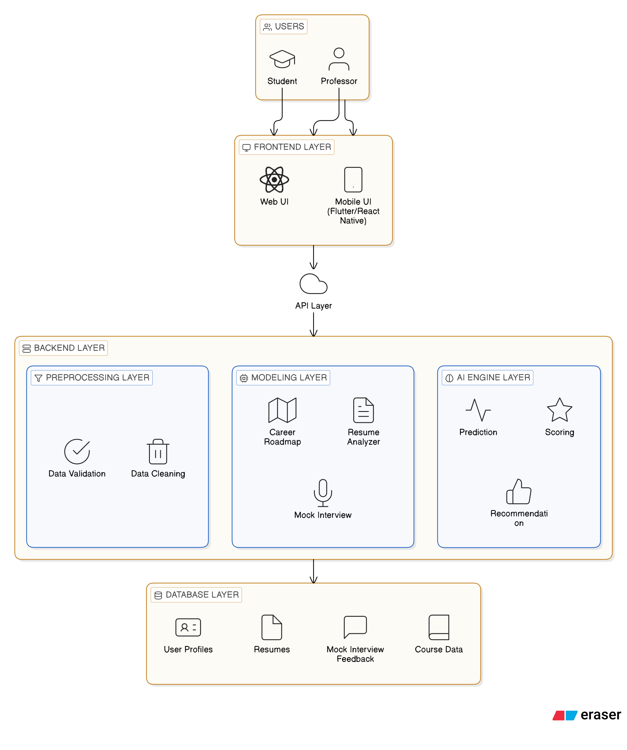
Fig 4.1 Layered Architecture Diagram

4.1.1 Description of Layers:
Frontend-Layer
The front-end layer is responsible for providing an interactive and user-friendly interface for the users. It allows users to upload resumes, access career roadmaps, and participate in mock interviews. This layer is developed using React and Tailwind CSS to ensure a responsive and visually appealing design.
API-Layer:
The API layer acts as a communication bridge between the front-end and the back-end. It handles all client requests, sends them to the appropriate backend services, and returns the processed responses. This layer ensures smooth data flow and secure interaction between different components of the system
Backend-Layer:
The back-end layer manages the core functionality of the system, including resume making, career roadmap generation, and mock interview processing. It is built using Node.js and handles business logic, authentication, and data processing efficiently.

Database-Layer:
The database layer is responsible for storing and managing all application data. It includes user profiles, uploaded resumes, ATS scores, generated roadmaps, and interview results. This layer ensures data consistency, security, and quick retrieval using a structured database system.

4.2 Module Description / Decomposition

The SkillNect system is divided into several functional modules to ensure modularity, maintainability, and clarity in system operations. Each module is responsible for handling a specific functionality, enabling the system to operate efficiently while providing a seamless experience to the users.

4.2.1 User Authentication Module

Handles user registration and login

Manages user sessions securely

Implements role-based access control for different types of users

4.2.2 Resume Builder Module
- Allows users to create and update their resumes
- Stores structured resume data in the database
- Provides user-friendly interface for entering resume details

4.2.3 Mock Interview Module
- Generates interview questions based on job description input
- Allows users to attend mock interview sessions
- Tracks number of interviews attended by the user.

4.2.4 Career Roadmap Module
- Generates AI-based roadmap based on selected career role
- Suggests learning resources including YouTube videos
- Helps users understand required skills and learning path

4.2.5 Dashboard Module
- Displays user activities and system usage information
- Shows interview count and generated roadmap details
- Provides centralized access to all system features

4.3 Database Design

The database stores user profiles, resumes, career roadmaps, mock interview feedback, and skill tracking data. Proper entity relationships ensure data integrity and efficient retrieval.

4.4 Data Flow / Control Flow

User actions such as resume upload, career roadmap requests, or mock interview practice trigger backend processing and AI analysis. Processed results are stored in the database and displayed on the dashboard. Error handling ensures smooth system operation and uninterrupted user experience.

4.5 UML Diagrams Set

The SkillNect system is represented using 14 UML diagrams, including use case, class, sequence, activity, deployment, and more. Each diagram illustrates system structure, behavior, or interaction.

4.5.1 Use Case Diagram

Illustrates the interaction between the user and the system functionalities such as resume creation, job description input, career roadmap generation, and mock interview participation. The user is the primary actor who interacts with the system to perform these operations. The system processes the input, generates interview questions and roadmap suggestions, and stores the results in the database for display on the dashboard.

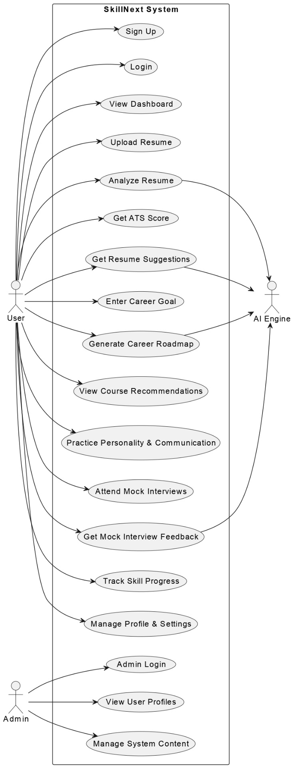

Fig 4.5.1 Use Case Diagram

4.5.2 Class Diagram

The class diagram represents the core structure of the system by defining key classes such as User, Resume, Roadmap, Mock Interview, and Job Description. Each class contains attributes and methods required to perform specific operations within the system. The relationships between these classes illustrate how different modules interact with each other to achieve the overall functionality of the application.

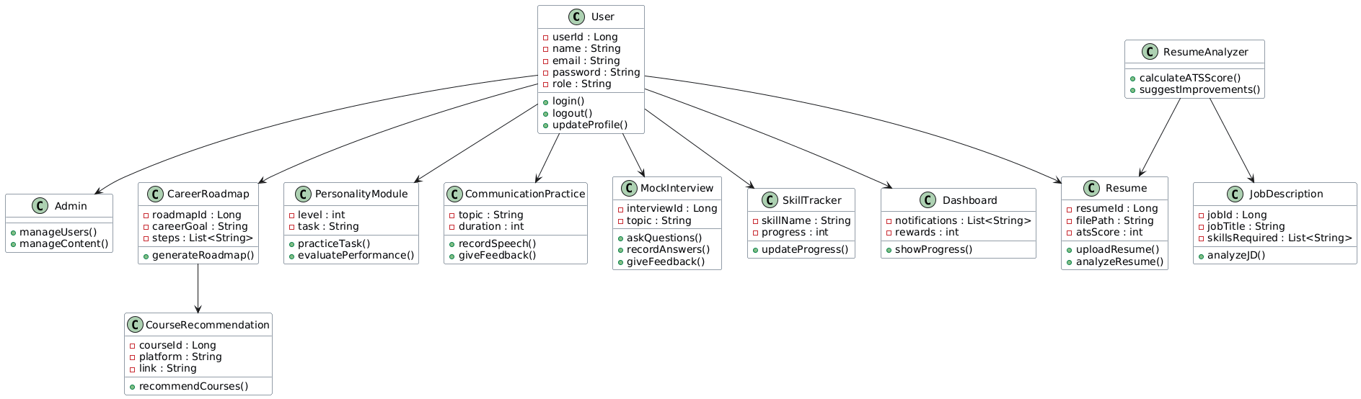

Fig 4.5.2 Class Diagram

4.5.3 Sequence Diagram
Depicts the step-by-step interaction between the user, system modules, backend services, and database for key operations such as resume creation, job description input, mock interview generation, and career roadmap suggestion. It shows how user requests are processed, how data flows through the system, and how responses are generated and displayed on the dashboard.

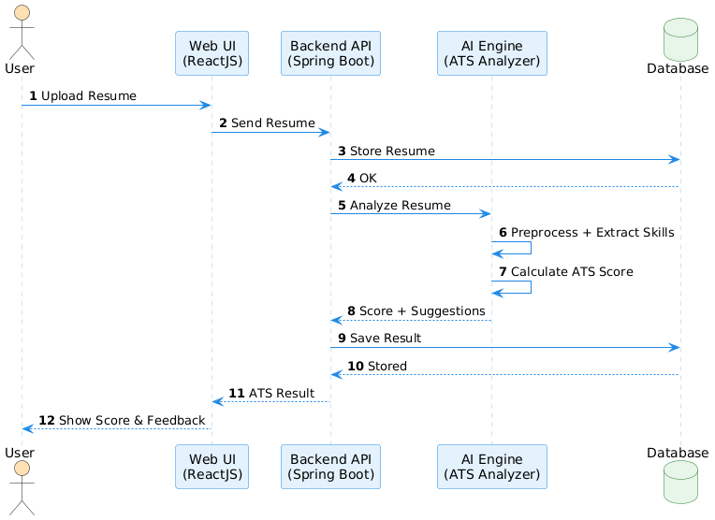

Fig 4.5.3 Sequence Diagram

4.5.4 Activity Diagram

Represents the workflow of key processes such as resume creation, job description input, career roadmap generation, and mock interview sessions. It illustrates the sequence of activities from user input to system processing and final output display. The diagram also highlights decision points and the overall flow of control within the system.

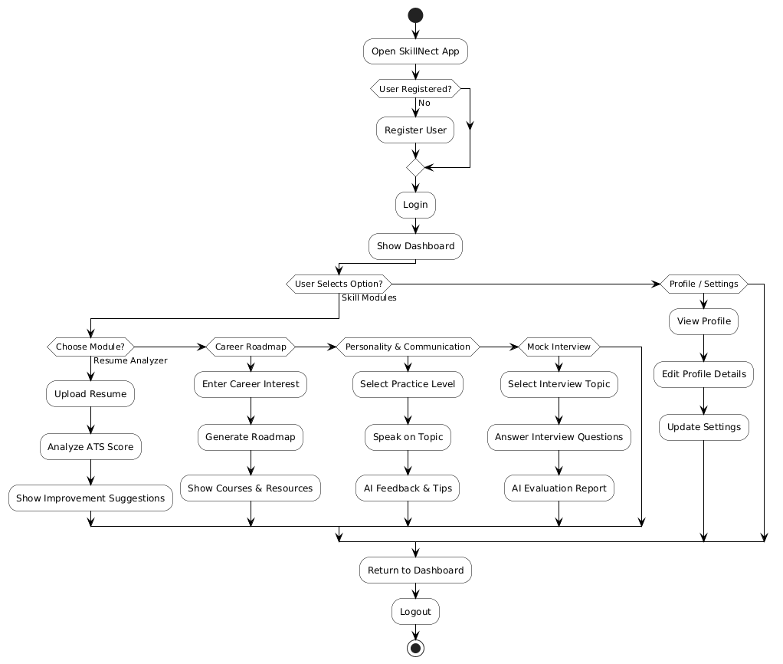

Fig 4.5.4 Activity Diagram

4.5.5 State Diagram

Shows the different states of user interaction within the system and the transitions between them. It includes states such as user login, resume creation, job description submission, mock interview participation, and viewing the dashboard. The diagram illustrates how the system moves from one state to another based on user actions and system responses.

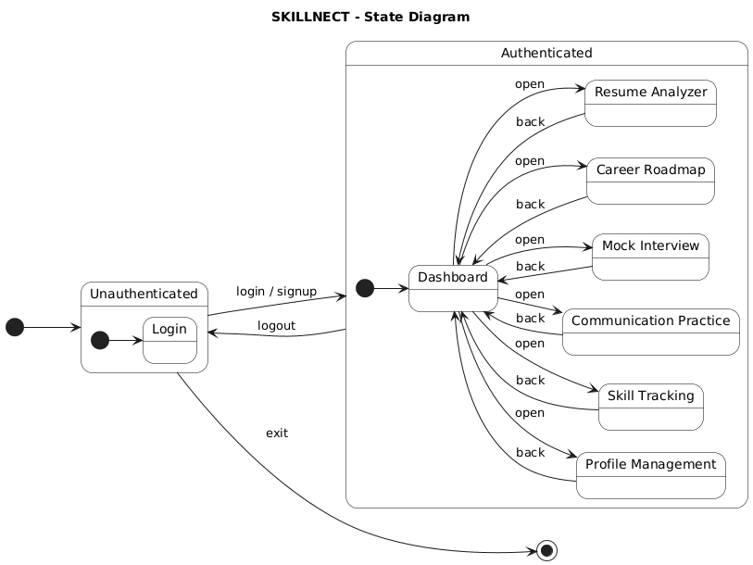

Fig 4.5.5 State Diagram

4.5.6 Component Diagram

Shows the major software components of the system such as the front-end interface, backend services, API layer, and database, along with their dependencies. It illustrates how the React-based user interface interacts with backend services, how APIs handle communication, and how data is stored and retrieved from the database. The diagram helps in understanding the overall structure and interaction between system components.

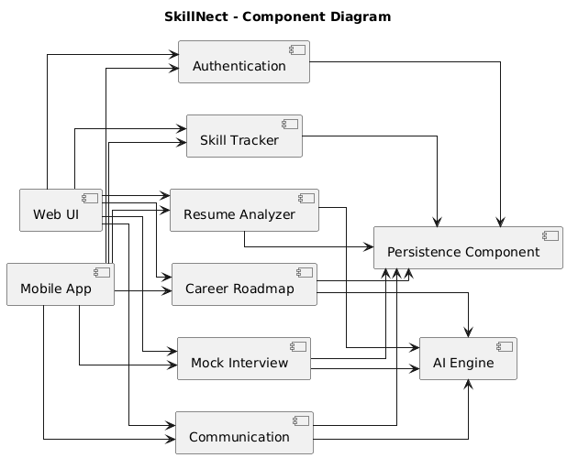

Fig 4.5.6 Component Diagram

4.5.7 Deployment Diagram
Depicts the physical deployment of the system components on cloud infrastructure, including the front-end, backend server, and database. It shows how the React-based client is accessed through the web browser, how the Node.js backend is hosted on a server, and how the database is connected for data storage and retrieval. The diagram illustrates the interaction between these deployed components over the network.

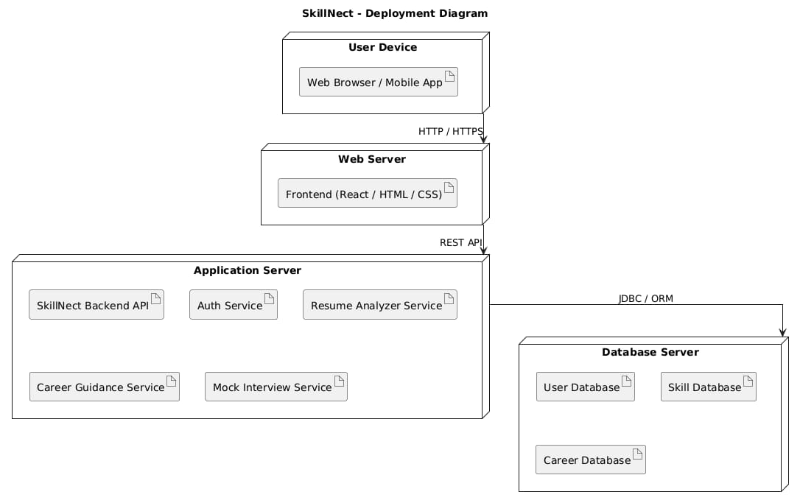

Fig 4.5.7 Deployment Diagram

4.5.8 Composite Structure Diagram

Represents the internal structure of major system components such as the front-end, backend services, and database, and how they collaborate to perform system operations. It illustrates how sub-components like resume handling, interview processing, and roadmap generation interact within the backend. The diagram helps in understanding how different parts of the system work together to deliver complete functionality.

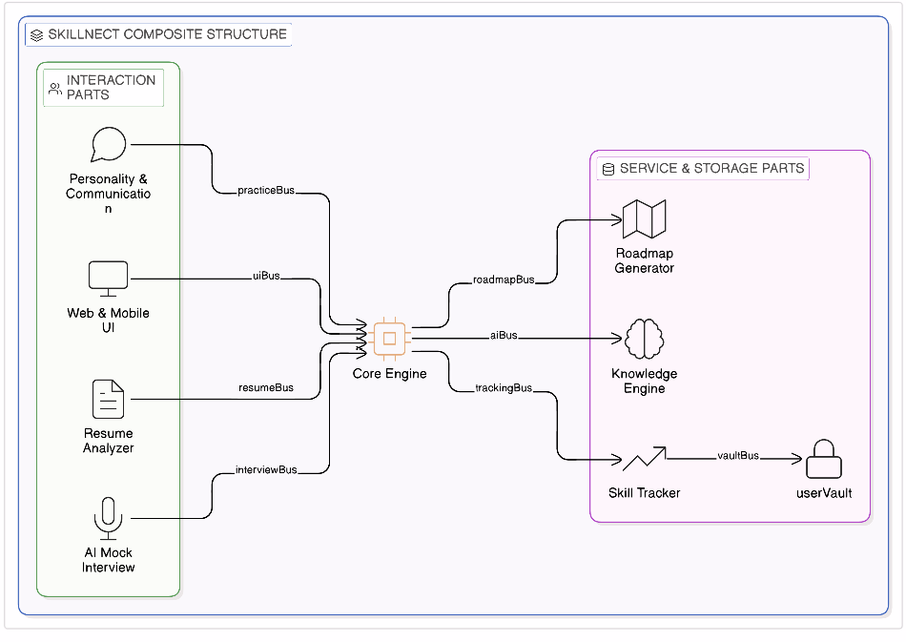

Fig 4.5.8 Composite Structure Diagram

4.5.9 Package Diagram
Organizes the system into logical packages such as front-end, backend, and database to improve maintainability and clarity. The backend package further includes modules like authentication, resume builder, mock interview, and career roadmap. This diagram helps in understanding how different parts of the system are grouped and structured for efficient development and maintenance.

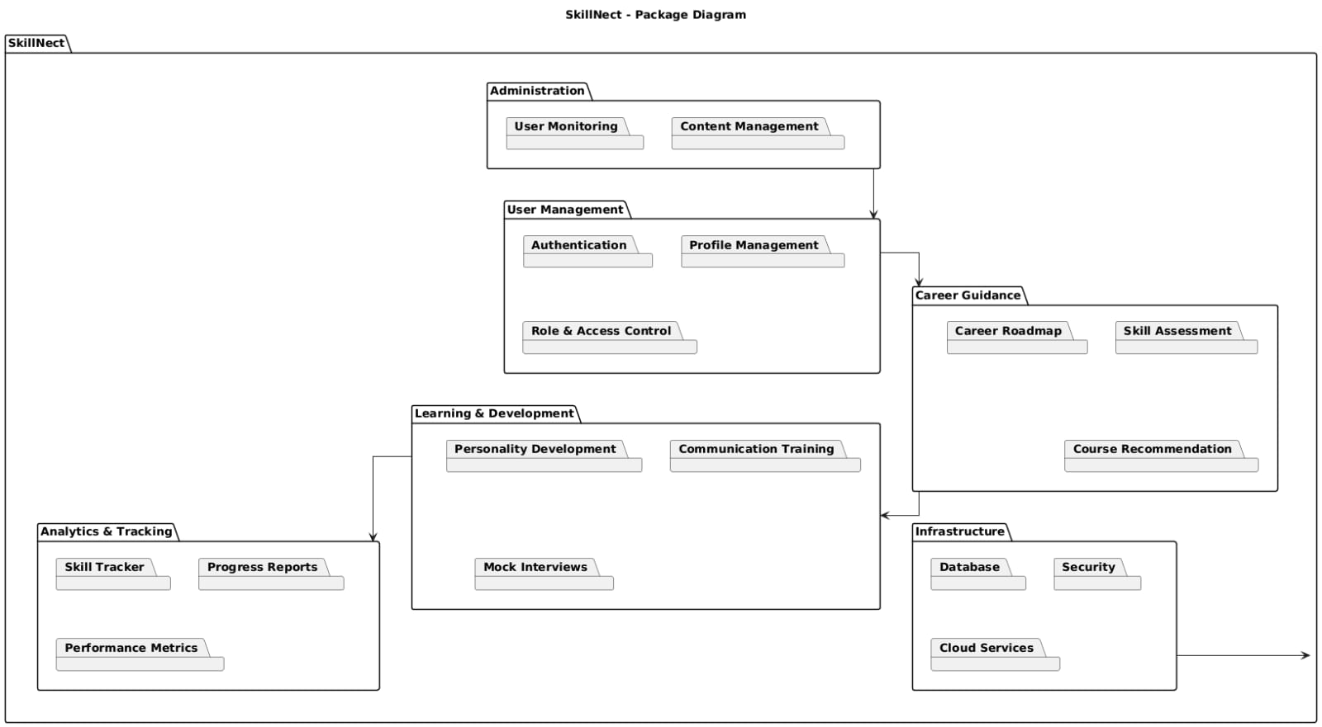

Fig 4.5.9 Package Diagram

4.5.10 Object Diagram
Illustrates real-time instances of system entities such as a specific user, their created resume, entered job description, generated roadmap, and mock interview session. It represents a snapshot of the system at a particular moment, showing how these objects are related and interact with each other during execution.

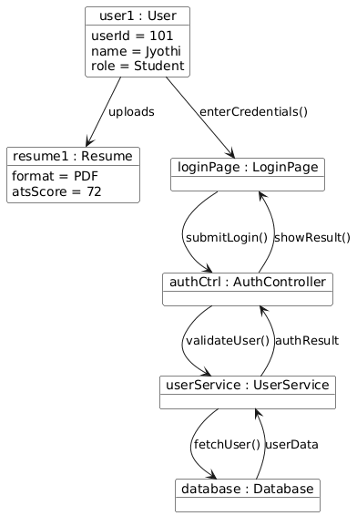

Fig 4.5.10 Object Diagram

4.5.11 Timing Diagram
Illustrates the sequence and duration of system processes such as resume creation, job description submission, mock interview generation, and roadmap display. It shows how different operations occur over time and the order in which system responses are generated after user actions.

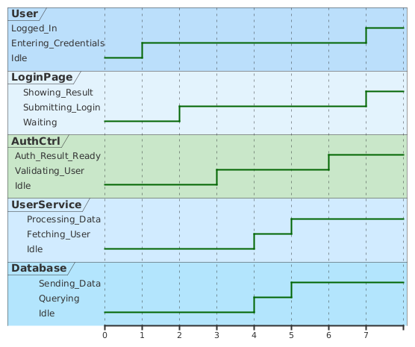

Fig 4.5.11 Timing Diagram

4.5.12 Communication Diagram
Shows the interaction between system components such as the user interface, backend services, and database during the execution of use cases like resume creation, job description input, mock interview generation, and career roadmap suggestion. It highlights how messages are exchanged between components to complete a specific operation.

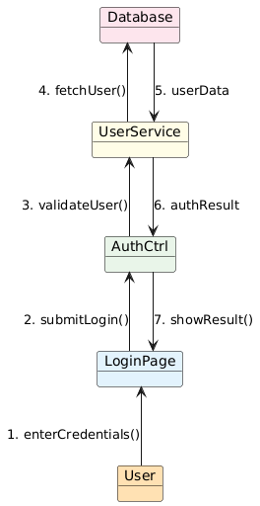

Fig 4.5.12 Communication Diagram

4.5.13 Profile Diagram
Defines extensions of standard UML elements using stereotypes and tagged values to customize the model according to system requirements. In this project, it can be used to represent specific roles or components such as user-related entities or system modules with additional properties. It helps in adapting UML diagrams to better describe the system structure and behavior.

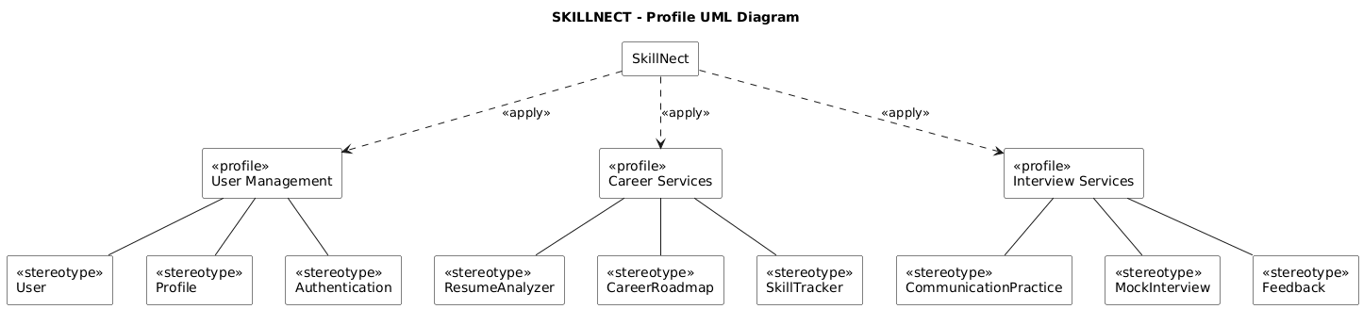

Fig 4.5.13 Profile Diagram

4.5.14 Interaction Overview Diagram
Combines activity and sequence views to provide a high-level flow of interactions within the system. It represents the overall process of operations such as resume creation, job description input, mock interview execution, and career roadmap generation. The diagram helps in understanding how different interactions are organized and executed across the system.

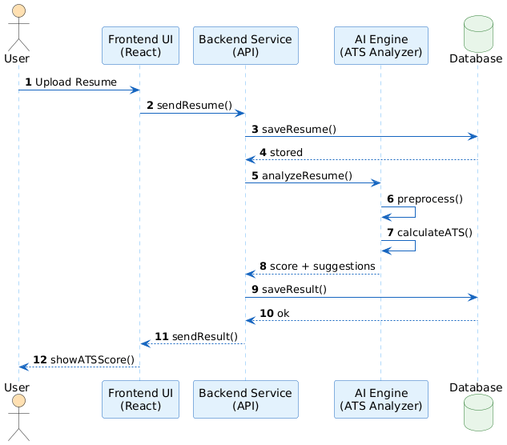

Fig 4.5.14 Interaction Diagram

4.6 Design Decisions and Constraints
Web-based architecture chosen for cross-device access without software installation.
AI engines focused on resume analysis, career roadmap, and mock interviews to reduce computational overhead.
Role-based access control ensures security and separates user/admin functionalities.
Cloud services used for scalability and reliability; AI models are lightweight due to academic constraints.
System is modular and extensible, allowing future enhancements like advanced AI, real-time simulations, or job portal integrations.

5. SYSTEM IMPLEMENTATION
5.1 Implementation Environment
The implementation environment of the SkillNect system consists of the technologies, tools, and platforms used to design, develop, and deploy the application. The system is built using modern web technologies to ensure efficient performance, scalability, and ease of maintenance. The frontend and backend are developed using JavaScript-based technologies, enabling seamless communication and faster development. The environment is designed to support real-time interactions such as resume creation, mock interviews, and roadmap generation. Overall, the chosen tools and technologies ensure a reliable and user-friendly system.

5.1.1 Programming Languages
JavaScript is used as the primary programming language for both frontend and backend development, ensuring consistency across the system. HTML5 is used to structure the web pages, while CSS3 is used for styling and layout design. These technologies together help in building a responsive and interactive user interface.
JavaScript – Used for frontend (React) and backend (Node.js)
HTML5 – Used for structuring web pages
CSS3 – Used for styling and responsive design

5.1.2 Frameworks / Libraries
The system uses React.js for developing the user interface, providing a dynamic and component-based structure. Node.js and Express.js are used for backend development and API handling. Tailwind CSS is used for efficient and responsive UI design. JWT is implemented for secure user authentication and session management.
React.js – Frontend development
Node.js & Express.js – Backend and API development
Tailwind CSS – UI styling and responsive design
JWT – Secure authentication mechanisms and mock interview feedback

5.1.3 IDE / Tools Used
Visual Studio Code is used as the primary development environment for writing and managing code. Postman is used for testing APIs and verifying backend functionality. Git and GitHub are used for version control and collaboration, allowing efficient code management and tracking of changes.
Visual Studio Code – Code editor
Postman – API testing
Git & GitHub – Version control and collaboration

5.1.4 Operating System
The system is developed and tested on Windows 10/11 operating systems, providing a stable and compatible environment for development tools and frameworks.
Windows 10 / 11 (Development environment)

5.1.5 Database / Server Details
The system uses a database such as MySQL to store user data, resumes, interview records, and roadmap details. The backend server is built using Node.js, which handles business logic and API requests. REST APIs are used to enable communication between frontend and backend components, ensuring smooth data flow.
MySQL – Stores user data, resumes, interviews, and roadmaps
Node.js Server – Handles backend logic and API requests
REST APIs – Connect frontend and backend

5.2 Module-Wise Implementation
5.2.1 User Authentication Module
The User Authentication Module manages user registration and login functionalities in a secure manner. It ensures that only authorized users can access the system by validating their credentials. The module maintains user sessions and protects sensitive data through authentication mechanisms. It plays a key role in securing the overall system and controlling access to features.

Purpose:
- To provide secure user access and protect system resources from unauthorized usage.

Logic Used:
- User details stored in database
- Password encrypted before storage
- JWT token generated after login
- Token verification for protected routes
Input: Name, Email, Password
Output: Successful login and dashboard access

5.2.2 Resume Builder Module
The Resume Builder Module allows users to create and manage their resumes within the system. It provides a structured interface for entering personal, educational, and skill-related details. The module ensures that resume data is stored properly and can be used for further processes such as interview generation. It simplifies resume creation and management for users.
Purpose:
- To help users create and maintain structured resumes for interview preparation.
Logic Used:
- User enters resume details through form
- Data is validated before submission
- Resume information is stored in database
- Users can update and retrieve resume data
Input:
Personal details, education, skills, experience
Output:
Stored and displayed resume

5.2.3 Mock Interview Module
The Mock Interview Module simulates real interview scenarios based on the job description provided by the user. It generates relevant questions and allows users to participate in interview sessions. The module tracks the number of interviews attended and helps users improve their preparation. It plays a key role in practical learning.

Purpose:
- To provide interview practice and improve user confidence.
Logic Used:
- User enters job description
- System generates interview questions
- User attends interview session
- Interview count is stored in database
Input:
Job description, user responses
Output:
Generated questions and interview tracking.

5.2.4 Career Roadmap Module
The Career Roadmap Module generates a structured learning path based on the user’s selected career role. It provides step-by-step guidance and suggests relevant learning resources such as YouTube videos. The module helps users understand the skills required and how to achieve their career goals effectively.
Purpose:
- To guide users with a clear and structured career development plan.
Logic Used:
- User selects career role
- System processes required skills
- Roadmap is generated in phases
- YouTube resources are suggested
Input:
Selected career role
Output:
Career roadmap and learning resources

5.2.5 Dashboard Module
The Dashboard Module acts as a centralized interface that displays all user-related activities and data. It shows resume details, interview count, and generated roadmaps in a structured format. This module improves user experience by providing easy access to all features in one place.
Purpose:
- To provide a unified view of user progress and system functionalities.
Logic Used:
- Fetch user data from database
- Display resume, interviews, roadmap
- Update dashboard dynamically
- Provide navigation to all modules
Input:
User activity data
Output:
Dashboard with user information and progress

5.3 Algorithm

5.3.1 Resume ATS Score Algorithm

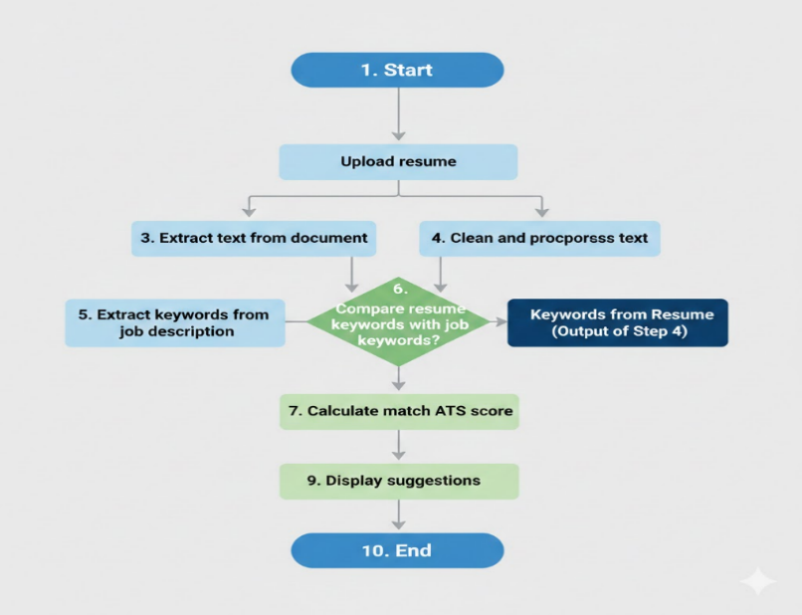

Fig 5.3.1 Resume ATS Score Algorithm

5.3.2 Career Roadmap Generation Module

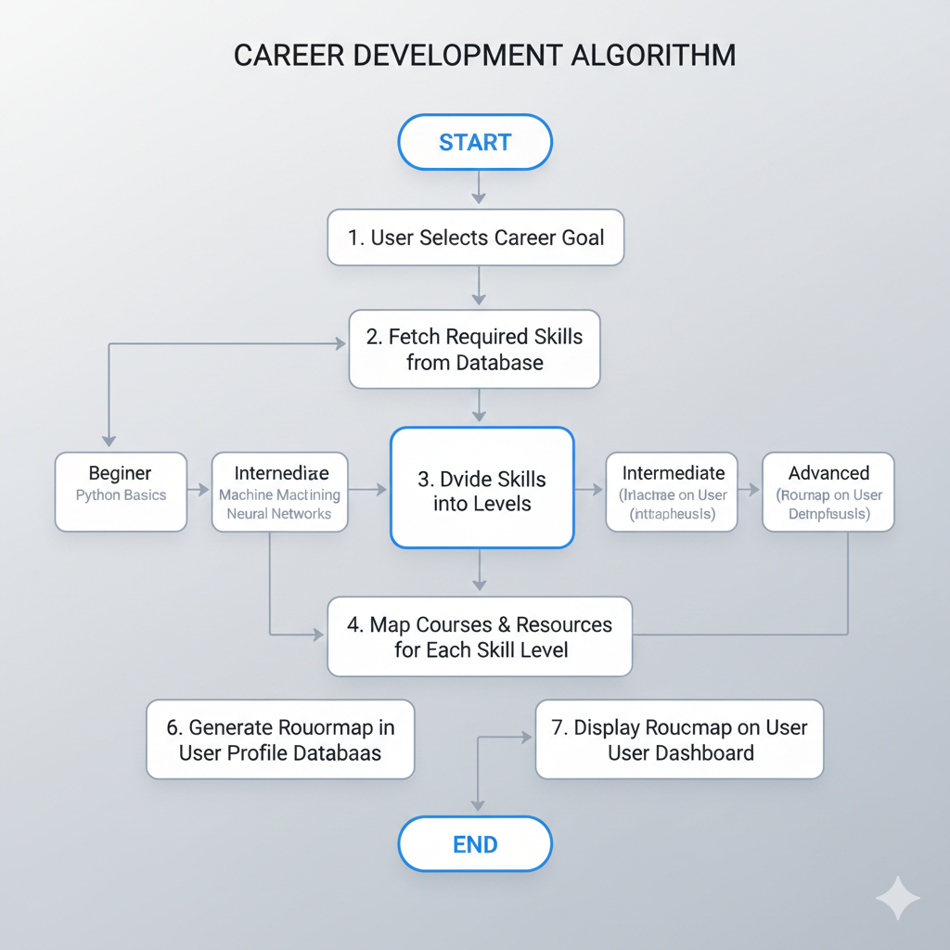

Fig 5.3.2 Carrer Roadmap Generation

5.3.3 AI Mock Interview Module

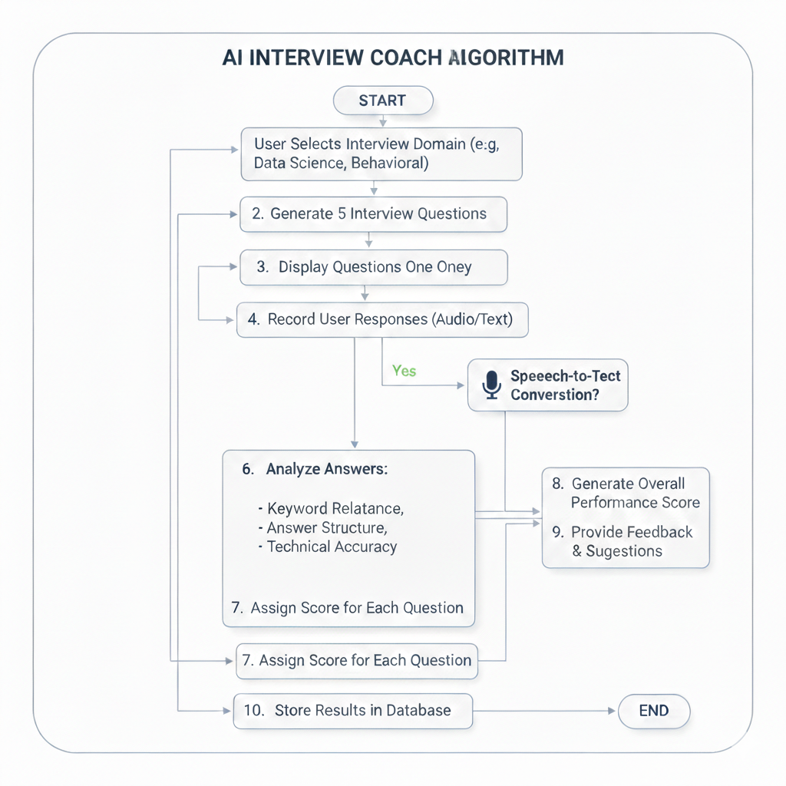

Fig 5.3.3 AI Mock Interview

5.4 Screenshots and Explanation

5.4.1 Landing Page

The landing page of SkillNect AI presents the platform’s main purpose and services, helping users build their careers through AI-powered resume analysis, interview preparation, and mentorship support.

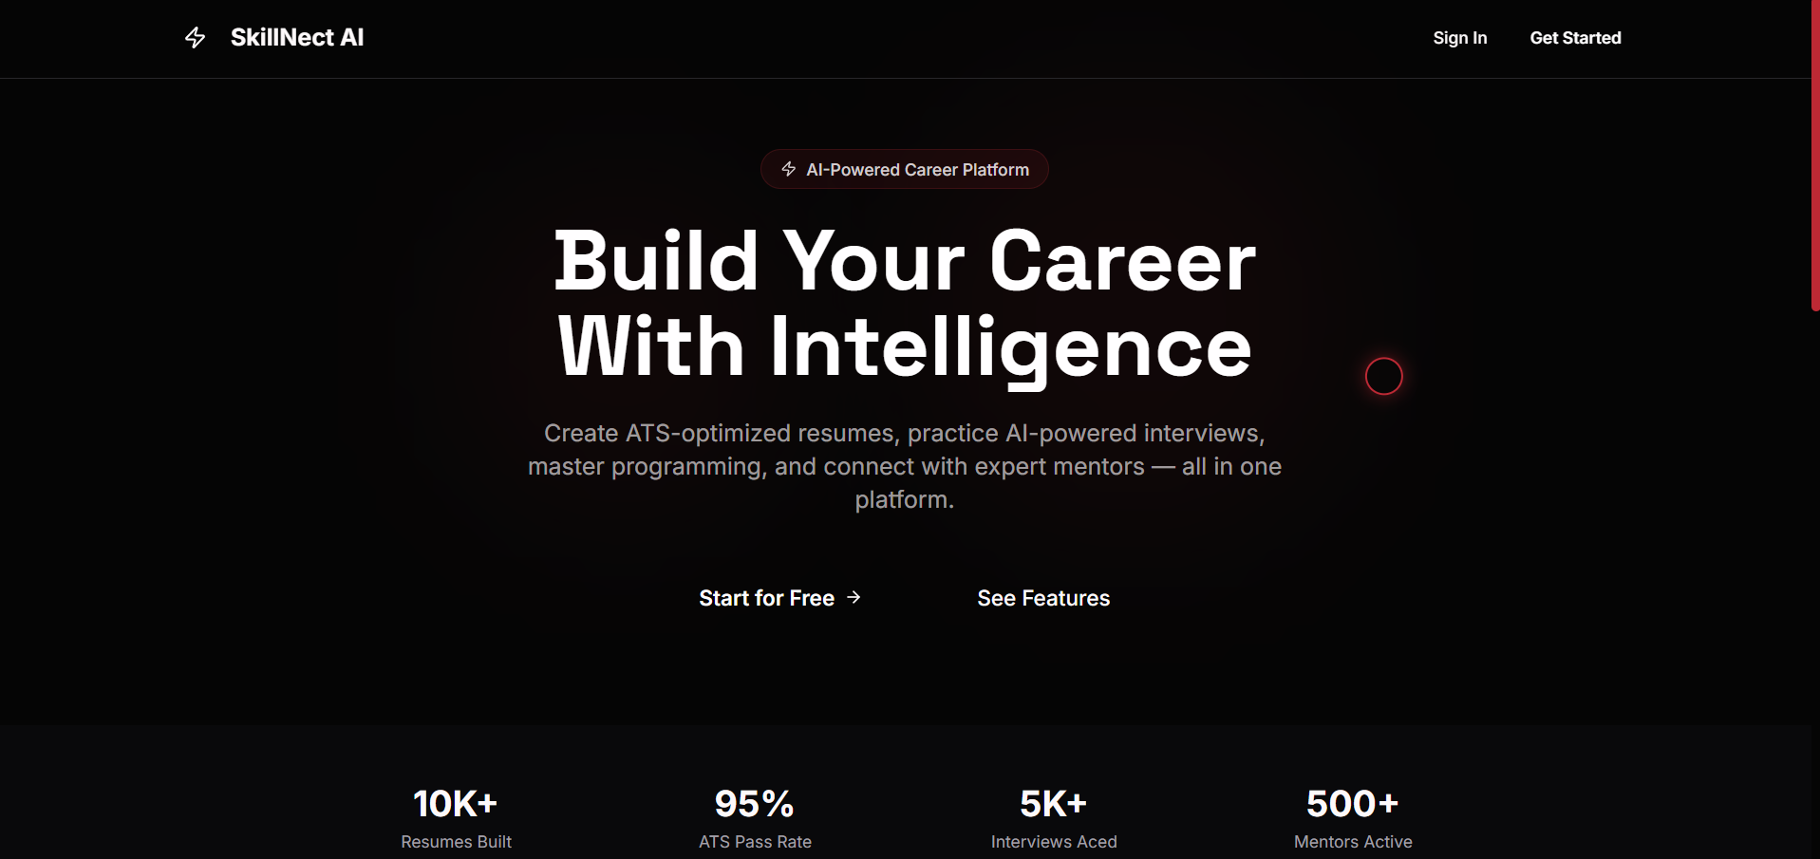

Fig 5.3.4 Landing Page

5.4.2 Sign-in Page

The sign-in page allows users to securely access the SkillNect platform using their registered email and password.

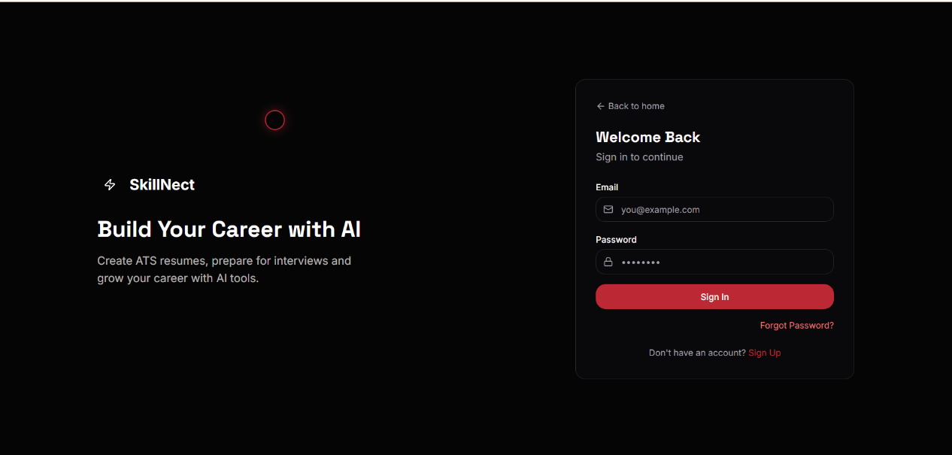

Fig 5.3.5 Sign-in Page

5.4.3 Dashboard

The dashboard displays overall progress including career roadmap status, recommended resources, and community updates. It gives users a clear overview of their development activities in one place.

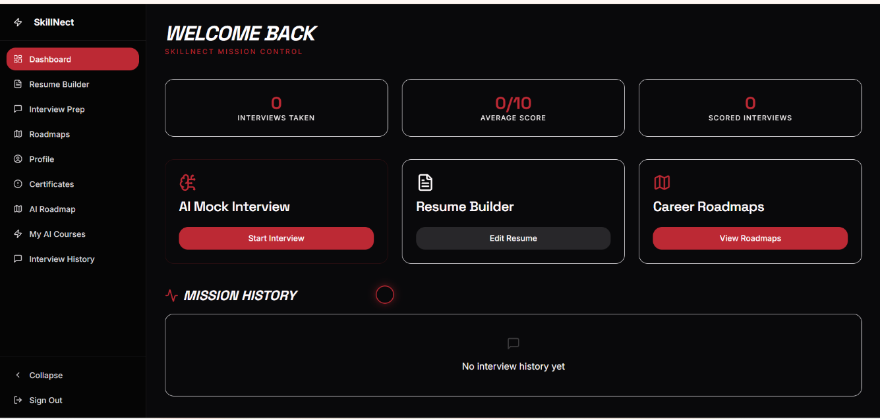

Fig 5.3.6 Dashboard

5.4.4 Roadmap Page
The roadmap page displays a structured career plan based on the user’s selected role. It shows required skills, learning stages, and recommended resources to guide the user step by step.

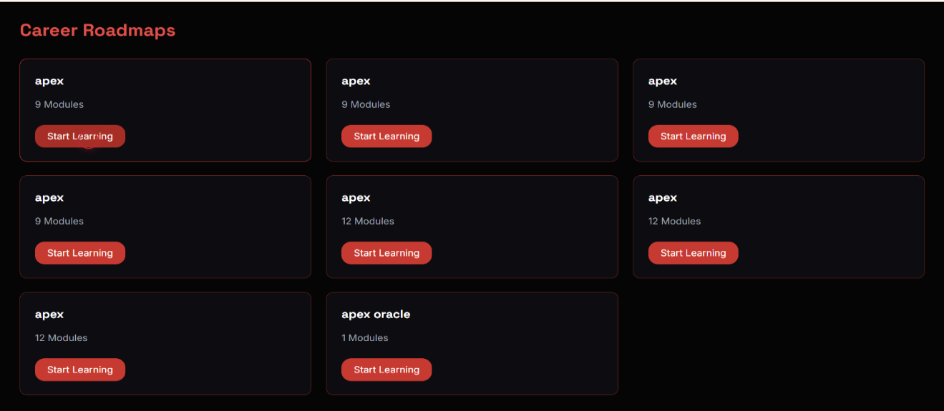Fig 5.3.7 Roadmap Page

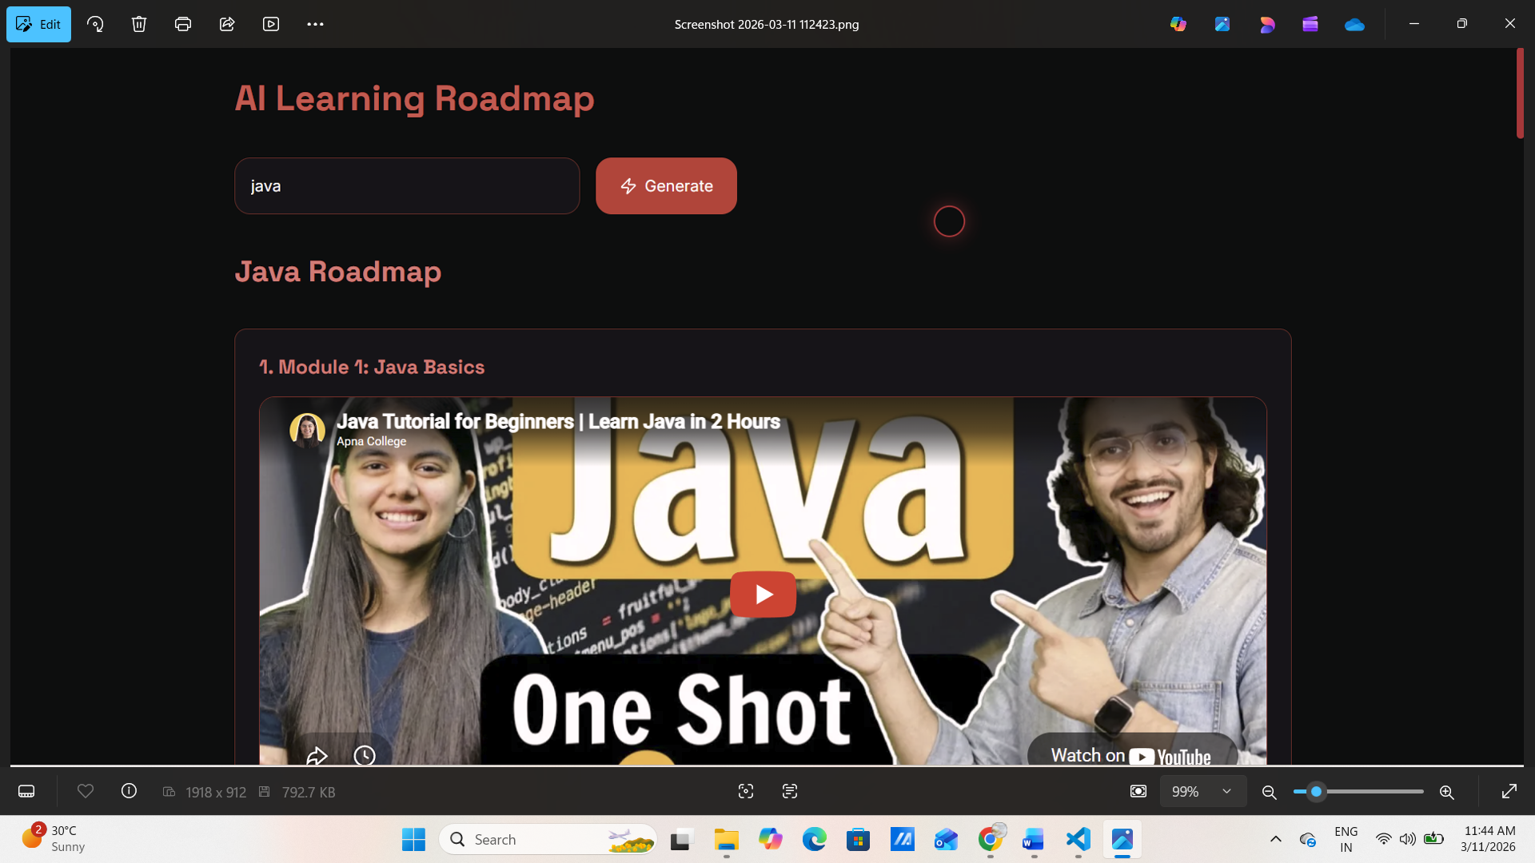

Fig 5.3.8 AI Learning Roadmap

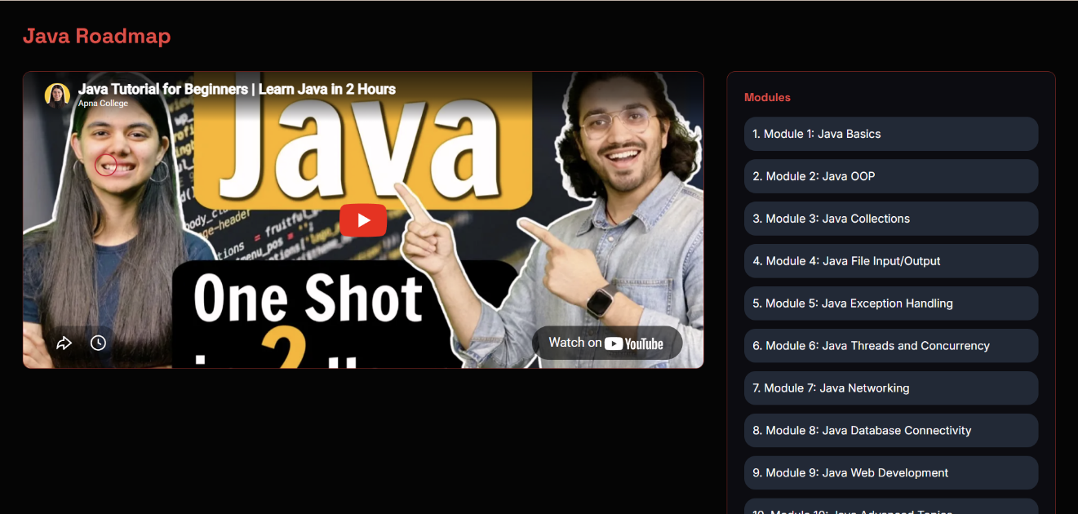

Fig 5.3.9 Roadmap

5.4.5 Resume Builder Page
The resume builder page allows users to create and edit their resumes in a structured format. It helps organize sections like education, skills, and experience in a professional layout.
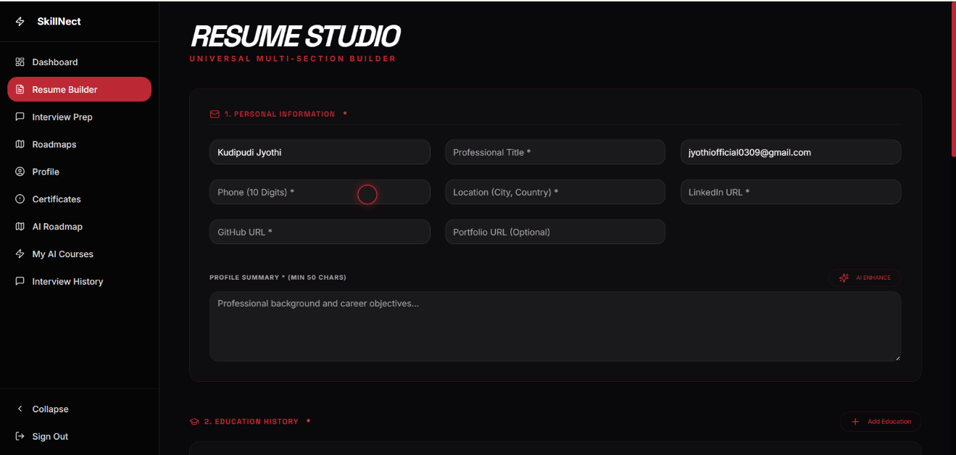

Fig 5.3.10 Resume Builder Page

5.4.6 Interview Page

The interview page provides mock interview questions based on the selected domain. It allows users to respond and view performance feedback for improvement.

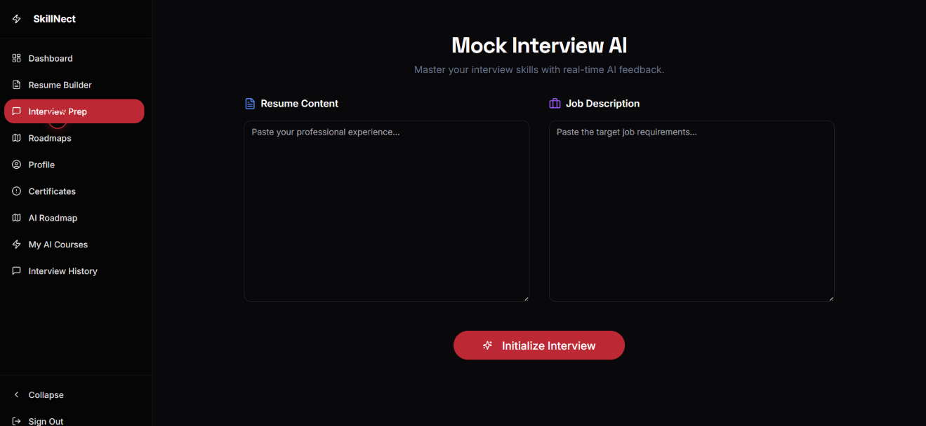

Fig 5.3.11 Interview Page

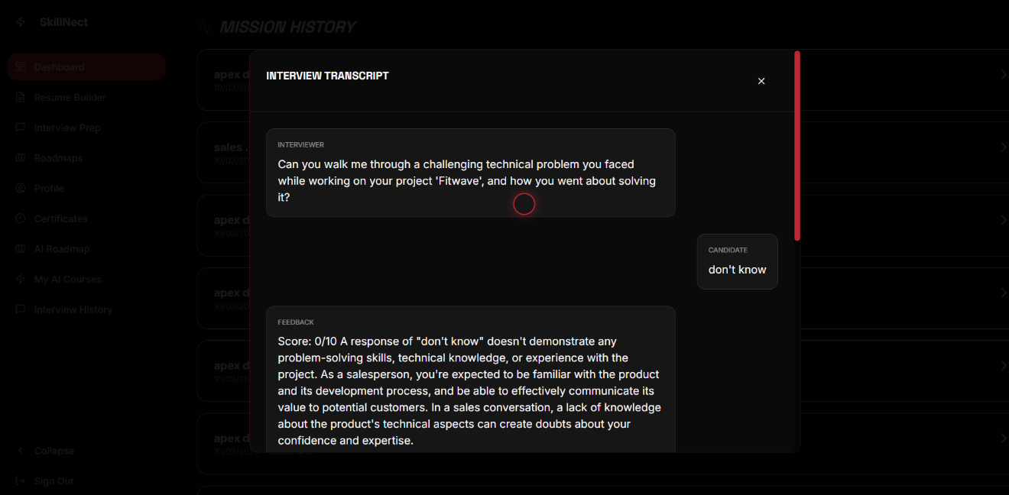

Fig 5.3.12 Interview Page

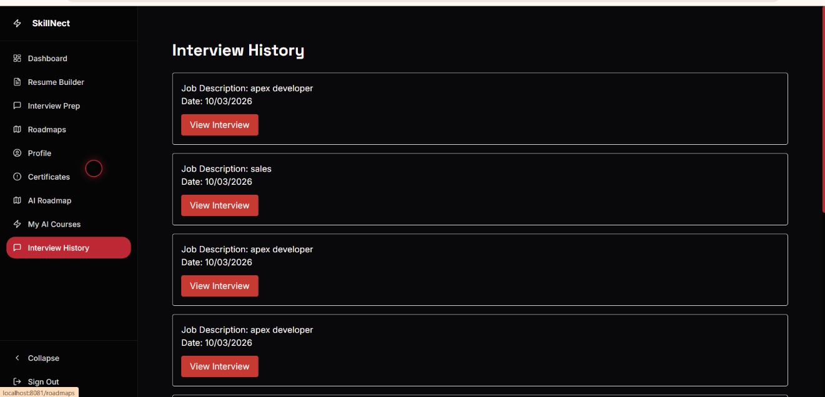

Fig 5.3.13 Interview History

5.4.7 Admin Dashboard

This figure shows the SkillNect Admin Dashboard, where the administrator can monitor
It displays key statistics such as the number of users, interviews, and roadmaps available in the system.

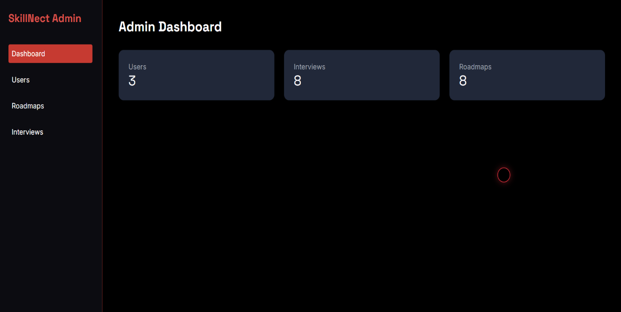

Fig 5.3.14 Admin Dashboard

5.4.8 Admin – User Management

This figure shows the User Management section of the SkillNect Admin Dashboard, where the administrator can view all registered users. It allows the admin to monitor user details and remove users from the system if necessary.

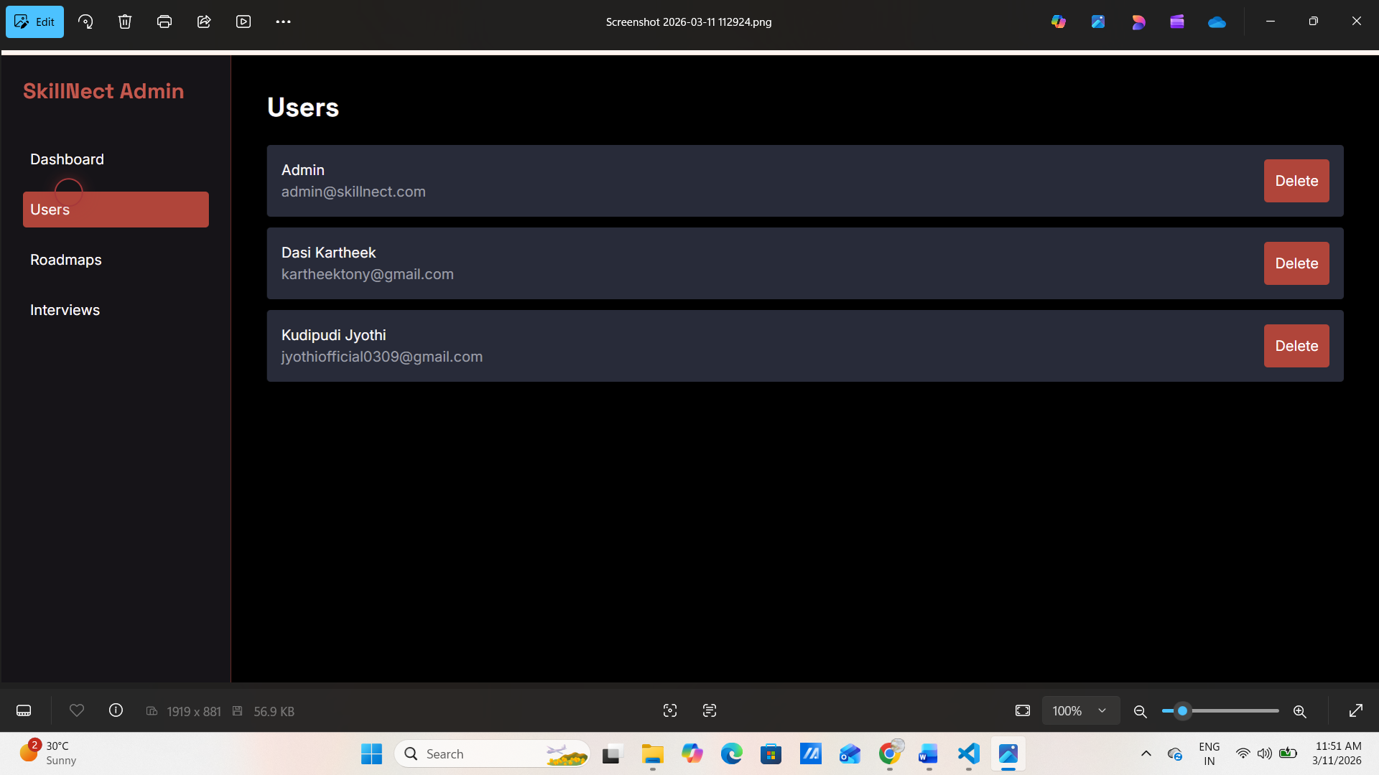

Fig 5.3.15 Admin-User Management

6. TESTING AND VALIDATION

6.1 Testing Strategy
Testing is performed to ensure that the SkillNect system functions correctly, efficiently, and securely. Different levels of testing were carried out to validate individual components as well as the complete integrated system.

6.1.1 Unit Testing
Unit testing was conducted on individual modules such as user authentication, resume builder, roadmap generation, interview module, and dashboard components. Each function and API endpoint was tested independently to verify correct input processing and expected output generation.

6.1.2 Integration Testing
Integration testing was performed to verify the interaction between React frontend, Node.js backend, and NEON SQL database. API calls were tested to ensure proper data transmission and response handling between modules without errors.

6.1.3 System Testing
System testing was conducted on the complete application to validate overall system behavior. All modules including login page, dashboard, roadmap page, resume builder page, and interview page were tested together to ensure smooth end to end functionality.

6.2 Test Cases
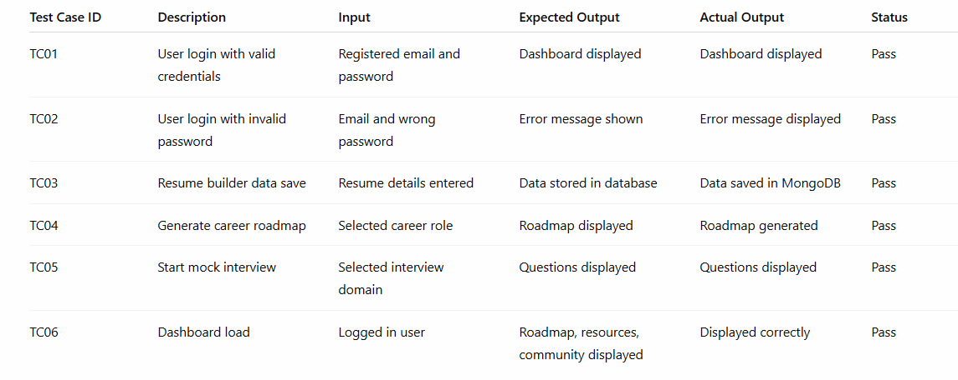

Table 6.1 Test Cases

6.3 Test Results

6.3.1 Summary of Test Cases

All major test cases were executed successfully. No critical errors were observed during system execution. The system responded correctly for both valid and invalid input scenarios.

6.3.2 Observations

The authentication module worked securely and reliably. Data storage and retrieval from SQL were consistent. Integration between frontend and backend was functioning properly. Minor user interface adjustments were corrected during testing.

6.4 Validation

The validation process was carried out by comparing the system output with the expected results defined during the design phase. Each module was tested multiple times with different input conditions to verify stability and correctness.

The system behavior matched the expected functional requirements. The roadmap page generated structured plans correctly, the resume builder stored user data properly, and the interview module displayed relevant questions. Overall system performance met the project objectives.

7. RESULTS AND PERFORMANCE ANALYSIS

7.1 Output Analysis

The SkillNect system was evaluated by executing all functional modules including login authentication, dashboard loading, roadmap generation, resume builder operations, and interview module interaction. The outputs were verified to ensure that each module performed according to the defined requirements.

7.1.1 Sample Outputs

• Successful authentication redirects the user to the dashboard.
• The roadmap page displays structured skill levels and recommended resources based on selected role.
• The resume builder stores and retrieves resume data from the database correctly.
• The interview page generates domain specific questions dynamically.

All modules produced consistent and expected outputs during repeated testing.

7.1.2 Graphical Representation of System Behavior

To analyze system behavior, performance characteristics such as response time and database interaction were observed during testing using browser developer tools and backend logs.

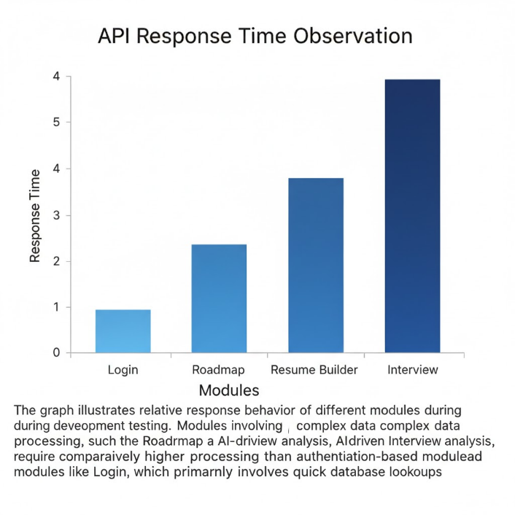

Fig. 7.1.1 API Response Time Observation

7.2 Performance Metrics

The performance of the system was evaluated using measurable parameters.

7.2.1 Database Operation Time

Database operations were analyzed to evaluate backend processing efficiency.

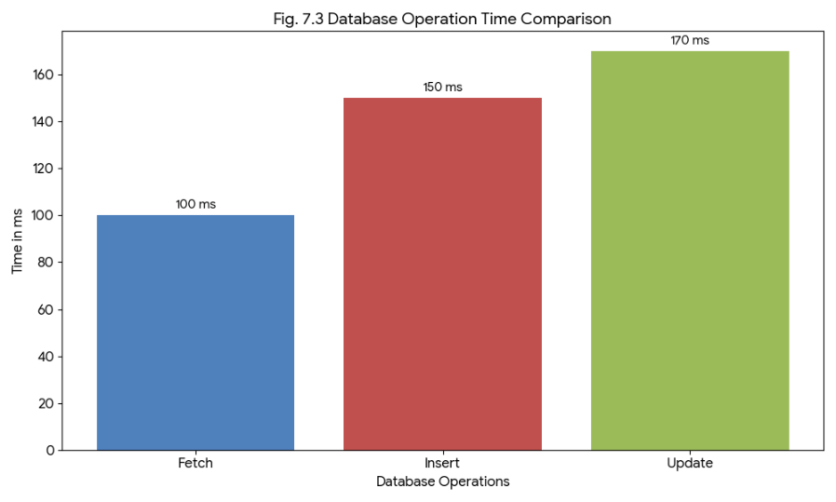

Fig. 7.2.1 Database Operation Time Comparison
The following metrics were considered for evaluating the system:
Response Time: Measured using browser network inspection tools to observe API request and response cycles.
Throughput: The system handled multiple user interactions sequentially without failure during testing.
Resource Utilization: Memory and CPU usage were monitored during execution. The system maintained stable performance without abnormal spikes.
Functional Accuracy: The outputs generated by roadmap and interview modules matched user selections, confirming logical correctness of implementation.

7.3 Comparative Analysis

A comparison between existing systems and the proposed SkillNect system was conducted.

7.3.1 Existing Versus Proposed System

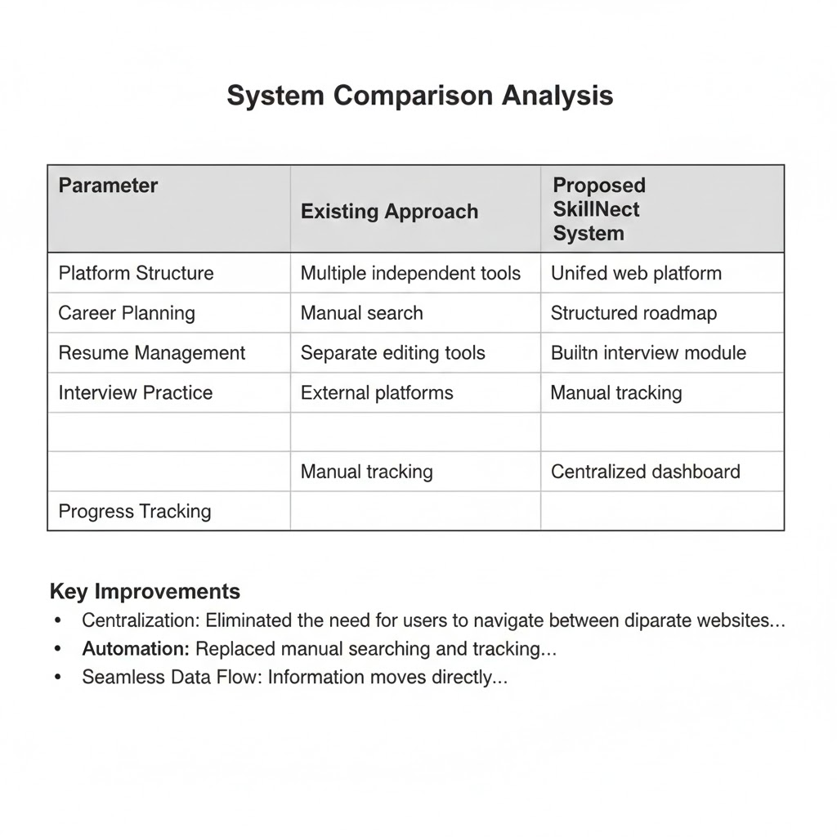

Table 7.1 Comparison Between Existing and Proposed System

The comparison demonstrates that the proposed system offers higher integration, centralized tracking, and improved automation compared to existing solutions.

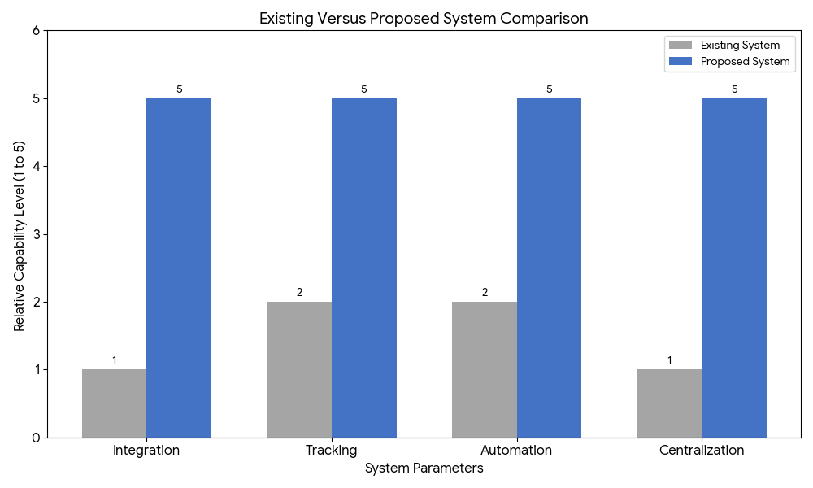

Fig. 7.3.1 Conceptual Comparison Between Existing and Proposed System

8. CONCLUSION AND FUTURE ENHANCEMENTS

8.1 Conclusion

What Was Achieved

• A unified web-based career guidance platform was successfully developed.
• Integration of roadmap generation, resume builder, interview module, and dashboard tracking-was-completed.
• Backend services using Node.js and database management using NEON SQL were implemented-effectively.
• A structured and centralized system replaced fragmented career tools.

How Objectives Were Met

• The objective of structured career planning was achieved through roadmap generation module.
• The resume management objective was met through development of an integrated resume-builder.
• The interview preparation objective was fulfilled by implementing domain-based interview-questions.
• The centralized monitoring objective was achieved through dashboard-based tracking.

Key Outcomes

• Improved integration of multiple career development functionalities.
• Efficient frontend and backend communication.
• Stable database operations and reliable data storage.
• Enhanced usability through centralized access to all modules.

8.2 Limitations

Dataset Size

• The system was developed and tested using limited structured data for roadmap and Interview-modules.
• Large scale dataset validation was not performed.

Hardware Constraints

• Testing was conducted on standard development hardware.
• Performance under high load enterprise environments was not evaluated.

Scalability Issues

• The application was tested under moderate user conditions only.
• Load balancing and distributed deployment were not implemented in the current version.

8.3 Future Scope and Enhancements

Features to Be Added

• Real time AI based resume analysis and scoring mechanism.
• User progress analytics with detailed graphical insights.
• Notification and reminder system for career milestones.
• Integration with external job portals.

Advanced Techniques

• Implementation of machine learning models for personalized recommendations.
• Use of Natural Language Processing for deeper interview evaluation.
• Cloud based auto scaling infrastructure.

Real World Deployment Possibilities

• Deployment on scalable cloud platforms such as AWS for handling larger user base.
• Integration with educational institutions for structured student career monitoring.
• Expansion into mobile application for broader accessibility.

REFERENCES

[1] S. R. Jagtap, V. Kulkarni, Y. Pachorkar, O. Taur, S. Gupta, and U. Pujeri, “AI-Driven Real-Time Interview Simulation App with Voice Recognition and Facial Analysis,” Indian Journal of Science and Technology, vol. 18, no. 25, pp. 2058–2066, Jul. 2025.

[2] P. P. Wadekar, Y. P. Pillai, M. U. Roy, and N. Phadnis, “Placement Predictor and Course Recommender System,” International Research Journal of Engineering and Technology (IRJET), vol. 5, no. 3, pp. 3960–3964, Mar. 2018.

[3] W. Wu, L. Chen, Q. Yang, and Y. Li, “Inferring Students’ Personality from Their Communication Behavior in Web-Based Learning Systems,” International Journal of Artificial Intelligence in Education, vol. 29, pp. 189–216, Jan. 2019.

[4] S. S. Shravan Kumar, K. B. Bhimsingh, T. K. Kaushlendra, A. P. Chitnis, V. H. Salvi, A. S. Patil, M. Parate, and S. Sharma, “Revolutionizing Resume Building with Intelligent ATS Optimization to Boost Career Development and Employability,” International Journal on Advanced Computer Theory and Engineering, 2025.

[5] I. Sommerville, Software Engineering, 10th ed. Boston, MA, USA: Pearson, 2016.

[6] M. Fowler, Patterns of Enterprise Application Architecture. Boston, MA, USA: Addison-Wesley, 2002.

[7] React Documentation, “React – A JavaScript Library for Building User Interfaces.” [Online]. Available: https://react.dev

[8] Node.js Documentation, “Node.js JavaScript Runtime.” [Online]. Available: https://nodejs.org

[9] MongoDB Documentation, “MongoDB Database Documentation.” [Online]. Available: https://www.mongodb.com

10. APPENDIX

10.1 Source Code (Sample / Snippets)

10.1.1 Backend – Server Configuration (Node.js)
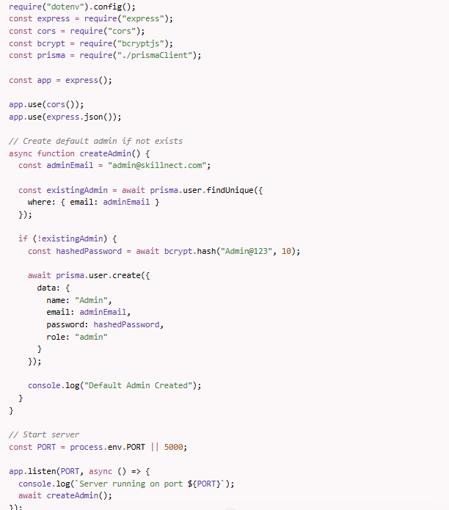

Fig 10.1.1 Backend Server Configuration

10.1.2 Backend – User Login Route
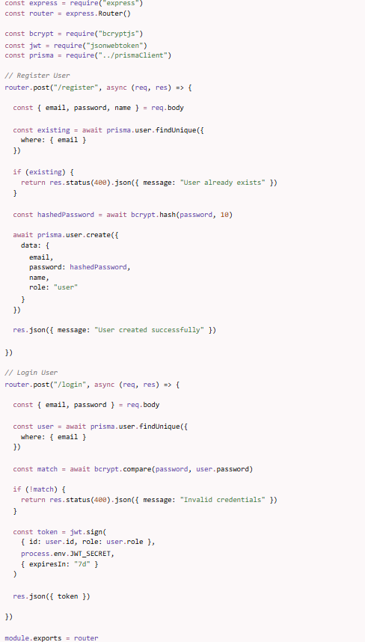

Fig 10.1.2 User Login Route

10.1.3 Frontend – React Component (Dashboard)

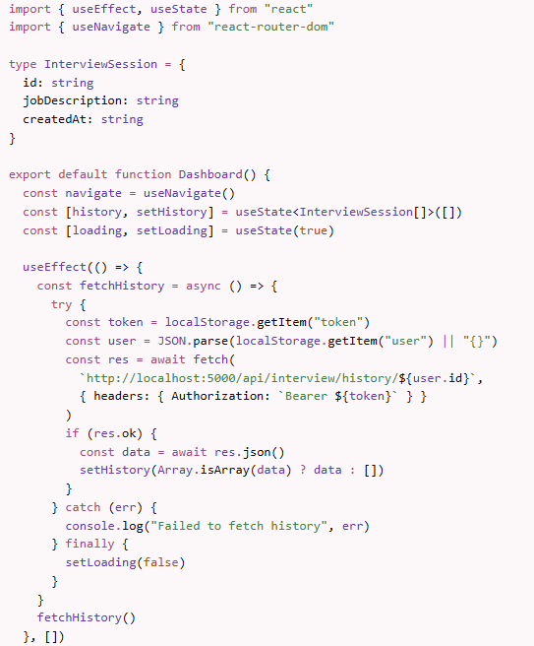

Fig 10.1.3 Frontend React Component

10.2 User Manual

Steps to Install

Install Node.js (v16 or above).

Install NEON SQL

Download or clone the SkillNect project folder.

Open terminal in backend folder and run:
npm install

Start backend server using:
npm start

Open terminal in frontend folder and run:
npm install

Start frontend using:
npm start

npm run dev

How to Run the Project

Ensure SQL service is running.

Start backend server (default port 5000).

Start frontend application (default port 3000).

Open browser and navigate to:
http://localhost:3000

Register or login to access dashboard features.

10.3 Abbreviations
Abbreviation | Full Form
API | Application Programming Interface
DBMS | Database Management System
UI | User Interface
UX | User Experience
HTTP | Hypertext Transfer Protocol
JWT | JSON Web Token
CPU | Central Processing Unit
RAM | Random Access Memory
NLP | Natural Language Processing
ATS | Applicant Tracking System

10.4 Publication Paper Copy
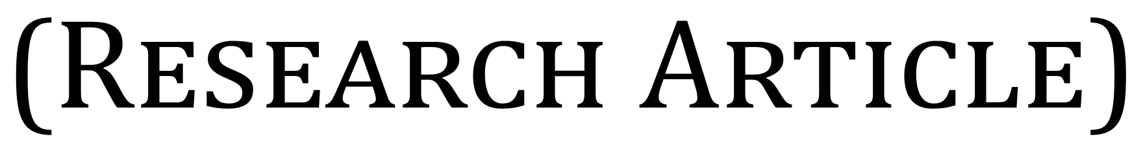


SkillNect: A smart career guidance and development platform
D. Venkata Ravi Kumar *, Kudipudi Jyothi, Bikash Prasad Yadav, Shivanand Prasad Kushwaha and Dasi Kartheek
Department of Computer Science and Engineering, Aditya College of Engineering and Technology, Andhra Pradesh, India.

International Journal of Science and Research Archive, 2026, 18(03), 621-626

Publication history: Received on 28 January 2026; revised on 06 March 2026; accepted on 06 March 2026 Article DOI: https://doi.org/10.30574/ijsra.2026.18.3.0467

Abstract
In the job market these days students and professionals have difficulty finding the right career path. They also struggle to make a resume and learn the skills they need. The problem is that the tools available for this purpose are scattered across different platforms so it is tough to keep track of progress and get a personalized plan.

SkillNect is a platform that helps with this. It is a website and mobile app that puts everything in one place. This includes looking at resumes making a plan for your career tracking your skills and even practicing for interviews with a computer. It also has parts to help you develop as a person. The people who made SkillNect used React and React Native to build the parts you see. Node.js for the parts that do the work behind the scenes. They put it all on Amazon Web Services (AWS) so it can handle a lot of users.

The system uses computers to look at resumes and give advice on careers. This helps people get from school to a job. SkillNect gives people help with their careers that's just, for them, based on data and organized.

Keywords: Career Guidance; Resume Analysis; AI Mock Interview; Skill Tracking; AWS Cloud

Introduction
The IT industry is changing fast and there are a lot of people looking for jobs so you need to have a good plan for your career. Students usually have a time figuring out what skills they are missing making their resumes better and getting ready for interviews. Even though websites like LinkedIn have job listings and ways to meet people in your industry they do not have everything you need to plan your career in one place.

Most systems only focus on one thing like building a resume taking classes or practicing for interviews. This means you have to keep track of everything which can be confusing and does not help you plan your career very well.

SkillNect solves these problems by putting a lot of tools together in one place. These tools include checking your resume making a plan for your career practicing interviews with intelligence learning how to be a better person and keeping track of job openings. The application is made to be able to handle a lot of users. Is built using Node.js for the backend and cloud deployment so it is always available. SkillNect is a career development platform that helps you with things, like resume evaluation and career roadmap generation which're important parts of planning your career with SkillNect.

SkillNect enables users to
- Improve resume quality with AI suggestions
- Receive structured career roadmaps
- Track technical and soft skill development
- Practice AI-driven mock interviews
- Monitor job applications and milestones

The platform ensures personalized, data-driven, and structured career development.

Literature Survey
- “AI-Driven Real-Time Interview Simulation App (Indian Journal of Science and Technology, 2025) This paper discusses AI-based mock interview systems that analyze speech to provide real-time feedback.
- Placement Predictor and Course Recommender System (IRJET, 2018) Proposes are commendation engine to predict placement chances and suggest relevant courses.
- Inferring Students’ Personality from Communication Behavior in Web-based Learning Systems (International Journal of Artificial Intelligence in Education, 2019) Demonstrates how AI models can evaluate personality traits through user interaction data.
- Intelligent ATS Optimization for Resume Development (IJACTE, 2025) Focuses on improving resume compatibility with Applicant Tracking Systems (ATS). These studies support the need for integrating AI in career guidance systems. However, most systems address only one module (resume, interview, or recommendation). SkillNect integrates all modules into a unified platform.

These systems look at parts of the process. None of them bring everything together in one place. They do not combine looking at resumes helping with career choices developing personalities and practicing interviews. SkillNect puts all these things together in one system that can grow and adapt.

Existing System

Current career development solutions are fragmented and include
- Separate resume analyzers
- Learning platforms like Coursera/Udemy
- Video platforms for mock interviews
- Manual tracking using spreadsheets

    - Disadvantages
      - No unified progress tracking
      - No centralized dashboard
      - Limited personalization
      - No integration of technical + soft skills
      - No real-time AI feedback system

Proposed System
SkillNect is a unified web and mobile application that integrates multiple career development modules into one platform.

    - Modules
      - Resume Analyzer & ATS Score
      - Resume upload
      - Keyword and format analysis
      - ATS compatibility score
      - Improvement suggestions

    - Career Roadmap Generator
      - Personalized roadmap
      - Course and project recommendations
      - Milestone tracking

    - Personality & Communication Module
      - Confidence evaluation
      - communication exercises
      - Personality assessment
    - AI-Powered Mock Interviews
      - Simulated interview questions
      - AI performance scoring
      - Feedback on answers

    - Skill & Job Tracker
      - Track applied companies
      - Monitor skill progress
      - Task reminders

    - Advantages
      - Unified career development system
      - AI-powered recommendations
      - Real-time tracking
      - Mobile and web accessibility
      - Scalable cloud deployment

Methodology

The system follows a modular architecture
    - User Authentication Module
      - Handles secure login and registration using backend APIs.

    - Resume Analysis Module
      - Uses AI-based keyword extraction and ATS scoring algorithms.

Resume Scoring Algorithm
The Resume Analysis Module follows a keyword-matching and scoring approach.
    - Algorithm Steps
      - Extract text from uploaded resume.
      - Identify relevant keywords using predefined job-role skill datasets.
      - Compare extracted keywords with required skill database.
      - Calculate ATS Score using matching ratio.
      - Generate improvement suggestions.

Mathematical Model
- Matched Keywords = 18
- Required Keywords = 25
A𝑇𝑆 𝑆𝑐𝑜𝑟𝑒 = 18 /25 × 100 = 72%
This score determines resume strength and generates targeted recommendations.

Career Recommendation Engine
Generates personalized learning paths based on selected job roles.

Mock Interview Engine
Evaluates responses and provides feedback using AI logic.

Dashboard Module
Displays performance metrics, progress charts, and recommendations
.
    - Technology Stack
      - Frontend: React (Web), React Native (Mobile)
      - Backend: Node.js (REST APIs)
      - Database: MySQL
      - Cloud: AWS (EC2, S3, RDS)
      - Version Control: Git & GitHub
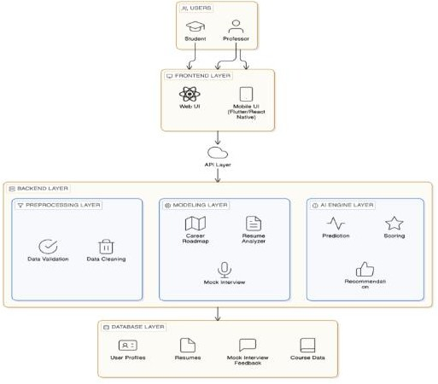
Figure 1 System Architecture of the SkillNect Platform

Implementation Details

Phase 1 – Initialization
- Defined objectives and modules
- Designed system architecture
- Developed UI prototypes

Phase 2 – Core Development
- Developed REST APIs
- Integrated database
- Implemented resume analysis logic

Phase 3 – AI Integration
- Developed recommendation algorithms
- Integrated mock interview evaluation

Phase 4 – Deployment
- Hosted on AWS Cloud
- Configured CI/CD pipeline

Conclusion
SkillNect successfully addresses the limitations of traditional and fragmented career guidance systems. By integrating AI-powered resume analysis, structured career roadmaps, mock interviews, and personality development into one platform, the system ensures structured, personalized, and scalable career growth. The application bridges the gap between academic preparation and industry expectations, providing students and professionals with a complete digital career companion.

Compliance with ethical standards

Acknowledgments
We sincerely thank Mr. D. Venkata Ravi Kumar, Assistant Professor, Department of Computer Science and Engineering, for his continuous guidance and support throughout the project development.

Disclosure of conflict of interest
The authors declare that there is no conflict of interest regarding the publication of this paper.

References
- S. R. Jagtap, V. Kulkarni, Y. Pachorkar, O. Taur, S. Gupta, and U. Pujeri, “AI-Driven Real-Time Interview Simulation App with Voice Recognition and Facial Analysis,” Indian Journal of Science and Technology, vol. 18, no. 25, pp. 2058–2066, Jul. 2025. doi: 10.17485/IJST/v18i25.760.
- P. P. Wadekar, Y. P. Pillai, M. U. Roy, and N. Phadnis, “Placement Predictor and Course Recommender System,”
International Research Journal of Engineering and Technology (IRJET), vol. 5, no. 3, Mar. 2018.
- W. Wu, L. Chen, Q. Yang, and Y. Li, “Inferring Students’ Personality from Their Communication Behaviour in Web- based Learning Systems,” International Journal of Artificial Intelligence in Education, vol. 29, pp. 189–216, Jan. 2019. doi: 10.1007/s40593-018-00173-9.
- S. S. Shravan Kumar et al., “Revolutionizing Resume Building with Intelligent ATS Optimization to Boost Career Development and Employability,” International Journal on Advanced Computer Theory and Engineering, vol. 14, no. 1, 2025.
- J. D. Lafferty, A. McCallum, and F. C. N. Pereira, “Conditional Random Fields: Probabilistic Models for Segmenting and Labeling Sequence Data,” in Proceedings of ICML, 2001.
- K. Sparck Jones, “A Statistical Interpretation of Term Specificity and Its Application in Retrieval,” Journal of
Documentation, vol. 28, no. 1, pp. 11–21, 1972.
- T. Mikolov, K. Chen, G. Corrado, and J. Dean, “Efficient Estimation of Word Representations in Vector Space,” in
Proceedings of ICLR Workshops, 2013.
- J. Brooke, “SUS: A Quick and Dirty Usability Scale,” in Usability Evaluation in Industry, London, U.K.: Taylor &
Francis, 1996.
- P. Resnick and H. R. Varian, “Recommender Systems,” Communications of the ACM, vol. 40, no. 3, pp. 56–58, Mar. 1997.
- I. Sommerville, Software Engineering, 10th ed., Boston, MA, USA: Pearson, 2016.

10.5 Publication Certificates

