Project Report on
SkillNect – Smart Career Guidance and Development App
Submitted in partial fulfillment of the requirements for the award of the degree of

BACHELOR OF TECHNOLOGY
in

COMPUTER SCIENCE & ENGINEERING

Submitted by
KUDIPUDI JYOTHI (22MH1A05B5)
BIKASH PRASAD YADAV (22MH1A0589)
SHIVANAND PRASAD KUSHWAHA (22MH1A05E3)
DASI KARTHEEK (22MH1A0597)

Under the esteemed supervision of

Mrs.D. Venkata Ravi Kumar,

M.Tech (Ph.D) , Assistant Professor



Department of Computer Science & Engineering

ADITYA COLLEGE OF ENGINEERING & TECHNOLOGY

An AUTONOMOUS Institution
Approved by AICTE, Permanently Affiliated to JNTUK, Accredited by NBA & NAAC with A+ Grade Recognized by UGC under Sections 2(f) and 12(B) of UGC Act, 1956
(2022-2026)

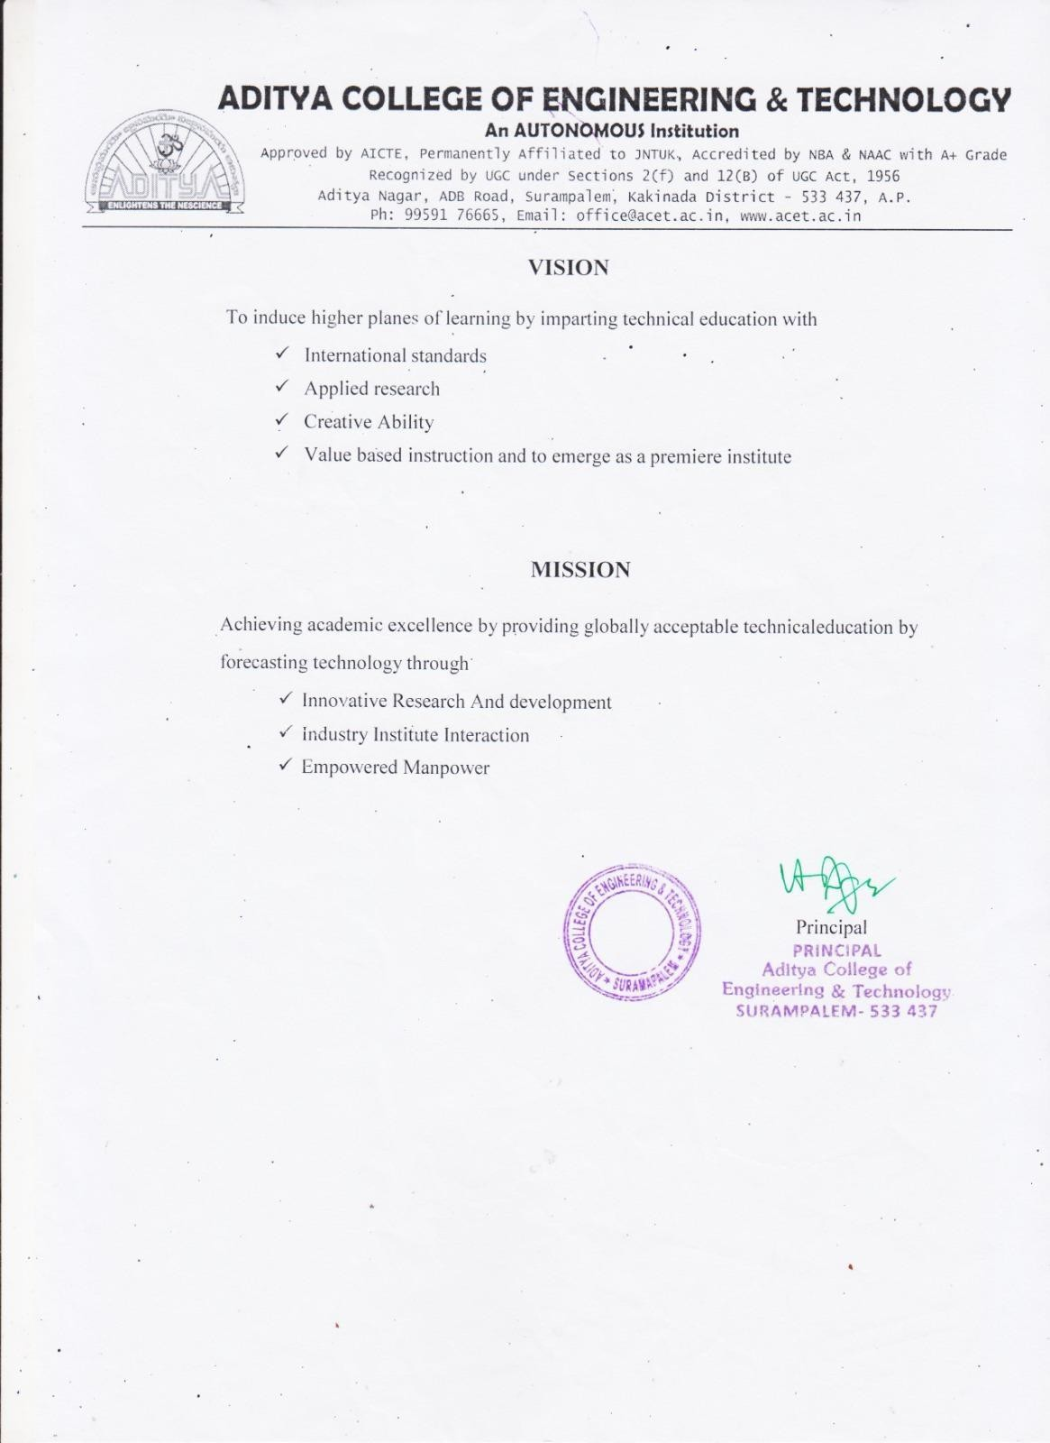

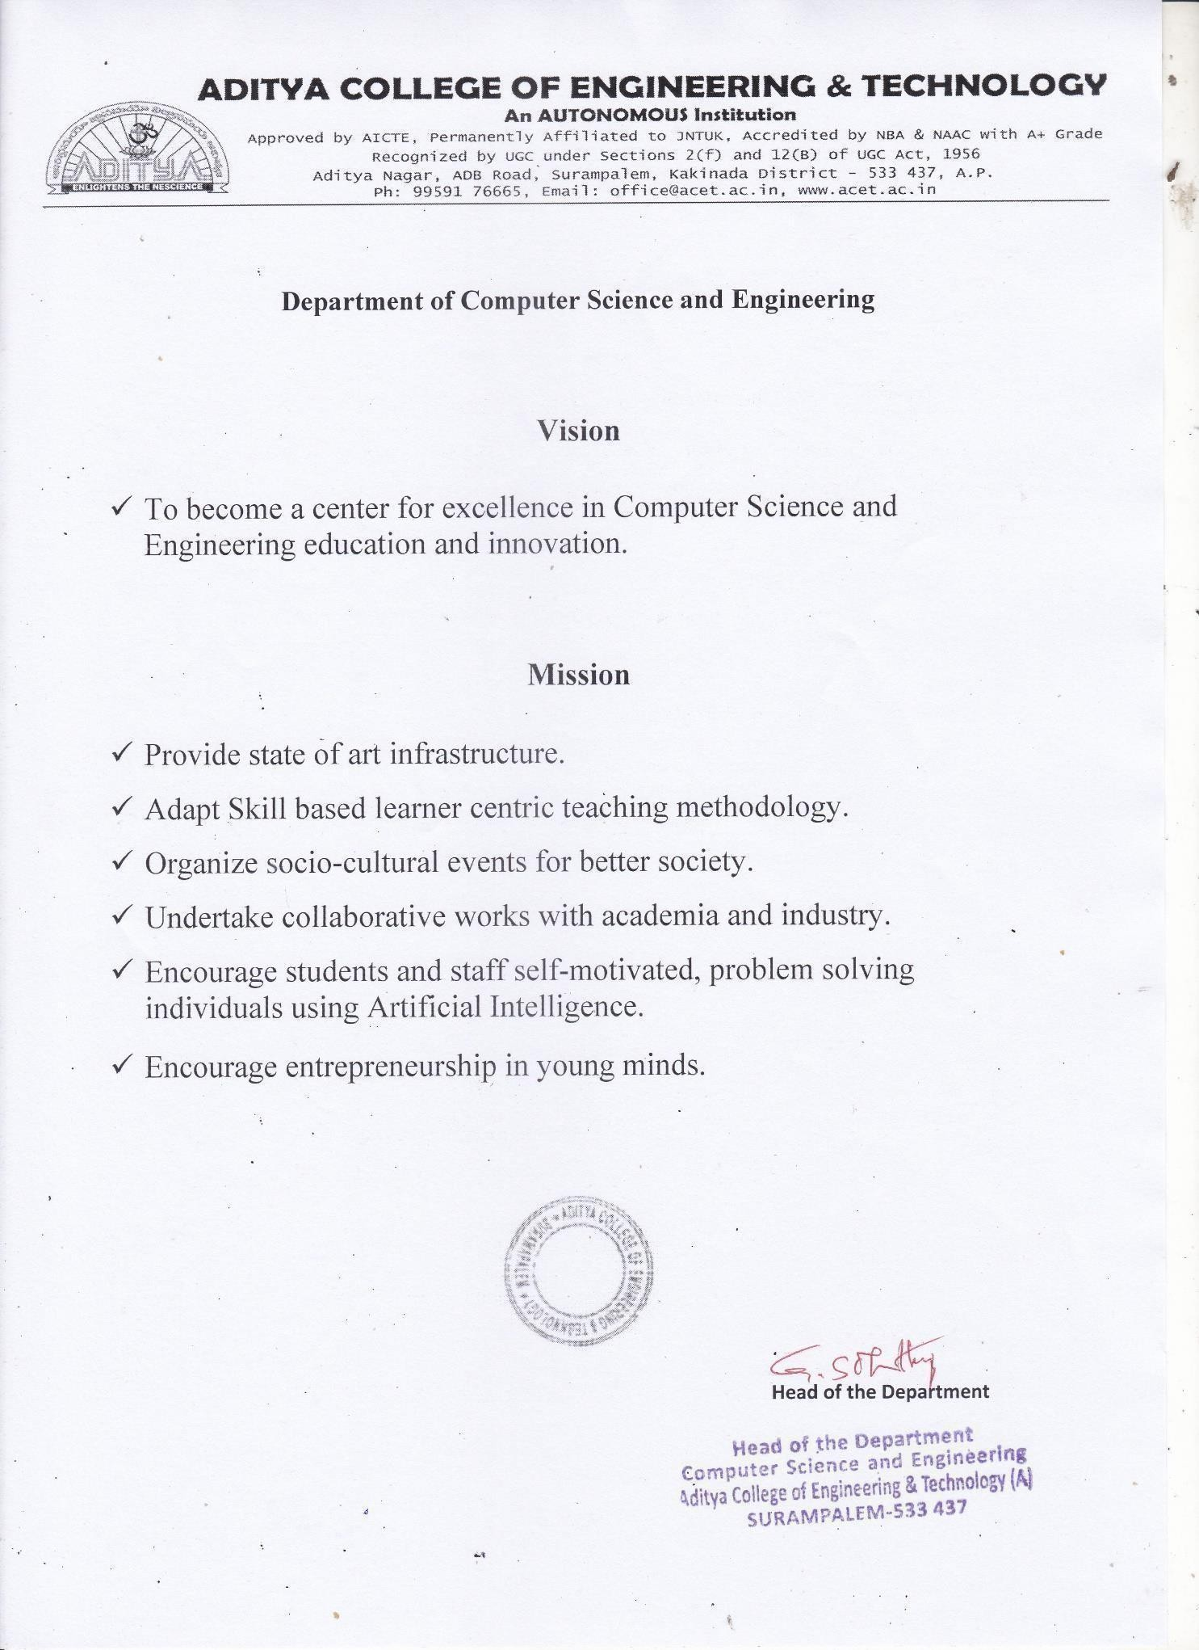

ADITYA COLLEGE OF ENGINEERING & TECHNOLOGY

An AUTONOMOUS Institution
Approved by AICTE, Permanently Affiliated to JNTUK, Accredited by NBA & NAAC with A+ Grade Recognized by UGC under Sections 2(f) and 12(B) of UGC Act, 1956

Department of Computer Science & Engineering

CERTIFICATE

This is to certify the project report entitled SKILLNECT – SMART CAREER GUIDANCE AND DEVELOPMENT APP is a bonified work carried out by Kudipudi Jyothi bearing with Regd No: 22MH1A05B5, Bikash Prasad Yadav bearing with Regd No: 22MH1A0589, Shivanand Prasad Kushwaha bearing with Regd No: 22MH1A05E3, Dasi Kartheek bearing with Regd No: 22MH1A0597.at the college for the award of Bachelor of Technology in COMPUTER SCIENCE & ENGINEERING from ADITYA COLLEGE OF ENGINEERING & TECHNOLOGY(A) during the academic year of 2022- 2026.

Project Guide Head of the Department
Mr. D.VENKATA RAVI KUMAR, M.Tech,(Ph.D). Dr. G. S. N. Murthy M.Tech Ph.D
Assistant Professor Professor
Dept. Of CSE Dept. Of CSE

EXTERNAL EXAMINER

DECLARATION

We here by declare that this project entitled "SKILLNECT – SMART CAREER GUIDANCE AND DEVELOPMENT APP " has been undertaken by us and this work has been submitted to ADITYA COLLEGE OF ENGINEERING & TECHNOLOGY (A), Surampalem affiliated to JNTUK, Kakinada, in partial fulfillment of the requirements for the award of the degree of BACHELOR OF TECHNOLOGY in COMPUTER SCIENCE & ENGINEERING.
We further declare that this project work has not been submitted in full or part to any other University or educational institute for the award of any degree or diploma.

PROJECT ASSOCIATES
KUDIPUDI JYOTHI (22MH1A05B5)
B PRASAD YADAV (22MH1A0589)
SHIVANAND PRASAD (22MH1A05E3)
DASI KARTHEEK (22MH1A0597)

ACKNOWLEDGEMENT

It is with immense pleasure that we would like to express our indebted gratitude to my project supervisor, Mr. D. VENKATA RAVI KUMAR, who has guided us a lot and encouraged us in every step of project work, her valuable moral support and guidance has been helpful in successful completion of this Project.
We wish to express our sincere thanks to Dr. G S N Murthy, Head of the Department of CSE, for his valuable guidance given to us throughout the period of the project work.
We feel elated to thank Dr A. Ramesh, Principal of Aditya College of Engineering & Technology for his cooperation in completion of our project and throughout our course.
We feel elated to thank Dr. P.S.V.V.S. Ravi Kumar, Dean (Academics)of Aditya College of Engineering & Technology for his cooperation in completion of our project work.
We wish to express our sincere thanks to all faculty members, and lab programmers for their valuable guidance given to us throughout the period of the project.
We avail this opportunity to express our deep sense and heart full thanks to the Management of Aditya College of Engineering & Technology for providing a great support for us by arranging the trainees, and facilities needed to complete our project and for giving us the opportunity for doing this work.

PROJECT ASSOCIATE
KUDIPUDI JYOTHI (22MH1A05B5)
B PRASAD YADAV (22MH1A0589)
SHIVANAND PRASAD (22MH1A05E3)
DASI KARTHEEK (22MH1A0597)

ABSTRACT

The career development process for students and fresh graduates often lacks personalized guidance, structured planning, and continuous skill assessment. Many individuals struggle with resume quality, unclear career paths, poor communication skills, and limited interview preparedness, which reduces their employability. Existing platforms are often fragmented, manual, or fail to provide end-to-end career support.

To address these challenges, this project proposes SkillNect – a Smart Career Guidance and Development Application. The system provides an integrated platform that offers resume analysis with ATS scoring, personalized career roadmaps, communication and personality development modules, mock interview simulations, and progress tracking. Users can upload resumes, receive actionable feedback, select target career paths, and monitor their improvement through visual analytics.

The application is developed using modern web technologies with a secure backend and an interactive frontend, ensuring scalability and usability. By providing structured guidance, skill assessment, and continuous progress monitoring in a single platform, SkillNect enhances career readiness, confidence, and employability of users in a practical and efficient manner.

KEYWORDS: Career Guidance, Resume Analysis, ATS Score, Skill Development, Mock Interview, Communication Skills, Progress Tracking, Employability, Web Application.

CHAPTER | INDEX | Page No
1.1 Introduction to project |  | 1
1.2 Literature Survey |  | 2
1.3 Existing System |  | 3
1.4 Scope of the Existing System |  | 4
1.5 Proposed System |  | 4
1.6 Novelty of the Proposed System |  | 5
2 Literature Survey |  | 6
2.1 Introduction to literature survey |  | 6
2.2 Theoretical background / key concepts |  | 7
2.3 Review of existing methods / systems |  | 8
2.4 Critical analysis and research gaps |  | 9
2.5 Summary and link to proposed work |  | 9-10
3.Requirement Analysis |  | 11
3.1 Functional Requirements |  | 11
3.2 Non-Functional Requirements |  | 12
4. System Design |  | 13
4.1 Overview of system architecture |  | 13-14
4.2 Module description / decomposition |  | 15-16
4.3 Database design (if applicable) |  | 16
4.4 Data flow / control flow (if needed) |  | 16
4.5 UML diagrams set |  | 16-30

INTRODUCTION

Introduction to Project:
Preparing for a career these days is a job. It involves a lot of things like building a resume developing skills improving communication and getting ready, for interviews. Career preparation is a lot of work. Because there are many people looking for jobs and things are changing so fast students and people looking for jobs need to get ready in a careful and ongoing way. They need to focus on career preparation and career preparation all the time. Most people use lots of different resources and websites which makes planning a career really confusing and hard to do. Career preparation is important. People need to take career preparation seriously.
Traditional career guidance methods are about talking to a counselor taking general classes and reading old learning materials. These methods do not really help people with what they want to do in their careers how good they are at something or how far they have gotten. So people who are looking for a job often have problems like resumes that're not very good they do not know what to learn next they are not good at talking to others and they are not ready, for job interviews. Traditional career guidance methods and traditional career guidance do not work well for people because they need something that can help them with their career goals and their own skill levels.
This project is going to help people with some problems. It is called SkillNect. SkillNect is a website and phone app that helps people with their careers. The SkillNect system looks at your resume. Helps you make a plan for your career. It also helps you talk to people and be more confident. You can even practice job interviews with SkillNect using intelligence. SkillNect is like a one stop shop for people who want to learn skills and get better at their jobs. The SkillNect system has a lot of tools, like resume analysis and skill tracking all in one place.

Literature Survey
People have done a lot of research on career guidance systems and platforms that help people get jobs. Nandakumar [1] Said that it is really important to have a career planning system that is structured and guides people based on what they like to do and what they are good at. This is better than giving people general advice. Their study showed that when people have a guided career frame work they are less confused and make decisions about their career. Digital career guidance systems are helpful because they provide a path for people to follow. Nandakumar et al. Found that digital career guidance systems and employability enhancement platforms are tools, for people who want to plan their career.
Kumar and Sharma [2] did some research on the tools that companies use to evaluate resumes when they are hiring people. They found out how these tools, called Applicant Tracking Systems look at resumes and pick the ones that have the keywords, skills and formatting. The research by Kumar and Sharma showed that if you make your resume work well with these systems you are more likely to get selected for an interview. The Kumar and Sharma research is, about resume evaluation tools and how they affect the recruitment process.
Zhao [3] and the other people who worked with him looked at training that helps people talk to others and fake interview websites. They found out that when people practice in an interview setting and get feedback on how they do they get better at speaking clearly and answering questions. This also helps them feel more confident. The people who did the study said that these systems do not do a good job of tracking how people do over a long time. Zhao and the other people who worked with him said that this is something that needs to be improved. The study, by Zhao and the other people who worked with him is important because it shows what works and what does not work in interview training.
Behl and Kaur [4] examined web-based career development platforms and identified major gaps such as fragmented services, limited personalization, and absence of integrated analytics. These studies collectively indicate the need for a unified system that combines resume optimization, skill development, communication training, interview preparation, and progress tracking, which forms the foundation for the SkillNect system.

1.3 Existing System

The career guidance system we have today is made up of different platforms that help people get ready for their careers. These platforms do things like help you build a resume or learn new things or practice talking to people or get ready for a job interview. The problem is that all these career guidance platforms work on their own without working. This means that resume building tools learning platforms, career guidance communication training apps and interview preparation systems all operate by themselves without any coordination, between the career guidance platforms.

Most platforms give you information and the same old suggestions. The tools that look at your resume do not give you help and are not tailored to the job you want. The websites that try to help you with talking to people do not really check how well you are doing. The fake interview systems do not help you keep track of how you are getting better. The resume analysis tools and mock interview systems and communication skill platforms all have these problems.

People have a time figuring out if they are ready, for a career because there is no integration and centralized monitoring. This makes it really tough for users to get a sense of their career readiness. The career readiness of users is affected by this approach. It leads to preparation that's not very efficient and career growth that is slower than it should be. The career growth of users is slower because of this.

1.4 Scope of the Existing System

The thing with systems that're already out there is that they can only do one thing at a time. They can help you make a resume. They can suggest some courses for you to take or they can even help you practice for a job interview. When it comes to planning your career you are pretty much on your own. You have to figure out what you want to learn and how you want to get without any real help, from these systems. Career planning is still something that you have to do by hand. It would be nice if these systems could give you some smart advice to help you make good choices.

We have a problem, with progress tracking. It only works on platforms. This makes it hard to see how things are improving overall. What we really need is to get feedback as things happen and have some way to measure how well we are doing. This is what is missing from our system. We need real-time feedback and some way to measure our performance so we can see if we are getting better or not. Progress tracking is the issue here.

The limitations of career preparation are a problem. They make it less effective. This shows that we need a career development platform that brings everything together. The career development platform should be integrated so that career preparation is more useful. We need to focus on career development and career preparation to make them better.

1.5 Proposed System

The SkillNect system is a way to help people with their careers. It is a place where you can get help with lots of things. The SkillNect system looks at your resume. Helps you figure out what to do next with your career. It also helps you practice talking to people and being a communicator. The SkillNect system even lets you do interviews to get ready for real ones. It keeps track of the skills you have and the ones you need to work on. The SkillNect system is, like a coach that helps you with your career.

SkillNect is a tool that helps with resume analysis using a system called ATS. It has two ways of doing this: it can give you an overall score for your resume and it can also help you make your resume better for a specific job you want. When you use SkillNect you pick the kind of job you want. It gives you a plan to learn the skills you need along, with some helpful resources that are chosen just for you and the SkillNect system makes it easy to follow. SkillNect provides this by using the ATS-based resume analysis.

The system helps people get better at talking by having practice sessions and fake interviews that use intelligence. There are boards that show how well people are doing with their skills so they can see what they are not good at and get ready for a job in a step-by-step way. The system really focuses on helping people with their skills and the fake interviews are a part of that. The skill boards are important because they help people see how they are doing with their skills and get ready, for a career.

1.6 Novelty of the Proposed System

What makes SkillNect special is that it has an integrated design and it keeps checking your progress all the time. Other systems only help with one thing at a time when it comes to getting ready for a career. SkillNect is different because it helps with the SkillNect career development process from start, to finish. SkillNect covers everything you need to know about your SkillNect career development.

The system puts together a few things to help you with your job search. It has resume optimization, which helps you make your resume better. It has personalized roadmaps, which are, like plans that are made just for you. You get communication training, which teaches you how to talk to people. There are interview simulations, where you can practice talking to people in an interview. You can track how you are doing. The system also gives you real-time analytics and feedback so you can see how you are doing. Make changes to get better. The system helps you improve. You can actually see that you are getting better.

SkillNect helps people understand their careers better by giving them directions and keeping an eye on their progress. This makes people feel more confident about their jobs and it becomes easier for them to get hired. SkillNect does all of this in a way that's easy to use and works well for a lot of people. SkillNect is really good, at helping people with their careers. It does this by making things simple and easy to follow.

- LITERATURE SURVEY

2.1 Introduction to Literature Survey

The literature survey is an important part of a software engineering project. It gives us a look, at the systems and technologies that already exist. We get to see what research has been done on the problem we are trying to solve. The literature survey helps us understand how other people have solved problems. We also get to see what is still not working well in the solutions that're already out there. The literature survey is really helpful because it shows us what we can learn from the software engineering project. The software engineering project can be better if we do a literature survey.

The SkillNect app is for Smart Career Guidance and Development. This app looks at career guidance platforms. It also looks at resume analysis and Applicant Tracking System tools. The SkillNect app looks at learning recommendation systems. It even checks out communication skill development platforms. The SkillNect app also uses AI-based mock interview systems to help people. The SkillNect app is, about helping people with their careers.

When it comes to career development solutions most of them only focus on one thing like helping you build a resume or suggesting courses to take. Not many systems offer a package that includes resume optimization, career planning, communication improvement, interview preparation and progress tracking all in one place. Career development solutions, like these are really helpful because they provide everything you need to improve your career development skills, including resume optimization, career planning, communication improvement, interview preparation and progress tracking. This means you can get help with your resume optimization, career planning, communication improvement, interview preparation and progress tracking from the same career development solution.

This chapter looks at what other people have found out and what systems are already in place to see what is missing and to show why we really need something, like SkillNect that can help people with their careers in a smart way.

2.2 Theoretical Background and Key Concepts

When we talk about career development systems they are based on an important idea. These ideas are about helping people figuring out what they are good at making things just right, for them and keeping an eye on how they're doing. The basics of SkillNect are built on some ideas.

Career Guidance Systems
When it comes to finding a career career guidance systems are really helpful for students and professionals. They help students and professionals find career paths that're a good fit for them. This is because career guidance systems look at the interests, skills and goals of students and professionals.

The old way of doing career guidance was not very effective. It usually involved talking to a counselor and taking tests that did not change. The problem with this way is that it does not adapt to the needs of students and professionals. Career guidance systems are better because they can help students and professionals find career paths that're right, for them.

Key concepts involved:

- Career interest identification

- Skill and aptitude assessment

- Goal-oriented career planning

- Limited personalization in traditional methods

- Resume Analysis and ATS Optimization

Resume analysis systems look at resumes to see if they have what is required. They check for things like skills and keywords and experience. How the resume is formatted. Organizations use systems called Applicant Tracking Systems to sort through resumes, on their own. These systems help them find the resumes.

2.3 Review of Existing Methods and Systems

Many career development platforms there only look at one part of getting ready for a career instead of looking at the whole thing. These career development platforms do not offer a solution. The career development platforms should help people with all parts of their career preparation. They do not. The main issue, with these career development platforms is that they are missing some parts.

When I look at resume evaluation platforms they do give me some idea of how my resume will do with the computer systems that companies use to screen resumes. These platforms also suggest some keywords that I can use to make my resume better. What they do not do is help me make my resume really good for a specific job I want. They also do not work well with the courses I take to learn new things.

Online learning platforms have a lot of courses that I can take to learn new skills. However, they do not help me plan out my career. They do not keep track of my progress. Resume evaluation platforms and online learning platforms, like resume evaluation platforms do not work together to help me get a job.

Communication skill platforms are okay. They usually just give you some recorded lessons or basic practice sessions. The problem is that you do not get feedback that is actually about you.

Then there are interview platforms that try to be, like real interviews. However, communication skill platforms and mock interview platforms often do not show you how much you are improving over time.

These systems work on their own so people have to use different platforms. This means that people have to prepare for things in a lot of ways. It is also really hard to plan your career when you have to use many different systems. The career planning process is not very efficient because of this.

2.4 Critical Analysis and Research Gaps

We have technology like artificial intelligence and digital platforms but the systems we have now are not perfect. They still have a lot of problems that need to be fixed. Artificial intelligence and digital platforms are really cool. They are not enough to make our systems work the way we want them to. There are limitations, in our existing systems that we need to work on.

Identified research gaps:

- Lack of a unified career development platform

- No centralized dashboard for career readiness

- Static recommendations without adapting to user progress

- Poor integration of technical and soft skills

- Limited AI-driven personalization

These gaps show that we really need a career guidance system that's easy to use and helps people make good choices. A career guidance system should be smart. Think about what the user needs. We need a system that puts the user first and helps them in a way. This kind of career guidance system is very important.

2.5 Summary and Link to Proposed Work

When you look at the research that has been done you can see that the systems we have now do not really help people with their career development. They might do a bit of resume analysis or career planning or communication training or interview preparation but they do all of these things separately. This means that they are not as helpful as they could be. The literature survey shows that career development systems are not doing a job. They only do things like resume analysis and career planning and communication training and interview preparation. They do not do them together which makes them less effective. Career development is what these systems are supposed to be helping with.

The SkillNect Smart Career Guidance and Development App is an idea that fixes the problems we have now. It does this by putting everything we need for career development in one place that we can use on the web and on our phones. This part of the book sets the stage, for the SkillNect Smart Career Guidance and Development App. We will talk about it in more detail in the next part System Proposed Work

We will look at the system. Figure out what is going on. Then we will propose some work to make it better. The system analysis is an important step. We have to do this so we can understand the system.

After that we will propose some work. This proposed work will help us fix the problems we found in the system analysis. System analysis and proposed work go hand in hand. We cannot do one without the other.

First, we do the system analysis. Then we come up with the proposed work. System analysis is like looking at the system to see what is wrong. Proposed work is, like coming up with a plan to fix it. System analysis and proposed work are very important.

- Requirement Analysis

  - Functional Requirements

The functional requirements define the core features and operations that the SkillNect system must perform to support career development efficiently. These include:
- User Authentication and Management
  - User registration and login functionality
  - Profile creation and management
  - Role-based access control for different types of users
- Resume Analyzer and ATS Scoring
  - Upload and parse user resumes
  - Extract relevant details such as education, skills, and experience
  - Evaluate ATS compatibility and provide scoring
  - Suggest improvements based on job-specific requirements
- Career Roadmap and Course Recommendation
  - Allow users to select career goals
  - Generate a structured learning roadmap
  - Recommend skills, courses, and projects aligned with user goals
- Personality and Communication Development
  - Provide speaking exercises and quizzes
  - Evaluate confidence, clarity, and communication skills
  - Generate personalized improvement suggestions
- AI-Powered Mock Interviews
  - Simulate technical and HR interviews
  - Evaluate user responses and assign scores
  - Provide actionable feedback for improvement
- Skill and Job Tracker
  - Track user skill milestones
  - Monitor job application status
  - Send notifications and reminders for important deadlines

- Dashboard and Reporting
  - Display overall progress and recommendations
  - Generate reports for skill development and career readiness

  - Non-Functional Requirements

Non-functional requirements specify system attributes such as performance, usability, and reliability that ensure smooth operation. These include:
- Performance
  - The system should handle multiple concurrent users efficiently
  - Resume parsing and AI evaluations should complete within a reasonable time (e.g., under 10 seconds per resume)
- Scalability
- The system must support the addition of new modules and features without major redesign
- Cloud-based architecture ensures resource scaling as user base grows
- Usability
  - User-friendly interfaces for web and mobile platforms
  - Clear navigation and easy access to core features
- Reliability
- Ensure high availability with minimal downtime
- Regular data backups to prevent data loss
- Security
  - Secure authentication and authorization mechanisms
  - Data encryption for sensitive user information
  - Compliance with data privacy standards
- Maintainability
  - Modular code design for easy updates and enhancements
  - Proper documentation for system modules and APIs
- Compatibility
  - Web application should work on modern browsers
  - Mobile application should support both Android and iOS platforms

4. SYSTEM DESIGN

4.1 Overview of System Architecture

The SkillNect system is made up of a client. A server that works together with artificial intelligence services. People use the SkillNect system by looking at it on the web or on their phone. When you do something, on the SkillNect system the part you see which is called the frontend takes care of what you're doing. The backend, which is the part you do not see handles all the requests you make checks who you are figures out what you can and cannot do and makes sure the artificial intelligence services are working properly with the SkillNect system and the artificial intelligence services.

The system is made up of a few parts: presentation, application, AI processing and data layers. This way of doing things makes the system more scalable, more secure and easier to maintain The AI modules for things, like looking at resumes creating career roadmaps and doing interviews can all work together really well with the AI processing and data layers. The AI modules and the AI processing and data layers all work together to make sure everything runs smoothly.

Layered Architecture Diagram

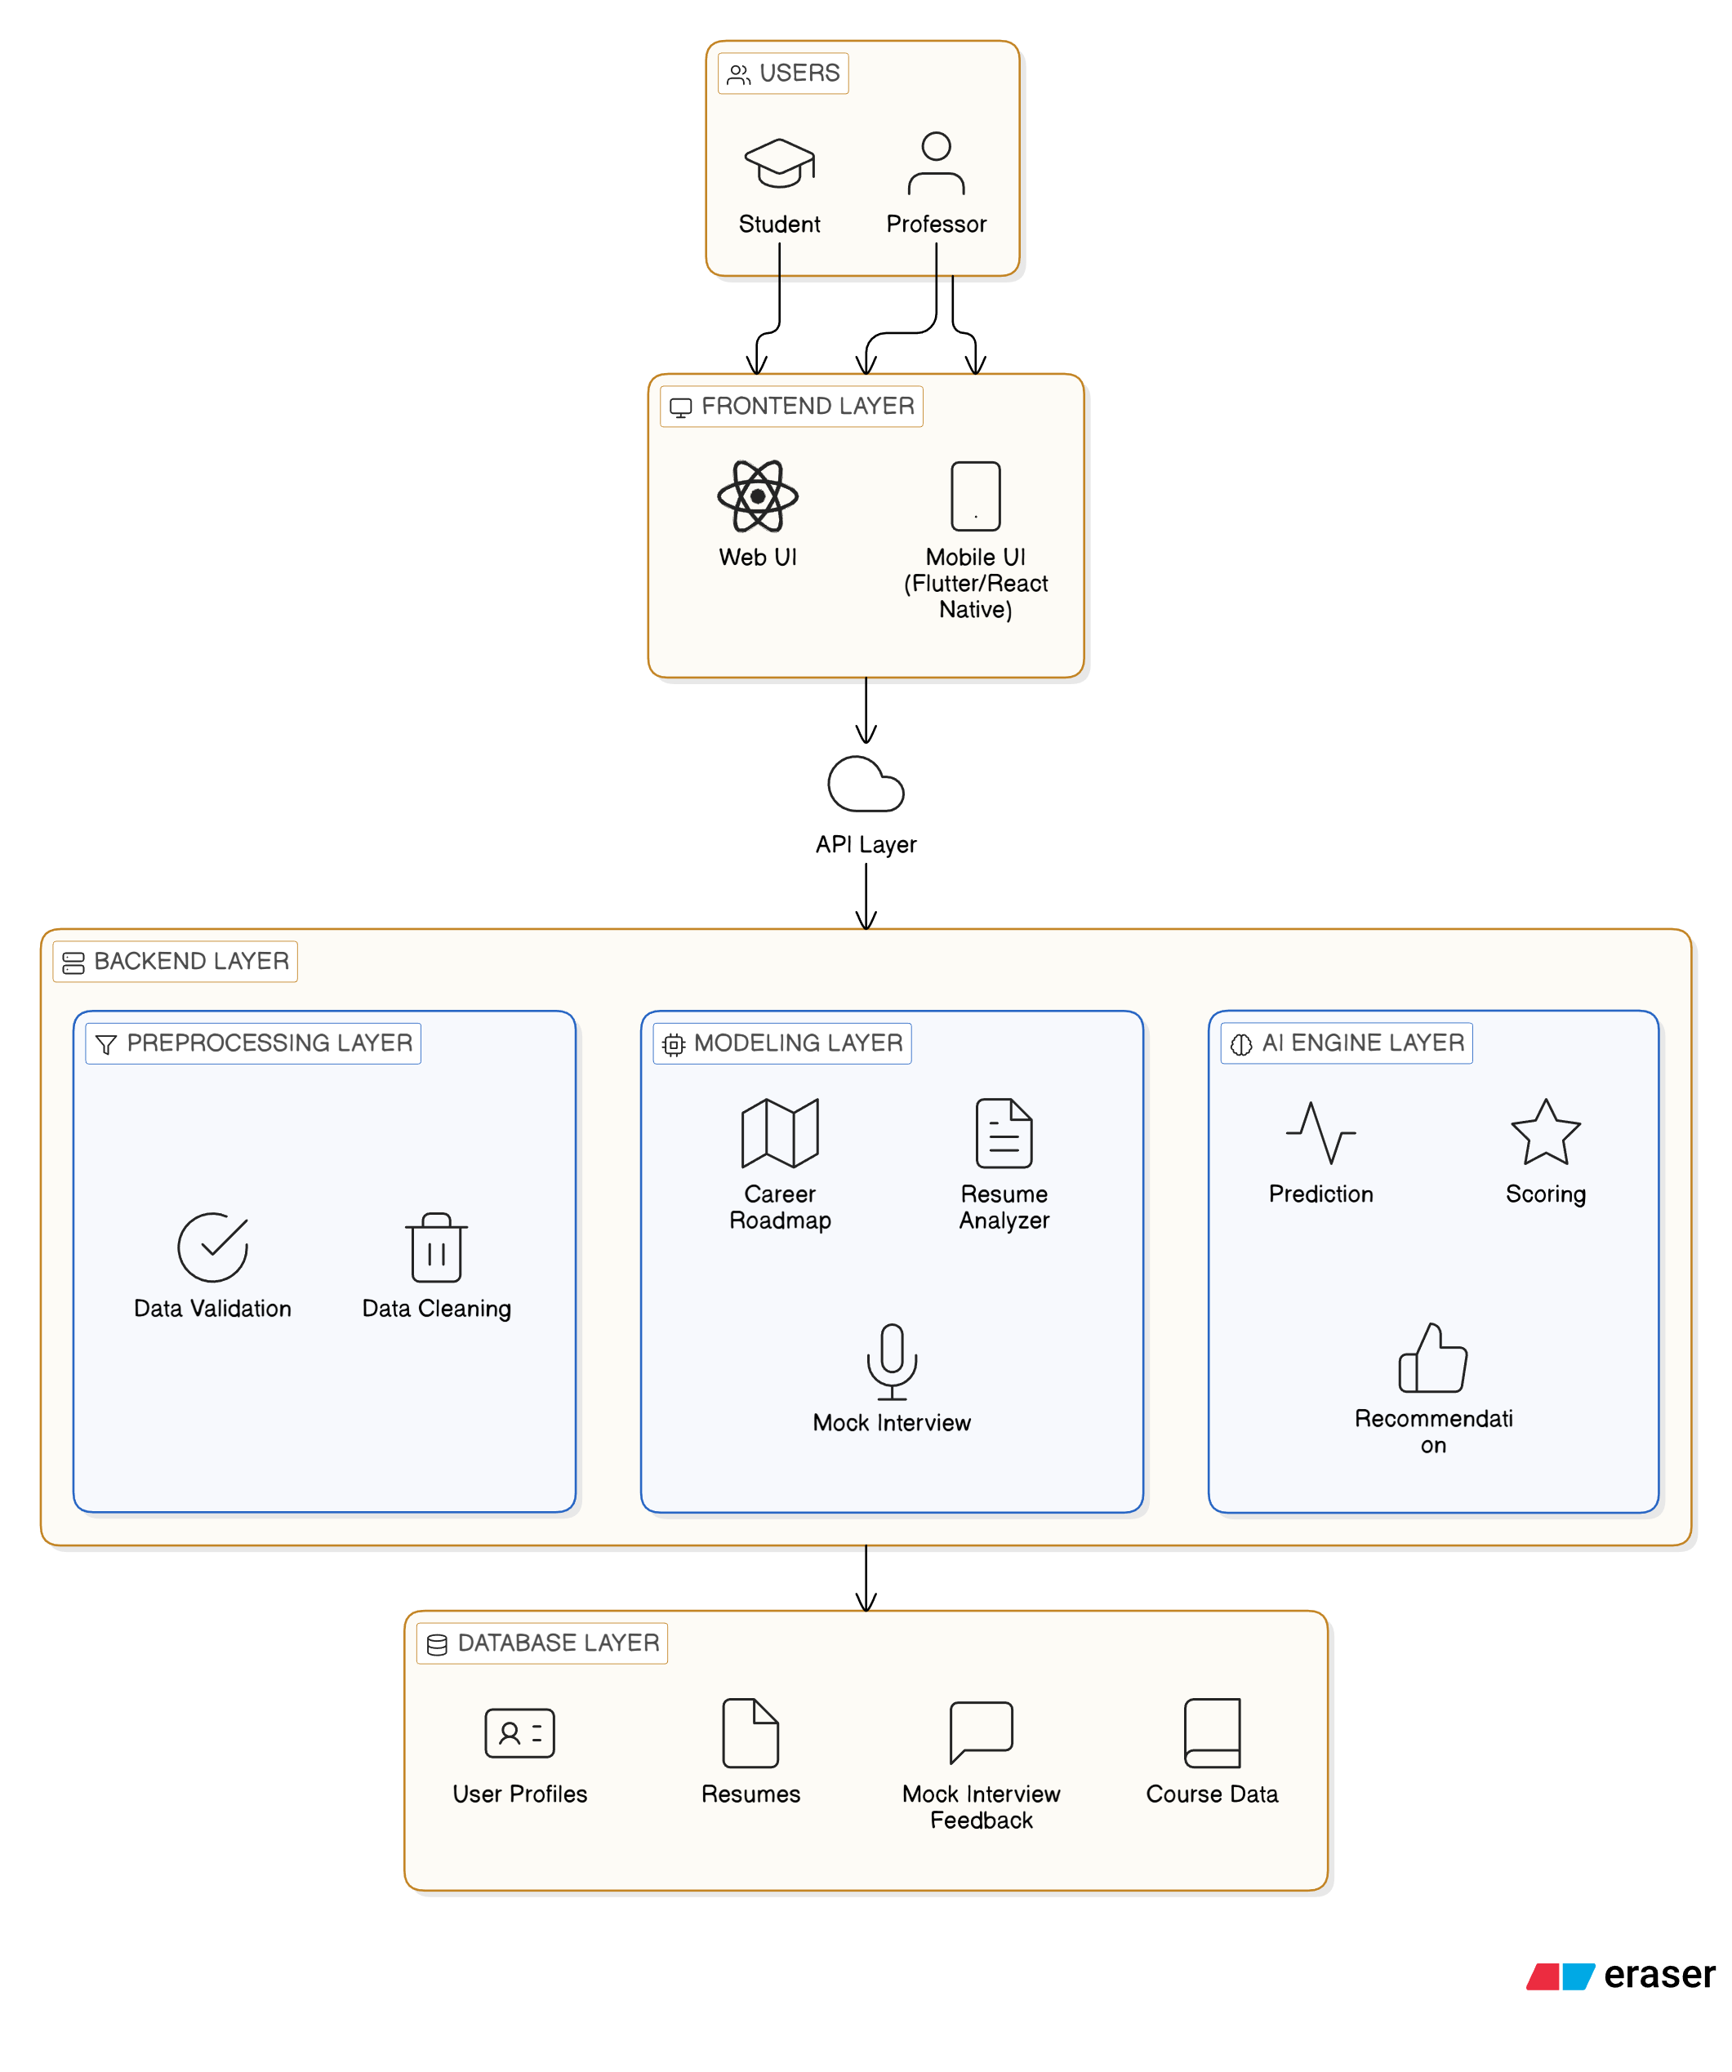

Fig 4.1

Description of Layers:

Front-end Layer: Provides intuitive interfaces for users to interact with the system.

API Layer: Facilitates communication between front-end and backend services.

Back-end Layer: Handles business logic, AI processing, and orchestrates module workflows.

Database Layer: Stores user data, resumes, ATS scores, roadmap recommendations, and analytics.

4.2 Module Description / Decomposition

The SkillNect system is divided into several functional modules to ensure modularity,

maintainability, and clarity in operations. Each module handles specific responsibilities to provide a seamless user experience.

4.2.1 User Authentication Module

Handles user registration and login

Manages user sessions securely

Implements role-based access control for different types of users

4.2.2 Resume Analyzer Module

Processes uploaded resumes and extracts relevant information

Generates ATS compatibility scores

Provides optimization suggestions for resumes based on job requirements

4.2.3 Career Roadmap Module

Generates personalized career paths for users based on their goals

Recommends relevant courses and learning resources

Tracks skill development progress over time

4.2.4 Communication and Personality Module

Offers AI-driven speaking exercises and quizzes

Evaluates responses for clarity, confidence, and communication skills

Provides personalized feedback for improvement

4.2.5 Mock Interview Module

Conducts technical and HR interview simulations

Records user responses for evaluation

Generates detailed feedback and improvement suggestions

4.2.6 Skill Tracker Module

Tracks user skill milestones and progress

Displays analytics and insights on skill development

Sends notifications and rewards for achievements

4.2.7 Dashboard Module

Consolidates all user activities, insights, notifications, and rewards

Provides a single interface for easy monitoring and access to all modules

4.3 Database Design

The database stores user profiles, resumes, ATS scores, career roadmaps, mock interview feedback, and skill tracking data. Proper entity relationships ensure data integrity and efficient retrieval.

4.4 Data Flow / Control Flow

User actions such as resume upload, career roadmap requests, or mock interview practice trigger backend processing and AI analysis. Processed results are stored in the database and displayed on the dashboard. Error handling ensures smooth system operation and uninterrupted user experience.

4.5 UML Diagrams Set

The SkillNect system is represented using 14 UML diagrams, including use case, class, sequence, activity, deployment, and more. Each diagram illustrates system structure, behavior, or interaction.

4.5.1 Use Case Diagram

Illustrates user interactions with the system: resume uploads, ATS evaluation, career roadmap generation, mock interviews, and skill tracking. Admin roles manage users, validate content, and monitor analytics, while the AI system and database support intelligent processing.

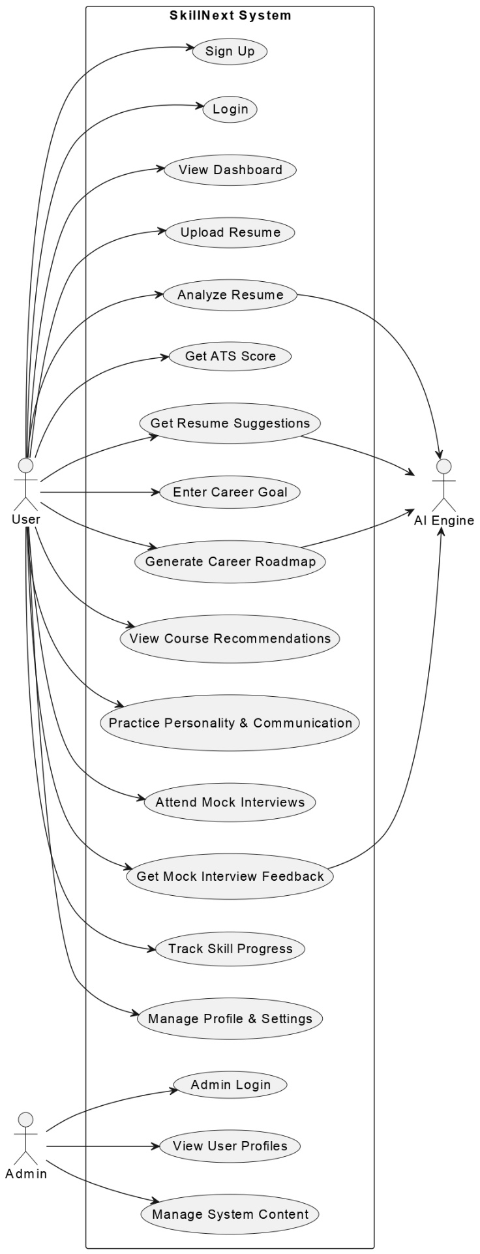 fig 4.2

4.5.2 Class Diagram

Shows core classes like User, Resume, Career Roadmap, Mock Interview, Job Application, AI Analyzer, with attributes, methods, and relationships. Explains how modules interact structurally.

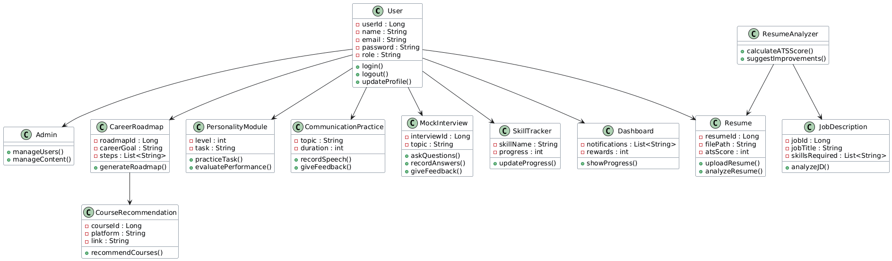

Fig 4.3

4.5.3 Sequence Diagram

Depicts step-by-step interactions between users, system modules, AI engines, and databases for key scenarios (e.g., resume analysis or mock interviews).

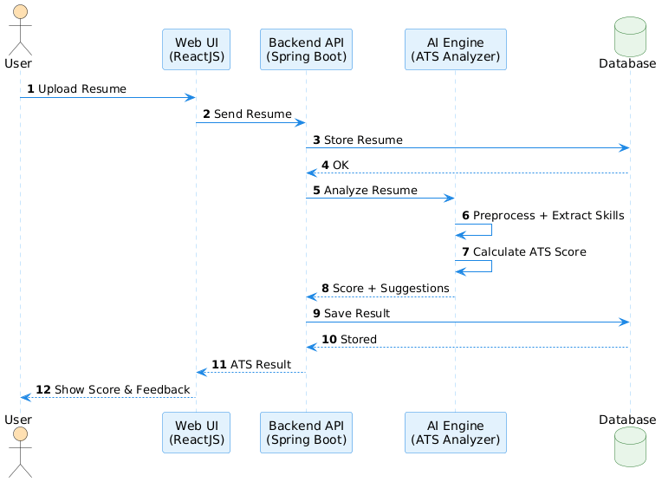

Fig 4.4

4.5.4 Activity Diagram

Represents workflow of main processes, such as career roadmap generation or mock interview sessions.

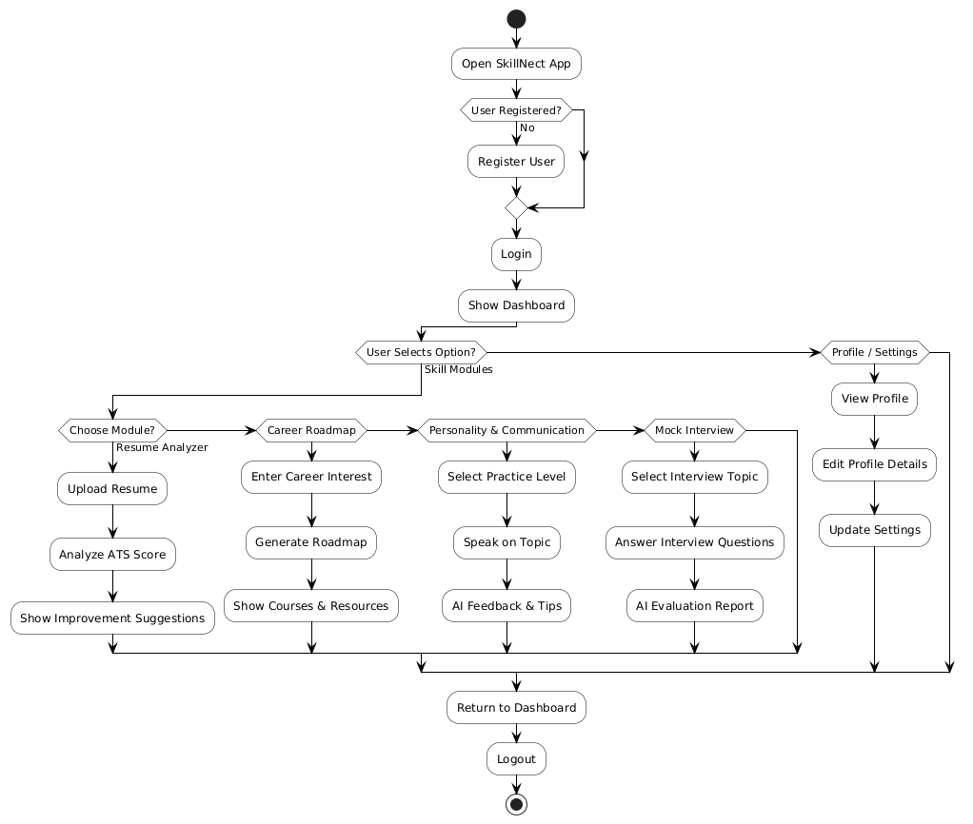

Fig 4.5

4.5.5 State Diagram

Shows the states of user sessions or resume analysis processes and transitions between them.

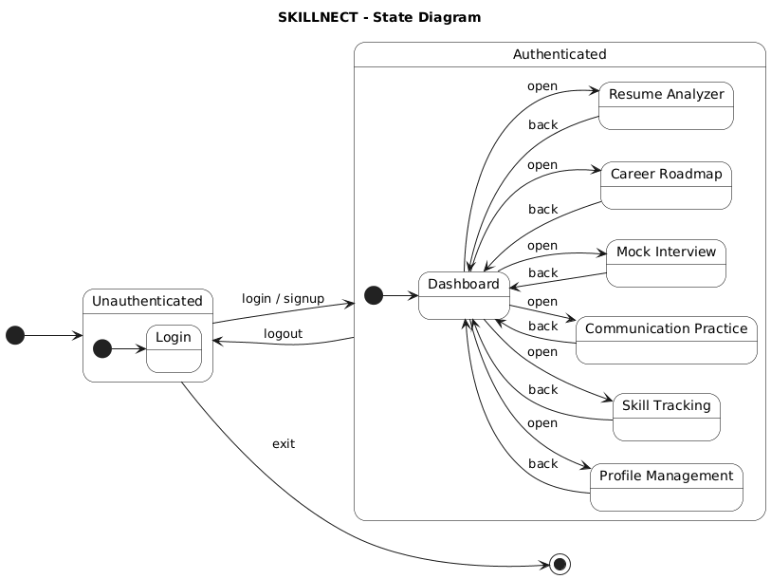

Fig 4.6

4.5.6 Object Diagram

Illustrates instances of classes during runtime for a specific scenario.

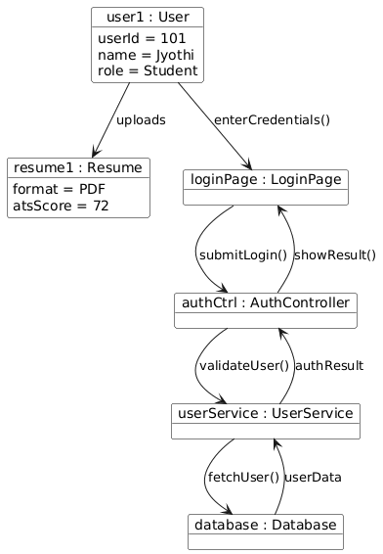

Fig 4.7

4.5.7 Deployment Diagram

Depicts physical deployment of software on servers, cloud services, and database nodes.

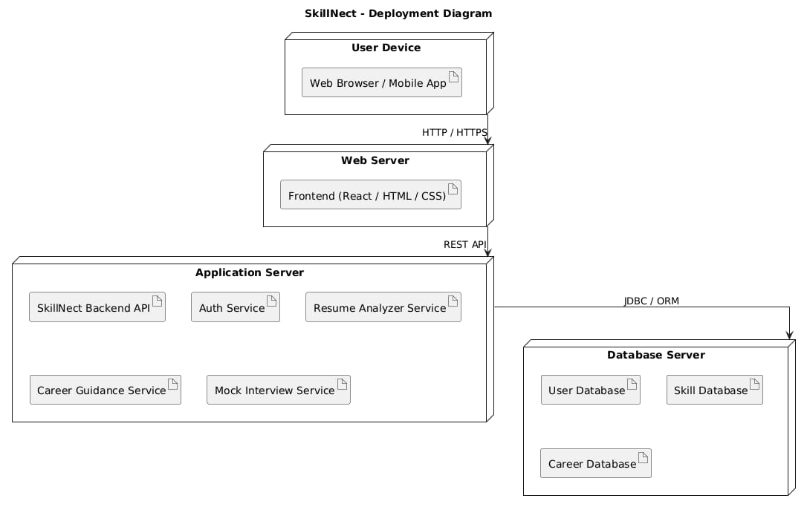

Fig 4.8

4.5.8 Communication Diagram

Shows interactions among system components during execution of use cases.

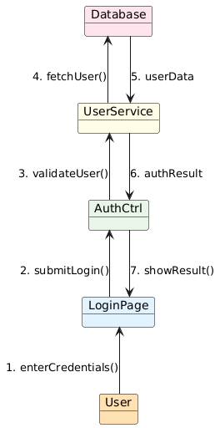

Fig 4.9

4.5.9 Interaction Overview Diagram

Combines activity and sequence views to give a high-level flow of interactions.

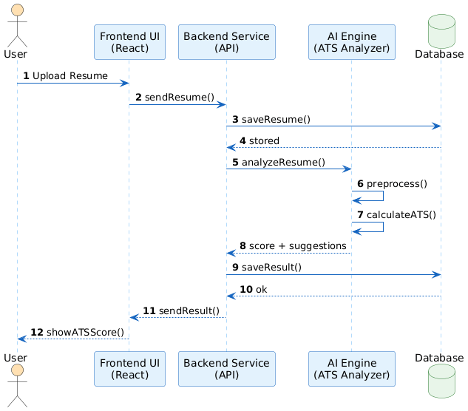

Fig 4.10

4.5.10 Composite Structure Diagram

Represents internal structure of components and their collaborations.

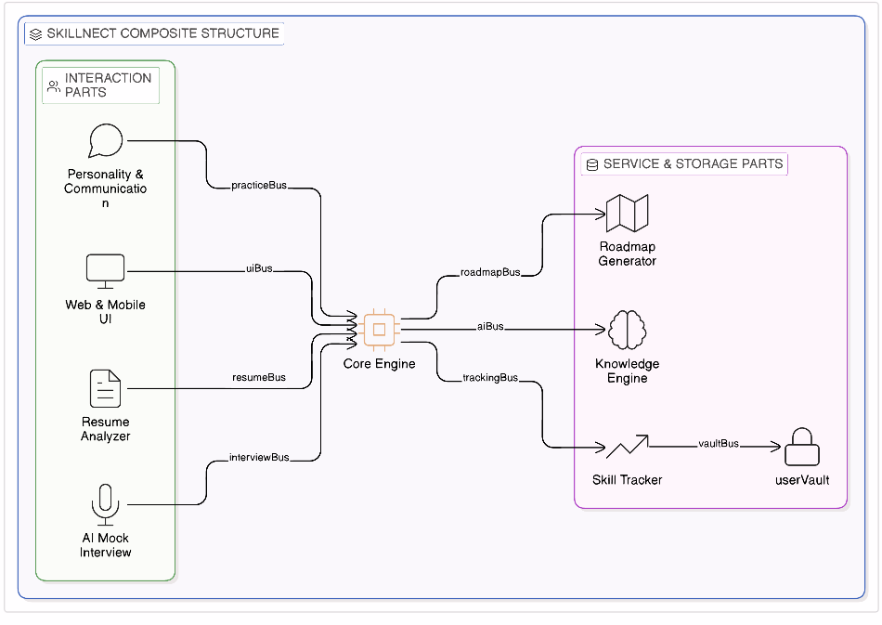

Fig 4.11

4.5.11 Package Diagram

Organizes modules and classes into logical packages for better maintainability.

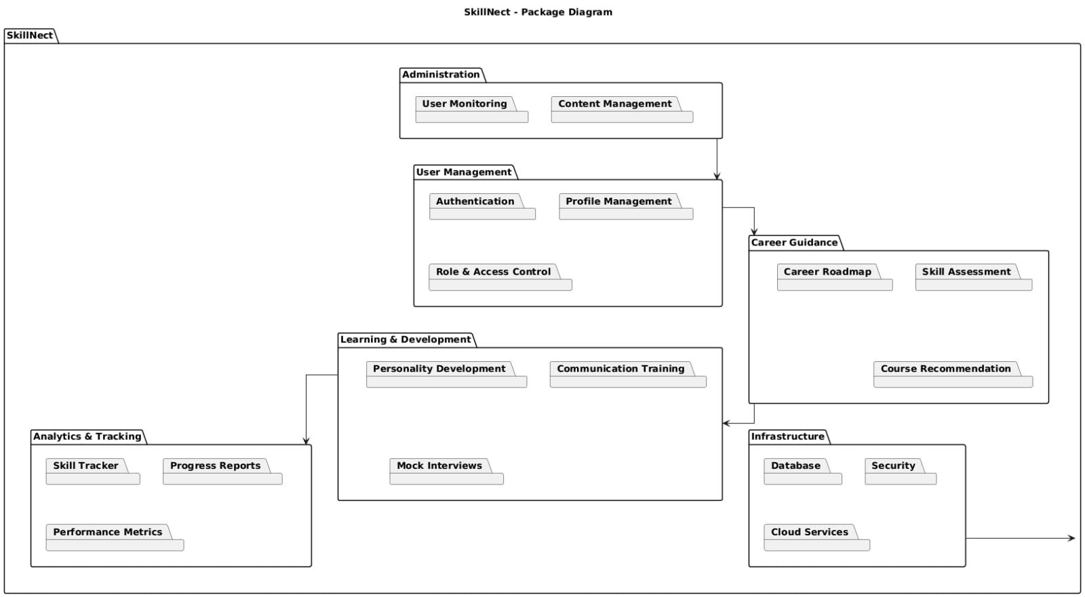

Fig 4.12

4.5.12 Component Diagram

Shows software components and their dependencies.

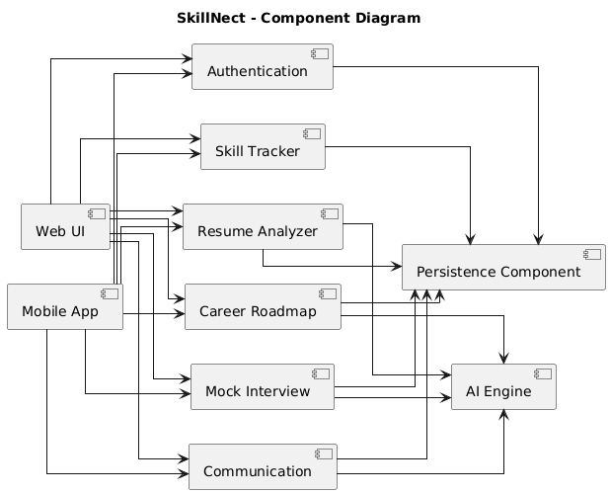

Fig 4.13

4.5.13 Profile Diagram

Defines stereotypes and tagged values for extending UML elements.

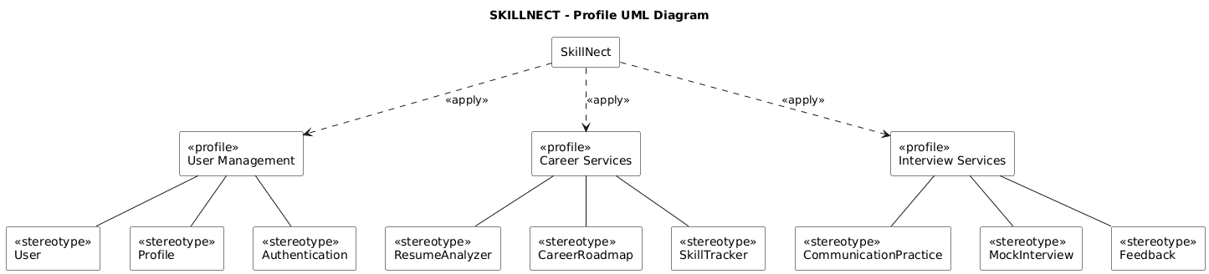

Fig 4.14

4.5.14 Timing Diagram

Illustrates timing constraints, sequence, and duration of processes within the system.

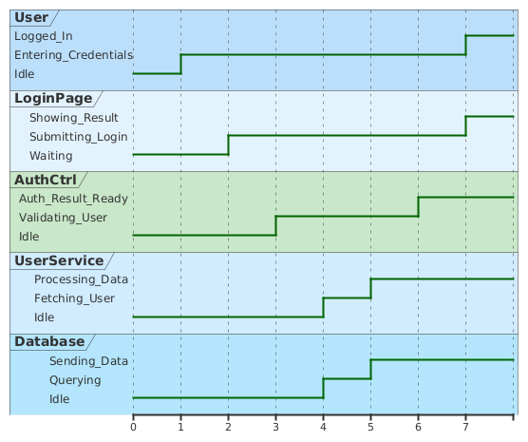

Fig 4.15

4.6 Design Decisions and Constraints

Web-based architecture chosen for cross-device access without software installation.

AI engines focused on resume analysis, career roadmap, and mock interviews to reduce computational overhead.

Role-based access control ensures security and separates user/admin functionalities.

Cloud services used for scalability and reliability; AI models are lightweight due to academic constraints.

System is modular and extensible, allowing future enhancements like advanced AI, real-time simulations, or job portal integrations.

