ASSIGNMENT

Q1. Find out the mail servers of the following domain :

Ibm.com

Wipro.com

Sol. Open pentest machine and then command prompt

Type command nslookup in pentest machine:

Then > set type=mx

>Ibm.com / Wipro.com

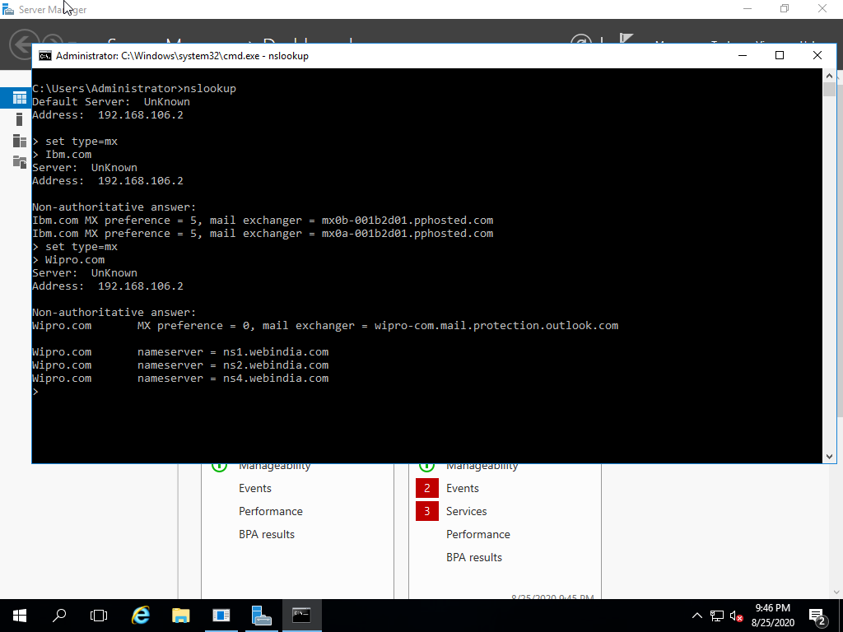

Q2. Find the locations, where these email servers are hosted?

Sol. Type command nslookup in kali machine.

>Ibm.com / Wipro.com

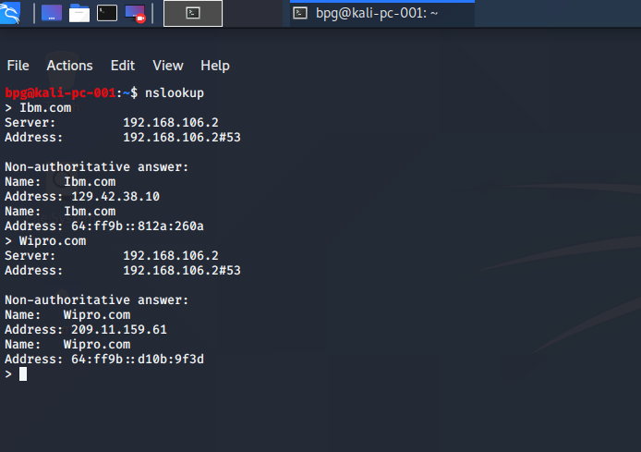

Q3. Scan and find out the port numbers open 203.168.246.23

Sol. Type command nslookup 203.168.246.23 -Pn

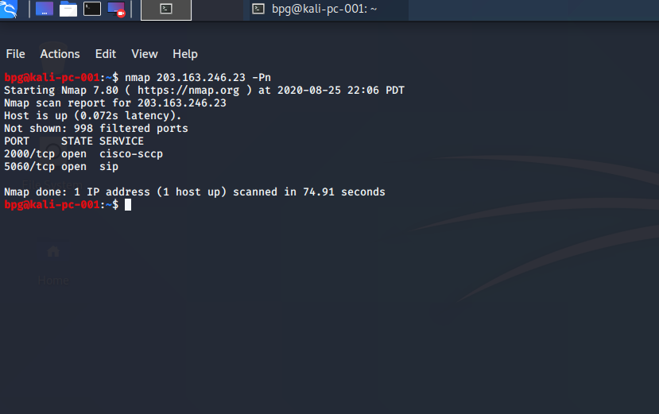

Q4. Install Nessus in a VM and scan your laptop/desktop for CVE.

Sol 