Answer1

(a)(i)

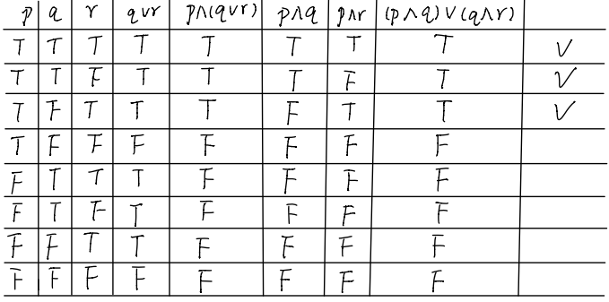

Therefore, it could prove the inference hold in propositional logic using truth table.

(a)(ii)

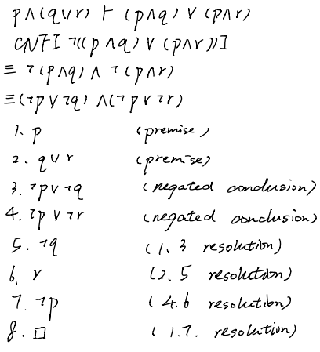

Therefore, it could prove the inference hold in propositional logic using resolution.

(b)(i)

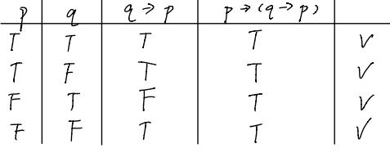

Therefore, it could prove the inference hold in propositional logic using truth table.

(b)(ii)

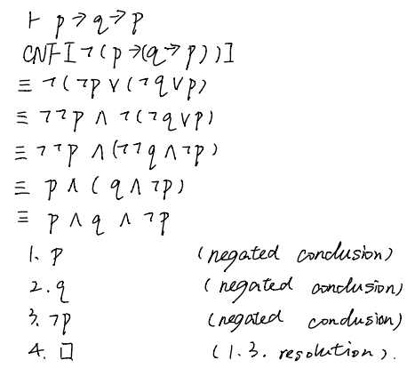

Therefore, it could not prove the inference hold in propositional logic using resolution.

(c)(i)

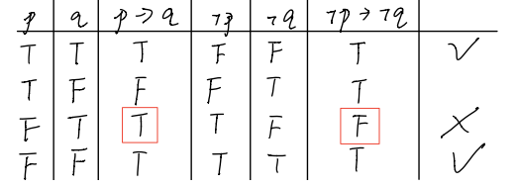

Therefore, it could not prove the inference hold in propositional logic using truth table since $p→q$ is truth but $¬p→¬q$ is false in the third row.

(c)(ii)

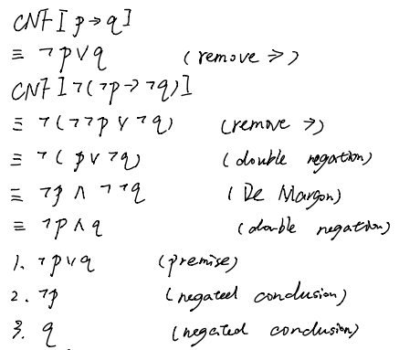

Therefore, it could not get empty clause using resolution.

(d)(i)

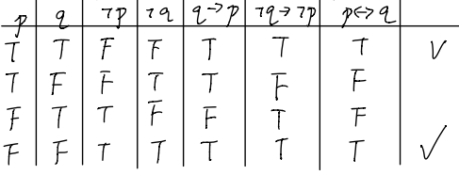

Therefore, it could prove the inference hold in propositional logic using truth table.

(d)(ii)

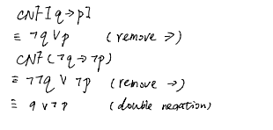

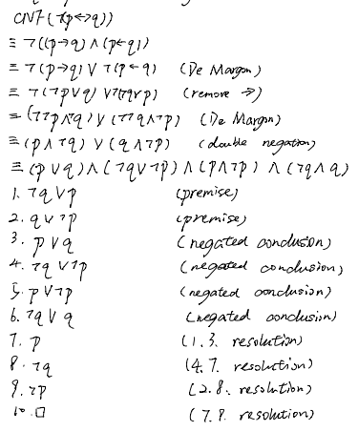

Therefore, it could not prove the inference hold in propositional logic using resolution.

(e)(i)

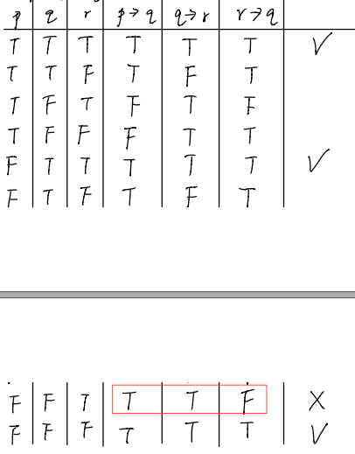



Therefore, it could not prove the inference hold in propositional logic using truth table since $p→q$ and $q→r$ are truth but $r→q$ is false in the second row from the bottom.

(e)(ii)

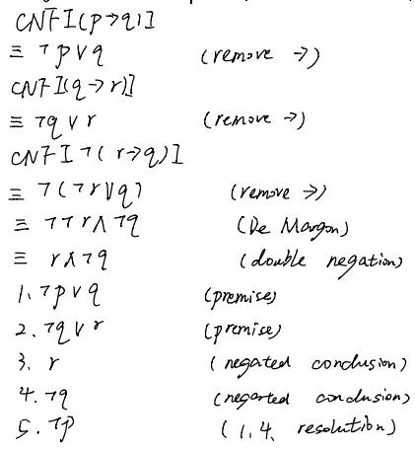

Therefore, it could not get empty clause using resolution.