Answer 2

(a)

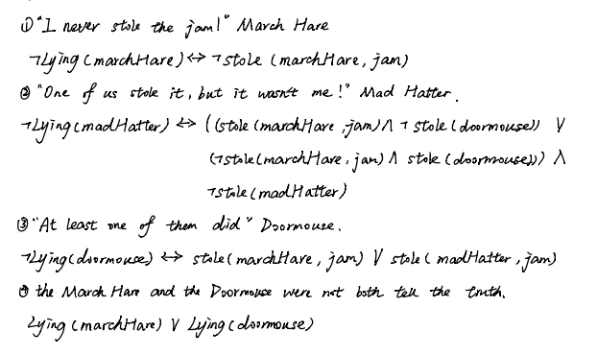

(b)

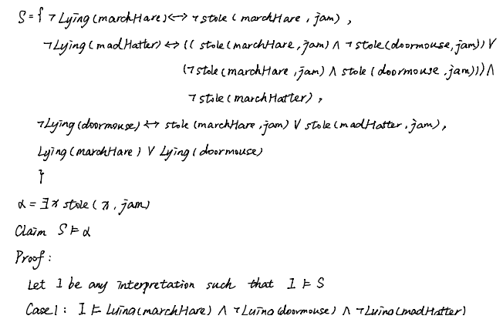

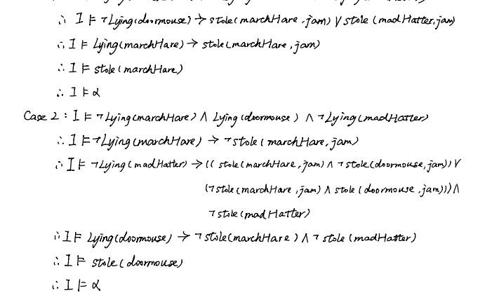

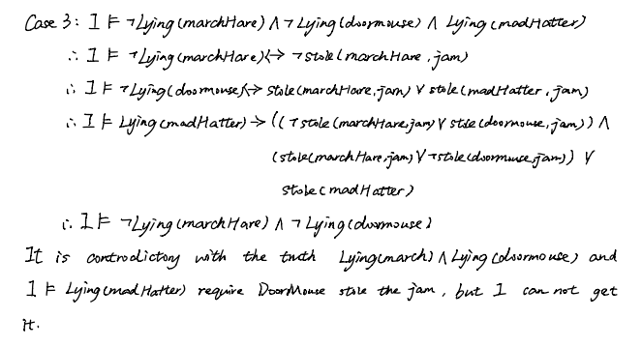

Therefore, I could not determine who stole the jam. In the case 1 and 2, I got two different result. The reason is that there have three conditions from Door Mouse. The first condition is that March Hare stole the jam, the second condition is that Mad Hatter stole the jam and the third condition is that both of them stole the jam. In case 3, it is conflict with the truth that the March Hare and Doormouse were not both speaking the truth. So, the answer is no.

(c)

As above condition from case 1 and 2, I think that if assuming only one person stole the jam, it could know that Mad Hatter stole the jam. The sentence I intend to add is as follows.



(d)

