**Background**

This protocol outlines how to obtain the traits used to quantify structure and to relate to the functions of leaf venation architecture. Leaf venation architecture has numerous common functions across plant species—see Sack & Scoffoni, 2013 for review. Briefly, the leaf venation serves for **mechanical support** (Niklas, 1999), **sugar and hormone transport** of signal molecules in the phloem (Kehr & Buhtz, 2008), and, via the xylem, the **replacement of water lost to transpiration when the stomata open** for photosynthesis (Sack & Holbrook, 2006). However, venation architecture is highly diverse across species (Uhl & Mosbrugger, 1999; Roth-Nebelsick *et al.*, 2001; Sack & Frole, 2006; Ellis *et al.*, 2009; Brodribb *et al.*, 2010). In dicotyledons, the leaf venation system typically **consists of three orders of major veins** and up to five higher orders of minor veins embedded in the mesophyll, with the vein orders arranged in a hierarchy; lower order veins are larger in diameter, with greater xylem conduit numbers and sizes, whereas higher order veins have greater length per leaf area (VLA; Sack & Holbrook, 2006; McKown *et al.*, 2010). The total VLA is positively related to physiological performance (e.g. hydraulic conductance and photosynthetic rate per leaf area; for review, see [Brodribb et al., 2010](javascript:;); [Sack and Scoffoni, 2013](javascript:;)). **Major VLA has been found to play a role in leaf drought** tolerance. Drought impacts less leaves with higher major vein density because they can provide more numerous water flow pathways around the damaged vein (Sack and Holbrook et al., 2006 ; Sack et al., 2008; Scoffoni et al., 2011).

**Units, terms, definitions**

Vein length per unit leaf area (VLA; mm mm-2). Also commonly known as “VLA”. Can be measured for veins of each order, or summed for major or minor veins or the whole system (see below). Total VLA correlates well with the average distance between veins (a.k.a. “interveinal distance”; see Uhl & Mosbrugger, 1999), and with areoles per area.

Major VLA = Sum of vein densities for 1°, 2° and 3° veins (mm mm-2)

Minor VLA = Sum of vein densities for 4° veins and higher (mm mm-2)

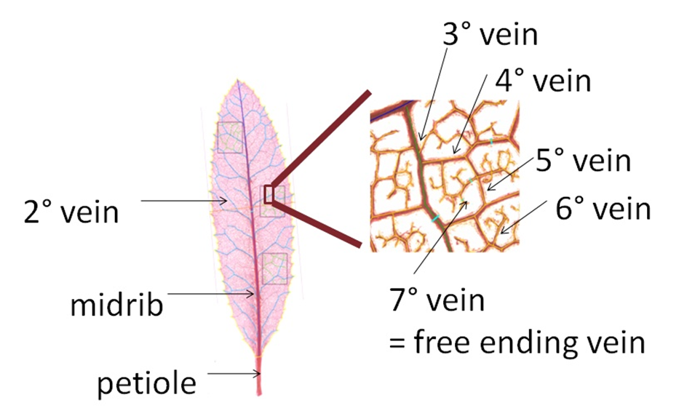

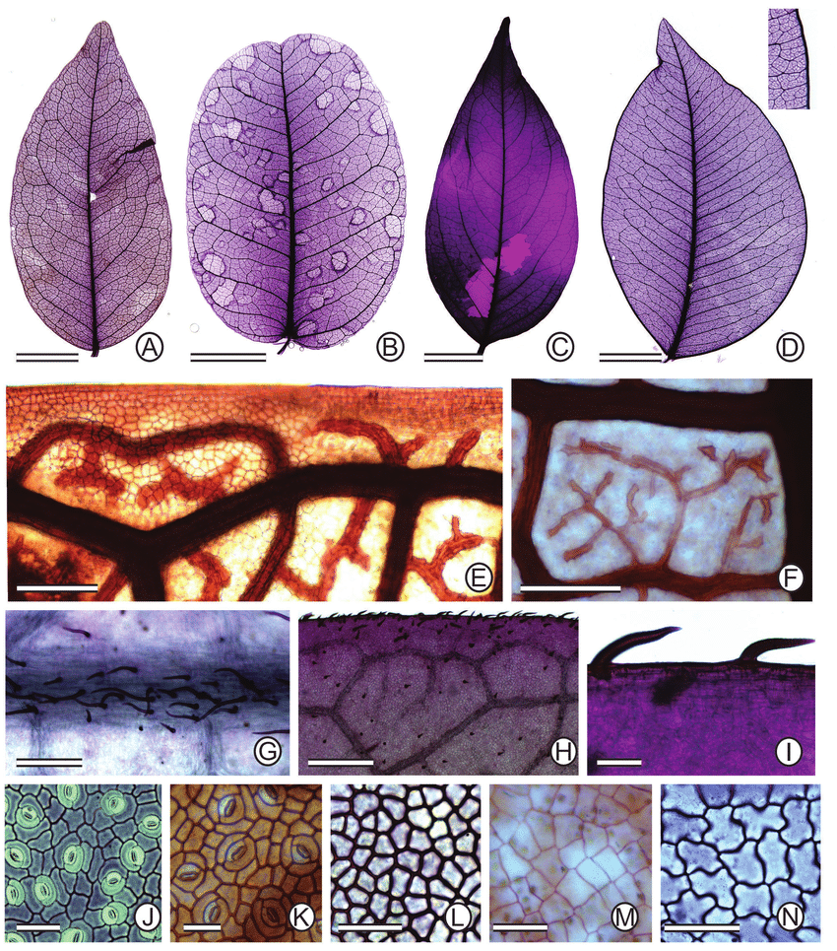

1. C. ensiformis var. ensiformis and (B) C. polystachya with **brochidodromous venation.** (C) C. negrensis var. negrensis with **eucamptodromous** becoming brochidodromous distally. (D) C. hymenaeifolia with **craspedodromous-brochidodromous** with detail of the perimarginal veins of marginal secondary type

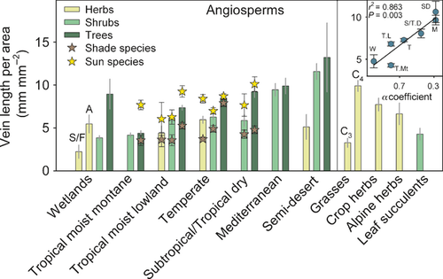

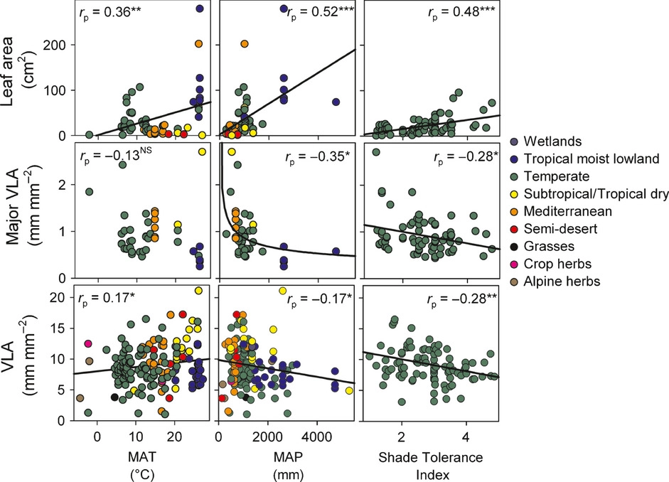

Sack and Scoffoni, 2013