**NAAN MUDHALVAN**

Internet of Thinks

Noise Pollution Monitoring

## Phase 1: Problem Definition and Design Thinking

In this part you will need to understand the problem statement and create a document on what have you understood and how will you proceed ahead with solving the problem.

Please think on a design and present in form of a document.

## Project Definition:

The project involves deploying IoT sensors to measure noise pollution in public areas and providing real-time noise level data accessible to the public through a platform or mobile app

objective is to raise awareness about noise pollution and enable informed decision-making.

This project includes defining objectives, designing the IoT sensor system, developing the noise pollution information platform, and integrating them using IoT technology and Python.

## Design Thinking:

1. Project Objectives: Define objectives such as real-time noise pollution monitoring, public awareness, noise regulation compliance, and improved quality of life.
2. IoT Sensor Design: Plan the deployment of IoT noise sensors in various public areas to measure noise levels.
3. Noise Pollution Information Platform: Design a web-based platform and mobile app to display real-time noise level data to the public.
4. Integration Approach: Determine how IoT sensors will send data to the noise pollution information platform.

## COMPONENTS

1. ArduinoUNO

2. MQ135 (Gassensor)

3. LM393 (Noisesensor)

4. ESP8266 WIFIModule

5.16*2 LCDDisplay

6.LED

7.Buzzer

## ArduinoUNO

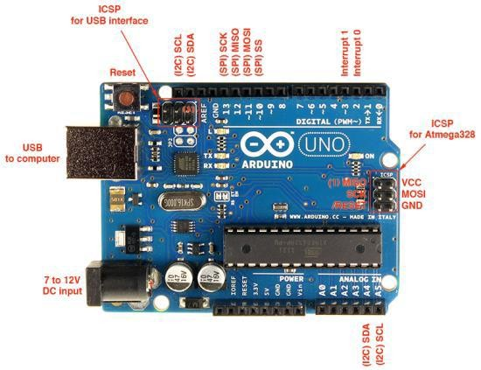

Arduino is 8 bit microcontroller board based on the ATmega328P. The operating voltage is 5V. It has 14 pins digital input output pins (Of which can be used 6 as PWM output)

Oscillator frequency is 16 MHz It contains everything needed to support the microcontroller simply connect it to a computer with USB cable. It has 6 analog input pins.

# BLOCK SCHEMATIC &WORKING

**Power**

**Supply**



**Power**

**Supply**

**Air Quality**

**Sensor**

**LCD**

**Display**

**Cloud**

**WIFI module**

**ThingSpea**

**LED**

**Sound**

**Sensor**

**Buzzer**

**Arduino uno**

As shown in fig. in system we use arduino as main controller. In system we use MQ135 gas sensor for detecting or sensing gases and also use sound sensor LM393 module for detect the sound pollution.

# LM393 Sound Sensor

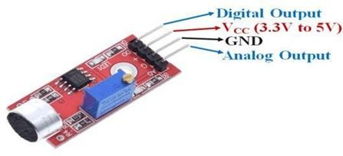

The sound sensor module provide an easy way to detect sound and it generally used for detecting sound intensity. Module detect the sound has exceeded a threshold value. Sound is detected via microphone and fed into an LM393 opamp

The sound level adjust through pot. The sound increases set value output is low. These module work on DC 3.3-5 voltage.

**ADVANTAGES**

1. Sensors are easily available.

2. Sensors are effortlessly accessible.

3. Detecting of wide range of gases.

4. Simple, compact and easy to handle.

5. Sensors have long life time.

6. Low cost

7. Data can be used to control pollution.

**APPLICATIONS**

1. To estimate the pollution.

### 

### PROJECT ID:Proj_224688_Team_1

## NAME: YOKESH J

## COLLEGE CODE: 4204

## REGISTER NO.: 420421106051