Technical Design for Patient Waiting Time

|  |  |  |  |
| --- | --- | --- | --- |
| **Logs** | **Editor** | **Approval** | **Date** |
| Initial | JYang | Dylan | 25Oct20 |
|  |  |  |  |

**Introduction**

Based on last quarter NSW survey, the indication of survey results show hospital patient waiting time has been increased by 50 percent, which sparks a broad un-satisfaction towards the hospital, especially Orachard Hospital according to ABC 4 corners show.

**Business analysis**

The Orachard hospital board has hold numerous meetings with department managers, representors of doctor and nurse to tackle the problem. The board has a feeling that the problem is not related to the facilities such as lack of rooms or beds; the problem may be related under human resources. The board decided letting IT involved.

**Technical analysis**

After analysed BA’s proposal, IT department is comfortable to use Microsoft SQL technologies and Tableau for data visualisation, because those technologies have been used in existing applications

**Detailed technical design**a. Database, it will be SQL server 2017 or Azure cloud database;

b. Data design  
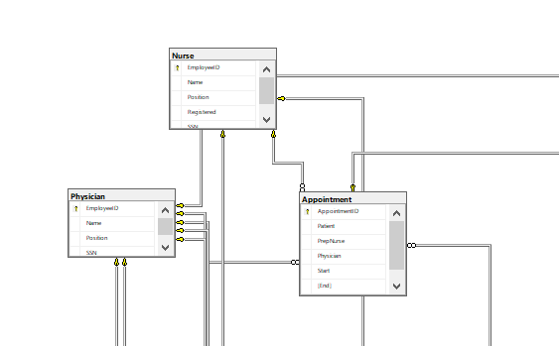

c. Query using for data analysis  
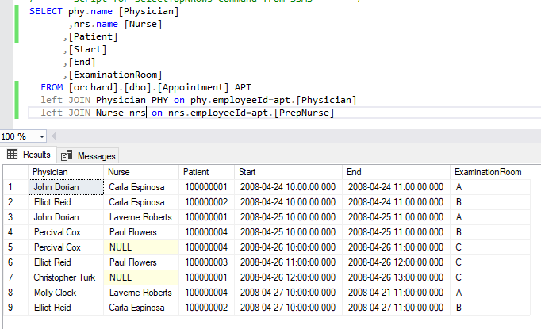

d. Tableau – workload will have two sheets, they are timetable of patient appointment with associated physicians and nurses, and number of patients will be treated by physicians and nurses.  
  
e. A Tableau dashboard is required for a summarized view  
  
f. The Tableau will be deployed online, only authorized viewer can access   
  
g. The new Tableau should check in with company GitHub server for version control

**Limitations**

Since existing data (database) has limited data, for example, patient’s health condition or   
 geographic information like city and stats, the potential root-cause of long waiting time may

Be still unknown.

**Questions and answers**

1. If you had more time, what would you change or focus more time on?  
   QA-> Data quality check, because if data stored incorrectly, the outcome will be wrong; will mislead the decision maker. Usually I use sample data to check the data accuracy.
2. Which part of the solution consumed the most amount of time?  
   QA-> Data modelling, because the data set must meet business requirements
3. What would you suggest to the analysts that they may not have thought of in regard to their request?

QA-> since board member think the root-cause of delay may be due to lack of professionals, unfortunately, it may not be the case; the long waiting time may be because of the pandemic which is highly possible.

**Timeframe of development**

|  |  |  |  |
| --- | --- | --- | --- |
| **Item** | **Person** | **Started** | **Finished** |
| Develop | JYang | 24Oct20 | 25Oct20 |
| Deployment |  |  |  |
| Test |  |  |  |
|  |  |  |  |

**Miscellanea**

None, so far, there may be some after tomorrow meeting