New Format for SWITRS Raw Data

Beginning with first quarter 2002 SWITRS data, there was a change in format of raw data provided to SWITRS users.

The Statewide Integrated Traffic Records System (SWITRS) was re-engineered beginning with collisions dated January 2002. As part of this re-engineering, we have changed the format of the raw data provided upon request to SWITRS data users.

Beginning with first quarter 2002 data, the raw data will no longer be available in the format previously provided. The new format is in three separate files in ASCII fixed record length. The three files are the collision data file, party data file and victim data file. All three files are linked together with the same case ID# of each collision. The victim data is linked to the collision file by the case ID# and to their respective party by the party #.

Starting February 2013, the I-SWITRS raw data is now in Comma Separated Value (.txt) format, but the field values are the same. Previously when the raw data was in Comma Separated Value (.csv) format, the data in the case ID# field did not display correctly. For collisions before 2002, a value such as 3.40401E+18 would display instead of the 19 digit number. Also, a case ID# of 7 digits for collisions after 2001 would display without the leading zeroes.

Please see Appendix A for instructions on how to open the files in Excel.

Following is the raw data export layout for this new format. The new format is comma delimited and is available for prior years 2000 through 2009 as well as the available 2010 and available 2011.

Latitude and Longitude coordinates were added to SWITRS data beginning April 2006.

For any questions regarding this change, contact the Information Services Unit at (916) 843-4230.

SWITRS Collision Raw Data Export Layout
H:\DATA\042\ISU\SW.RAWDATANWrev2013.DOC
2/1/2013
Item Name | Datatype(Length) | Description | Possible Values
Case Id | Varchar2(19) | the unique identifier of the collision report (barcode beginning 2002; 19 digit code prior to 2002)
Collision Year | Number(4) | the year when the collision occurred
Process Date | Number(8) | (YYYYMMDD)
Jurisdiction | Number(4) | Four numerics assigned by DOJ
Collision Date | Number(8) | the date when the collision occurred (YYYYMMDD)
Collision Time | Number(4) | the time when the collision occurred (24 hour time) | Data may appear with no leading zero(s).
Officer Id | Varchar2(8)
Reporting District | Varchar2(5)
Day of Week | Char(1) | the code for the day of the week when the collision occurred | 1 - Monday  2 - Tuesday  3 - Wednesday  4 - Thursday  5 - Friday  6 - Saturday  7 - Sunday
CHP Shift | Char(1) |  | 1 - 0600 thru 1359  2 - 1400 thru 2159  3 - 2200 thru 0559  4 - CHP Not Stated  5 - Not CHP
Population | Char(1) |  | 1 - Incorporated (less than 2500)  2 - Incorporated (2500 - 10000)  3 - Incorporated (10000 - 25000)  4 - Incorporated (25000 - 50000)  5 - Incorporated (50000 - 100000)  6 - Incorporated (100000 - 250000)  7 - Incorporated (over 250000)  9 - Unincorporated (Rural)  0 - University (Private Property)  - - Not Stated
County City Location | Varchar2(4) | the location code of where the collision occurred | Data may appear with no leading zero.
Special Condition | Char(1) |  | 1 - Schoolbus on Public Roadway (CHP Beat or CHP Adm Beat 901)  2 - State University (Also SFIA)  3 - Schoolbus Not on Public Roadway (CHP Adm Beat 903)  4 - Offroad (Unimproved) (CHP Adm Beat 906, 907)  5 - Vista Point or Rest Area (CHP Adm Beat 903) or Scales or Inspection Facility (CHP Com Beat 860-898)  6 - Other Public Access (Improved) (CHP Adm Beat 903)  0 - Not Above  - - Not Stated
Beat Type | Char(1) |  | 1 - CHP State Highway  2 - CHP County Road Line  3 - CHP County Road Area  4 - Schoolbus on City Roadway (CHP Adm Beat 901)  5 - Schoolbus not on Public Roadway (CHP Adm Beat 903)  6 - Offroad (Unimproved) (CHP Adm Beat 906, 907)  7 - Vista Point or Rest Area (CHP Adm Beat 903) or Scales or Inspection Facility (CHP Com Beat 860-898)  8 - Other Public Access (Improved) (CHP Adm Beat 903)  0 - Not CHP
CHP Beat Type | Char(1) |  | 1 - Interstate  2 - US Highway  3 - State Route  4 - County Road Line  5 - County Road Area  A - Safety Services Program Beats  S - Administrative Beats (900’s)  0 - Not CHP  Contract City:  6 - US Highway  7 - State Route  8 - County Road Line  9 - County Road Area
City Division LAPD | Char(1) |  | Includes blanks and dashes as not stated.
CHP Beat Class | Char(1) |  | 1 - CHP Primary  2 - CHP Other  0 - Not CHP
Beat Number | Varchar2(6)
Primary Rd | Varchar2(50)
Secondary Rd | Varchar2(50)
Distance | Number(9,2) |  | distance converted to feet
Direction | Char(1) |  | N - North  E - East  S - South  W - West  - or blank - Not Stated, in Intersection
Intersection | Char(1) |  | Y - Intersection  N - Not Intersection  Blank - Not stated
Weather 1 | Char(1) | the weather condition at the time of the collision | A - Clear  B - Cloudy  C - Raining  D - Snowing  E - Fog  F - Other  G - Wind  - - Not Stated
Weather 2 | Char(1) | the weather condition at the time of the collision, if a second description is necessary | same as weather 1 above
State Highway Indicator | Char(1) |  | Y - State Highway  N - Not State Highway  Blank - Not stated
Caltrans County | Char(3) |  | Includes blanks and nulls
Caltrans District | Number(2)
State Route | Number(3) |  | 0 = Not State Highway
Route Suffix | Char(1)
Postmile Prefix | Char(1)
Postmile | Number(6,3)
Location Type | Char(1) |  | H - Highway  I - Intersection  R - Ramp (or Collector)  - or blank - Not State Highway
Ramp Intersection | Char(1) |  | 1 - Ramp Exit, Last 50 Feet  2 - Mid-Ramp  3 - Ramp Entry, First 50 Feet  4 - Not State Highway, Ramp-related, Within 100 Feet  5 - Intersection  6 - Not State Highway, Intersection-related, Within 250 Feet  7 - Highway  8 - Not State Highway  - - Not Stated
Side Of Highway | Char(1) | Code provided by Caltrans Coders; applies to divided highway, based on nominal direction of route; for single vehicle is same as nominal direction of travel, overruled by impact with second vehicle after crossing median | N - Northbound  S - Southbound  E - Eastbound  W - Westbound  Blank - Not stated/not state highway
Tow Away | Char(1) |  | Y - Yes  N - No
Collision Severity | Char(1) | the injury level severity of the collision  (highest level of injury in collision) | 1 - Fatal  2 - Injury (Severe)  3 - Injury (Other Visible)  4 - Injury (Complaint of Pain)  0 - PDO
Killed victims | Number(3) | counts victims in the collision with degree of injury of 1 | 0 to N for each collision
Injured victims | Number(3) | counts victims in the collision with degree of injury of 2, 3, or 4 | 0 to N for each collision
Party Count | Number(3) | counts total parties in the collision | 1 to N for each collision
Primary Collision Factor | Char(1) |  | A - (Vehicle) Code Violation  B - Other Improper Driving  C - Other Than Driver  D - Unknown  E - Fell Asleep  - - Not Stated
PCF Violation Code | Char(1) |  | B - Business and Professions  C - Vehicle  H - City Health and Safety  I - City Ordinance  O - County Ordinance  P - Penal  S - Streets and Highways  W - Welfare and Institutions  - - Not Stated
PCF Violation Category | Char(2) |  | 01 - Driving or Bicycling Under the Influence of Alcohol or Drug  02 - Impeding Traffic  03 - Unsafe Speed  04 - Following Too Closely  05 - Wrong Side of Road  06 - Improper Passing  07 - Unsafe Lane Change  08 - Improper Turning  09 - Automobile Right of Way  10 - Pedestrian Right of Way  11 - Pedestrian Violation  12 - Traffic Signals and Signs  13 - Hazardous Parking  14 - Lights  15 - Brakes  16 - Other Equipment  17 - Other Hazardous Violation  18 - Other Than Driver (or Pedestrian)  19 -  20 -  21 - Unsafe Starting or Backing  22 - Other Improper Driving  23 - Pedestrian or "Other" Under the Influence of Alcohol or Drug  24 - Fell Asleep  00 - Unknown  - - Not Stated
PCF Violation | Number (5)
PCF Violation Subsection | Char(1) |  | Blank if no subsection.
Hit And Run | Char(1) |  | F - Felony  M - Misdemeanor  N - Not Hit and Run
Type of Collision | Char(1) |  | A - Head-On  B - Sideswipe  C - Rear End  D - Broadside  E - Hit Object  F - Overturned  G - Vehicle/Pedestrian  H - Other  - - Not Stated
Motor Vehicle Involved With | Char(1) |  | A - Non-Collision  B - Pedestrian  C - Other Motor Vehicle  D - Motor Vehicle on Other Roadway  E - Parked Motor Vehicle  F - Train  G - Bicycle  H - Animal  I - Fixed Object  J - Other Object  - - Not Stated
Ped Action | Char(1) |  | A - No Pedestrian Involved  B - Crossing in Crosswalk at Intersection  C - Crossing in Crosswalk Not at Intersection  D - Crossing Not in Crosswalk  E - In Road, Including Shoulder  F - Not in Road  G - Approaching/Leaving School Bus  - - Not Stated
Road Surface | Char(1) |  | A - Dry  B - Wet  C - Snowy or Icy  D - Slippery (Muddy, Oily, etc.)  - - Not Stated
Road Condition 1 | Char(1) |  | A - Holes, Deep Ruts  B - Loose Material on Roadway  C - Obstruction on Roadway  D - Construction or Repair Zone  E - Reduced Roadway Width  F - Flooded  G - Other  H - No Unusual Condition  - - Not Stated
Road Condition 2 | Char(1) |  | same as road condition 1 above
Lighting | Char(1) |  | A - Daylight  B - Dusk - Dawn  C - Dark - Street Lights  D - Dark - No Street Lights  E - Dark - Street Lights Not Functioning  - - Not Stated
Control Device | Char(1) |  | A - Functioning  B - Not Functioning  C - Obscured  D - None  - - Not Stated
CHP Road Type | Char(1) |  | May be blank
Pedestrian Collision | Char(1) | indicates whether the collision involved a pedestrian | Y or blank
Bicycle Collision | Char(1) | indicates whether the collision involved a bicycle | Y or blank
Motorcycle Collision | Char(1) | indicates whether the collision involved a motorcycle | Y or blank
Truck Collision | Char(1) | indicates whether the collision involved a big truck | Y or blank
Not Private Property | Char(1) | indicates whether the collision occurred on private property | Y or blank
Alcohol Involved | Char(1) | indicates whether the collision involved a party that had been drinking | Y or blank
Statewide Vehicle Type At Fault | Char(1) | indicates the Statewide Vehicle Type of the party who is at fault | see Party folder Statewide Vehicle Type item
CHP Vehicle Type At Fault | Char(2) | indicates the CHP Vehicle Type of the party who is at fault | see Party folder CHP Vehicle Type Towing item
Severe Injury count | Number(3) | counts victims in the collision with degree of injury of 2 | 0 to N for each collision
Other Visible Injury count | Number(3) | counts victims in the collision with degree of injury of 3 | 0 to N for each collision
Complaint of Pain Injury count | Number(3) | counts victims in the collision with degree of injury of 4 | 0 to N for each collision
Pedestrian Killed count | Number(3) | Counts the victims in the collision with party type of 2 and degree of injury is 1 | 0 or 1 for each collision
Pedestrian Injured count | Number(3) | Counts the victims in the collision with party type of 2 and degree of injury is 2, 3, or 4 | 0 or 1 for each collision
Bicyclist Killed count | Number(3) | Counts the victims in the collision with party type of 4 and degree of injury is 1 | 0 to N for each collision
Bicyclist Injured count | Number(3) | Counts the victims in the collision with party type of 4 and degree of injury is 2, 3, or 4 | 0 to N for each collision
Motorcyclist Killed count | Number(3) | counts victims in the collision with statewide vehicle type of C or O and degree of injury of 1 | 0 to N for each collision
Motorcyclist Injured count | Number(3) | counts victims in the collision with statewide vehicle type of C or O and degree of injury of 2, 3, or 4 | 0 to N for each collision
Primary Ramp | Varchar2(2) |  | NO-NB On Ramp, NF-NB Off Ramp, SO-SB On Ramp, SF-SB Off Ramp, EO-EB On Ramp, EF-EB Off Ramp, WO-WB On Ramp, WF-WB Off Ramp, To, From, Transition, Collector, Connector & blank
Secondary Ramp | Varchar2(2) |  | Same as above
Latitude
Longitude

SWITRS Party Raw Data Export Layout

Case Id | Varchar2(19) | the unique identifier of the collision report (barcode beginning 2002; 19 digit code prior to 2002)
Party Number | Number(3) |  | 1 to 999
Party Type | Char(1) |  | 1 - Driver (including Hit and Run)  2 - Pedestrian  3 - Parked Vehicle  4 - Bicyclist  5 - Other  - - Not Stated
At Fault | Char(1) | indicates whether the party was at fault in the collision | Y
Party Sex | Char(1) | the code of the sex of the party | M - Male  F - Female  - - Not Stated
Party Age | Number(3) | the age of the party at the time of the collision | 0 to 100+ (0 & blank = Not Stated)
Party Sobriety | Char(1) |  | A - Had Not Been Drinking  B - Had Been Drinking, Under Influence  C - Had Been Drinking, Not Under Influence  D - Had Been Drinking, Impairment Unknown  G - Impairment Unknown  H - Not Applicable  - - Not Stated
Party Drug Physical | Char(1) |  | E - Under Drug Influence  F - Impairment - Physical  H - Not Applicable  I - Sleepy/Fatigued  - - Not Stated
Direction Of Travel | Char(1) |  | N - North  S - South  E - East  W - West  - - Not Stated
Party Safety Equipment 1 | Char(1) |  | A - None in Vehicle  B - Unknown  C - Lap Belt Used  D - Lap Belt Not Used  E - Shoulder Harness Used  F - Shoulder Harness Not Used  G - Lap/Shoulder Harness Used  H - Lap/Shoulder Harness Not Used  J - Passive Restraint Used  K - Passive Restraint Not Used  L - Air Bag Deployed  M - Air Bag Not Deployed  N - Other  P - Not Required  Q - Child Restraint in Vehicle Used  R - Child Restraint in Vehicle Not Used  S - Child Restraint in Vehicle, Use Unknown  T - Child Restraint in Vehicle, Improper Use  U - No Child Restraint in Vehicle  V - Driver, Motorcycle Helmet Not Used  W - Driver, Motorcycle Helmet Used  X - Passenger, Motorcycle Helmet Not Used  Y - Passenger, Motorcycle Helmet Used  - or blank - Not Stated
Party Safety Equipment 2 | Char(1) |  | same as Party Safety Equipment 1 above
Financial Responsibility | Char(1) |  | N - No Proof of Insurance Obtained  Y - Yes, Proof of Insurance Obtained  O - Not Applicable (used for parked cars, bicyclists, pedestrians, and party type others)  E - Used if the officer is called away from the scene of the collision prior to obtaining the insurance information  Blank - not stated
Special Information 1 | Char(1) |  | A - Hazardous Materials  - - Not Stated
Special Information 2 | Char(1) |  | B - Cell Phone in Use (4/1/01)  C - Cell Phone Not in Use (4/1/01)  D - No Cell Phone/Unknown (4/1/01)  - - Not Stated (4/1/01)
Special Information  3 | Char(1) |  | E - School Bus Related (1/1/02)  - - Not Stated (1/1/02)
OAF Violation Code | Char(1) |  | B - Business and Professions  C - Vehicle  H - City Health and Safety  I - City Ordinance  O - County Ordinance  P - Penal  S - Streets and Highways  W - Welfare and Institutions  - - Not Stated
OAF Violation Category | Char(2) |  | 01 - Under Influence in Public (647F)  02 - County Ordinance  03 - City Ordinance  05 - Business/Professions Code  06 - Felony Penal Code  08 - Controlled Substances (Felony Health and Safety)  09 - Health/Safety Code (Misdemeanor)  10 - Penal Code (Misdemeanor)  11 - Streets/Highways Code  13 - Welfare/Institutions Code  15 - Manslaughter  16 - Non-Vehicle Code Not Specified Above  17 - Fish & Game Code  18 - Agriculture Code  19 - Hit and Run  20 - Driving or Bicycling Under the Influence of Alcohol or Drug  21 - Improper Lane Change  22 - Impeding Traffic  23 - Failure to Heed Stop Signal  24 - Failure to Heed Stop Sign  25 - Unsafe Speed  26 - Reckless Driving  27 - Wrong Side of Road  28 - Unsafe Lane Change  29 - Improper Passing  30 - Following Too Closely  31 - Improper Turning  33 - Automobile Right-of-Way  34 - Pedestrian Right-of-Way  35 - Pedestrian Violation  37 -  38 - Hazardous Parking  39 - Lights  40 - Brakes  43 - Other Equipment  44 - Other Hazardous Movement  46 - Improper Registration  47 - Other Non-Moving Violation  48 - Excessive Smoke  49 - Excessive Noise  50 - Overweight  51 - Oversize  52 - Over Maximum Speed  53 - Unsafe Starting or Backing  60 - Off-Highway Vehicle Violation  61 - Child Restraint  62 - Seat Belt  63 - Seat Belt (Equipment)  00 or Blank - Not Stated
OAF Violation Section | Number(5)
OAF Violation Suffix | Char(1) |  | Blank may appear if no suffix.
Other Associated Factor 1 | Char(1) |  | A - Violation  E - Vision Obscurements  F - Inattention (beginning 1/1/01, inattention not stated)  G - Stop and Go Traffic  H - Entering/Leaving Ramp  I - Previous Collision  J - Unfamiliar With Road  K - Defective Vehicle Equipment  L - Uninvolved Vehicle  M - Other  N - None Apparent  O - Runaway Vehicle  P - Inattention, Cell Phone (1/1/01)  Q - Inattention, Electronic Equip.(1/1/01)  R - Inattention, Radio/CD (1/1/01)  S - Inattention, Smoking (1/1/01)  T - Inattention, Eating (1/1/01)  U - Inattention, Children (1/1/01)  V - Inattention, Animal (1/1/01)  W - Inattention, Personal Hygiene (1/1/01)  X - Inattention, Reading (1/1/01)  Y - Inattention, Other (1/1/01)  - - Not Stated
Other Associated Factor 2 | Char(1) |  | same as OAF 1 above
Party Number Killed | Number(3) | counts victims in the party with degree of injury of 1 | 0 to N for each party
Party Number Injured | Number(3) | counts victims in the party with degree of injury of 2, 3, or 4 | 0 to N for each party
Movement Preceding Collision | Char(1) |  | A - Stopped  B - Proceeding Straight  C - Ran Off Road  D - Making Right Turn  E - Making Left Turn  F - Making U-Turn  G - Backing  H - Slowing/Stopping  I - Passing Other Vehicle  J - Changing Lanes  K - Parking Maneuver  L - Entering Traffic  M - Other Unsafe Turning  N - Crossed Into Opposing Lane  O - Parked  P - Merging  Q - Traveling Wrong Way  R - Other  - - Not Stated
Vehicle Year | Number(4) | the model year of the party's vehicle | 9999 or blank = not stated
Vehicle Make | Varchar2(50) | the full description of the make of the party's vehicle
Statewide Vehicle Type | Char(1) |  | A - Passenger Car/Station Wagon  B - Passenger Car with Trailer  C - Motorcycle/Scooter  D - Pickup or Panel Truck  E - Pickup or Panel Truck with Trailer  F - Truck or Truck Tractor  G - Truck or Truck Tractor with Trailer  H - Schoolbus  I - Other Bus  J - Emergency Vehicle  K - Highway Construction Equipment  L - Bicycle  M - Other Vehicle  N - Pedestrian  O - Moped  - or blank - Not Stated
CHP Vehicle Type Towing | Char(2) |  | 01 - Passenger Car, Station Wagon, or Jeep  02 - Motorcycle  03 - Motor-Driven Cycle (< 15 hp)  04 - Bicycle  05 - Motorized Bicycle  06 - All-Terrain Vehicle (ATV)  07 - Sport Utility Vehicle  08 - Minivan  09 - Paratransit Bus  10 - Tour Bus  11 - Other Commercial Bus  12 - Non-Commercial Bus  13 - Schoolbus Public I (eff. 2002)  14 - Schoolbus Public II (eff. 2002)  15 - Schoolbus Private I (eff. 2002)  16 - Schoolbus Private II (eff. 2002)  17 - Schoolbus Contractual I (eff. 2002)  18 - Schoolbus Contractual II (eff. 2002  19 – General Public Paratransit Vehicle (eff 2002  20 - Public Transit Authority  21 - Two-Axle Tank Truck  22 - Pickup or Panel Truck  23 - Pickup Truck With Camper  24 - Three-Axle Tank Truck  25 - Truck Tractor  26 - Two-Axle Truck  27 - Three-Axle Truck  41 - Ambulance  42 - Dune Buggy  43 - Fire Truck (not rescue)  44 - Forklift  45 - Highway Construction Equipment (only while not in construction area)  46 - Implement of Husbandry  47 - Motor Home (40 ft or less)  48 - CHP, Police, or Sheriff Car (emergency service or not)  49 - CHP, Police, or Sheriff Motorcycle (emergency service or not)  50 - Mobile Equipment  51 - Farm Labor Vehicle (certified)  55 - Two-Axle Tow Truck  56 - Three-Axle Tow Truck  57 - Farm Labor Vehicle (non-certified)  58 - Farm Labor Transporter  59 - Motorhome (over 40 ft)  60 - Pedestrian (includes motorized wheelchair)  61 - School Pupil Activity Bus I (prior to 2002)  62 - School Pupil Activity Bus II (prior to 2002  63 - "Youth" Bus  64 - School Pupil Activity Bus I (eff. 2002)  65 - School Pupil Activity Bus II (eff. 2002)  66 – School Bus – No Pupils on Board (eff 2002)  71 - Passenger Car - Hazardous Materials Only  72 - Pickups and Panels - Hazardous Materials Only  73 - Pickups and Campers - Hazardous Materials Only  75 - Truck Tractor - Hazardous Materials Only  76 - Two-Axle Truck - Hazardous Materials Only  77 - Three or More Axle Truck - Hazardous Materials Only  78 - Two-Axle Tank Truck - Hazardous Materials Only  79 - Three-Axle Tank Truck - Hazardous Materials Only  81 - Passenger Car - Hazardous Waste or Waste/Material Combo  82 - Pickups and Panels - Hazardous Waste or Waste/Material Combo  83 - Pickups and Campers - Hazardous Waste or Waste/Material Combo  85 - Truck Tractor - Hazardous Waste or Waste/Material Combo  86 - Two-Axle Truck - Hazardous Waste or Waste/Material Combo  87 - Three or More Axle Truck - Hazardous Waste or Waste/Material Combo  88 - Two-Axle Tank Truck - Hazardous Waste or Waste/Material Combo  89 - Three-Axle Tank Truck - Hazardous Waste or Waste/Material Combo  94 - Motorized Transportation Device  95 - Miscellaneous Non-Motorized Vehicle(Ridden Animal, Animal-Drawn Conveyance, Train, Or Building) With Victim  96 - Miscellaneous Motorized Vehicle (Golf Cart)  97 - Low Speed Vehicle  99 or dash - Not Stated or Unknown (Hit and Run)
CHP Vehicle Type Towed | Char(2) |  | same as CHP vehicle type towing above with the following additions:  28 - Semi-Tank Trailer  29 - Pull-Tank Trailer  30 - Two-Tank Trailer  31 - Semi-Trailer  32 - Pull Trailer (includes dolly)  33 - Two Trailers (or 31 + 32)  34 - Boat Trailer  35 - Utility Trailer  36 - Trailer Coach  37 - Extralegal Permit Load  38 - Pole, Pipe, or Logging Dolly  39 - Three Trailers (or 31 + 33)  40 - Federally Legal Semi-Trailer  52 - Federally Legal Double Cargo Combo (over 75 ft)  53 - Fifth Wheel Trailer  54 - Container Chassis  98 – Emergency Vehicle on an Emergency Run
Party Race | Char(1) |  | A - Asian O - Other  B - Black W - White  H - Hispanic Blank - Not stated  Eff. 1/1/2002

SWITRS Victim Raw Data Export Layout

Case Id | Varchar2(19) | the unique identifier of the collision report (barcode beginning 2002; 19 digit code prior to 2002)
Party Number | Number (3) |  | 1 to 999
Victim Role | Char(1) |  | 1 - Driver  2 - Passenger (includes non-operator on bicycle or any victim on/in parked vehicle or multiple victims on/in non-motor vehicle)  3 - Pedestrian  4 - Bicyclist  5 - Other (single victim on/in non-motor vehicle; e.g. ridden animal, horse-drawn carriage, train, or building)  6 - Non-Injured Party
Victim Sex | Char(1) |  | M - Male  F - Female  - - Not Stated
Victim Age | Number(3) | the age of the victim at the time of the collision | 0 – 125  998 – Not Stated  999 – Fatal Fetus
Victim Degree of Injury | Char(1) |  | 1 - Killed  2 - Severe Injury  3 - Other Visible Injury  4 - Complaint of Pain  0 - No Injury
Victim Seating Position | Char(1) |  | 1 - Driver  2 thru 6 - Passengers  7 - Station Wagon Rear  8 - Rear Occupant of Truck or Van  9 - Position Unknown  0 - Other Occupants  A thru Z - Bus Occupants  - - Not Stated
Victim Safety Equipment 1 | Char(1) |  | A - None in Vehicle  B - Unknown  C - Lap Belt Used  D - Lap Belt Not Used  E - Shoulder Harness Used  F - Shoulder Harness Not Used  G - Lap/Shoulder Harness Used  H - Lap/Shoulder Harness Not Used  J - Passive Restraint Used  K - Passive Restraint Not Used  L - Air Bag Deployed  M - Air Bag Not Deployed  N - Other  P - Not Required  Q - Child Restraint in Vehicle Used  R - Child Restraint in Vehicle Not Used  S - Child Restraint in Vehicle, Use Unknown  T - Child Restraint in Vehicle, Improper Use  U - No Child Restraint in Vehicle  V - Driver, Motorcycle Helmet Not Used  W - Driver, Motorcycle Helmet Used  X - Passenger, Motorcycle Helmet Not Used  Y - Passenger, Motorcycle Helmet Used  - or blank - Not Stated
Victim Safety Equipment 2 | Char(1) |  | same as Victim Safety Equipment 1 above  (eff. Jan 2002)
Victim Ejected | Char(1) |  | 0 - Not Ejected  1 - Fully Ejected  2 - Partially Ejected  3 - Unknown  - - Not Stated

APPENDIX A – How to Open the Files in Excel

First, you must extract all 3 files (CollisionRecords.txt, PartyRecords.txt, VictimRecords.txt) to a directory on your hard drive. Next, start Excel and open any of the three files. In the dialogue box, make sure you select All Files(*.*) for Files of type:,
otherwise only Excel files will be displayed.

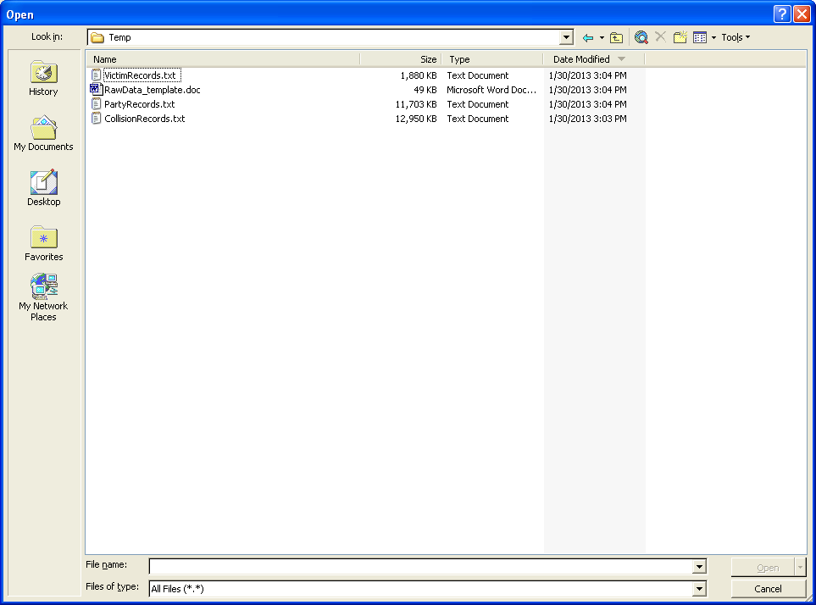

A-1
A wizard will immediately appear as follows:

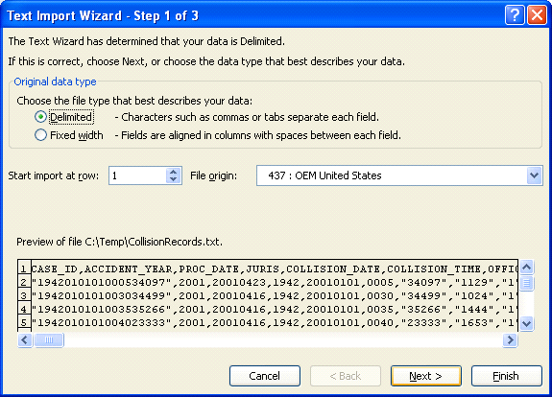

Click the Next> button

A-2

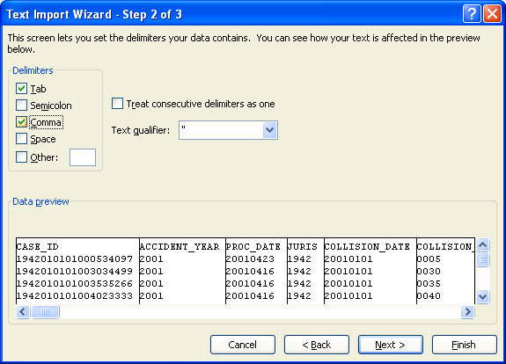

Select checkbox for Comma and click the Next>button.

A-3

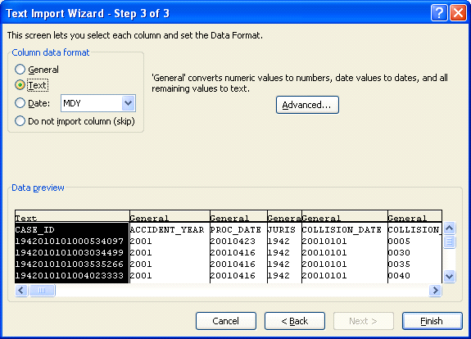

Select radio button for Text and click Finish. The CASE_ID field now displays as a 19 digits (if the accident date is in 2001 or earlier, or as 7 digits with leading zeroes if the collision date is later than 2001).

A-4
Save the file as an .xls Excel file. Repeat the steps for the other 2 files.

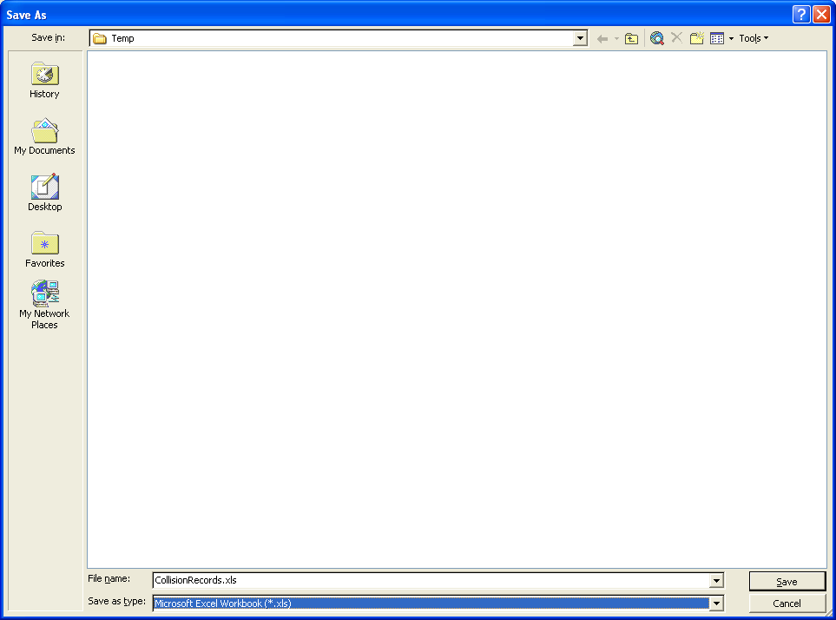

A-5

