**Numerical Analysis – Fall 2020**

Assignment #3

Issued: Sep. 20, 2020 Due: Oct. 18, 2020

Please hand in the C or Matlab code (.m files), graphics, and a brief description of your reasoning as well as comments if any. You should pack all of your files into a .rar or .zip file, titled as “xxxxxxx(your student ID)_Homework_3”, and then submit it by uploading to ftp server or sending to TA before 11:59pm of the due day.

**Please upload to the ‘hw3’ directory if you submit your homework in time.**

**Problem 1:**

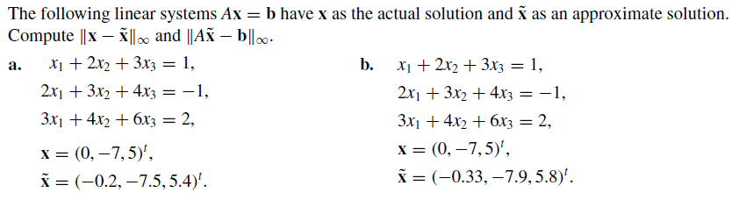

**Problem 2:**



**Problem 3:**

Implement the algorithm of Gaussian elimination with scaled partial pivoting, and solve the following linear systems.

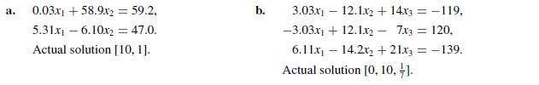

**Problem 4:**

Implement the Jacobi iterative method and list the first three iteration results when solving the following linear systems, using **x**(0) = **0**.

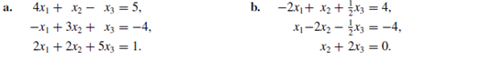

**Problem 5:**

Use the Jacobi method and Gauss-Seidel method to solve the following linear systems, with TOL = 0.001 in the L $∞$ norm.

