**Numerical Analysis – Fall 2020**

Assignment #4

Issued: Oct. 12, 2020 Due: Oct.29, 2020

Please hand in the C or Matlab code (.m files), graphics, and a brief description of your reasoning as well as comments if any. You should pack all of your files into a .rar or .zip file, titled as “xxxxxxx(your student ID)_Homework_4”, and then submit it by uploading to ftp server or sending to TA before 11:59pm of the due day.

**Please upload to the ‘hw4’ directory if you submit your homework in time.**

**Problem 1:**

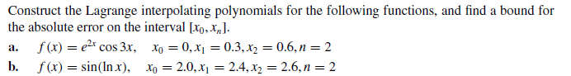

**Problem 2:**



**Problem 3:**

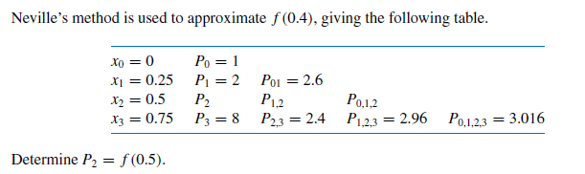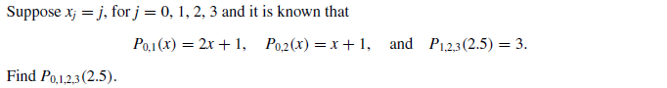

**Problem 4:**

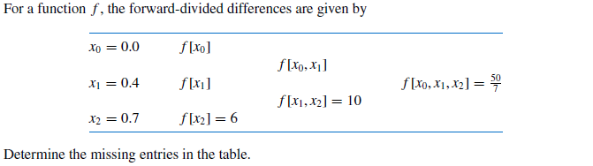

**Problem 5:**



**Problem 6:**

Proof that a strictly diagonally dominant matrix is invertible