**Numerical Analysis – Fall 2020**

Assignment #5

Issued: Oct. 14, 2020 Due: Nov. 13, 2020

Please hand in the C or Matlab code (.m files), graphics, and a brief description of your reasoning as well as comments if any. You should pack all of your files into a .rar or .zip file, titled as “xxxxxxx(your student ID)_Homework_5”, and then submit it by uploading to ftp server or sending to TA before 11:59pm of the due day.

**Please upload to the ‘hw5’ directory if you submit your homework in time.**

**Problem 1:**

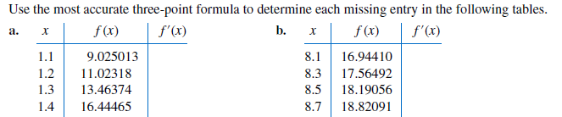

**Problem 2：**

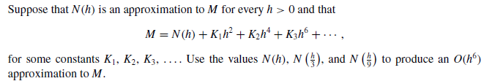

**Problem 3:**

Approximate the following integrals using the Trapezoidal rule and Simpson’s rule, respectively.

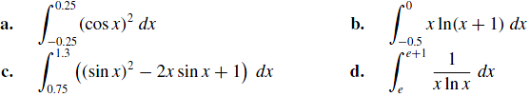

**Problem 4:**

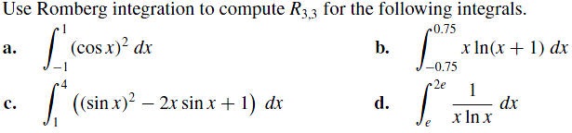

**Problem 5:**

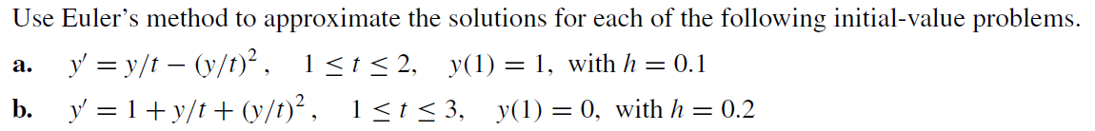

Problem 6 （请上交程序代码）:

写一个程序，来计算sin(x)函数的（6,6）级帕德逼近，正确答案应该是：



并验证它与sin(x)的12阶泰勒级数完全相同



Problem 7

Consider the following data:

|  |  |  |
| --- | --- | --- |
| i | xi | yi |
| 1 | 0 | 6 |
| 2 | 2 | 8 |
| 3 | 4 | 14 |
| 4 | 5 | 20 |

1. Compute the linear least squares polynomial approximation for this data.
2. Compute the error E of the above approximation.