**因子1：Investor sentiment 情绪因子**

数据来源：Wugler’s NYU 针对债券市场需要调整，根据文献调整（下面截图了公式（14））

文献：Laborda and Olmo（2014）

Laborda, R., Olmo, J., 2014. Investment sentiment and bond risk premia. *Journal of Financial Markets* 18, 206-233.

Their findings reveal that this factor has predictive power beyond that contained in the yield curve and benchmark macroeconomic factors. The predictive power of this variable is time-varying, exhibiting more relevance during recession periods.（取自文章摘要）

主要贡献：Our main contribution is to document a positive relationship between investor sentiment variables and expected excess bond returns that is above and beyond the information contained in the term structure of bonds and macroeconomic factors.

计算方法：

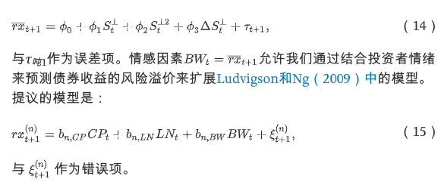

（14）是计算公式

（表示超额收益

a sentiment index that is orthogonal（正交）to a sample of macroeconomic factors selected by Baker and Wurgler(2006)

的平方 表示the magnitude of the underlying sentiment

Deta measures the variation in sentiment）

**Excel中 SENT^** 表示（1965年-2018年都有）

**因子2: stock market illiquidity股票市场的非流动性**

文献：Stock Market Illiquidity, Funding Liquidity, and Bond Risk Premia*

为何用：

We argue that stock market illiquidity is a timely variable that is associated with the state of funding liquidity.

数据：Amihud（2002） is the same used in Næs et al. (2011) and is kindly provided by Johannes Skjeltorp.

算了 看了好久 感觉比较复杂 涉及因素较多 不要了