**一、bond supply and excess bond returns**

文献来源：The Review of Financial Studies

[**https://academic.oup.com/rfs/article/27/3/663/1581525#M5**](https://academic.oup.com/rfs/article/27/3/663/1581525#M5)

(1)因子

1. supply

the empirically relevant measure of supply is maturity-weighted debt, which captures the duration risk that arbitrageurs must bear.

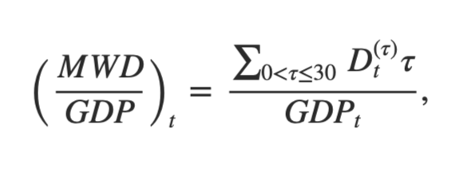

MWD/GDP is the maturity-weighted-debt-to-GDP ratio, computed by multiplying each debt payment by the corresponding maturity, summing across maturities, and scaling by GDP.

A useful decomposition of maturity-weighted debt to GDP is

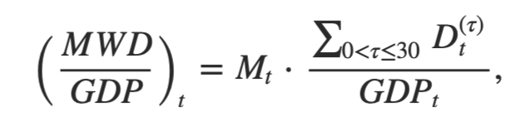

The variable Mt is dollar-weighted average maturity, constructed by weighting each maturity τ by the fraction that the corresponding payments

$D_{t}^{（τ）}$ represent of total payments. The variable $\sum_{0<τ≤30}{{D_{t}^{（τ）}}/{{GDP}_{t}}}$ is total debt payments divided by GDP.

1. maturity structure

We use the Fama-Bliss discount bond database to obtain yields and holding-period returns for one-, two-, three-, four-, and five-year zero-coupon bonds for the 1952–2007 sample period.

Yields and returns are computed in logs. We denote by y(τ)t the yield of the τ-year bond at date *t*. (This is consistent with the notation in our model for the one- to five-year bonds because they are zero-coupon, and for simplicity we also use this notation for the long-term coupon bond.) We denote by r(τ)t+1 the return of the τ-year bond during the year following date *t*, and by

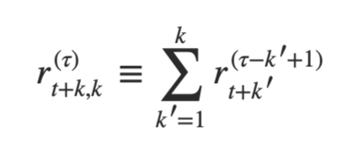

the bond's cumulative return during the *k* years following date *t*.

（2）原因

The supply and maturity structure of government debt play no role in standard term-structure theories. Yet, their effects on bond yields and expected returns are the subject of numerous policy debates, ranging from debt management by treasury departments to quantitative easing by central banks. Given the importance of these debates, it is surprising how little empirical evidence there is correlating supply and maturity structure to bond yields and returns in long time series.

**二、variable rare disasters：an exactly solved framework for ten puzzles in macro-finance**

（1）因子：rare large disasters

文献来源：The Quarterly Journal of Economics

<https://www.jstor.org/stable/23251995?pq-origsite=summon&seq=1#metadata_info_tab_contents>

is its constant part and It is its variable part. The variable part of inflation follows the process:

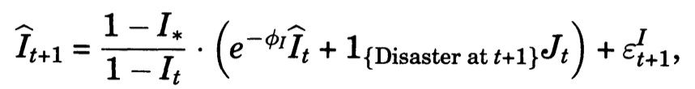

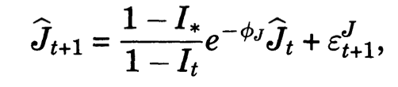

$π_{t}$ is the variable part of the bond risk premium

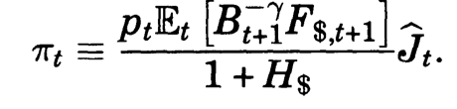

（2）原因

When a disaster occurs, inflation increases (on average). Since very short-term bills are essentially immune to inflation risk and long-term bonds lose value when inflation is higher, long-term bonds are riskier, so they yield a higher risk premium.

三、The Banking View of Bond Risk Premia

文献来源：the journal of finance

<https://onlinelibrary.wiley.com/doi/full/10.1111/jofi.12949>

（1）因子：the average bank exposure to interest rate risk

We start by constructing a measure of the average bank exposure to interest rate risk. At the bank level, we use the income gap as our measure of interest rate risk exposure.

We use the average income gap across banks with more than $1bn of total assets as our measure of financial intermediaries' interest rate risk exposure.

we show that the relevant measure of banks' exposure, 𝑔𝑡, can be constructed from our basic income gap measure as

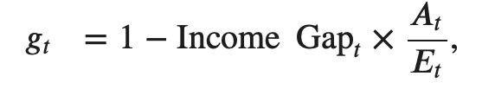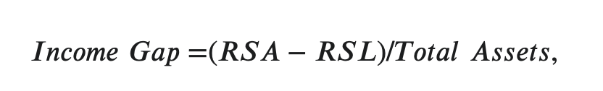

（2）原因

Banks are large sophisticated intermediaries in the market for interest rate risk, but are absent from standard studies of the yield curve.1 In this paper, we show that banks' balance sheet exposure to fluctuations in interest rates strongly forecasts excess Treasury bond returns.

数据来源：

<https://www.federalreserve.gov/econresdata/researchdata/feds200628_1.html>