Course: ENSF694 – Summer 2025

Lab #: Lab 1

Instructor: Mahmood Moussavi

Student Name: John Zhou

Submission Date: July 10, 2025

# Exercise A

/*

 *  lab1exe_A.cpp

 *  ENSF 694 Lab 1, exercise A

 *  Created by Mahmood Moussavi

 *  Completed by: John Zhou

 */

#include <iostream>

#include <cmath>

using namespace std;

const double G = 9.8; /* gravitation acceleration 9.8 m/s^2 */

const double PI = 3.141592654;

void create_table(double v);

/*

 * REQUIRES:

 *   - velocity 'v' > 0.

 *

 * PROMISES:

 *   - Prints a table showing the time of flight and distance for projectile for each angle from 0° to 90°, at the given velocity.

 */

double Projectile_travel_time(double a, double v);

/*

 * REQUIRES:

 *   - a (angle) in degrees

 *   - v (velocity) in m/s (v > 0).

 *

 * PROMISES:

 *   - Returns the time of flight for the projectile

 *     Formula: time = (v^2 * sin(2 * a)) / g

 */

double Projectile_travel_distance(double a, double v);

/*

 * REQUIRES:

 *   - a (angle) in degrees

 *   - v (velocity) in m/s (v > 0).

 *

 * PROMISES:

 *   - Returns the horizontal distance the projectile will travel

 *     Formula: distance = (2 * v * sin(a)) / g

 */

double degree_to_radian(double d);

/*

 * REQUIRES:

 *   - angle 'd' in degrees

 *

 * PROMISES:

 *   - Returns the corresponding angle in radians.

 */

int main(void)

{

    double velocity;

    cout << "Please enter the velocity at which the projectile is launched (m/sec): ";

    cin >> velocity;

    if (!cin) // means if cin failed to read

    {

        cout << "Invlid input. Bye...\n";

        exit(1);

    }

    while (velocity < 0)

    {

        cout << "\nplease enter a positive number for velocity: ";

        cin >> velocity;

        if (!cin)

        {

            cout << "Invlid input. Bye...";

            exit(1);

        }

    }

    create_table(velocity);

    return 0;

}

double degree_to_radian(double d)

{

    return d * PI / 180.0;

}

double Projectile_travel_time(double a, double v)

{

    double radian = degree_to_radian(a);

    return v * v * sin(2 * radian) / G;

};

double Projectile_travel_distance(double a, double v)

{

    double radian = degree_to_radian(a);

    return 2 * v * sin(radian) / G;

};

void create_table(double v)

{

    cout << "Angle\t\tt\t\td\n";

    cout << " (deg)\t\t(sec)\t\t(m)\n";

    for (int a = 0; a <= 90; a += 5)

    {

        double time = Projectile_travel_time(a, v);

        double distance = Projectile_travel_distance(a, v);

        cout << a << "\t\t" << time << "\t\t" << distance << "\n";

    }

}

Execution result

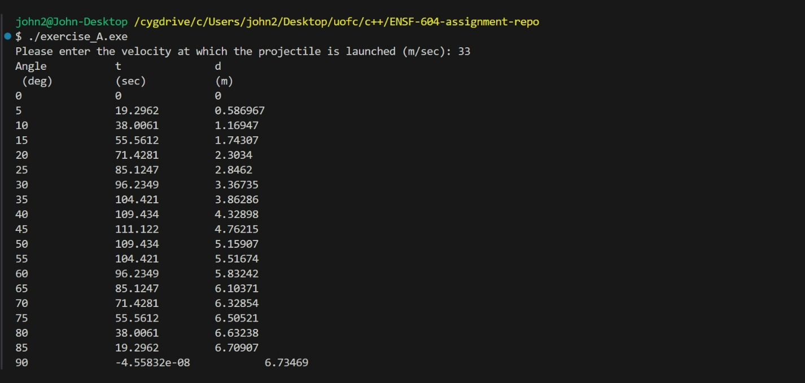

Exercise B

## Part II

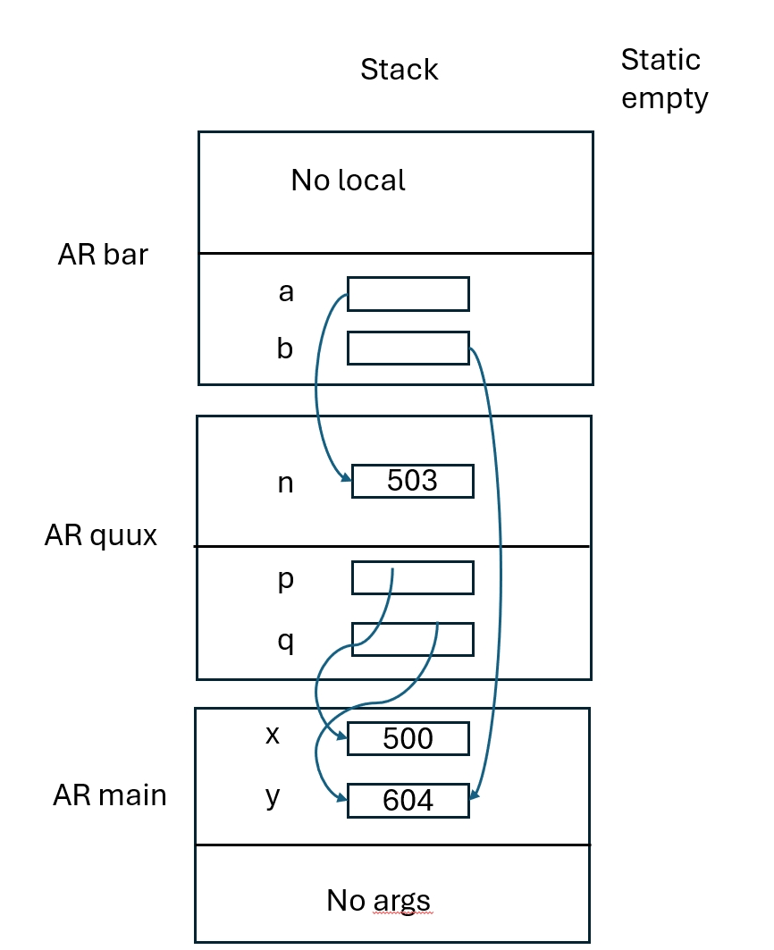

Exercise C

/*

 *  lab1exe_C.cpp

 *  ENSF 694 Lab 1, exercise C

 *  Created by Mahmood Moussavi

 *  Completed by: John Zhou

 */

#include <iostream>

using namespace std;

void time_convert(int ms_time, int *minutes_ptr, double *seconds_ptr);

/*

 * Converts time in milliseconds to time in minutes and seconds.

 * For example, converts 123400 ms to 2 minutes and 3.4 seconds.

 * REQUIRES:

 *    ms_time >= 0.

 *    minutes_ptr and seconds_ptr point to variables.

 * PROMISES:

 *    0 <= *seconds_ptr & *seconds_ptr < 60.0

 *    *minutes_ptr minutes + *seconds_ptr seconds is equivalent to

 *    ms_time ms.

 */

int main(void)

{

  int millisec;

  int minutes;

  double seconds;

  cout << "Enter a time interval as an integer number of milliseconds: ";

 // printf("Enter a time interval as an integer number of milliseconds: ");

  cin >> millisec;

  if (!cin) {

    cout << "Unable to convert your input to an int.\n";

    exit(1);

  }

  cout << "Doing conversion for input of " <<  millisec <<" milliseconds ... \n";

  /* MAKE A CALL TO time_convert HERE. */

  time_convert(millisec,&minutes,&seconds);

  cout << "That is equivalent to " << minutes << " minute(s) and " << seconds << " second(s).\n";

  return 0;

}

/* PUT YOUR FUNCTION DEFINITION FOR time_convert HERE. */

void time_convert(int ms_time, int *minutes_ptr, double *seconds_ptr){

  *minutes_ptr=ms_time/60000;

  *seconds_ptr=ms_time%60000/1000.0;

}

Execution result  
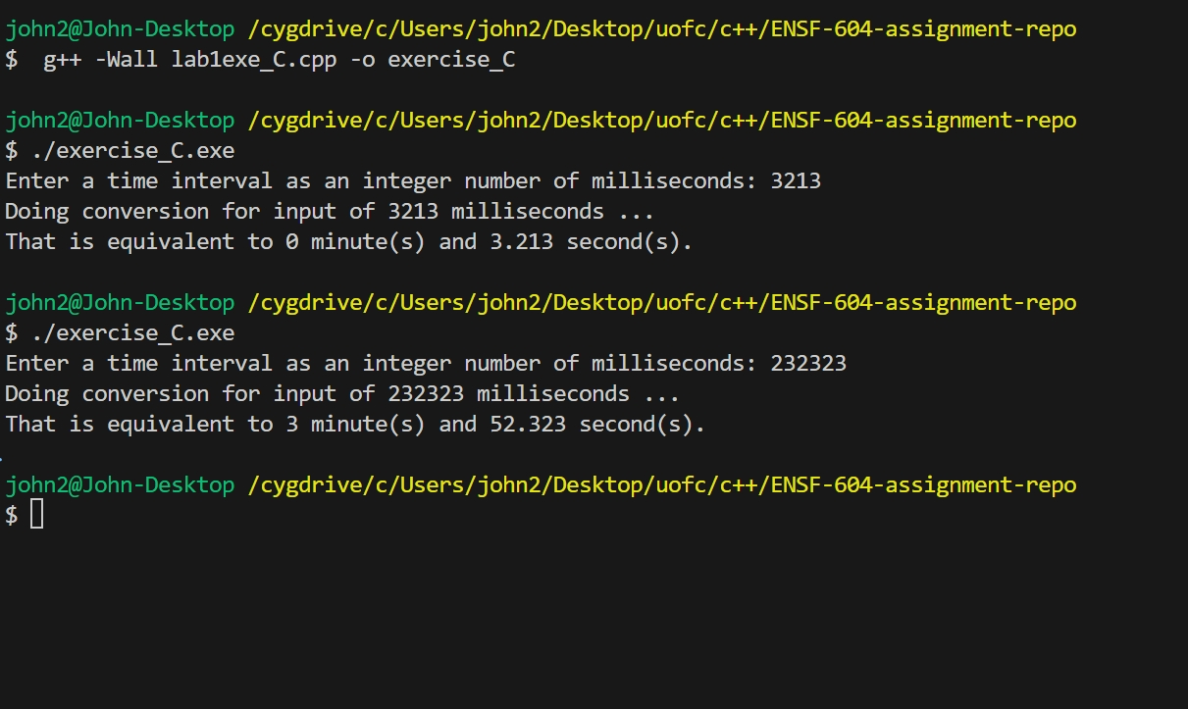

Exercise D

## Part I

## In the static area, there will be the Global constants const int COL_SIZE = 3;

## const int ROW_SIZE = 3;

## The String constant area will have : " sizeof(double) is \0", " bytes.\n \0" etc. AR at Point 1 for stack

## 

## AR at Point 2 for stack

## 

## AR at Point 3 for stack

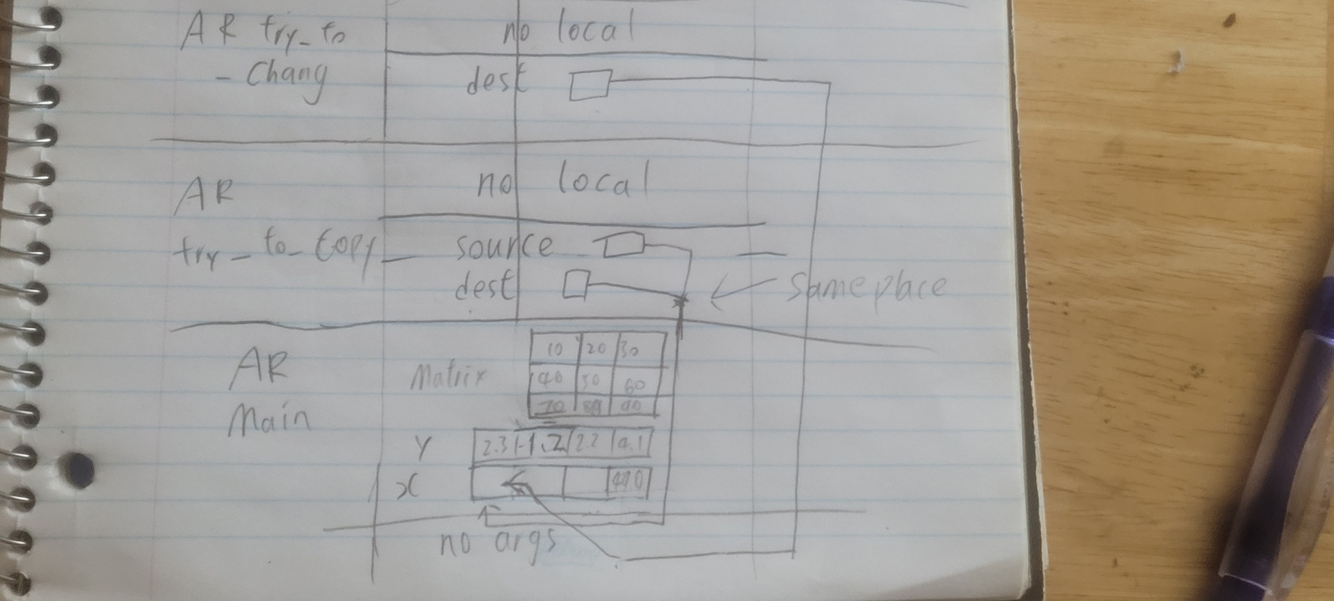  
  
Part II

/*

 *  lab1exe_D.cpp

 *  ENSF 694 Lab 1, exercise D

 *  Created by Mahmood Moussavi

 *  Completed by: John Zhou

 */

#include <iostream>

#include <iomanip>

using namespace std;

const int COL_SIZE = 3;

const int ROW_SIZE = 3;

void try_to_change(double *dest);

void try_to_copy(double dest[], double source[]);

double add_them(double a[5]);

void print_matrix(double matrix[][COL_SIZE], int rows);

/*

 * PROMISES: displays the values in the elements of the 2-D array, matrix,

 * formated in rows columns separated with one or more spaces.

 */

void good_copy(double *dest, double *source, int n);

/* REQUIRES: dest and source points to two array of double numbers with n to n-1 elements

 * PROMISES: copies the values in each element of array source to the corresponding element

 * in array dest.

 */

int main(void)

{

    double sum = 0;

    double x[4];

    double y[] = {2.3, 1.2, 2.2, 4.1};

    double matrix[ROW_SIZE][COL_SIZE] = {{10, 20, 30}, {40, 50, 60}, {70, 80, 90}};

    cout << " sizeof(double) is " << (int)sizeof(double) << " bytes.\n";

    cout << " size of x in main is: " << (int)sizeof(x) << " bytes.\n";

    cout << " y has " << (int)(sizeof(y) / sizeof(double)) << " elements and its size is: " << (int)sizeof(y) << " bytes.\n";

    cout << " matrix has " << (int)(sizeof(matrix) / sizeof(double)) << " elements and its size is: " << (int)sizeof(matrix) << " bytes.\n";

    try_to_copy(x, y);

    try_to_change(x);

    sum = add_them(&y[1]);

    cout << "\n sum of values in y[1], y[2] and y[3] is: " << sum << endl;

    good_copy(x, y, 4);

    cout << "\nThe values in array x after call to good_copy are expected to be:";

    cout << "\n2.30, -8.25, 2.20, 4.10\n";

    cout << "And the values are:\n";

    for (int i = 0; i < 4; i++)

        cout << fixed << setprecision(2) << x[i] << "  ";

    cout << "\nThe values in matrix are:\n";

    print_matrix(matrix, 3);

    cout << "\nProgram Ends...\n";

    return 0;

}

void try_to_copy(double dest[], double source[])

{

    dest = source;

    /* point one*/

    return;

}

void try_to_change(double *dest)

{

    dest[3] = 49.0;

    /* point two*/

    cout << "\n sizeof(dest) in try_to_change is " << (int)sizeof(dest) << " bytes.\n";

    return;

}

double add_them(double arg[5])

{

    *arg = -8.25;

    /* point three */

    cout << "\n sizeof(arg) in add_them is " << (int)sizeof(arg) << " bytes.\n";

    cout << "\n Incorrect array size computation: add_them says arg has " << (int)(sizeof(arg) / sizeof(double)) << " element.\n";

    return arg[0] + arg[1] + arg[2];

}

void good_copy(double *dest, double *source, int n)

{

    for (int i = 0; i < n; i++)

    {

        dest[i] = source[i];

    }

}

void print_matrix(double matrix[][COL_SIZE], int rows)

{

    cout << "___________Print Matrix__________\n";

    for (int i = 0; i <rows; i++)

    {

        for (int j = 0;j < COL_SIZE;j++){

           cout << matrix[i][j]<<" ";

        }

         cout << "\n";

    }

}

execution output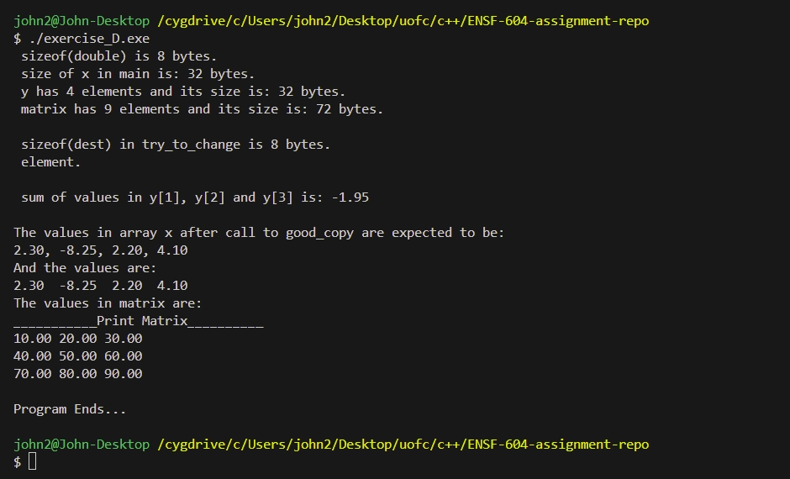

# Exercise E

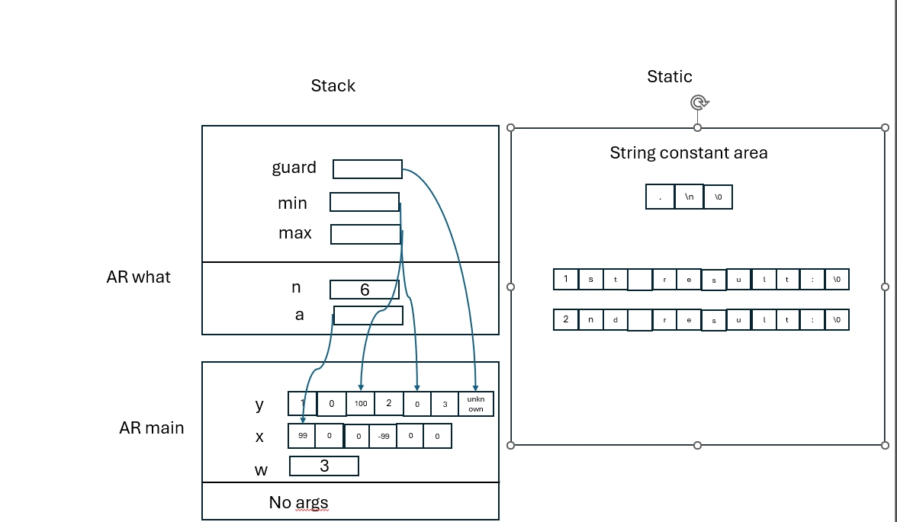

# Exercise F

#include "MyArray.h"

int search(const MyArray* myArray, int obj)

{

     int currentSize = myArray->list_size;

    for (int i = 0; i < currentSize; i++)

    {

        if (myArray->array[i] == obj)

        {

            return i;

        }

    }

    return -1;

}

void initialize(MyArray *myArray)

{

    myArray->list_size = 0;

}

int retrieve_at(MyArray *myArray, int pos)

{

    int currentSize = size(myArray);

    if (pos >= 0 && pos < currentSize)

    {

        return myArray->array[pos];

    }

    return 0;

}

int count(MyArray *myArray, int obj)

{

    int occurances_count = 0;

    int currentSize = size(myArray);

    for (int i = 0; i < currentSize; i++)

    {

        if (myArray->array[i] == obj)

        {

            occurances_count++;

        }

    }

    return occurances_count;

}

void append(MyArray *myArray, int array[], int n)

{

    if (myArray->list_size + n <= SIZE)

    {

        int *start = myArray->array + myArray->list_size;

        for (int i = 0; i < n; i++)

        {

            start[i] = array[i];

        }

        myArray->list_size += n;

    }

}

void insert_at(MyArray *myArray, int pos, int val)

{

    int arrayCurrentSize = size(myArray);

    if (pos >= 0 && pos <= arrayCurrentSize)

    {

        for (int i = arrayCurrentSize; i > pos; i--)

        {

            myArray->array[i] = myArray->array[i - 1];

        }

        myArray->array[pos] = val;

        myArray->list_size++;

    }

}

int remove_at(MyArray *myArray, int pos)

{

    int arrayCurrentSize = size(myArray);

    if (pos >= 0 && pos < arrayCurrentSize)

    {

        int removedElement = myArray->array[pos];

        for (int i = pos; i < arrayCurrentSize-1; i++)

        {

            myArray->array[i] = myArray->array[i + 1];

        }

        myArray->list_size--;

        return removedElement;

    }

    return 0;

}

int remove_all(MyArray *myArray, int value)

{

    int countRemoved = 0;

    int currentSize = size(myArray);

    for (int i = 0; i < currentSize; i++)

    {

        if (myArray->array[i] == value)

        {

            remove_at(myArray, i);

            countRemoved++;

            i--;

            currentSize--;

        }

    }

    return countRemoved;

}

// You can modify this function however you want:  it will not be tested

void display_all(MyArray *myArray)

{

    for (int i = 0; i < myArray->list_size; i++)

    {

        cout << myArray->array[i] << " ";

    }

    cout << endl;

}

bool is_full(MyArray *myArray)

{

    return myArray->list_size == SIZE;

}

bool isEmpty(MyArray *myArray)

{

    return myArray->list_size == 0;

}

int size(MyArray *myArray)

{

    return myArray->list_size;

}

Program output

