Course: ENSF694 – Summer 2025

Lab #: Lab 1

Instructor: Mahmood Moussavi

Student Name: John Zhou

Submission Date: July 10, 2025

# Exercise A

/*

 *  my_lab2exe_A.cpp

 *  ENSF 694 Lab 2 Exercise A

 * Created by Mahmood Moussavi

 *  Completed by: John Zhou

 */

int my_strlen(const char *s);

/*  Duplicates my_strlen from <cstring>, except return type is int.

 *  REQUIRES

 *     s points to the beginning of a string.

 *  PROMISES

 *     Returns the number of chars in the string, not including the

 *     terminating null.

 */

void my_strncat(char *dest, const char *source, int n);

/*  Duplicates my_strncat from <cstring>, except return type is void.

 *  REQUIRES

 *     dest points to the beginning of a string

 *     source points to the beginning of a string

 *     n integer that define the length of the string added to the destination

 *  PROMISES

 *     Appends at most n characters from source to the end of dest

 */

#include <iostream>

#include <cstring>

using namespace std;

int main(void)

{

    char str1[7] = "banana";

    const char str2[] = "-tacit";

    const char *str3 = "-toe";

    /* point 1 */

    char str5[] = "ticket";

    char my_string[100] = "";

    int bytes;

    int length;

    /* using my_strlen libarary function */

    length = (int)my_strlen(my_string);

    cout << "\nLine 1: my_string length is " << length;

    /* using sizeof operator */

    bytes = sizeof(my_string);

    cout << "\nLine 2: my_string size is " << bytes << " bytes.";

    /* using strcpy libarary function */

    strcpy(my_string, str1);

    cout << "\nLine 3: my_string contains: " << my_string;

    length = (int)my_strlen(my_string);

    cout << "\nLine 4: my_string length is " << length << ".";

    my_string[0] = '\0';

    cout << "\nLine 5: my_string contains:\"" << my_string << "\"";

    length = (int)my_strlen(my_string);

    cout << "\nLine 6: my_string length is " << length << ".";

    bytes = sizeof(my_string);

    cout << "\nLine 7: my_string size is still " << bytes << " bytes.";

    /* my_strncat append the first 3 characters of str5 to the end of my_string */

    my_strncat(my_string, str5, 3);

    cout << "\nLine 8: my_string contains:\"" << my_string << "\"";

    length = (int)my_strlen(my_string);

    cout << "\nLine 9: my_string length is " << length << ".";

    my_strncat(my_string, str2, 4);

    cout << "\nLine 10: my_string contains:\"" << my_string << "\"";

    /* my_strncat append ONLY up ot '\0' character from str3 -- not 6 characters */

    my_strncat(my_string, str3, 6);

    cout << "\nLine 11: my_string contains:\"" << my_string << "\"";

    length = (int)my_strlen(my_string);

    cout << "\nLine 12; my_string has " << length << " characters.";

    cout << "\n\nUsing strcmp - C library function: ";

    cout << "\n\"ABCD\" is less than \"ABCDE\" ... strcmp returns: " << strcmp("ABCD", "ABCDE");

    cout << "\n\"ABCD\" is less than \"ABND\" ... strcmp returns: " << strcmp("ABCD", "ABND");

    cout << "\n\"ABCD\" is equal than \"ABCD\" ... strcmp returns: " << strcmp("ABCD", "ABCD");

    cout << "\n\"ABCD\" is less than \"ABCd\" ... strcmp returns: " << strcmp("ABCD", "ABCd");

    cout << "\n\"Orange\" is greater than \"Apple\" ... strcmp returns: " << strcmp("Orange", "Apple") << endl;

    return 0;

}

int my_strlen(const char *s){

    int count=0;

    while (*s){

        count++;

        s++;

    }

    return count;

}

void my_strncat(char *dest, const char *source, int n) {

    while (*dest != '\0') {

        dest++;

    }

    int i = 0;

    while (i < n && *source != '\0') {

        *dest = *source;

        dest++;

        source++;

        i++;

    }

    *dest = '\0';

}

Execution result

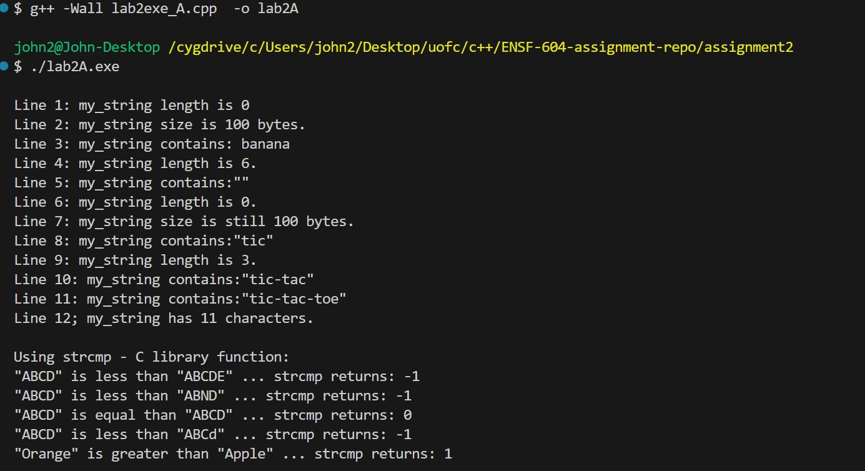

Exercise B

/*

* my_lab1exe_B.cpp

* ENSF 694 Lab 2 Exercise B

* Created by Mahmood Moussavi

* Completed by: John Zhou

*/

#include <iostream>

#include <assert.h>

using namespace std;

int sum_of_array(const int *a, int n);

// REQUIRES

// n > 0, and elements a[0] ... a[n-1] exist.

// PROMISES:

// Return value is a[0] + a[1] + ... + a[n-1].

int main()

{

int a[] = {100};

int b[] = {100, 200, 300, 400};

int c[] = {-100, -200, -200, -300};

int d[] = {10, 20, 30, 40, 50, 60, 70};

int sum = sum_of_array(a, 1);

cout << "sum of integers in array a is: " << sum << endl;

sum = sum_of_array(b, 4);

cout << "sum of integers in array b is: " << sum << endl;

sum = sum_of_array(c, 4);

cout << "sum of integers in array c is: " << sum << endl;

sum = sum_of_array(d, 7);

cout << "sum of integers in array d is: " << sum << endl;

return 0;

}

int sum_of_array(const int *a, int n)

{

// int sum = 0;

// for(int i=0; i < n; i++)

// sum += a[i];

// return sum;

if (n == 0)

{

return 0;

}

return (a[0] + sum_of_array(a + 1, n - 1));

}

Execution result

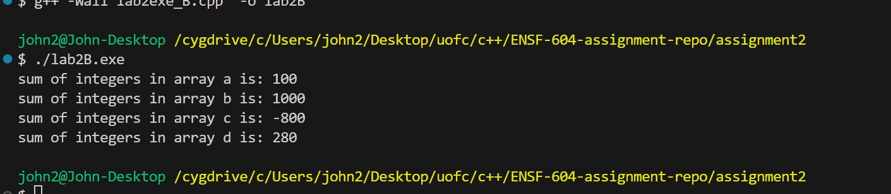

Exercise C

/*

 *  lab1exe_C.cpp

 *  ENSF 694 Lab 1, exercise C

 *  Created by Mahmood Moussavi

 *  Completed by: John Zhou

 */

#include <iostream>

using namespace std;

void time_convert(int ms_time, int *minutes_ptr, double *seconds_ptr);

/*

 * Converts time in milliseconds to time in minutes and seconds.

 * For example, converts 123400 ms to 2 minutes and 3.4 seconds.

 * REQUIRES:

 *    ms_time >= 0.

 *    minutes_ptr and seconds_ptr point to variables.

 * PROMISES:

 *    0 <= *seconds_ptr & *seconds_ptr < 60.0

 *    *minutes_ptr minutes + *seconds_ptr seconds is equivalent to

 *    ms_time ms.

 */

int main(void)

{

  int millisec;

  int minutes;

  double seconds;

  cout << "Enter a time interval as an integer number of milliseconds: ";

 // printf("Enter a time interval as an integer number of milliseconds: ");

  cin >> millisec;

  if (!cin) {

    cout << "Unable to convert your input to an int.\n";

    exit(1);

  }

  cout << "Doing conversion for input of " <<  millisec <<" milliseconds ... \n";

  /* MAKE A CALL TO time_convert HERE. */

  time_convert(millisec,&minutes,&seconds);

  cout << "That is equivalent to " << minutes << " minute(s) and " << seconds << " second(s).\n";

  return 0;

}

/* PUT YOUR FUNCTION DEFINITION FOR time_convert HERE. */

void time_convert(int ms_time, int *minutes_ptr, double *seconds_ptr){

  *minutes_ptr=ms_time/60000;

  *seconds_ptr=ms_time%60000/1000.0;

}

Execution result  
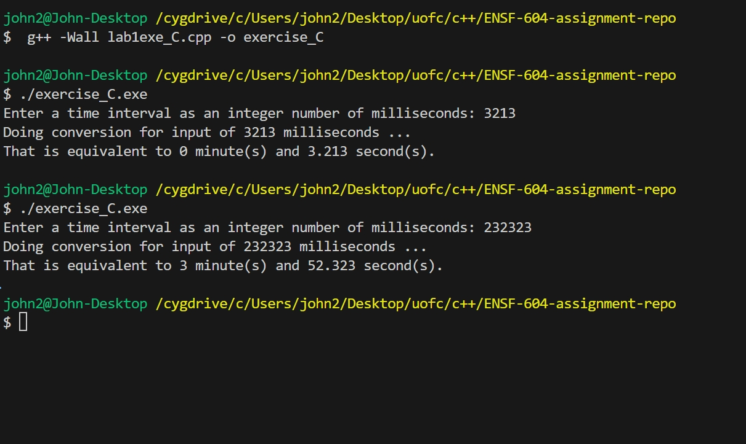

Exercise D

## Part I

## In the static area, there will be the Global constants const int COL_SIZE = 3;

## const int ROW_SIZE = 3;

## The String constant area will have : " sizeof(double) is \0", " bytes.\n \0" etc. AR at Point 1 for stack

## 

## AR at Point 2 for stack

## 

## AR at Point 3 for stack

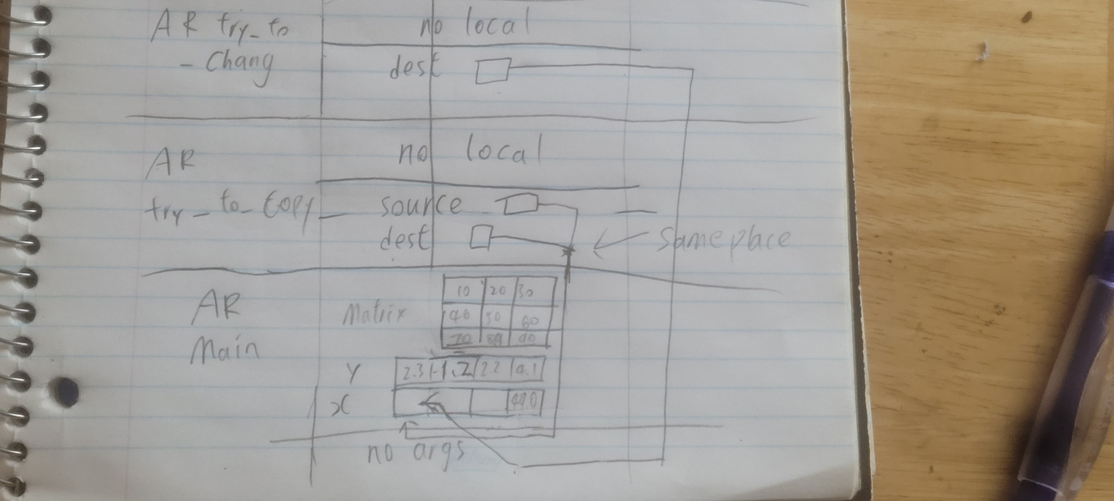  
  
Part II

/*

 *  lab1exe_D.cpp

 *  ENSF 694 Lab 1, exercise D

 *  Created by Mahmood Moussavi

 *  Completed by: John Zhou

 */

#include <iostream>

#include <iomanip>

using namespace std;

const int COL_SIZE = 3;

const int ROW_SIZE = 3;

void try_to_change(double *dest);

void try_to_copy(double dest[], double source[]);

double add_them(double a[5]);

void print_matrix(double matrix[][COL_SIZE], int rows);

/*

 * PROMISES: displays the values in the elements of the 2-D array, matrix,

 * formated in rows columns separated with one or more spaces.

 */

void good_copy(double *dest, double *source, int n);

/* REQUIRES: dest and source points to two array of double numbers with n to n-1 elements

 * PROMISES: copies the values in each element of array source to the corresponding element

 * in array dest.

 */

int main(void)

{

    double sum = 0;

    double x[4];

    double y[] = {2.3, 1.2, 2.2, 4.1};

    double matrix[ROW_SIZE][COL_SIZE] = {{10, 20, 30}, {40, 50, 60}, {70, 80, 90}};

    cout << " sizeof(double) is " << (int)sizeof(double) << " bytes.\n";

    cout << " size of x in main is: " << (int)sizeof(x) << " bytes.\n";

    cout << " y has " << (int)(sizeof(y) / sizeof(double)) << " elements and its size is: " << (int)sizeof(y) << " bytes.\n";

    cout << " matrix has " << (int)(sizeof(matrix) / sizeof(double)) << " elements and its size is: " << (int)sizeof(matrix) << " bytes.\n";

    try_to_copy(x, y);

    try_to_change(x);

    sum = add_them(&y[1]);

    cout << "\n sum of values in y[1], y[2] and y[3] is: " << sum << endl;

    good_copy(x, y, 4);

    cout << "\nThe values in array x after call to good_copy are expected to be:";

    cout << "\n2.30, -8.25, 2.20, 4.10\n";

    cout << "And the values are:\n";

    for (int i = 0; i < 4; i++)

        cout << fixed << setprecision(2) << x[i] << "  ";

    cout << "\nThe values in matrix are:\n";

    print_matrix(matrix, 3);

    cout << "\nProgram Ends...\n";

    return 0;

}

void try_to_copy(double dest[], double source[])

{

    dest = source;

    /* point one*/

    return;

}

void try_to_change(double *dest)

{

    dest[3] = 49.0;

    /* point two*/

    cout << "\n sizeof(dest) in try_to_change is " << (int)sizeof(dest) << " bytes.\n";

    return;

}

double add_them(double arg[5])

{

    *arg = -8.25;

    /* point three */

    cout << "\n sizeof(arg) in add_them is " << (int)sizeof(arg) << " bytes.\n";

    cout << "\n Incorrect array size computation: add_them says arg has " << (int)(sizeof(arg) / sizeof(double)) << " element.\n";

    return arg[0] + arg[1] + arg[2];

}

void good_copy(double *dest, double *source, int n)

{

    for (int i = 0; i < n; i++)

    {

        dest[i] = source[i];

    }

}

void print_matrix(double matrix[][COL_SIZE], int rows)

{

    cout << "___________Print Matrix__________\n";

    for (int i = 0; i <rows; i++)

    {

        for (int j = 0;j < COL_SIZE;j++){

           cout << matrix[i][j]<<" ";

        }

         cout << "\n";

    }

}

execution output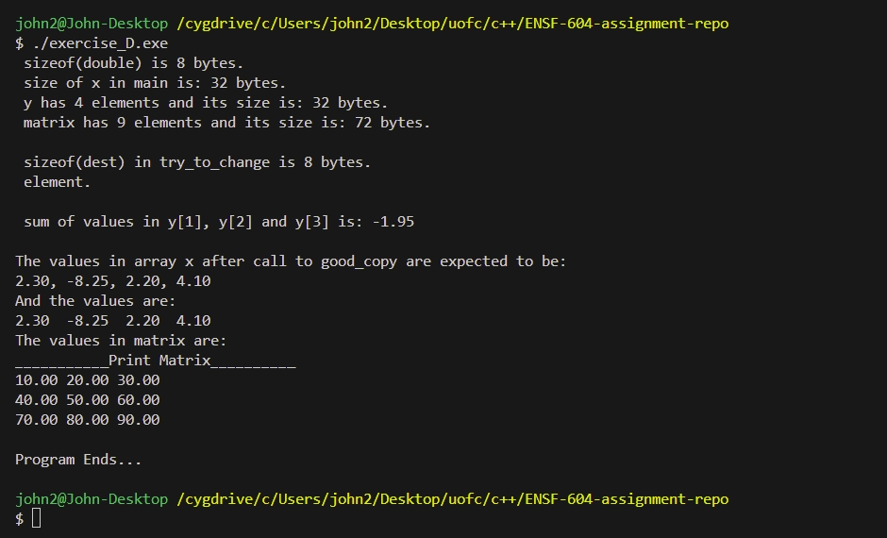

# Exercise E

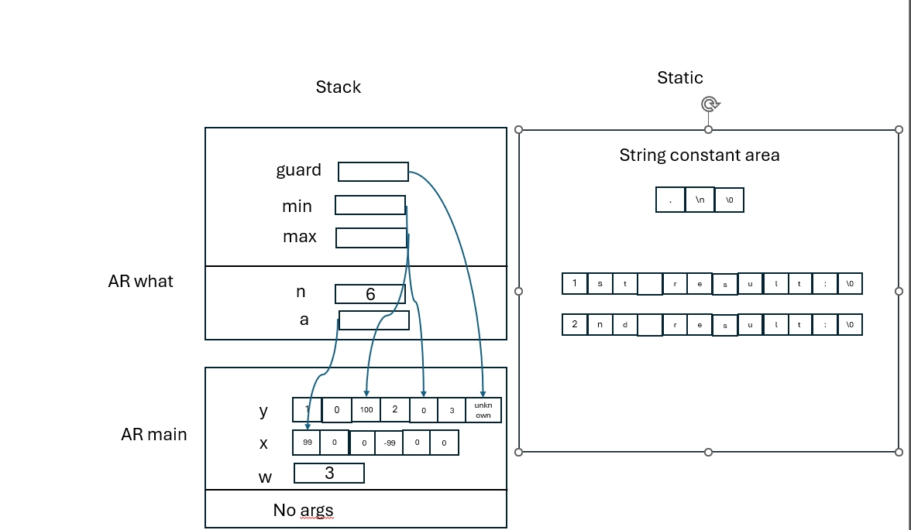

# Exercise F

#include "MyArray.h"

int search(const MyArray* myArray, int obj)

{

     int currentSize = myArray->list_size;

    for (int i = 0; i < currentSize; i++)

    {

        if (myArray->array[i] == obj)

        {

            return i;

        }

    }

    return -1;

}

void initialize(MyArray *myArray)

{

    myArray->list_size = 0;

}

int retrieve_at(MyArray *myArray, int pos)

{

    int currentSize = size(myArray);

    if (pos >= 0 && pos < currentSize)

    {

        return myArray->array[pos];

    }

    return 0;

}

int count(MyArray *myArray, int obj)

{

    int occurances_count = 0;

    int currentSize = size(myArray);

    for (int i = 0; i < currentSize; i++)

    {

        if (myArray->array[i] == obj)

        {

            occurances_count++;

        }

    }

    return occurances_count;

}

void append(MyArray *myArray, int array[], int n)

{

    if (myArray->list_size + n <= SIZE)

    {

        int *start = myArray->array + myArray->list_size;

        for (int i = 0; i < n; i++)

        {

            start[i] = array[i];

        }

        myArray->list_size += n;

    }

}

void insert_at(MyArray *myArray, int pos, int val)

{

    int arrayCurrentSize = size(myArray);

    if (pos >= 0 && pos <= arrayCurrentSize)

    {

        for (int i = arrayCurrentSize; i > pos; i--)

        {

            myArray->array[i] = myArray->array[i - 1];

        }

        myArray->array[pos] = val;

        myArray->list_size++;

    }

}

int remove_at(MyArray *myArray, int pos)

{

    int arrayCurrentSize = size(myArray);

    if (pos >= 0 && pos < arrayCurrentSize)

    {

        int removedElement = myArray->array[pos];

        for (int i = pos; i < arrayCurrentSize-1; i++)

        {

            myArray->array[i] = myArray->array[i + 1];

        }

        myArray->list_size--;

        return removedElement;

    }

    return 0;

}

int remove_all(MyArray *myArray, int value)

{

    int countRemoved = 0;

    int currentSize = size(myArray);

    for (int i = 0; i < currentSize; i++)

    {

        if (myArray->array[i] == value)

        {

            remove_at(myArray, i);

            countRemoved++;

            i--;

            currentSize--;

        }

    }

    return countRemoved;

}

// You can modify this function however you want:  it will not be tested

void display_all(MyArray *myArray)

{

    for (int i = 0; i < myArray->list_size; i++)

    {

        cout << myArray->array[i] << " ";

    }

    cout << endl;

}

bool is_full(MyArray *myArray)

{

    return myArray->list_size == SIZE;

}

bool isEmpty(MyArray *myArray)

{

    return myArray->list_size == 0;

}

int size(MyArray *myArray)

{

    return myArray->list_size;

}

Program output

