Course: ENSF614 – Fall 2025

Lab #: Lab 1

Instructor: Mahmood Moussavi

Student Name: John Zhou

Submission Date: Sep 17th, 2025  
  
  
  
  
  
  
I have been keeping all the files in github. I hope by providing this github link will help you a little bit.  
https://github.com/JZ-Zhou-UofC/ENSF-614-assignment-repo

Exercise B

/*

*

*

File Name: dictionaryList.cpp

Assignment: Lab 1 Exercise B

* Completed by: John

* Submission Date: Sept 17, 2025

*/

#include <assert.h>

#include <iostream>

#include <stdlib.h>

#include "dictionaryList.h"

using namespace std;

Node::Node(const int &keyA, const Datum &datumA, Node *nextA)

: keyM(keyA), datumM(datumA), nextM(nextA)

{

}

DictionaryList::DictionaryList()

: sizeM(0), headM(0), cursorM(0)

{

}

int DictionaryList::size() const

{

return sizeM;

}

int DictionaryList::cursor_ok() const

{

return cursorM != 0;

}

const int &DictionaryList::cursor_key() const

{

assert(cursor_ok());

return cursorM->keyM;

}

const Datum &DictionaryList::cursor_datum() const

{

assert(cursor_ok());

return cursorM->datumM;

}

void DictionaryList::insert(const int &keyA, const string &datumA)

{

// Add new node at head?

if (headM == 0 || keyA < headM->keyM)

{

headM = new Node(keyA, datumA, headM);

sizeM++;

}

// Overwrite datum at head?

else if (keyA == headM->keyM)

headM->datumM = datumA;

// Have to search ...

else

{

// POINT ONE

// if key is found in list, just overwrite data;

for (Node *p = headM; p != 0; p = p->nextM)

{

if (keyA == p->keyM)

{

p->datumM = datumA;

return;

}

}

// OK, find place to insert new node ...

Node *p = headM->nextM;

Node *prev = headM;

while (p != 0 && keyA > p->keyM)

{

prev = p;

p = p->nextM;

}

prev->nextM = new Node(keyA, datumA, p);

sizeM++;

}

cursorM = NULL;

}

void DictionaryList::remove(const int &keyA)

{

if (headM == 0 || keyA < headM->keyM)

return;

Node *doomed_node = 0;

if (keyA == headM->keyM)

{

doomed_node = headM;

headM = headM->nextM;

// POINT TWO

}

else

{

Node *before = headM;

Node *maybe_doomed = headM->nextM;

while (maybe_doomed != 0 && keyA > maybe_doomed->keyM)

{

before = maybe_doomed;

maybe_doomed = maybe_doomed->nextM;

}

if (maybe_doomed != 0 && maybe_doomed->keyM == keyA)

{

doomed_node = maybe_doomed;

before->nextM = maybe_doomed->nextM;

}

}

if (doomed_node == cursorM)

cursorM = 0;

delete doomed_node; // Does nothing if doomed_node == 0.

sizeM--;

}

void DictionaryList::go_to_first()

{

cursorM = headM;

}

void DictionaryList::step_fwd()

{

assert(cursor_ok());

cursorM = cursorM->nextM;

}

// The following functions are supposed to be completed by the stuents, as part

// of the exercise B. the given code for this fucntion are just place-holders

// in order to allow successful linking when you're esting insert and remove.

// Replace them with the definitions that work.

DictionaryList::DictionaryList(const DictionaryList &source) : sizeM(0), headM(0), cursorM(0)

{

if (source.headM == 0)

{

return;

}

headM = new Node(source.headM->keyM, source.headM->datumM, nullptr);

sizeM = 1;

if (source.cursorM == source.headM)

cursorM = headM;

Node *currentNode = headM;

Node *sourceNextNode = source.headM->nextM;

while (sourceNextNode)

{

currentNode->nextM = new Node(sourceNextNode->keyM, sourceNextNode->datumM, nullptr);

currentNode = currentNode->nextM;

sizeM++;

if (source.cursorM != nullptr && source.cursorM == sourceNextNode)

{

cursorM = currentNode;

}

sourceNextNode = sourceNextNode->nextM;

}

}

DictionaryList &DictionaryList::operator=(const DictionaryList &rhs)

{

if (this == &rhs)

{

return *this;

}

make_empty();

if (rhs.headM == 0)

{

headM = 0;

cursorM = 0;

sizeM = 0;

return *this;

}

headM = new Node(rhs.headM->keyM, rhs.headM->datumM, nullptr);

sizeM = 1;

if (rhs.cursorM == rhs.headM)

cursorM = headM;

Node *currentNode = headM;

Node *rhsNextNode = rhs.headM->nextM;

while (rhsNextNode)

{

currentNode->nextM = new Node(rhsNextNode->keyM, rhsNextNode->datumM, nullptr);

currentNode = currentNode->nextM;

sizeM++;

if (rhs.cursorM != nullptr && rhs.cursorM == rhsNextNode)

{

cursorM = currentNode;

}

rhsNextNode = rhsNextNode->nextM;

}

return *this;

}

DictionaryList::~DictionaryList()

{

make_empty();

}

void DictionaryList::find(const int &keyA)

{

Node *current = headM;

while (current)

{

if (current->keyM == keyA)

{

cursorM = current;

return;

}

if (current->keyM > keyA)

{

break;

}

current = current->nextM;

}

cursorM = nullptr;

}

void DictionaryList::make_empty()

{

Node *current = headM;

while (current)

{

Node *next = current->nextM;

delete current;

current = next;

}

headM = 0;

cursorM = 0;

sizeM = 0;

}

Screenshot:

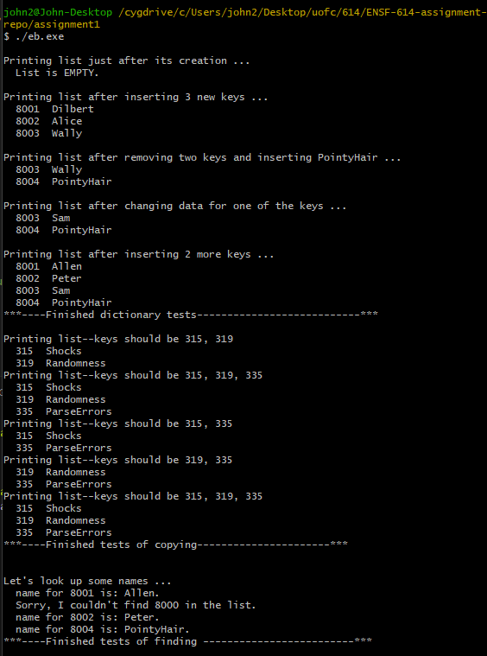

Exercise D  
  
  
  
  
/*

*

*

File Name: Human.cpp

Assignment: Lab 1 Exercise D

*  Completed by: John Zhou

*  Submission Date: Sept 17, 2025

*/

#include "Human.h"

#include <cstring>

#include <iostream>

using namespace std;

Human::Human(const char *nam, double x, double y)

    : location(x, y)

{

    name = new char[strlen(nam) + 1];

    strcpy(name, nam);

}

Human::Human(const Human &other)

    : location(other.location)

{

    name = new char[strlen(other.name) + 1];

    strcpy(name, other.name);

}

Human &Human::operator=(const Human &rhs)

{

    if (this != &rhs)

    {

        location = rhs.location;

        delete[] name;

        name = new char[strlen(rhs.name) + 1];

        strcpy(name, rhs.name);

    }

    return *this;

}

Human::~Human()

{

    delete[] name;

}

const char *Human::get_name() const { return name; }

Point Human::get_point() const { return location; }

void Human::set_name(const char *nam)

{

    delete[] name;

    name = new char[strlen(nam) + 1];

    strcpy(name, nam);

}

void Human::display() const

{

    cout << "Human Name: " << name

         << "\nHuman Location: "

         << location.get_x() << " ,"

         << location.get_y() << ".\n"

         << endl;

}

/*

*

*

File Name: Human.H

Assignment: Lab 1 Exercise D

*  Completed by: John Zhou

*  Submission Date: Sept 17, 2025

*/

#ifndef HUMAN_H

#define HUMAN_H

#include "Point.h"

class Human {

protected:

    Point location;   // Location of an object of Human on a Cartisian Plain

    char *name;       // Human's name

public:

    // Constructor

    Human(const char* nam = "", double x = 0, double y = 0);

    //the name will be created in the run time. Copy constructor, assignment operater and destructor are needed

    Human(const Human& other);

    Human& operator=(const Human& rhs);

    ~Human();

    // this getter should not have the ability to change anything inside the class

    // this should return a const char pointer for safety.

    const char* get_name() const;

    Point get_point() const;

    void set_name(const char* nam);

    void display() const;

};

#endif

/*

*

*

File Name: main.cpp

Assignment: Lab 1 Exercise D

*  Completed by: John Zhou

*  Submission Date: Sept 17, 2025

*/

#include "Human.h"

#include <iostream>

int main()

{

    double x = 2000, y = 3000;

    Human h("Ken Lai", x, y);

    h.display();

    return 0;

}

/*

*

*

File Name: point.cpp

Assignment: Lab 1 Exercise D

*  Completed by: John Zhou

*  Submission Date: Sept 17, 2025

*/

#include "Point.h"

Point::Point(double a, double b) : x(a), y(b) {}

double Point::get_x() const { return x; }

double Point::get_y() const { return y; }

void Point::set_x(double a) { x = a; }

void Point::set_y(double a) { y = a; }

/*

*

*

File Name: point.h

Assignment: Lab 1 Exercise D

*  Completed by: John Zhou

*  Submission Date: Sept 17, 2025

*/

#ifndef POINT_H

#define POINT_H

class Point

{

private:

    double x;

    double y;

public:

    Point(double a = 0, double b = 0);

    double get_x() const;

    double get_y() const;

    void set_x(double a);

    void set_y(double a);

};

#endif

Screenshot

