Course: ENSF614 – Fall 2025

Lab #: Lab 6

Instructor: Mahmood Moussavi

Student Name: John Zhou

Submission Date: Nov 5th, 2025
I have been keeping all the files in github. I hope by providing this github link will help you a little bit.
https://github.com/JZ-Zhou-UofC/ENSF-614-assignment-repo

Ex A & Ex B
Output A
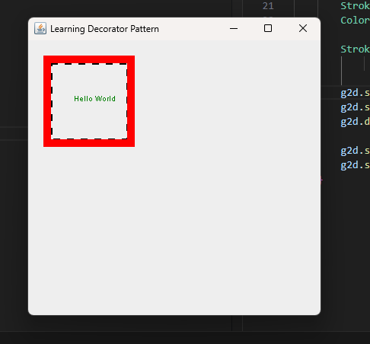
Output B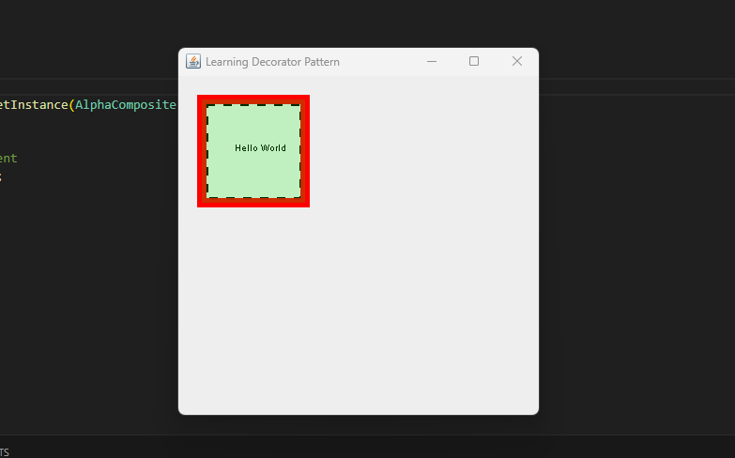

/*
*
*
File Name: BorderDecorator.java
Assignment: Lab 6 Exercise A&B
* Completed by: John Zhou
* Submission Date: Nov 5th, 2025
*/
package EA;

import java.awt.BasicStroke;
import java.awt.Color;
import java.awt.Graphics;
import java.awt.Graphics2D;
import java.awt.Stroke;
import java.awt.geom.Rectangle2D;

public class BorderDecorator extends Decorator {

public BorderDecorator(Component cmp, int x, int y, int width, int height) {
super(cmp, x, y, width, height);
};

@Override
public void draw(Graphics g) {

cmp.draw(g);
Graphics2D g2d = (Graphics2D) g;
Stroke oldStroke = g2d.getStroke();
Color oldColor = g2d.getColor();

Stroke dashed = new BasicStroke(3, BasicStroke.CAP_BUTT,
BasicStroke.JOIN_BEVEL, 0, new float[] { 9 }, 0);

g2d.setStroke(dashed);
g2d.setColor(Color.BLACK);
g2d.draw(new Rectangle2D.Float(x, y, width, height));

g2d.setStroke(oldStroke);
g2d.setColor(oldColor);
}

}

/*
*
*
File Name: ColouredFrameDecorator.java
Assignment: Lab 6 Exercise A&B
* Completed by: John Zhou
* Submission Date: Nov 5th, 2025
*/
package EA;

import java.awt.BasicStroke;
import java.awt.Color;
import java.awt.Graphics;
import java.awt.Graphics2D;
import java.awt.Stroke;

public class ColouredFrameDecorator extends Decorator {
protected int thickness;

public ColouredFrameDecorator(Component cmp, int x, int y, int width, int height, int thickness) {
super(cmp, x, y, width, height);
this.thickness = thickness;
};

@Override
public void draw(Graphics g) {
cmp.draw(g);
Graphics2D g2d = (Graphics2D) g;
Stroke oldStroke = g2d.getStroke();
Color oldColor = g2d.getColor();

g2d.getColor();
g2d.setStroke(new BasicStroke(thickness));
g2d.setColor(Color.red);
g2d.drawRect(x, y, width, height);
g2d.setStroke(oldStroke);
g2d.setColor(oldColor);

}
}

/*
*
*
File Name: Component.java
Assignment: Lab 6 Exercise A&B
* Completed by: John Zhou
* Submission Date: Nov 5th, 2025
*/
package EA;
import java.awt.Graphics;

public interface Component {
void draw(Graphics g);
}

/*
*
*
File Name: Decorator.java
Assignment: Lab 6 Exercise A&B
* Completed by: John Zhou
* Submission Date: Nov 5th, 2025
*/
package EA;

abstract class Decorator implements Component {

protected Component cmp;
protected int x;
protected int y;
protected int width;
public int height;

public Decorator(Component cmp, int x, int y, int width, int height) {
this.cmp = cmp;
this.x = x;
this.y = y;
this.width = width;
this.height = height;
}
};

package EA;
import java.awt.Font;
import java.awt.Graphics;
import javax.swing.JFrame;
import javax.swing.JPanel;

public class DemoDecoratorPattern extends JPanel {
Component t;

public DemoDecoratorPattern(){
t = new Text ("Hello World", 60, 80);
}

public void paintComponent(Graphics g){
int fontSize = 10;
g.setFont(new Font("TimesRoman", Font.PLAIN, fontSize));

// Now lets decorate t with BorderDecorator: x = 30, y = 30, width = 100, and height 100
t = new BorderDecorator(t, 30, 30, 100, 100);

// Now lets add a ColouredFrameDecorator with x = 25, y = 25, width = 110, height = 110,
// and thickness = 10.
t = new ColouredFrameDecorator(t, 25, 25, 110, 110, 10);

// Now lets draw the product on the screen
t.draw(g);
}

public static void main(String[] args) {
DemoDecoratorPattern panel = new DemoDecoratorPattern();
JFrame frame = new JFrame("Learning Decorator Pattern");
frame.getContentPane().add(panel);
frame.setSize(400,400);
frame.setDefaultCloseOperation(JFrame.EXIT_ON_CLOSE);
frame.setLocationRelativeTo(null);
frame.setVisible(true);
}
}

/*
*
*
File Name: Text.java
Assignment: Lab 6 Exercise A&B
* Completed by: John Zhou
* Submission Date: Nov 5th, 2025
*/
package EA;

import java.awt.Color;
import java.awt.Graphics;

public class Text implements Component {

protected String text;
protected int x;
protected int y;

public Text(String text, int x, int y) {
this.text = text;
this.x = x;
this.y = y;
}

@Override
public void draw(Graphics g) {
Color darkGreen = new Color(0, 128, 0); // Slightly Darker green
g.setColor(darkGreen);

//Changing this back to black for part2
g.drawString(text, x, y);

}
}

Part B code
/*
*
*
File Name: DemoDecoratorPattern.java
Assignment: Lab 6 Exercise A&B
* Completed by: John Zhou
* Submission Date: Nov 5th, 2025
*/
package EAPart2;

import java.awt.Font;
import java.awt.Graphics;
import javax.swing.JFrame;
import javax.swing.JPanel;

public class DemoDecoratorPattern extends JPanel {
Component t;

public DemoDecoratorPattern() {
t = new Text("Hello World", 60, 80);
}

public void paintComponent(Graphics g) {
int fontSize = 10;
g.setFont(new Font("TimesRoman", Font.PLAIN, fontSize));
// GlassFrameDecorator info: x = 25, y = 25, width = 110, and height = 110
t = new ColouredGlassDecorator(new ColouredFrameDecorator(
new BorderDecorator(t, 30, 30, 100, 100), 25, 25, 110, 110, 10), 25, 25,
110, 110);
t.draw(g);
}

public static void main(String[] args) {
DemoDecoratorPattern panel = new DemoDecoratorPattern();
JFrame frame = new JFrame("Learning Decorator Pattern");
frame.getContentPane().add(panel);
frame.setSize(400, 400);
frame.setDefaultCloseOperation(JFrame.EXIT_ON_CLOSE);
frame.setLocationRelativeTo(null);
frame.setVisible(true);
}
}

/*
*
*
File Name: ColouredGlassDecorator.java
Assignment: Lab 6 Exercise A&B
* Completed by: John Zhou
* Submission Date: Nov 5th, 2025
*/
package EAPart2;

import java.awt.AlphaComposite;
import java.awt.Color;
import java.awt.Graphics;
import java.awt.Graphics2D;

public class ColouredGlassDecorator extends Decorator {

public ColouredGlassDecorator(Component cmp, int x, int y, int width, int height) {
super(cmp, x, y, width, height);
}

@Override
public void draw(Graphics g) {

cmp.draw(g);

Graphics2D g2d = (Graphics2D) g;

Color oldColor = g2d.getColor();

g2d.setColor(Color.green);
g2d.setComposite(AlphaComposite.getInstance(AlphaComposite.SRC_OVER, 1 *
0.1f));

g2d.fillRect(x, y, width, height);

g2d.setColor(oldColor);
}
}

