ENSF 692 Project

Group 7

Jack Shenfield & John Zhou

June 20th 2025

# Datasets

Multiple datasets were selected from Statistics Canada. The group’s initial focus was on interprovincial migration, so we looked for datasets that we thought may have some sort of correlation. In no particular order, the chosen datasets were:

* Interprovincial migration [1]
* Population [2]
* Labour force characteristics (unemployment) [3]
* Wages/Salaries [4]
* Consumer price index [5]
* Housing index [6]

Net migration Eq. (1) calculated to clearly determine if the migration trend was in or out of a given province, using the following equation:

Equation 1: Net migration calculation

$$Net migration = \left(Out-migration\right)-\left(In-migration\right)$$

This could then be plotted against and statistically compared to the other relevant datasets. Correlation coefficients could be calculated to statistically prove what likely affected interprovincial migration the most.

# UI Input/Output

The program consists of a primary input/output portion to satisfy project requirements, as well as some secondary outputs to demonstrate the group’s data manipulation.

## Primary Input/Output

The user is asked to input up to 4 provinces via integer input (i.e. 1, 2, 3, 4). Then, they are asked to input that number of provinces by their short form (e.g. AB for Alberta, QC for Quebec). Additionally, the user inputs what dataset they want to compare the chosen provinces against, as seen in Fig. X below:A screenshot of a computer program

Figure 1: Primary input/output console interface

## Other Outputs

The program additionally generates more outputs dependent on the user pressing ‘any key to continue’. This is less interactive but acts as a more demonstrative process in the analysis. Initially when the program is ran, it asks the user to input any key to continue. Then it displays the created Pandas Dataframe Fig. (1), as seen below:

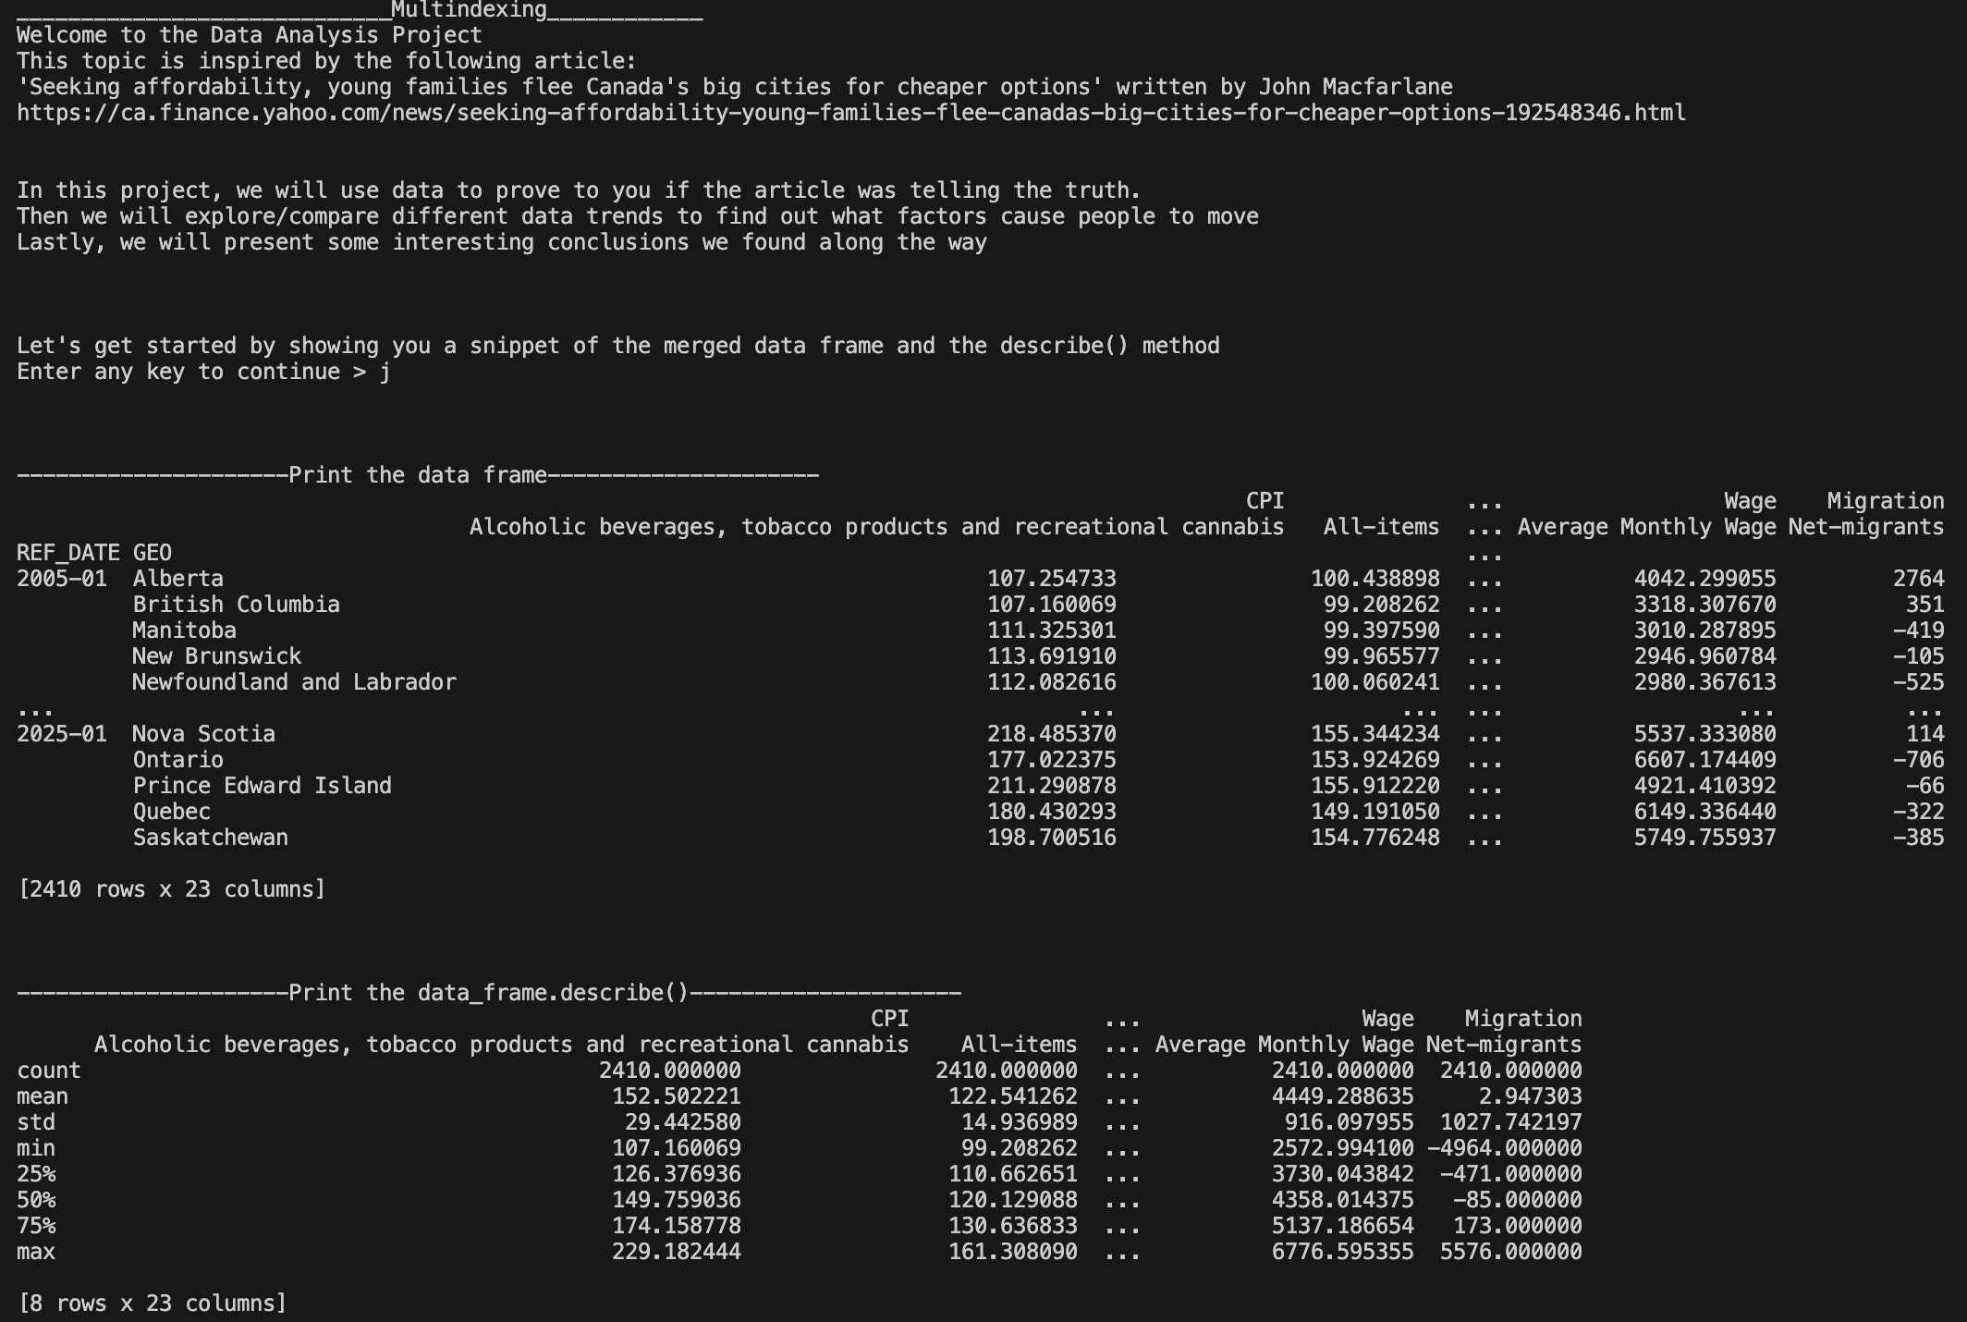

Figure 2: Pandas Dataframe printout

# Conclusion

In conclusion, it seems that the thesis laid out in the linked article was proven correct. There is a strong negative correlation between housing index and net migration in British Columbia and Ontario, the two provinces with the most expensive housing.

# Discussion

To further extend this analysis, intraprovincial migration should be an incorporated dataset. Although analyzing migration between provinces has been demonstrative, it may be more astute to prove that people are moving out of metropolitan areas.

References

[1] Statistics Canada, “Table 17‑10‑0020‑01 – Estimates of the components of interprovincial migration, quarterly,” released Jun. 18, 2025. DOI: https://doi.org/10.25318/1710002001‑eng :contentReference[oaicite:1]{index=1}

[2] Statistics Canada, “Table 17‑10‑0009‑01 – Population estimates, quarterly,” released Jun. 18, 2025. DOI: https://doi.org/10.25318/1710000901‑eng :contentReference[oaicite:2]{index=2}

[3] Statistics Canada, “Table 14‑10‑0287‑03 – Labour force characteristics by province, monthly, seasonally adjusted,” released Jun. 20, 2025. DOI: https://doi.org/10.25318/1410028701‑eng :contentReference[oaicite:3]{index=3}

[4] Statistics Canada, “Table 36‑10‑0205‑01 – Wages, salaries and employers’ social contributions (x 1,000), monthly,” released May 30, 2025. DOI: https://doi.org/10.25318/3610020501‑eng :contentReference[oaicite:4]{index=4}

[5] Statistics Canada, “Table 18‑10‑0004‑01 – Consumer Price Index, monthly, not seasonally adjusted,” published May 2025. DOI: https://doi.org/10.25318/1810000401‑eng :contentReference[oaicite:5]{index=5}

[6] Statistics Canada, “Table 18‑10‑0205‑01 – New housing price index, monthly,” released Jun. 20, 2025. DOI: https://doi.org/10.25318/1810020501‑eng :contentReference[oaicite:6]{index=6}