**第五章作业**

5-9：

利用AM.m产生信号并解调。

|  |
| --- |
| time = .3;  Ts = 1/10000;  t = Ts:Ts:time;  lent = length(t);  f0 = 1000;  A0 = 1;  c = A0 * cos(2*pi*f0*t); % generate a carrier.  fm = 100;  w = cos(2*pi*fm*t); % generate a signal bandwidth 100Hz.  s = (w + c).^2; % add signal and carrier and square.  v = (1/2) * bandp(s, 900, 1100, 800, 1200, 0.1, 30, 1/Ts);  % use a bandpass filter to get v(t)  % use AM.m to demodulate signal  gamma = 0;  phi = 0;  c2 = cos(2*pi*(f0 + gamma)*t + phi);  x= v.*c2;  fbe = [0 0.1 0.2 1];  damps = [1 1 0 0];  fl = 100;  b = remez(fl, fbe, damps);  m = 2 * filter(b, 1, x);  % plot  subplot(4, 1, 1);  plot(t, w);  title('原始信号w(t)');  subplot(4, 1, 2);  plot(t, c);  title('载波信号c(t)');  subplot(4, 1, 3);  plot(t, v)  title('已调信号v(t) = {A0}w(t)cos(2{\pi}{fc}t)');  subplot(4, 1, 4);  plot(t, m);  title('解调信号m(t)'); |

带通滤波器函数

|  |
| --- |
| function y=bandp(x,f1,f3,fsl,fsh,rp,rs,Fs)  wp1=2*pi*f1/Fs;  wp3=2*pi*f3/Fs;  wsl=2*pi*fsl/Fs;  wsh=2*pi*fsh/Fs;  wp=[wp1 wp3];  ws=[wsl wsh];  [n,~]=cheb1ord(ws/pi,wp/pi,rp,rs);  [bz1,az1]=cheby1(n,rp,wp/pi);  [h,~]=freqz(bz1,az1,256,Fs);  h=20*log10(abs(h));  y=filter(bz1,az1,x);  end |

结果图：

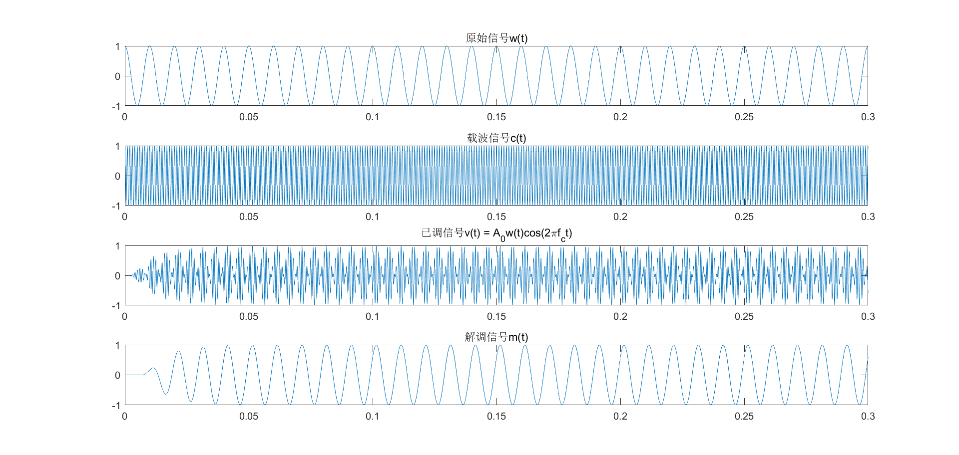

5-10：

(a)系统对余弦波频率误差的敏感度较高。

如果余弦波频率和信号相差过小，解调中会失败。所以余弦波频率和信号频率相差需要大些。

(b)系统对余弦波未知相位偏差的敏感度高。

余弦波相位为 $\frac{π}{2}$ 的奇数倍时，信号最终解调失败。

余弦波相位为 $\frac{π}{4}$ 的奇数倍时，信号最终信号功率损失近一半。

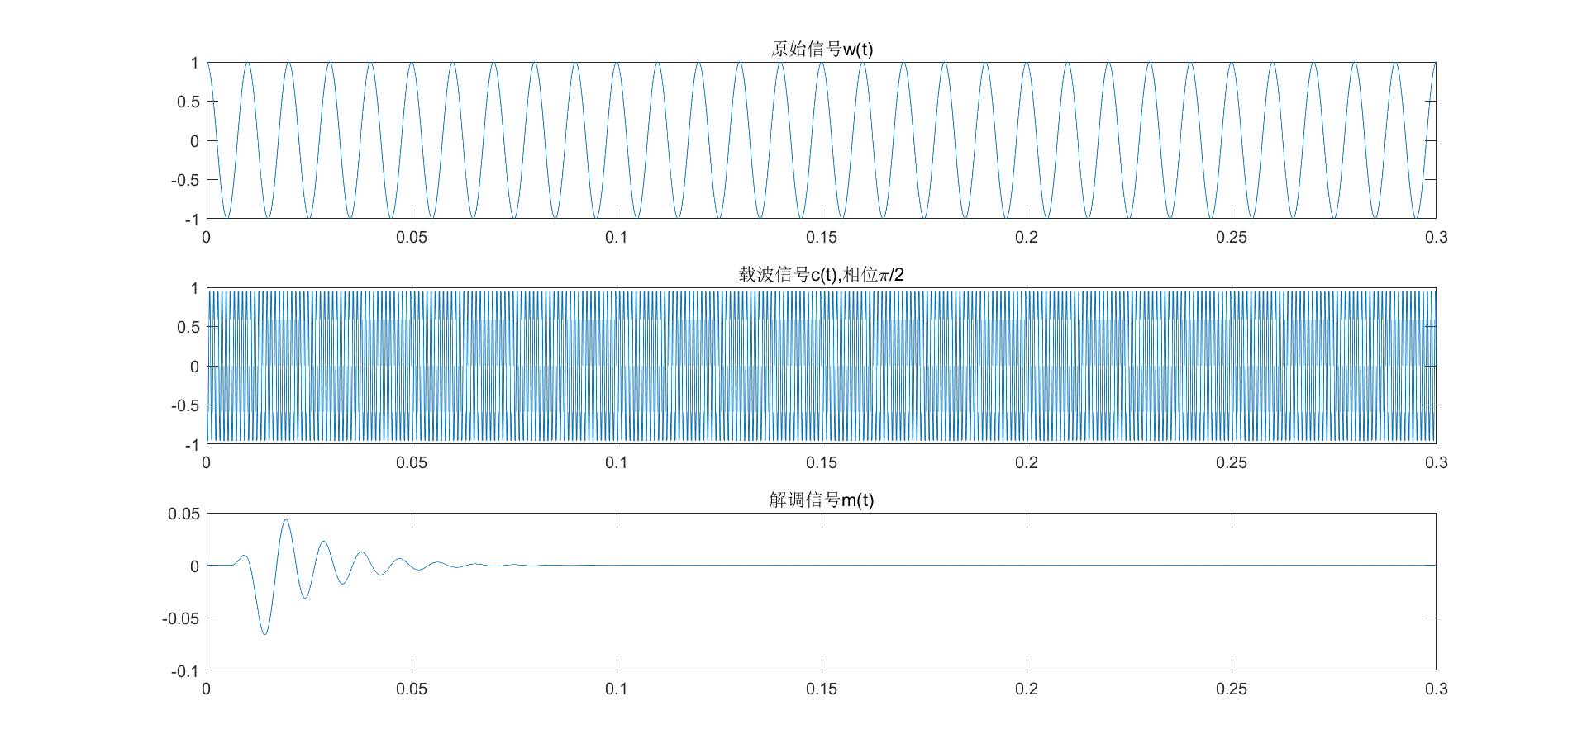

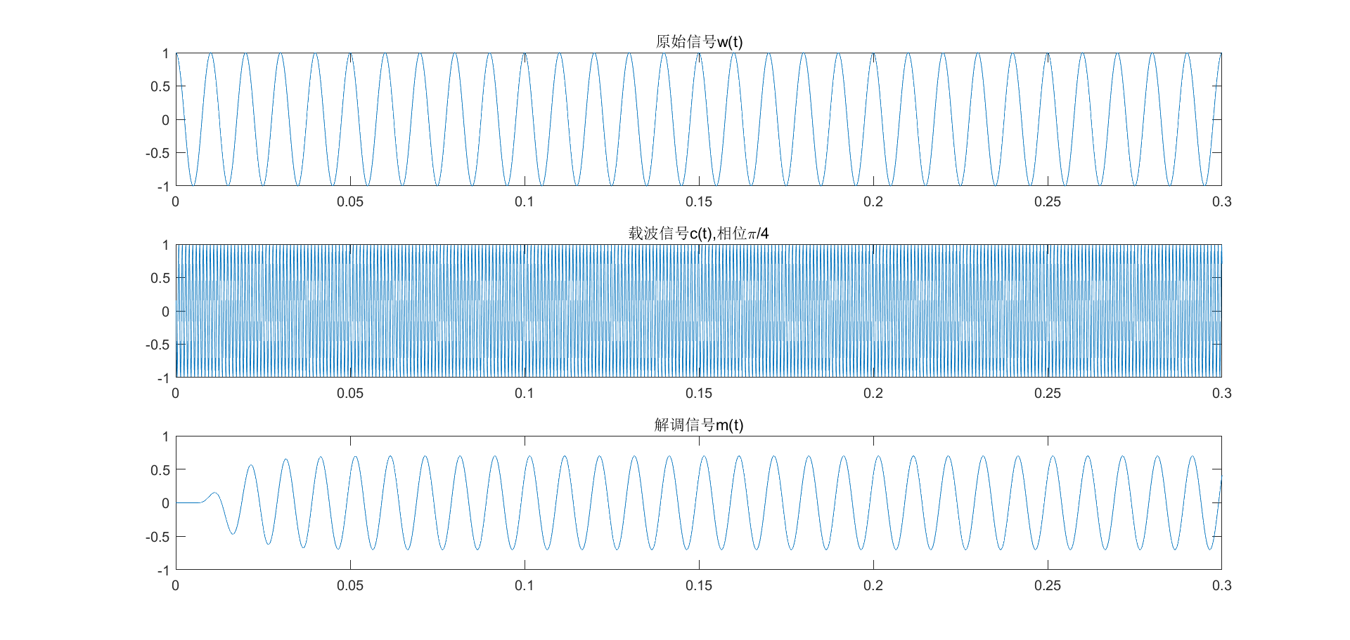

5-13：

|  |
| --- |
| time = .3;  Ts = 1/10000;  t = Ts:Ts:time;  lent = length(t);  fm1 = 20;  fm2 = 10;  m1 = cos(2*pi*fm1*t);  m2 = cos(2*pi*fm2*t); % two signal with different frequence  fc = 1000;  phi1 = 0;  phi2 = pi;  c1 = cos(2*pi*fc*t + phi1);  c2 = sin(2*pi*fc*t + phi2); % two carrier with different phase  v = m1.*c1 + m2.*c2;  % demodulation  x1 = v .* c1;  x2 = v .* c2;  fbe = [0 0.1 0.2 1];  damps = [1 1 0 0];  fl = 100;  b = remez(fl, fbe, damps);  s1 = 2 * filter(b, 1, x1);  s2 = 2 * filter(b, 1, x2);  subplot(4, 1, 1);  plot(t, m1);  title('调制前{m_1}(t)')  subplot(4, 1, 2);  plot(t, m2);  title('调制前{m_2}(t)')  subplot(4, 1, 3);  plot(t, s1);  title('解调后{s_1}(t)')  subplot(4, 1, 4);  plot(t, s2);  title('解调后{s_2}(t)') |

结果图：

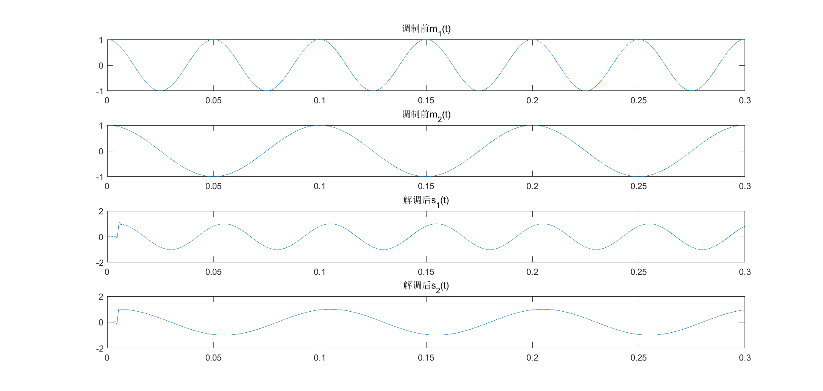

使用不同的