Abstract

Burnout has become more prevalent, mainly in social jobs, and there is evidence that certain personality traits promote or protect against burnout. Only recently, studies have focused on investment traits like Need for Cognition (NFC), the stable intrinsic motivation to seek out and enjoy effortful cognitive activities. This study had three aims: First, replicating findings of NFC and the burnout subscale reduced personal efficacy in student teachers in a sample of *N =* 180 teachers, second, investigating the role of perceived ratios of demands and resources in the context of NFC and burnout, and finally, creating an exploratory model as a starting point for future research. The results indicated that unlike the student sample, the teachers’ association of NFC and reduced personal efficacy was mediated by self-control but not reappraisal. Teachers with higher NFC and self-control also had lower burnout because they experienced their resources as fitting to the demands.

*Keywords:* behaviour, resources, demands, education, Covid-19

Word count: 6,800

## Introduction

Need for Cognition (NFC) is a stable intrinsic motivation to seek out and especially to enjoy effortful cognitive activities (Cacioppo and Petty, 1982). As it bridges the gap between cognition and motivation, NFC is considered to be an investment trait (Stumm and Ackerman, 2013), and has come to the fore of psychological research in the last years. NFC can easily be assessed using the Need for Cognition Scale (NCS), a self-report questionnaire with 18 to 34 items (Cacioppo et al., 1984; Cacioppo and Petty, 1982; German form: Bless et al., 1994). While many studies have found medium sized positive associations of NFC with academic performance (Cazan and Indreica, 2014; Grass et al., 2017; Lavrijsen et al., 2021; Stumm and Ackerman, 2013; Zheng et al., 2020), recent investigations have also looked at NFC as a personal resource in academic and work contexts. Individuals high in NFC have more positive emotions at the end of the work day (Rosen et al., 2020), higher work motivation, perceive their roles as less ambiguous (Nowlin et al., 2017), are less likely to drop out of college (Grass et al., 2017; Klaczynski and Fauth, 1996), and have less anxiety regarding their course work (Karagiannopoulou et al., 2020), with these associations being in a small to medium range. These findings suggest that individuals high in NFC might be less prone to experience adverse effects of work stress, which range from physical (Dragano et al., 2017; Steptoe and Kivimäki, 2013) to psychological consequences (Madsen et al., 2017; Maslach and Leiter, 2016; Wiesner et al., 2005).

One of these psychological consequences is burnout, a state of exhaustion and cynicism caused by long-term overstimulation in the workplace, which results in employees being dissatisfied, being sick more often, and performing poorly (Schaufeli and Salanova, 2014). Burnout is especially prevalent in social jobs such as healthcare or teaching because the worker is often in conflict between advocating for their client and meeting the goals set by the employer (Gray-Stanley and Muramatsu, 2011; Lloyd et al., 2002). Lackritz (2004) found that university teachers’ burnout scores were higher the more students they had, the higher their teaching load was, and the more time they spent grading students’ work. Burnout is most often assessed using the Maslach Burnout Inventory (MBI) (Maslach et al., 1997), a self-report questionnaire with three subscales: *Emotional exhaustion*, a sense of fatigue and depletion, *depersonalisation*, a negative attitude towards clients, along with a loss of idealism, and *reduced personal efficacy*, a decline of capability and coping skills.

Individuals with high burnout scores are often passive copers, high in neuroticism, low in self-esteem, and have an external locus of control (Schaufeli and Salanova, 2014). NFC on the other hand shows opposite associations with those variables (*r* = -.19 with passive coping (Grass et al., 2018), *r* = -.19–-.33 with neuroticism (Fleischhauer et al., 2019), *r* = .42 with self-esteem (Osberg, 1987), *r* = .32 with internal locus of control (Fletcher et al. 1986)), suggesting that people high in NFC are less prone to experience burnout. This is supported by findings that NFC showed moderate to large negative associations with burnout scores in adults (Fleischhauer et al., 2019), students (Fleischhauer et al., 2019; Naderi et al., 2018), and student teachers (Grass et al., 2018). However, the associations of NFC with the sum score and the subscales of the MBI are not always consistent between these studies. This is likely not caused by inaccurate measurement, since the validity of both NCS (Bless et al., 1994; Osberg, 1987; Tolentino et al., 1990) and MBI (Brady et al., 2021; Kantas and Vassilaki, 1997; Schaufeli et al., 2001; Valdivia Vázquez et al., 2021) has been demonstrated in multiple studies. What is more likely is the influence of one or more other variables, moderating or mediating the association of NFC and burnout. Grass et al. (2018) investigated such a mediation in a sample of 167 students, who were studying to become teachers in primary, secondary, special needs, or vocational schools, and who had been studying for *M*± *SD* = 5.13 ± 2.63 semesters. They found that the relation of NFC and the MBI subscale reduced personal-efficacy was fully mediated by higher habitual use of reappraisal, more active coping, and less passive coping, but not by habitual use of suppression or self-control. Reappraisal and suppression are two emotion regulation strategies, which refer to the cognitive reassessment of a stressor and the inhibition of emotional reactions, respectively (Gross, 1998). The findings by Grass et al. (2018) suggest that individuals high in NFC experience a weaker decline in personal efficacy in response to long-term stress because they actively reassess the situation in a way that reinforces their sense of self-efficacy and don’t avoid dealing with the stressor (Strobel et al., 2017). One goal of this paper was to replicate the findings of Grass et al. (2018) in a teacher sample using a multiple mediation model on cross-sectional self-report data of teachers. We expected NFC to be negatively associated with reduced personal efficacy via higher reappraisal scores, but not via suppression, via self-control, or directly.

Furthermore, we extended the analysis to other possible mediators. These mediators were motivated by our own recent survey of the literature on NFC and well-being, which suggested that individuals high in NFC might not only have a high level of personal resources but also overestimate their own resources to a certain degree ([*retracted for peer review*]). This can take the form of patients with higher NFC having lower intentions to consult their physician (Latimer et al., 2007) or adults with higher NFC having higher intentions to consume high calorie beverages (Gallivan, 2020) after detailed message interventions designed to promote consultations and healthier beverage choices, respectively. Only a balance of resources and demands results in personal well-being, while an imbalance threatens well-being, regardless of whether this imbalance is in favour of resources or demands (Dodge et al., 2012). Following the framework of Hobfoll (1989), resources can be objects with practical or status purpose, conditions like marriage or tenure, personality aspects like coping style, and energies such as time, money, or knowledge. In the case of NFC, resources are from the categories personality and energies: Personality, because NFC is a trait, encompassing a curious, analytic, and passionate approach to challenges, and energies, because individuals high in NFC have been coping actively all their life, which enriches their level of experience and knowledge in approaching challenges (Cacioppo et al., 1996). These personal resources matter with regard to stress assessment (how the situation is appraised) and with regard to both coping and recovery (Salanova et al., 2006). We therefore investigated whether the association of NFC and burnout was mediated by different ratios of demands and resources; demands that are too high to be dealt with using one’s personal resources (*demands too high*), demands that are too low for one’s personal resources (*demands too low*), and a balanced fit of demands and resources (*demand-resource-fit*). Using the same data as for the replication, we computed a structural equation model (SEM) to assess the influence of these mediators. Since individuals high in NFC are confident in their abilities (Bye and Pushkar, 2009; Ghorbani et al., 2004; Heppner et al., 1983; Klaczynski and Fauth, 1996), we expected NFC to be negatively associated with *demands too high*, and positively associated with *demands too low* and *demand-resource-fit*. And since burnout results from constant unpleasant activation by high demands, we expected it to be positively associated with *demands too high* and negatively associated with *demand-resource-fit*. However, we had no hypothesis regarding the association of *demands too low* and burnout, because even though *demands too low* is akin to the concept of boredom and the consequences of boredom and burnout are very similar, burnout is a state with even lower activation and even more negative affect than boredom (Schaufeli and Salanova, 2014). It has already been shown that the Covid-19 pandemic has exacerbated the rising prevalence of burnout (Fröbe and Franco, 2021), so we incorporated the degree of feeling burdened by the pandemic in an exploratory approach. To sum up, this study had three aims: Replicating findings of mediation between NFC and reduced personal efficacy in a teacher sample, investigating the impact of different demand-resource-ratios on the relationship between NFC and burnout, and exploring the impact of other variables such as perceived burden by the pandemic.

## Methods

We report how we determined our sample size, all data exclusions (if any), all manipulations, and all measures in the study (Simmons et al., 2012). Our preregistration, the data, and the R Markdown document used to analyze the data and write this manuscript, using the R package *papaja* (Aust and Barth, 2020), are available at *[[retracted for peer review]](https://osf.io/36ep9/)*[.](https://osf.io/36ep9/) The procedure was evaluated and approved by the Ethics Committee of the *[retracted for peer review]* (reference number: V-389-15-AS-Burnout-08062020). It was not considered to require further ethical approvals and hence, as uncritical concerning ethical aspects according to the criteria used by the Ethics Committee, which includes aspects of the sample of healthy adults, voluntary attendance, noninvasive measures, no deception, and appropriate physical and mental demands on the subject.

## Participants

The initial study was aiming to recruit a sample of *N ≥* 287 teachers as determined using the R package *pwr* (Champely, 2020), assuming a small to medium correlation of *r = .*20 between the measures of interest and targeting at a power of 1 *− β = .*80 at *α = .*01. Teachers were recruited via social media, personal contacts to teachers, and to *[retracted for peer review]* schools with the request to pass on the information. All teachers were eligible, no payment was issued. Of the *N =*278 participants, who started filling out the online survey, *N =*180 (72.20% female, aged 20 to 67 years) data sets were complete and those participants indicated to have answered truthfully. All of them were currently teaching at a primary, secondary, comprehensive, or vocational school. Data was collected between the 12th of June and the 24th of July 2020. At this point, schools had been switching between digital and hybrid forms of teaching for at least three months due to the Covid-19 pandemic, causing additional stress for many teachers. This may have also be one reason why we did not reach our estimated sample size. Using the smallest standardized indirect effect from the mediation in Grass et al. (2018) in a post hoc power analysis with *G*Power* (Faul et al., 2007, 2009) yielded a power of 1 *− β = .*85 for linear multiple regression, given *α = .*05, *N =*180, and *f* 2 = *.*05.

## 

## Materials

All questionnaires were used in their German form. Burnout was assessed using the 21-item Maslach Burnout Inventory (MBI, Büssing and Perrar, 1992), with items such as “I don’t really care what happens to some recipients” and responses on a 7-point Likert scale from 0 (never) to 6 (every day). Its subscales *emotional exhaustion*, *depersonalization*, and *reduced personal efficacy* showed acceptable internal consistency (Cronbach’s *α > .*70) and low retest reliabilities of *rtt = .*60, *rtt = .*54, and *rtt = .*57, respectively, over the span of one year in teachers (Maslach et al., 1997). NFC was assessed with the 16-item short version of the German NFC scale (NCS) (Bless et al., 1994), consisting of items (e.g., “Thinking is not my idea of fun”, recoded) that are answered on a 7-point Likert scale ranging from -3 (completely disagree) to +3 (completely agree). The scale shows comparably high internal consistency (Cronbach’s *α > .*80) (Bless et al., 1994; Fleischhauer et al., 2010) and a retest reliability of *rtt = .*83 across 8 to 18 weeks (Fleischhauer et al., 2015). Self-control was measured using the short form of the German Self-Control Scale [SCS-K-D; Bertrams and Dickhäuser (2009)] that comprises 13 items (e.g., “I am able to work effectively toward long-term goals”) with a 5-point Likert scale ranging from -2 (completely disagree) to +2 (completely agree), with comparably high reliability (Cronbach’s *α > .*80, 7-week retest reliability *rtt = .*82) (Bertrams and Dickhäuser, 2009). Reappraisal and suppression was measured using the 10-item Emotion Regulation Questionnaire (ERQ) (Abler and Kessler, 2009). The scale has items such as “When I’m faced with a stressful situation, I make myself think about it in a way that helps me stay calm” (reappraisal) and “I keep my emotions to myself” (suppression), which are answered on a 7-point Likert scale ranging from 1 (strongly disagree) to 7 (strongly agree), and has acceptable to high internal consistency (Cronbach’s *α > .*75) (Preece et al., 2019). Work satisfaction was assessed using the Allgemeine Arbeitszufriedenheit questionnaire (Fischer and Lück, 2014) with items such as “Sometimes I feel like my work doesn’t really matter in my firm”, which are answered on a 5-point Likert scale from 1 to 5 and different anchors depending on the item. The scale has a split-half reliability of *rtt = .*95 (Fischer and Lück, 2014). Eleven items were created to assess each participant’s current burden by the Covid-19 pandemic, such as whether they belong to a risk group or whether they currently had a higher workload. The translated Covid-19 items can be found in the *Supplementary Material S1*. Due to a technical error during survey setup, the coping style data of the Erfurter Belastungsinventar (Böhm-Kasper et al., 2001) could not be used, so we could not replicate the mediation of NFC and burnout by active and passive coping.

## Procedure

The questionnaires were provided online using SoSci Survey (Leiner, 2019). Participants were informed about aims and duration of the study and data security, then they provided demographic information, answered the questionnaires, and could optionally enter their email address to be informed about the results of the analysis of *[retracted for peer review]*’s thesis.

## Data analysis

We used *R Studio* (R Core Team, 2020; RStudio Team, 2020) with the main packages *lavaan* (Rosseel, 2012) and *psych* (Revelle, 2021) for all our analyses. Data were checked for multivariate normality using Mardia’s coefficient. To account for non-linear relationships, correlations were computed using Spearman’s rank coefficient rather than Pearson’s product moment correlation. Internal consistencies were assessed with Cronbach’s Alpha and MacDonald’s Omega. Since Cronbach’s Alpha has been criticized for being insensitive to violations of internal consistency (Dunn et al., 2014; Taber, 2018), the additional computation of MacDonald’s Omega has the purpose of ensuring a more reliable estimation. Correlations between variables were classified according the scheme by Gignac and Szodorai (2016), which recommends .10, .20, and .30 to be considered small, typical, and relatively large, respectively.

**Replication of Grass et al. (2018) in a teacher sample.** Items were reverse coded according to the scale manuals. NFC and self-control were computed as the sum scores of the NCS and the SCS, respectively. *Reduced personal efficacy* was computed using the sum of the MBI subscale, and reappraisal and suppression were computed using the sum of each ERQ subscale. NFC was entered as the independent variable, having a direct and multiple indirect effects on MBI via self-control, reappraisal, and suppression as mediators. Following Grass et al. (2018), bootstrapped confidence with *N =*2,000 replicates and the seed 13 were computed to account for deviations from normality. Multiple indices were used to evaluate model fit as recommended by Hu and Bentler (1999): the Chi-square test statistic, which measures the fit compared to a saturated model (small values indicate better fit of predicted and observed covariances), the Comparative Fit Index (CFI), which compares the fit to the baseline model (*CFI > .*95 indicates good fit, but *CFI > .*90 is also commonly used), the Standardized Root Mean Square Residual (SRMR), which compares the residuals of the observed and predicted covariance matrix (*SRMR < .*08 indicates fair fit, *SRMR < .*05 good fit), and the Root Mean Square Error of Approximation (RMSEA), which does the same as the latter but takes degrees of freedom and model complexity into account (*RMSEA < .*08 indicates acceptable fit, *RMSEA < .*05 good fit, *RMSEA < .*01 excellent fit).

**Demand-resource-ratio model.** All items, apart from those making up the demand-resource-ratios, were reverse coded according to the scale manuals. The latent factor NFC was computed by subjecting the NCS items to a parcelling procedure (Little et al., 2002), a method that is used in SEM when only relations between but not within constructs are of interest. Principal component analysis was used to determine the factor loadings of each NCS item onto the first component. Then, the items were randomly divided into four parcels and the average item loading per parcel was computed. This was repeated 10,000 times to find the parcelling choice with the smallest difference in average item loadings between parcels. The latent factor MBI was computed using the three subscales as indicators. For the demand-resource-ratios, we used three items from the work satisfaction scale each. The latent factor *demands too high* was indicated by items 4, 8, and 9, *demands too low* by the recoded items 12, 26, and 27, and *demand-resource-fit* by items 17, 22, and 24. The items can be translated as follows: 4) “There is too much pressure on me.”, 8) “There is often too much being demanded of us at work.”, 9) “I often feel tired and weary because of my work.”, 12) “I can realize my ideas here.”, 17) “I take pleasure in my work.”, 22) “Does your place of work give you the opportunity to do what you do best?”, 24) “Does your place of work give you enough opportunities to use your skills?”, 26) “Are you happy with your promotion prospects?”, and 27) “Are you happy with your position when comparing it to your skills?”. Model parameters were estimated using the maximum likelihood method with robust standard errors. Model fit was evaluated by looking at the Chi-square test statistic, CFI, SRMR, and RMSEA.

**Exploratory analyses.** We preregistered two exploratory analyses. Firstly, we repeated the SEM with the subscale *reduced personal efficacy* in place of the MBI score, since this subscale has shown higher correlations with NFC than the other subscales (Grass et al., 2018; Naderi et al., 2018). And secondly, we included a Covid-19 burden score into the SEM, computed as the sum of the Covid-19 items.

## Results

During visual inspection of correlation plots we noticed an unexpected outlier with very high MBI scores and very low NFC scores. A Q-Q-plot contrasting Mahalanobis *D2* against expected Chi Square values confirmed the outlier. To adhere to the preregistration, we report the results containing the outlier in this section and the results excluding the outlier in the *Supplementary Material S2*.

## Descriptive statistics.

Basic metric descriptives of the questionnaire scores and subscales are listed in Table 1. Only the ERQ sum score and its reappraisal subscale followed a normal distribution, so the results of the models should be interpreted with some caution and with a focus on indices that are robust against violation of normality, such as the Satorra-Bentler or Yuan-Bentler-scaled test statistics (Rosseel, 2012).

Table 1

*Descriptive statistics of the questionnaire scores.*

|  |  |  |  |  |  |  |  |
| --- | --- | --- | --- | --- | --- | --- | --- |
| Variable | Minimum | Maximum | Mean | SD | Normality | Skewness | Kurtosis |
| MBI | 27 | 101 | 52.93 | 13.06 | No | 0.35 | 0.02 |
| MBI EE | 12 | 52 | 27.99 | 8.87 | No | 0.19 | -0.59 |
| MBI DP | 5 | 24 | 9.72 | 3.26 | No | 0.82 | 0.86 |
| MBI RPE | 7 | 28 | 15.22 | 3.43 | No | 0.42 | 1.11 |
| ERQ | 16 | 63 | 39.18 | 7.82 | Yes | -0.16 | 0.45 |
| ERQ S | 4 | 26 | 12.59 | 4.85 | No | 0.14 | -0.73 |
| ERQ R | 9 | 42 | 26.59 | 6.29 | Yes | -0.05 | 0.01 |
| SCS | -19 | 23 | 7.79 | 8.42 | No | -0.39 | -0.22 |
| NFC | -34 | 48 | 20.37 | 14.04 | No | -0.59 | 0.56 |
| DTH | -6 | 6 | 0.49 | 2.65 | No | -0.15 | -0.56 |
| DTL | -6 | 6 | -2.22 | 2.24 | No | 0.46 | 0.28 |
| DRF | -4 | 6 | 3.63 | 1.79 | No | -0.91 | 1.75 |
| COV | 14 | 33 | 24.53 | 4.28 | No | -0.14 | -0.70 |

*Note:* MBI = Maslach Burnout Inventory, MBI EE = Emotional exhaustion subscale, MBI DP = Depersonalisation subscale, MBI RPE = Reduced personal efficacy subscale, ERQ = Emotion Regulation Questionnaire, ERQ S = Suppression subscale, ERQ R = Reappraisal subscale, SCS = Self-Control Scale, NFC = Need for Cognition, DTH = Demands Too High, DTL = Demands Too Low, DRF = Demand-Resource-Fit, COV = Covid-19 Burden, SD = Standard deviation. *N =*180.

Correlations and internal consistencies are displayed in Table 2. For this descriptive analysis, the variables *demands too high*, *demands too low*, and *demand-resource-fit* were computed as a sum of their item scores, not weighted as in the structural equation model. Using traditional cut-off values (Nunnally and Bernstein, 1994), the Cronbach’s Alpha of the three demand-resource-ratios can be considered *acceptable*. The more robust MacDonald’s Omega (Dunn et al., 2014) did not deviate much from Cronbach’s Alpha and indicated *acceptable* to *good* internal consistency. As expected, the MBI score showed a large positive correlation with *demands too high* (*rs =*.67, *p <*.001) and a large negative one with *demand-resource-fit* (*rs =*-.55, *p <*.001). Surprisingly, the correlation between the MBI score and *demands too low* was positive and also large (*rs =*.44, *p <*.001). The NFC score correlated negatively with the MBI sum score and about equally with all subscales, contrary to some previous observations in other studies.

Table 2

NFC AND BURNOUT IN TEACHERS

12

*Spearman correlations and internal consistencies of the questionnaire scores.*

|  |  |  |  |  |  |  |  |  |  |  |  |  |  |
| --- | --- | --- | --- | --- | --- | --- | --- | --- | --- | --- | --- | --- | --- |
|  |  | 1 | 2 | 3 | 4 | 5 | 6 | 7 | 8 | 9 | 10 | 11 | 12 |
| 1 | MBI | .90(.91) |  |  |  |  |  |  |  |  |  |  |  |
| 2 | MBI EE | .92*** | .91(.92) |  |  |  |  |  |  |  |  |  |  |
| 3 | MBI DP | .75*** | .54*** | .68(.69) |  |  |  |  |  |  |  |  |  |
| 4 | MBI RPE | .67*** | .43*** | .48*** | .79(.79) |  |  |  |  |  |  |  |  |
| 5 | ERQ | -.06 | -.06 | .04 | -.10 | .73(.62) |  |  |  |  |  |  |  |
| 6 | ERQ S | .05 | .00 | .17* | .08 | .59*** | .75(.79) |  |  |  |  |  |  |
| 7 | ERQ R | -.10 | -.06 | -.06 | -.20** | .71*** | -.07 | .84(.84) |  |  |  |  |  |
| 8 | SCS | -.34*** | -.28*** | -.37*** | -.19* | -.03 | -.12 | .05 | .85(.86) |  |  |  |  |
| 9 | NFC | -.25*** | -.20** | -.22** | -.21** | -.01 | -.18* | .16* | .22** | .89(.89) |  |  |  |
| 10 | DTH | .67*** | .72*** | .35*** | .36*** | .03 | .05 | -.01 | -.21** | -.15* | .73(.73) |  |  |
| 11 | DTL | .44*** | .36*** | .38*** | .43*** | .01 | .16* | -.14 | -.19* | -.16* | .41*** | .73(.75) |  |
| 12 | DRF | -.55*** | -.46*** | -.41*** | -.53*** | .00 | -.10 | .10 | .18* | .24** | -.42*** | -.56*** | .77(.77) |
| 13 | COV | .24** | .32*** | .08 | .02 | -.03 | .02 | -.07 | -.04 | .13 | .45*** | .10 | -.13 |

*Note:* MBI = Maslach Burnout Inventory, MBI EE = Emotional exhaustion subscale, MBI DP = Depersonalisation subscale, MBI RPE = Reduced personal efficacy subscale, ERQ = Emotion Regulation Questionnaire, ERQ S = Suppression subscale, ERQ R = Reappraisal subscale, SCS = Self-Control Scale, NFC = Need for Cognition, DTH = Demands Too High, DTL = Demands Too Low, DRF = Demand-Resource-Fit, COV = Covid-19 Burden. *N =*180. *\* p <*.05, \**\* p <*.01, \**\* p <*.001. Diagonal is Cronbach’s Alpha and (in brackets) MacDonald’s Omega. The diagonal value of Covid-19 Burden is Cronbach’s Alpha = .77 and MacDonald’s Omega = .81.

## Replication of Grass et al. (2018) in a teacher sample

In order to replicate findings by Grass et al. (2018) we computed a multiple mediation model to investigate whether the association of NFC and *reduced personal efficacy* was partially mediated by self-control and habitual use of reappraisal and suppression, respectively. The baseline model did not fit the data (*χ*2(10, *N =*180) = 49.64, *p < .*001). Applying the cutoffs by Hu and Bentler (1999) to the fit indices of *CFI =*1, *TLI =*1.14, *SRMR =*0.02, and *RMSEA =*0.00, 95% *CI* [0,0.09], suggested good fit of the proposed model throughout all indices. Standardized estimates are displayed in Figure 1, total, direct, and indirect effects are listed in Table 3. We could replicate a positive association of NFC and self-control (*β =*0.27, *p = .*002), and a negative association of habitual reappraisal and *reduced personal efficacy* (*β =*-0.17, *p = .*008). However, we could neither replicate the effect of NFC on reappraisal (*β =*0.12, *p = .*105), nor the indirect effect of NFC on *reduced personal efficacy* via reappraisal (*β =*-0.02, *p = .*153). Furthermore, even though NFC and *reduced personal efficacy* were both associated with self-control in the correlational analysis, the indirect effect of NFC on *reduced personal efficacy* via self-control did not reach significance (*β =*-0.05, *p = .*090). Additionally, NFC was negatively associated with habitual use of suppression (*β* = -0.18, *p* = .012), which was not the case in the study by Grass et al. (2018).

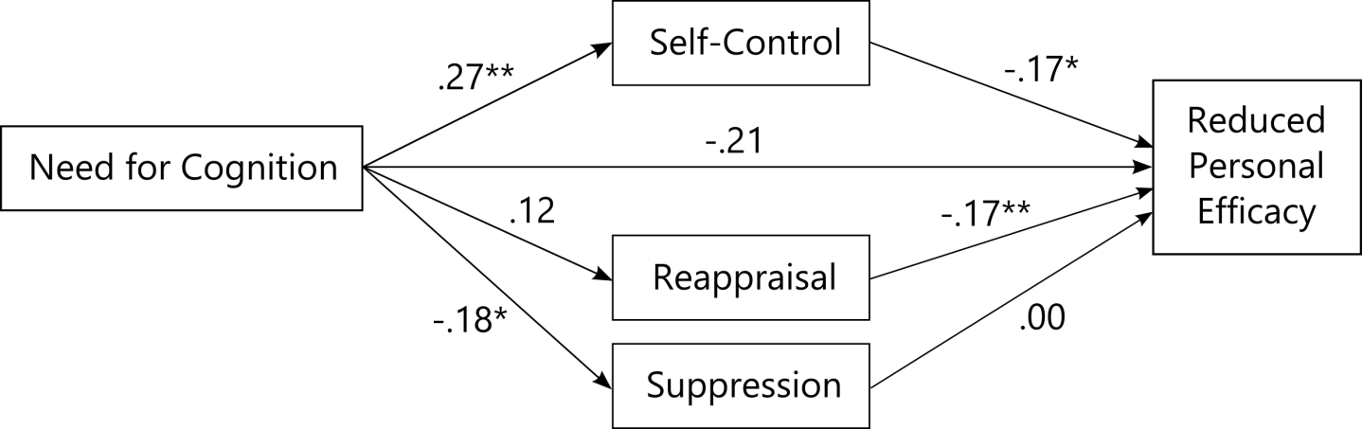

*Figure 1*. Standardized regression coefficients in the replication of Grass et al. (2018). *\* p < .*05. ** p < .01.

Grass et al. (2018) controlled for age and a-level grade in their analysis, which we did not consider when preregistering this analysis. Since grade was not assessed in this sample, and age was assessed as a categorical variable, we instead incorporated how many years each participant had spent teaching at the point of assessment. We placed this variable as an independent variable influencing self-control, as the latter was the only variable in the model that showed a partial correlation with years spent teaching. As it was not preregistered, this was an exploratory analysis. Again, the baseline model did not fit the data (*χ*2(14, *N =*180) = 60.41, *p < .*001), and the fit indices of *CFI =*1, *TLI =*1.19, *SRMR =*0.02, and *RMSEA =*0.00, 95% *CI* [0,0.04], suggested good fit of the proposed model throughout all indices. Standardized estimates, total, direct, and indirect effects are displayed and listed in *Supplementary Material S3*. The associations between NFC, self-control, reappraisal, suppression, and *reduced personal efficacy* were almost identical to the first model. However, because of the positive association of years spent teaching and self-control (*β* = 0.22, p < .001), the indirect path leading from NFC and years spent teaching via self-control to reduced personal efficacy reached significance in this model (*β* = -0.09, *p* = .049). Therefore, the total effect also increased slightly, compared to the first model (*β* = -0.32, *p* = .002).

Table 3

*Results of the replication of Grass et al. (2018) in a teacher sample.*

|  |  |  |  |  |  |  |  |
| --- | --- | --- | --- | --- | --- | --- | --- |
| Path | *B* | *SE* | *z*-value | *p*-value | CI Lower | CI Upper | *β* |
| Direct Effects | | | | | | | |
| NFC on Self-Control | 0.162 | 0.051 | 3.154 | .002 | 0.055 | 0.258 | 0.271 |
| NFC on Reappraisal | 0.055 | 0.034 | 1.619 | .105 | -0.011 | 0.120 | 0.123 |
| NFC on Suppression | -0.063 | 0.025 | -2.524 | .012 | -0.113 | -0.017 | -0.182 |
| Self-Control on RPE | -0.069 | 0.030 | -2.318 | .020 | -0.126 | -0.009 | -0.169 |
| Reappraisal on RPE | -0.094 | 0.036 | -2.652 | .008 | -0.159 | -0.023 | -0.173 |
| Suppression on RPE | 0.002 | 0.051 | 0.043 | .966 | -0.094 | 0.106 | 0.003 |
| NFC on RPE | -0.051 | 0.021 | -2.473 | .013 | -0.089 | -0.008 | -0.208 |
| Indirect Effects | | | | | | | |
| NFC on RPE via Self-Control | -0.011 | 0.007 | -1.695 | .090 | -0.026 | -0.001 | -0.046 |
| NFC on RPE via Reappraisal | -0.005 | 0.004 | -1.429 | .153 | -0.013 | 0.001 | -0.021 |
| NFC on RPE via Suppression | 0.000 | 0.004 | -0.039 | .969 | -0.008 | 0.006 | -0.001 |
| Total Effect | | | | | | | |
| Total Effect | -0.067 | 0.023 | -2.957 | .003 | -0.111 | -0.021 | -0.276 |

*Note: B =*unstandardized regression coefficient, beta = standardized regression coefficient, *CI =*confidence interval, NFC = Need for Cognition, RPE = reduced personal efficacy subscale of the Maslach Burnout Inventory, *SE =*standard error, *N* = 180.

## Demand-Resource Model

Next we looked at how different ratios of subjective demands and resources affect the association of NFC and burnout. The parcelling procedure for the indicators of the latent factor NFC resulted in four parcels with a summed difference in average loadings of 0.00. The first parcel contained item 4, 6, 8, and 9, the second parcel item 2, 14, 15, and 16, the third parcel item 7, 11, 12, and 13, and the fourth parcel item 1, 3, 5, and 10. Standardized path coefficients of the demand-resource model are illustrated in Figure 2, total, direct, and indirect effects are listed in Table 4. The robust Chi-square statistic of *χ*2 = 399.08 (*p < .*001) did not indicate good model fit. However, since it was in the range of 4 *df < χ*2 *>* 5 *df* the lack of good fit might have been due to the underlying assumption of multivariate normality (Hu and Bentler, 1999; Schumacker and Lomax, 2012), which was violated here. This also held true for the CFI of 0.78, the SRMR of 0.17, and the RMSEA of 0.13, 95% *CI* [0.12,0.14]. Overall, the fit indices did not support the proposed model, and not all proposed paths were significant. NFC showed no direct association with the MBI score (*β =*0.00, *p = .*989), even though it was negatively correlated with the sum score and all subscales. Instead, NFC showed indirect negative associations with the MBI score via lower scores in the latent variable *demands too high* (*β =*-0.20, *p = .*026) and via higher scores in the latent variable *demand-resource-fit* (*β =*-0.13, *p = .*025). The latent variable demands too low was neither related to NFC (*β =*-0.18, *p = .*128) nor to the MBI score (*β =*0.11, *p = .*198).

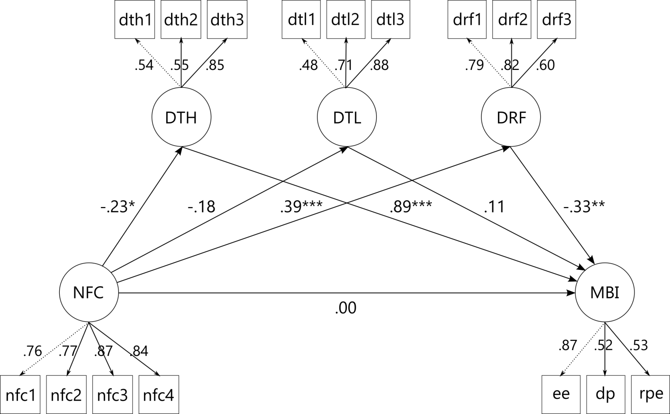

*Figure 2*. Standardized path coefficients in the mediation of NFC and burnout by demand- resource-ratios. *\* p < .*05, *\*\* p < .*01, \*\**\* p < .*001. NFC = Need for Cognition, DTH = demands too high, DTL = demands too low, DRF = demand resource fit, MBI = Maslach Burnout Inventory, nfc1-4 = item parcels, dth/dtl/drf1-3 = item indicators, ee = emotional exhaustion, dp = depersonalisation, rpe = reduced personal efficacy.

## Exploratory analyses

The first exploratory analysis concerned a modification of the demand-resource-model in which the subscale *reduced personal efficacy* would be used in place of the MBI sum score. Path coefficients, total, direct, and indirect effects are displayed and listed in *Supplementary Material S4*. Similar to the previous model, this model’s indices did not indicate good fit, with a Chi-square statistic of *χ*2 = 247.82 (*p < .*001), a CFI of 0.83, a SRMR of 0.17, and a RMSEA of 0.12, 95% *CI* [0.10,0.13]. NFC showed no direct association with *reduced personal efficacy* (*β =*-0.05, *p = .*551), but an indirect one via higher scores in the latent variable *demand-resource-fit* (*β =*-0.22, *p = .*002). And again, NFC was associated with lower scores in the latent variable *demands too high* (*β =*-0.22, *p = .*025), but the latter did not mediate the relationship between NFC and *reduced personal efficacy* (*β =*-0.03, *p = .*243) as it did with the MBI score in the previous model. The latent variable *demands too low* was neither related to NFC (*β =*-0.19, *p = .*102) nor to the MBI score (*β =*0.11, *p = .*196).

Table 4

*Results of the demand-resource-ratio model.*

|  |  |  |  |  |  |  |  |
| --- | --- | --- | --- | --- | --- | --- | --- |
| Path | *B* | *SE* | *z*-value | *p*-value | CI Lower | CI Upper | *β* |
| Direct Effects | | | | | | | |
| NFC on DTH | -0.042 | 0.020 | -2.154 | .031 | -0.081 | -0.004 | -0.228 |
| NFC on DTL | -0.023 | 0.015 | -1.522 | .128 | -0.052 | 0.007 | -0.180 |
| NFC on DRF | 0.070 | 0.020 | 3.488 | .000 | 0.031 | 0.110 | 0.386 |
| NFC on MBI | 0.002 | 0.144 | 0.014 | .989 | -0.281 | 0.285 | 0.001 |
| DTH on MBI | 10.624 | 2.229 | 4.767 | .000 | 6.256 | 14.991 | 0.892 |
| DTL on MBI | 1.838 | 1.428 | 1.287 | .198 | -0.960 | 4.637 | 0.106 |
| DRF on MBI | -4.036 | 1.080 | -3.736 | .000 | -6.153 | -1.918 | -0.332 |
| Indirect Effects | | | | | | | |
| NFC on MBI via DTH | -0.451 | 0.203 | -2.221 | .026 | -0.848 | -0.053 | -0.203 |
| NFC on MBI via DTL | -0.042 | 0.033 | -1.270 | .204 | -0.107 | 0.023 | -0.019 |
| NFC on MBI via DRF | -0.284 | 0.127 | -2.236 | .025 | -0.533 | -0.035 | -0.128 |
| Total Effect | | | | | | | |
| Total Effect | -0.775 | 0.258 | -3.003 | .003 | -1.280 | -0.269 | -0.349 |

*Note: B =*unstandardized regression coefficient, *β =*standardized regression coefficient, CI = confidence interval, DTH = Demands Too High, DTL = Demands Too Low, DRF = Demand Resource Fit, MBI = Maslach Burnout Inventory, NFC = Need for Cognition, *SE =*standard error.

The second exploratory analysis concerned the incorporation of the Covid burden score into the model. We based the development of this model on the partial correlations of all variables, which provide an indication of how closely or remotely related variables might be in a path model. Then we modified the structure of the model using the *modindices()*-function in *lavaan* in order to increase the goodness-of-fit indices within the framework of contentually meaningful variable relationships. The final model is illustrated in Figure 3, the total, direct, and indirect effects are listed in *Supplementary Material S5*. All fit indices suggested that the proposed model had good fit while the baseline model did not (*χ*2 = 130.13 (*p < .*001), *CFI =*0.95, *RMSEA =*0.07 (95% *CI* [0.05,0.08]), *SRMR =*0.06). Neither the ERQ sum score, nor its subscales, nor the *depersonalisation* subscale of the MBI contributed significantly to the explained variance and were therefore not included in the final model. Years spent teaching was associated with higher self-control (*β =*0.21, *p = .*002) and higher Covid burden (*β =*0.17, *p = .*020) but not with NFC. NFC covaried with self-control (*σNFC,scs =*0.31, *p = .*008) and Covid burden (*σNFC,covb =*0.19, *p = .*018), but not with years spent teaching (*p = .*722). In turn, NFC was associated with higher *demand-resource-fit* scores (*β =*0.34, *p = .*002) and lower *demands too high* scores (*β =*-0.21, *p = .*008) but not directly with any of the two MBI subscales. *Demand-resource-fit* scores fully mediated the negative association of NFC and self-control with *reduced personal efficacy* (indirect effect *β =*-0.29, *p.*001), which was also true for *demands too high* scores and *emotional exhaustion*, but *demands too high* also partially mediated between Covid burden and *emotional exhaustion* (indirect effect *β =*-0.18, *p = .*008). Covid burden was not associated with *demand-resource-fit* or *reduced personal efficacy*.

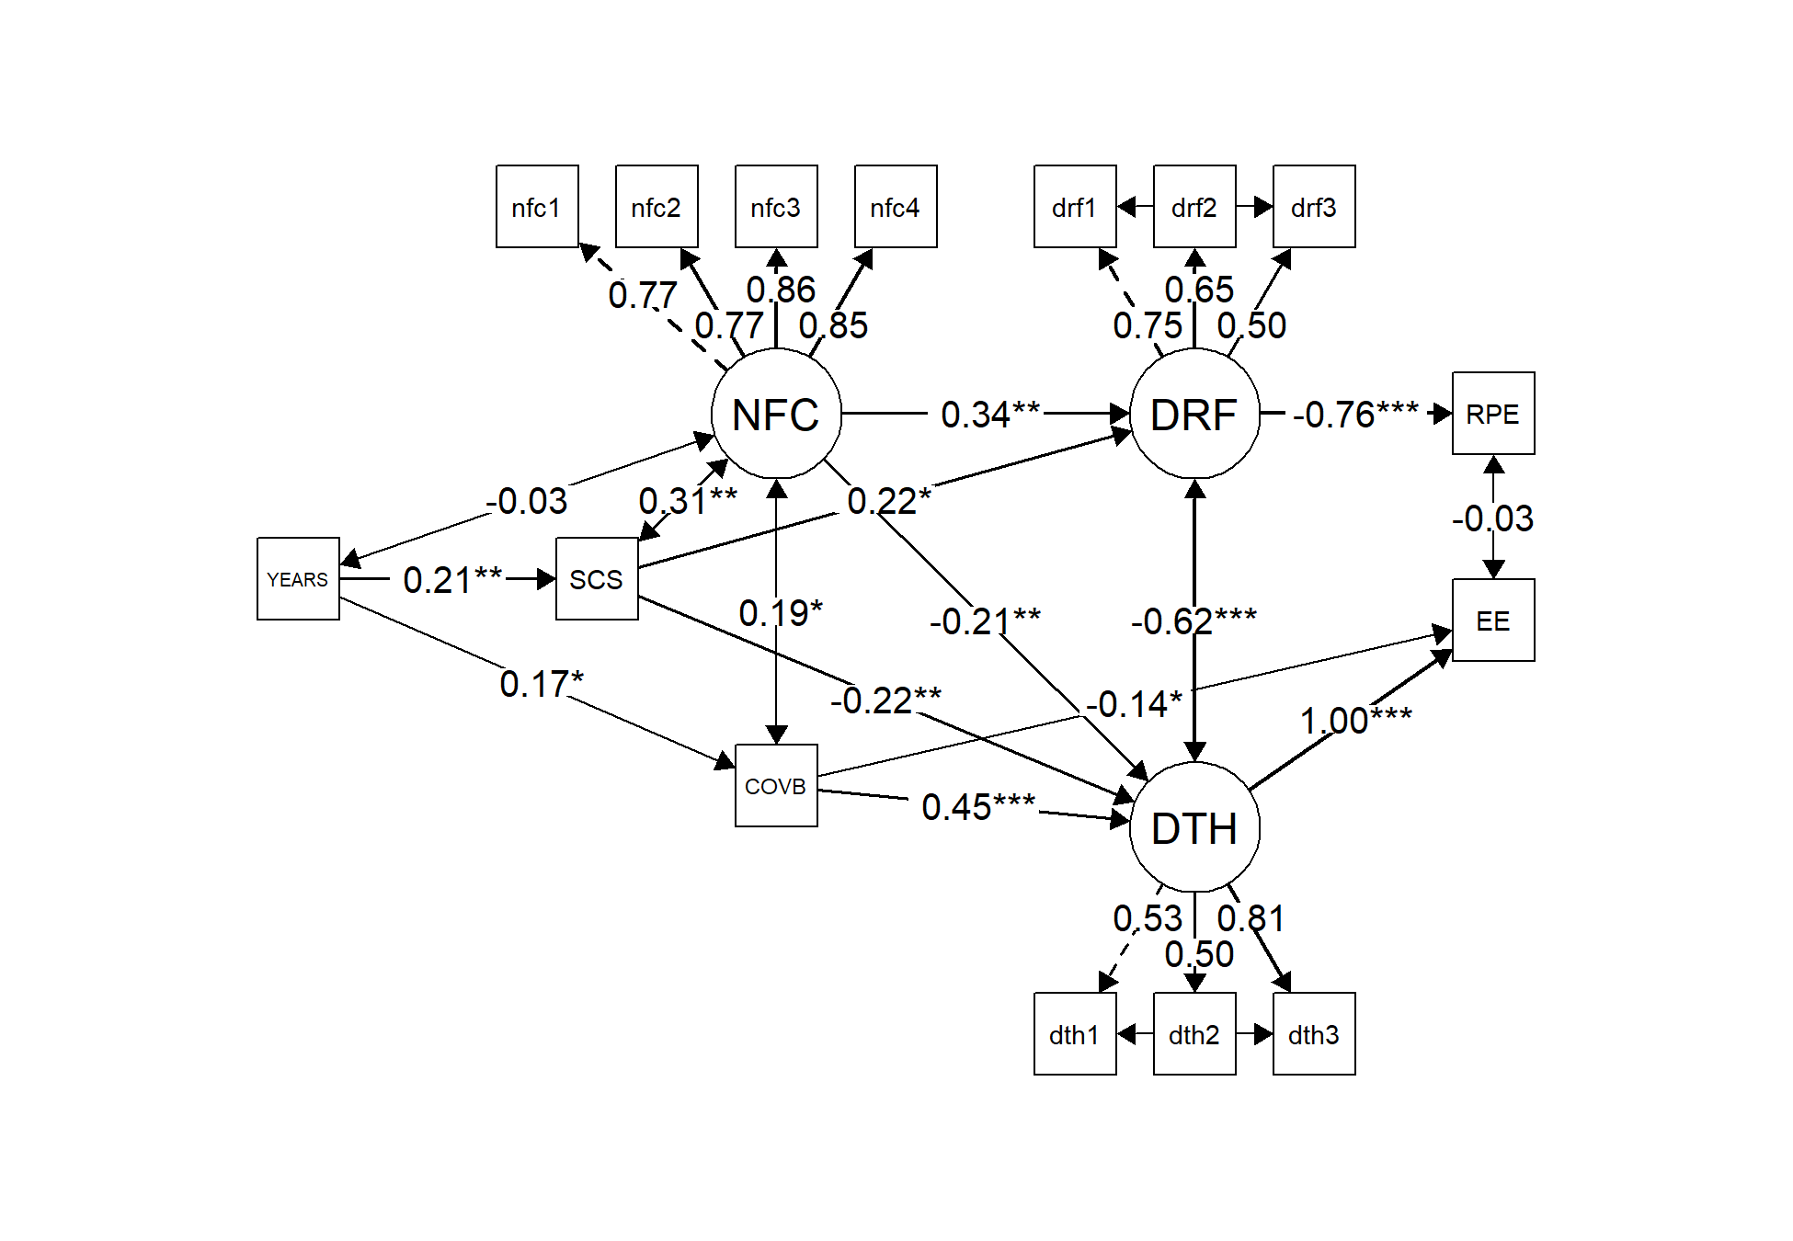

*Figure 3*. Standardized path coefficients in the exploratory analysis of variable relations. *\* p < .*05, \**\* p < .*01, \*\**\* p < .*001. Years = years spent teaching, SCS = Self-Control Scale, COVB = Covid burden, NFC = Need for Cognition, DTH = demands too high, DRF = demand resource fit, nfc1-4 = item parcels, dth/drf1-3 = item indicators, EE = emotional exhaustion, RPE = reduced personal efficacy.

## Discussion

The present study aimed to investigate the role of Need for Cognition, the stable preference for and enjoyment of cognitive effort, in the context of burnout in teachers. To achieve this, we replicated findings of mediators between Need for Cognition and reduced personal efficacy, and extended the analysis to the role of different ratios of demands and resources in burnout using latent variable models. In an exploratory approach, we investigated the influence of the burden that the Covid-19 pandemic has placed on teachers. Previous studies have indicated a protective effect of NFC against burnout, but the associations with the burnout subscales were inconsistent, suggesting that there are more variables influencing this relationship.

## Replication of Grass et al. (2018) in a teacher sample

While the mediation model had good fit, not all patterns were similar to the original study: NFC and self-control had a medium positive association, and reappraisal and *reduced personal efficacy* had a small negative association, but NFC and reappraisal were not associated. There was, however, a small negative association between self-control and *reduced personal efficacy*, and between NFC and suppression.

NFC had a direct, medium negative effect on *reduced personal efficacy*, but this relationship was not mediated by any other variable. Only when the amount of teaching experience was included as a predictor of self-control next to NFC, a very small indirect effect via self-control reached significance, indicating that teachers with high NFC and more years of teaching experience have higher self-control and, consequently, lower *reduced personal efficacy*. The higher self-control that comes with more teaching experience is in line with findings of fluctuations in self-control in young adults, reaching a low point between the age of 15 and 19 (Oliva et al., 2019). The participants in the study by Grass et al. (2018) were student teachers with a mean age of 25.5 years, while the majority of the current sample was between 40 and 59 years old. Therefore, it is likely that not only the teaching experience itself but also higher age might be associated with higher self-control. However, one could argue that more experience provides the teacher with a bigger repertoire of coping strategies to enable an efficient exertion of self-control, especially for teachers high in NFC who are intrinsically motivated to find and apply such strategies.

We could replicate the relation between the two emotion regulation strategies reappraisal and suppression with *reduced personal efficacy*, but not their association with NFC. There is ample evidence that reappraisal is associated with positive outcomes for students (Haga et al., 2007; Levine et al., 2012; Schmidt et al., 2010) and teachers alike (Jiang et al., 2016; Moè and Katz, 2020; Tsouloupas et al., 2010), so it is suprising that reappraisal did not mediate between NFC and *reduced personal efficacy*. Reappraisal did correlate with NFC, as it should appease the preference for cognitive effort in individuals with high NFC, but it was not a mediator in this model. One possible explanation could be that the ways by which reappraisal can be achieved, such as taking the role of an uninvolved observer, are less feasible for teachers in retaining their sense of efficacy in the classroom than the self-control needed to structurally manage students and situations. Hence, the mediation of NFC and *reduced personal efficacy* by self-control when taking the years spent teaching into account.

## Demand-resource-ratio model

Despite not having good fit indices, the model suggested a complete mediation of NFC and burnout via *demands too high* and *demand-resource-fit* but not *demands too low*. Specifically, individuals with higher NFC had lower burnout scores through perceiving demands as fitting to and not exceeding their own resources. Interestingly, the medium correlation between NFC and burnout disappeared in the context of the demand-resource-ratios as mediators. The mediator that did not reach significance was the perception of own resources exceeding the job demands. As this latent variable was conceptualized as boredom at work, we could not confirm the positive association of boredom and burnout found by Reijseger et al. (2013.). However, the positive association of *demands too high* and *demands too low* in the correlation analysis suggests that boredom and burnout are not mutually exclusive. A teacher can have a very high workload, which is reflected in an elevated *demands too high* score, but the work in question might not be intellectually stimulating at all or might not appeal to their ideals and goals, which increases their *demands too low* score. Both of these variables were correlated with higher MBI scores, but in this model, high demands appear to have contributed more to explaining variance in MBI scores than low demands, suggesting that the perceived workload is more important in the burnout context than how stimulating the work is. The fact that the items that made up the demand-resource-ratios were about the subjective perception and not about objective measures, supports the idea that the individual appraisal of one’s own circumstances plays a crucial role in the development of burnout. This individual appraisal has been emphasized as the cause for the ambiguous impact of demands on psychological well-being before, in the form of challenge demands and hindrance demands (Lazarus and Folkman, 1984; Lepine et al., 2005; Podsakoff et al., 2007). Challenge demands such as time pressure, responsibility, and workload (Podsakoff et al., 2007) are being positively valued due to their potential to increase personal growth, positive affect, and problem-focused coping (Lepine et al., 2005). In contrast, hindrance demands such as inadequate resources, role conflict, and organisational politics (Podsakoff et al., 2007) are perceived as negative because they harm personal growth, trigger negative emotions, and increase passive coping (Lepine et al., 2005). Ventura et al. (2015) found that hindrance but not challenge demands were positively related to burnout in teachers, and teachers who reported high challenge and low hindrance demands also reported higher engagement. Whether and to what extent a circumstance is perceived as a challenge or hindrance demand is highly influenced by a person’s level of self-efficacy (Bandura, 1997), so much so that a reduction in self-efficacy is considered to be a precurser of burnout, not necessarily a symptom (Cherniss, 1993; Vera et al., 2012). Self-efficacy and self-control are closely entwined (Przepiórka et al., 2019; Vera et al., 2004; Yang et al., 2019) and both are positively associated with NFC (Bertrams and Dickhäuser, 2012; Holch and Marwood, 2020; Naderi et al., 2018; Xu and Cheng, 2021). Cacioppo et al. (1996) even proposed that higher levels of NFC might develop as a result of a high need for structure or control in those who have the skill, ability, and inclination to do so. These associations would imply that teachers with high levels of NFC report lower levels of burnout because their higher (desire for) self-control motivates them to appraise demands as a chance for personal growth, thereby meeting their passion for thinking and problem-solving. Nevertheless, appraisal is no universal remedy for circumstances that threaten well-being, as there certainly are circumstances that one cannot get any benefit out of. It remains an open question whether a high desire for control and high NFC might cloud one’s judgement in this case, by encouraging to invest one’s own insufficient resources in order to meet these high external demands. Such behavioural tendencies would threaten personal well-being in the long term, as the demands cannot be met, self-efficacy declines, and stress increases.

## Exploratory analyses

**Demand-resource-ratio model with subscale reduced personal efficacy.** The demand-resource-ratio model with the subscale *reduced personal efficacy* in place of the MBI score did not have good fit indices. Compared to the confirmatory demand-resource-ratio model, the mediation of NFC and *reduced personal efficacy* via *demands too high* did not reach significance, but both the mediation via *demand-resource-fit* and the total effect remained significant. Overall, this pattern did not resemble those from previous studies in which NFC had the strongest relation with this subscale of the MBI (Grass et al., 2018; Naderi et al., 2018). Teachers with high NFC appear to retain their sense of personal efficacy to a higher degree, because they experience a fit of demands and resources, which allows them to complete tasks and reinforce their self-efficacy in return. However, while this association was similar in the confirmatory and the exploratory demand-resource-ratio model, the mediation via *demands too high* was not significant with this subscale, suggesting that the large association of *demands too high* and MBI in the confirmatory model was driven by a different subscale. To explore this, we built a second exploratory model.

**Exploratory model with Covid burden.** Due to the complete freedom in setting up the structure of this model, it had good fit indices. Interestingly, the third MBI subscale *depersonalisation* and the latent variable *demands too low* did not explain any variance in the model, so they were removed. Once again, NFC and self-control were positively related, but NFC was also positively related to Covid burden. One possible explanation is that teachers with higher NFC show higher consideration of the consequences and progression of the pandemic, thereby anticipating that it will take a long time until normal teaching can resume, which heightens their feeling of being burdened. Although NFC has been shown to be related to more reflective thinking and unrelated to rumination, which are considered healthy and unhealthy thinking styles, respectively (Nishiguchi et al., 2018; Vannucci and Chiorri, 2018), a higher perceived Covid burden itself cannot indicate whether it stems from a realistic view on the pandemic or a feeling of being overwhelmed. Teachers with more years of experience also reported higher Covid burden, presumably because older people are less comfortable with technology (Hauk et al., 2018) and therefore stressed by the prospect of online teaching. Teachers with higher self-control and higher NFC reported a stronger fit of demands and resources, which was associated with a strong decrease in *reduced personal efficacy*. Higher self-control, higher NFC, and lower Covid burden was in turn associated with a lower *demands too high* score, so teachers with those characteristics felt less overwhelmed and consequently less emotionally exhausted. The degree of association between *demands too high* and *emotional exhaustion* indeed suggested a congruence between the two, indicating that *emotional exhaustion* in burnout is caused by excessive demands that cannot be met with one’s resources, while *reduced personal efficacy* in burnout is caused by a lack of opportunities to utilize one’s resources at work. Curiously, higher Covid burden also showed a small negative association with *emotional exhaustion*. It could be that for some teachers, remote teaching was experienced as a relief from the strain of dealing with a group of over twenty students each day, who are more likely to misbehave in a classroom setting than when they are studying at home. So while those teachers did feel the pandemic burden, they also felt less emotionally exhausted. However, as this part of the study was exploratory, the results should be interpreted with some caution and examined with new data in a confirmatory approach.

## Limitations and future implications

The data used in this study had been collected with a focus on emotion regulation and burnout, so there were several aspects that would have improved the investigation of our research questions but were not feasible. Firstly, collecting coping style data would have enabled a full replication of the mediation model of Grass et al. (2018). Secondly, longitudinal data would have facilitated more definitive conclusions about causal relations, as well as about inter-individual differences in the perception of demands and resources as the pandemic progresses. Furthermore, the latent variables for the demand-resource-ratios were item groups chosen from the work satisfaction questionnaire and had not been validated for this use before. However, as two of them showed meaningful relations with self-control, NFC, and two of the three MBI subscales, pursuing this concept further seems promising. Especially because we worked with pre-existing data, we preregistered all analyses and clearly differentiated between confirmatory and exploratory models in order to make the results as reliable as possible.

## Conclusions

Our study showed that self-control mediated between NFC and reduced personal efficacy when teaching experience was being taken into account. Contrary to prior studies, neither habitual use of reappraisal nor use of suppression mediated between NFC and burnout. However, a crucial role in the relation of NFC and burnout seemed to be the perceived ratio of personal resources and demands, specifically, a resource-demand-fit was associated with lower and excessive demands were associated with higher burnout scores. Applied to real-life teaching practise, our results suggest that a healthy work environment should offer ample opportunities to make use of one’s abilities, without creating demands that are too high. As a consequence, experiences and sense of self-efficacy will increase, which in turn heightens confidence in one’s skills to deal with future demands that are higher, preventing loss of personal efficacy and burnout in the long term.

## References

Abler B and Kessler H (2009) Emotion Regulation Questionnaire – Eine deutschsprachige Fassung des ERQ von Gross und John. *Diagnostica* 55(3): 144–152. DOI: [10.1026/0012-1924.55.3.144.](https://doi.org/10.1026/0012-1924.55.3.144)

Aust F and Barth M (2020) papaja: Create APA Manuscripts with R Markdown. Available at: <https://github.com/crsh/papaja>.

Bandura A (1997) Self-Efficacy: The Exercise of Control. Worth Publishers.

Bertrams A and Dickhäuser O (2009) Messung dispositioneller Selbstkontroll-Kapazität. Diagnostica 55(1): 2–10. DOI: [10.1026/0012-1924.55.1.2.](https://doi.org/10.1026/0012-1924.55.1.2)

Bertrams A and Dickhäuser O (2012) Passionate thinkers feel better. Journal of Individual Differences 33(2): 69–75. DOI: [10.1027/1614-0001/a000081.](https://doi.org/10.1027/1614-0001/a000081)

Bless H, Wänke M, Bohner G, et al. (1994) Need for Cognition: Eine Skala zur Erfassung von Engagement und Freude bei Denkaufgaben. Zeitschrift für Sozialpsychologie 25. DOI: [1779110.](https://doi.org/1779110)

Böhm-Kasper O, Bos O, Körner SC, et al. (2001) EBI. Das Erfurter Belastungsinventar zur Erfassung von Belastung und Beanspruchung von Lehrern und Schülern am Gymnasium. Schulforschung und Schulentwicklung. Aktuelle Forschungsbeiträge 14: 35–66. Available at: <https://pub.uni-bielefeld.de/record/1858836>(accessed 25 May 2021).

Brady KJS, Sheldrick RC, Ni P, et al. (2021) Examining the measurement equivalence of the Maslach Burnout Inventory across age, gender, and specialty groups in US physicians. Journal of Patient-Reported Outcomes 5(1): 43. DOI: [10.1186/s41687-021-00312-2.](https://doi.org/10.1186/s41687-021-00312-2)

Büssing A and Perrar K-M (1992) Die Messung von Burnout. Untersuchung einer deutschen Fassung des Maslach Burnout Inventory (MBI-D). [Measuring burnout: A study of a German version of the Maslach Burnout Inventory (MBI-D).]. Diagnostica 38(4): 328–353.

Bye D and Pushkar D (2009) How need for cognition and perceived control are differentially linked to emotional outcomes in the transition to retirement. Motivation and Emotion 33(3). Springer Science; Business Media LLC: 320–332. DOI: [10.1007/s11031-009-9135-3.](https://doi.org/10.1007/s11031-009-9135-3)

Cacioppo JT and Petty RE (1982) The Need for Cognition. Journal of Personality and Social Psychology 42(1): 116–131. DOI: [10.1037//0022-3514.42.1.116.](https://doi.org/10.1037//0022-3514.42.1.116)

Cacioppo JT, Petty RE and Kao CF (1984) The Efficient Assessment of Need for Cognition. Journal of Personality Assessment 48(3): 306–307. DOI: [10.1207/s15327752jpa4803_13.](https://doi.org/10.1207/s15327752jpa4803_13)

Cacioppo JT, Petty RE, Feinstein JA, et al. (1996) Dispositional differences in cognitive motivation: The life and times of individuals varying in need for cognition. Psychological Bulletin 119(2): 197–253. DOI: [10.1037/0033-2909.119.2.197.](https://doi.org/10.1037/0033-2909.119.2.197)

Cazan A-M and Indreica SE (2014) Need for Cognition and Approaches to Learning among University Students. Procedia - Social and Behavioral Sciences 127. The International Conference PSYCHOLOGY and THE REALITIES OF THE CONTEMPORARY WORLD – 4th edition - PSIWORLD 2013: 134–138. DOI: [10.1016/j.sbspro.2014.03.227.](https://doi.org/10.1016/j.sbspro.2014.03.227)

Champely S (2020) Pwr: Basic Functions for Power Analysis. Available at: [https://CRAN.R-project.org/package=pwr.](https://CRAN.R-project.org/package%3Dpwr)

Cherniss C (1993) Professional burnout: Recent developments in theory and research. In: Schaufeli WB, Maslach C, and Marek T (eds). Taylor & Francis, pp. 135–149.

Dodge R, Daly AP, Huyton J, et al. (2012) The challenge of defining wellbeing. International Journal of Wellbeing 2(3). Available at: [https:](https://www.internationaljournalofwellbeing.org/index.php/ijow/article/view/89) [//www.internationaljournalofwellbeing.org/index.php/ijow/article/view/89](https://www.internationaljournalofwellbeing.org/index.php/ijow/article/view/89) (accessed 27 April 2021).

Dragano N, Siegrist J, Nyberg ST, et al. (2017) Effortreward imbalance at work and incident coronary heart disease. Epidemiology 28(4). Ovid Technologies (Wolters Kluwer Health): 619–626. DOI: [10.1097/ede.0000000000000666.](https://doi.org/10.1097/ede.0000000000000666)

Dunn TJ, Baguley T and Brunsden V (2014) From alpha to omega: A practical solution to the pervasive problem of internal consistency estimation. British Journal of Psychology 105(3): 399–412. DOI: [10.1111/bjop.12046.](https://doi.org/10.1111/bjop.12046)

Faul F, Erdfelder E, Lang A-G, et al. (2007) G*Power 3: A flexible statistical power analysis program for the social, behavioral, and biomedical sciences. Behavior Research Methods 39(2): 175–191. DOI: [10.3758/BF03193146.](https://doi.org/10.3758/BF03193146)

Faul F, Erdfelder E, Buchner A, et al. (2009) Statistical power analyses using G*Power 3.1: Tests for correlation and regression analyses. Behavior Research Methods 41(4): 1149–1160. DOI: [10.3758/BRM.41.4.1149.](https://doi.org/10.3758/BRM.41.4.1149)

Fischer L and Lück HE (2014) Allgemeine Arbeitszufriedenheit. Zusammenstellung sozialwissenschaftlicher Items und Skalen (ZIS). DOI: [10.6102/ZIS1.](https://doi.org/10.6102/ZIS1)

Fleischhauer M, Enge S, Brocke B, et al. (2010) Same or different? Clarifying the relationship of need for cognition to personality and intelligence. Personality & Social Psychology Bulletin 36(1): 82–96. DOI: [10.1177/0146167209351886.](https://doi.org/10.1177/0146167209351886)

Fleischhauer M, Strobel A and Strobel A (2015) Directly and indirectly assessed Need for Cognition differentially predict spontaneous and reflective information processing behavior. Journal of Individual Differences 36(2). Hogrefe Publishing Group: 101–109. DOI: [10.1027/1614-0001/a000161.](https://doi.org/10.1027/1614-0001/a000161)

Fleischhauer M, Miller R, Wekenborg MK, et al. (2019) Thinking against burnout? An individual’s tendency to engage in and enjoy thinking as a potential resilience factor of burnout symptoms and burnout-related impairment in executive functioning. Frontiers in Psychology 10: 420. DOI: [10.3389/fpsyg.2019.00420.](https://doi.org/10.3389/fpsyg.2019.00420)

Fletcher, G., Danilovics, P., Fernandez, G., Peterson, D., & Reeder, G. (1986). Attributional Complexity—An individual-differences measure. Journal of Personality and Social Psychology, 51(4), 875–884. https://doi.org/10.1037/0022-3514.51.4.875

Fröbe A and Franco P (2021) Burnout among health care professionals in COVID19 pandemic. Libri Oncologici: 40–42. Available at: [https://pesquisa.bvsalud.org/global-literature-on-novel-coronavirus-2019-](https://pesquisa.bvsalud.org/global-literature-on-novel-coronavirus-2019-ncov/resource/pt/covidwho-1282947?lang=en) [ncov/resource/pt/covidwho-1282947?lang=en](https://pesquisa.bvsalud.org/global-literature-on-novel-coronavirus-2019-ncov/resource/pt/covidwho-1282947?lang=en) (accessed 4 August 2021).

Gallivan N (2020) Behavior feedback and Need for Cognition: Factors affecting coffee beverage consumption. Thesis. Available at: <https://krex.k-state.edu/dspace/handle/2097/40878>(accessed 16 March 2021).

Ghorbani N, Davison HK, Bing MN, et al. (2004) Private Self-Consciousness factors: Relationships With Need for Cognition, locus of control, and obsessive thinking in Iran and the United States. Journal of Social Psychology 144(4): 359–372. Available at: [http://search.ebscohost.com/login.aspx?direct=true&](http://search.ebscohost.com/login.aspx?direct=true&db=a9h&AN=14015824&site=ehost-live) [db=a9h&AN=14015824&site=ehost-live](http://search.ebscohost.com/login.aspx?direct=true&db=a9h&AN=14015824&site=ehost-live) (accessed 5 March 2018).

Gignac GE and Szodorai ET (2016) Effect size guidelines for individual differences researchers. Personality and Individual Differences 102: 74–78. DOI: [10.1016/j.paid.2016.06.069.](https://doi.org/10.1016/j.paid.2016.06.069)

Grass J, Strobel A and Strobel A (2017) Cognitive investments in academic success: The role of Need for Cognition at university. Frontiers in Psychology 8. DOI: [10.3389/fpsyg.2017.00790.](https://doi.org/10.3389/fpsyg.2017.00790)

Grass J, John N and Strobel A (2018) The joy of thinking as the key to success? The importance of Need for Cognition for subjective experience and achievement in academic studies. Zeitschrift für Padagogische Psychologie 32(3): 145–154. DOI: [10.1024/1010-0652/a000222.](https://doi.org/10.1024/1010-0652/a000222)

Gray-Stanley JA and Muramatsu N (2011) Work stress, burnout, and social and personal resources among direct care workers. Research in Developmental Disabilities 32(3). Elsevier BV: 1065–1074. DOI: [10.1016/j.ridd.2011.01.025.](https://doi.org/10.1016/j.ridd.2011.01.025)

Gross JJ (1998) Antecedent- and response-focused emotion regulation: Divergent consequences for experience, expression, and physiology. Journal of Personality and Social Psychology 74(1): 224–237. DOI: [10.1037//0022-3514.74.1.224.](https://doi.org/10.1037//0022-3514.74.1.224)

Haga SM, Kraft P and Corby E-K (2007) Emotion regulation: Antecedents and well-being outcomes of cognitive reappraisal and expressive suppression in cross-cultural samples. Journal of Happiness Studies 10(3). Springer Science; Business Media LLC: 271–291. DOI: [10.1007/s10902-007-9080-3.](https://doi.org/10.1007/s10902-007-9080-3)

Hauk N, Hüffmeier J and Krumm S (2018) Ready to be a Silver Surfer? A meta-analysis on the relationship between chronological age and technology acceptance. Computers in Human Behavior 84. Elsevier BV: 304–319. DOI: [10.1016/j.chb.2018.01.020.](https://doi.org/10.1016/j.chb.2018.01.020)

Heppner PP, Reeder BL and Larson LM (1983) Cognitive variables associated with personal problem-solving appraisal: Implications for counseling. Journal of Counseling Psychology 30(4): 537–545. DOI: [10.1037/0022-0167.30.4.537.](https://doi.org/10.1037/0022-0167.30.4.537)

Hobfoll SE (1989) Conservation of resources: A new attempt at conceptualizing stress. American Psychologist 44(3): 513–524. DOI: [10.1037/0003-066X.44.3.513.](https://doi.org/10.1037/0003-066X.44.3.513)

Holch P and Marwood JR (2020) EHealth literacy in UK teenagers and young adults: Exploration of predictors and factor structure of the eHealth Literacy Scale (eHEALS). JMIR formative research 4(9): e14450. DOI: [10.2196/14450.](https://doi.org/10.2196/14450)

Hu L and Bentler PM (1999) Cutoff criteria for fit indexes in covariance structure analysis: Conventional criteria versus new alternatives. Structural Equation Modeling: A Multidisciplinary Journal 6(1): 1–55. DOI: [10.1080/10705519909540118.](https://doi.org/10.1080/10705519909540118)

Jiang J, Vauras M, Volet S, et al. (2016) Teachers emotions and emotion regulation strategies: Self- and students perceptions. Teaching and Teacher Education 54. Elsevier BV: 22–31. DOI: [10.1016/j.tate.2015.11.008.](https://doi.org/10.1016/j.tate.2015.11.008)

Kantas A and Vassilaki E (1997) Burnout in Greek teachers: Main findings and validity of the Maslach Burnout Inventory. Work & Stress 11(1). Routledge: 94–100. DOI: [10.1080/02678379708256826.](https://doi.org/10.1080/02678379708256826)

Karagiannopoulou E, Milienos FS and Rentzios C (2020) Grouping learning approaches and emotional factors to predict students’ academic progress. International Journal of School & Educational Psychology 0(0): 1–18. DOI: [10.1080/21683603.2020.1832941](https://doi.org/10.1080/21683603.2020.1832941).

Klaczynski PA and Fauth JM (1996) Intellectual ability, rationality, and intuitiveness as predictors of warranted and unwarranted optimism for future life events. Journal of Youth and Adolescence 25(6): 755–773. DOI: [10.1007/BF01537452.](https://doi.org/10.1007/BF01537452)

Lackritz JR (2004) Exploring burnout among university faculty: Incidence, performance, and demographic issues. Teaching and Teacher Education 20(7): 713–729. DOI: [10.1016/j.tate.2004.07.002.](https://doi.org/10.1016/j.tate.2004.07.002)

Latimer AE, Williams-Piehota P, Cox A, et al. (2007) Encouraging Cancer Patients to Talk to Their Physicians About Clinical Trials: Considering Patients’ Information Needs1. Journal of Applied Biobehavioral Research 12(3-4): 178–195. DOI: [10.1111/j.1751-9861.2008.00020.x.](https://doi.org/10.1111/j.1751-9861.2008.00020.x)

Lavrijsen J, Preckel F, Verachtert P, et al. (2021) Are motivational benefits of adequately challenging schoolwork related to students’ need for cognition, cognitive ability, or both? Personality and Individual Differences 171: 110558. DOI: [10.1016/j.paid.2020.110558.](https://doi.org/10.1016/j.paid.2020.110558)

Lazarus RS and Folkman S (1984) Stress, Appraisal, and Coping. 11 West 42nd Street, New York, NY 10036-8002: Springer Publsihing Company.

Leiner DJ (2019) SoSci Survey. Available at: [https://www.soscisurvey.de.](https://www.soscisurvey.de/)

Lepine JA, Podsakoff NP and Lepine MA (2005) A meta-analytic test of the Challenge StressorHindrance Stressor Framework: An explanation for inconsistent relationships among stressors and performance. Academy of Management Journal 48(5). Academy of Management: 764–775. DOI: [10.5465/amj.2005.18803921.](https://doi.org/10.5465/amj.2005.18803921)

Levine LJ, Schmidt S, Kang HS, et al. (2012) Remembering the silver lining: Reappraisal and positive bias in memory for emotion. Cognition & Emotion 26(5). Informa UK Limited: 871–884. DOI: [10.1080/02699931.2011.625403.](https://doi.org/10.1080/02699931.2011.625403)

Little TD, Cunningham WA, Shahar G, et al. (2002) To Parcel or Not to Parcel: Exploring the Question, Weighing the Merits. Structural Equation Modeling: A Multidisciplinary Journal 9(2): 151–173. DOI: [10.1207/S15328007SEM0902_1.](https://doi.org/10.1207/S15328007SEM0902_1)

Lloyd C, King R and Chenoweth L (2002) Social work, stress and burnout: A review. Journal of Mental Health 11(3). Informa UK Limited: 255–265. DOI: [10.1080/09638230020023642.](https://doi.org/10.1080/09638230020023642)

Madsen IEH, Nyberg ST, Hanson LLM, et al. (2017) Job strain as a risk factor for clinical depression: Systematic review and meta-analysis with additional individual participant data. Psychological Medicine 47(8). Cambridge University Press (CUP): 1342–1356. DOI: [10.1017/s003329171600355x.](https://doi.org/10.1017/s003329171600355x)

Maslach C and Leiter M (2016) Burnout. In: Stress: Concepts, Cognition, Emotion, and Behavior. Elsevier, pp. 351–357. DOI: [10.1016/b978-0-12-800951-2.00044-3.](https://doi.org/10.1016/b978-0-12-800951-2.00044-3)

Maslach C, Jackson SE and Leiter MP (1997) Maslach Burnout Inventory: Third edition. In: Zalaquett CP and Wood RJ (eds) Evaluating Stress: A Book of Resources. Lanham, MD, US: Scarecrow Education, pp. 191–218.

Moè A and Katz I (2020) Emotion regulation and need satisfaction shape a motivating teaching style. Teachers and Teaching 27(5). Informa UK Limited: 370–387. DOI: [10.1080/13540602.2020.1777960.](https://doi.org/10.1080/13540602.2020.1777960)

Naderi Z, Bakhtiari S, Momennasab M, et al. (2018) Prediction of academic burnout and academic performance based on the need for cognition and general self-efficacy: A cross-sectional analytical study. Latinoamericana de Hipertensión 13(6). Available at: <http://saber.ucv.ve/ojs/index.php/rev_lh/article/view/15958>(accessed 22 March 2021).

Nishiguchi Y, Mori M and Tanno Y (2018) Need for Cognition promotes adaptive style of self-focusing with the mediation of Effortful Control. Japanese Psychological Research 60(1): 54–61. DOI: [10.1111/jpr.12167.](https://doi.org/10.1111/jpr.12167)

Nowlin E, Walker D, Deeter-Schmelz DR, et al. (2017) Emotion in sales performance: Affective orientation and Need for Cognition and the mediating role of motivation to work. Journal of Business & Industrial Marketing 33(1): 107–116. DOI: [10.1108/JBIM-06-2016-0136.](https://doi.org/10.1108/JBIM-06-2016-0136)

Nunnally J and Bernstein I (1994) Psychometric Theory. McGraw-Hill Companies,Incorporated.

Oliva A, Antolín-Suárez L and Rodríguez-Meirinhos A (2019) Uncovering the link between self-control, age, and psychological maladjustment among Spanish adolescents and young adults. Psychosocial Intervention 28(1). Colegio Oficial de Psicologos de Madrid: 49–55. DOI: [10.5093/pi2019a1.](https://doi.org/10.5093/pi2019a1)

Osberg TM (1987) The convergent and discriminant validity of the Need for Cognition Scale. Journal of Personality Assessment 51(3): 441–450. DOI: [10.1207/s15327752jpa5103_11.](https://doi.org/10.1207/s15327752jpa5103_11)

Podsakoff NP, LePine JA and LePine MA (2007) Differential Challenge Stressor-Hindrance Stressor relationships with job attitudes, turnover intentions, turnover, and withdrawal behavior: A meta-analysis. Journal of Applied Psychology 92(2). American Psychological Association (APA): 438–454. DOI: [10.1037/0021-9010.92.2.438.](https://doi.org/10.1037/0021-9010.92.2.438)

Preece DA, Becerra R, Robinson K, et al. (2019) The Emotion Regulation Questionnaire: Psychometric properties in general community samples. Journal of Personality Assessment 102(3). Informa UK Limited: 348–356. DOI: [10.1080/00223891.2018.1564319](https://doi.org/10.1080/00223891.2018.1564319).

Przepiórka A, Błachnio A and Siu NY-F (2019) The relationships between self-efficacy, self-control, chronotype, procrastination and sleep problems in young adults. Chronobiology International 36(8). Informa UK Limited: 1025–1035. DOI: [10.1080/07420528.2019.1607370.](https://doi.org/10.1080/07420528.2019.1607370)

R Core Team (2020) R: A Language and Environment for Statistical Computing.

Vienna, Austria: R Foundation for Statistical Computing. Available at: [https://www.R-project.org/.](https://www.R-project.org/)

Reijseger G, Schaufeli WB, Peeters MCW, et al. (2013) Watching the paint dry at work: Psychometric examination of the Dutch Boredom Scale. Anxiety, Stress, & Coping 26(5): 508–525. DOI: [10.1080/10615806.2012.720676.](https://doi.org/10.1080/10615806.2012.720676)

Revelle W (2021) Psych: Procedures for Psychological, Psychometric, and Personality Research. Evanston, Illinois: Northwestern University. Available at: [https://CRAN.R-project.org/package=psych](https://CRAN.R-project.org/package%3Dpsych).

Rosen CC, Gabriel AS, Lee HW, et al. (2020) When lending an ear turns into mistreatment: An episodic examination of leader mistreatment in response to venting at work. Personnel Psychology: 1–21. DOI: [10.1111/peps.12418.](https://doi.org/10.1111/peps.12418)

Rosseel Y (2012) lavaan: An R package for structural equation modeling. Journal of Statistical Software 48(2): 1–36. Available at: [https://www.jstatsoft.org/v48/i02/.](https://www.jstatsoft.org/v48/i02/)

RStudio Team (2020) RStudio: Integrated development for R. Boston, MA: RStudio, PBC. Available at: [http://www.rstudio.com](http://www.rstudio.com/).

Salanova M, Bakker AB and Llorens S (2006) Flow at Work: Evidence for an Upward Spiral of Personal and Organizational Resources*. Journal of Happiness Studies 7(1): 1–22. DOI: [10.1007/s10902-005-8854-8.](https://doi.org/10.1007/s10902-005-8854-8)

Schaufeli W and Salanova M (2014) Burnout, boredom and engagement at the workplace. In: Peeters M, Jonge J de, and Taris T (eds) People at Work: An Introduction to Contemporary Work Psychology. Wiley Blackwell; Chichester, pp. 293–320. Available at: <https://lirias.kuleuven.be/retrieve/307889>(accessed 25 June 2021).

Schaufeli W, Bakker AB, Hoogduin K, et al. (2001) On the clinical validity of the Maslach Burnout Inventory and the burnout measure. Psychology & Health 16(5). Routledge: 565–582. DOI: [10.1080/08870440108405527.](https://doi.org/10.1080/08870440108405527)

Schmidt S, Tinti C, Levine LJ, et al. (2010) Appraisals, emotions and emotion regulation: An integrative approach. Motivation and Emotion 34(1). Springer Science; Business Media LLC: 63–72. DOI: [10.1007/s11031-010-9155-](https://doi.org/10.1007/s11031-010-9155-z)z.

Schumacker RE and Lomax RG (2012) A Beginner’s Guide to Structural Equation Modeling: Third Edition. Routledge.

Simmons JP, Nelson LD and Simonsohn U (2012) A 21 word solution. ID 2160588, {SSRN} {Scholarly} {Paper}, October. Rochester, NY: Social Science Research Network. DOI: [10.2139/ssrn.2160588.](https://doi.org/10.2139/ssrn.2160588)

Steptoe A and Kivimäki M (2013) Stress and cardiovascular disease: An update on current knowledge. Annual Review of Public Health 34(1). Annual Reviews: 337–354. DOI: [10.1146/annurev-publhealth-031912-114452.](https://doi.org/10.1146/annurev-publhealth-031912-114452)

Strobel A, Anacker K and Strobel A (2017) Cognitive engagement mediates the relationship between positive life events and positive emotionality. Frontiers in Psychology 8. DOI: [10.3389/fpsyg.2017.01861.](https://doi.org/10.3389/fpsyg.2017.01861)

Stumm S von and Ackerman PL (2013) Investment and intellect: A review and meta-analysis. Psychological Bulletin 139(4). American Psychological Association (APA): 841–869. DOI: [10.1037/a0030746.](https://doi.org/10.1037/a0030746)

Taber KS (2018) The use of Cronbach’s Alpha when developing and reporting research instruments in science education. Research in Science Education 48(6): 1273–1296. DOI: [10.1007/s11165-016-9602-2.](https://doi.org/10.1007/s11165-016-9602-2)

Tolentino E, Curry L and Leak G (1990) Further validation of the short form of the Need for Cognition Scale. Psychological Reports 66(1). SAGE Publications Inc: 321–322. DOI: [10.2466/pr0.1990.66.1.321.](https://doi.org/10.2466/pr0.1990.66.1.321)

Tsouloupas CN, Carson RL, Matthews R, et al. (2010) Exploring the association between teachers’ perceived student misbehaviour and emotional exhaustion: The importance of teacher efficacy beliefs and emotion regulation. Educational Psychology 30(2). Informa UK Limited: 173–189. DOI: [10.1080/01443410903494460.](https://doi.org/10.1080/01443410903494460)

Valdivia Vázquez JA, Hernández Castillo GD and Maiz García SI (2021) Burnout in Police Officers from Northern Mexico: A validity study of the Maslach Burnout Inventory. Journal of Police and Criminal Psychology. DOI: [10.1007/s11896-021-09452-z.](https://doi.org/10.1007/s11896-021-09452-z)

Vannucci M and Chiorri C (2018) Individual differences in self-consciousness and mind wandering: Further evidence for a dissociation between spontaneous and deliberate mind wandering. Personality and Individual Differences 121: 57–61. DOI: [10.1016/j.paid.2017.09.022.](https://doi.org/10.1016/j.paid.2017.09.022)

Ventura M, Salanova M and Llorens S (2015) Professional Self-Efficacy as a Predictor of Burnout and Engagement: The Role of Challenge and Hindrance Demands. The Journal of Psychology 149(3): 277–302. DOI: [10.1080/00223980.2013.876380.](https://doi.org/10.1080/00223980.2013.876380)

Vera EM, Shin RQ, Montgomery GP, et al. (2004) Conflict resolution styles, self-efficacy, self-control, and future orientation of urban adolescents. Professional School Counseling 8(1): 73–80.

Vera M, Salanova M and Lorente L (2012) The predicting role of self-efficacyin the Job Demands-Resources Model: A longitudinal study. Studies in Psychology 33(2): 167–178. DOI: [10.1174/021093912800676439.](https://doi.org/10.1174/021093912800676439)

Wiesner M, Windle M and Freeman A (2005) Work stress, substance use, and depression among young adult workers: An examination of main and moderator effect model. Journal of Occupational Health Psychology 10(2). American Psychological Association (APA): 83–96. DOI: [10.1037/1076-8998.10.2.83.](https://doi.org/10.1037/1076-8998.10.2.83)

Xu P and Cheng J (2021) Individual differences in social distancing and mask-wearing in the pandemic of COVID-19: The role of need for cognition, self-control and risk attitude. Personality and Individual Differences 175: 110706. DOI: [10.1016/j.paid.2021.110706.](https://doi.org/10.1016/j.paid.2021.110706)

Yang C, Zhou Y, Cao Q, et al. (2019) The relationship between self-control and self-efficacy among patients with substance use sisorders: Resilience and self-esteem as mediators. Frontiers in Psychiatry 10. Frontiers Media SA. DOI: [10.3389/fpsyt.2019.00388.](https://doi.org/10.3389/fpsyt.2019.00388)

Zheng A, Briley D, Jacobucci R, et al. (2020) Incremental Validity of Character Measures Over the Big Five and Fluid intelligence in Predicting Academic Achievement. PsyArXiv. DOI: [10.31234/osf.io/652qz](https://doi.org/10.31234/osf.io/652qz).

## Supplementary Material S1: Items used to assess Covid burden

* + 1. How burdened do you currently feel by the measures associated with Covid-19?
    2. Are you in a Covid-19 risk group?
    3. Do you have or have you had a Covid-19 infection?
    4. Are or were family members or other people close to you infected with Covid-19?
    5. Do you feel more burdened at work?
    6. Are your worried more?
    7. Do you feel restricted in your current day-to-day life?
    8. Do you currently have additional responsibilities?
    9. How much time do you currently spend on leisure activities?
    10. Do you currently spend more/less time on work-related activities (e.g. preparing lessons, reading literature, attending trainings for digital teaching)?
    11. Did the current demands within your job change?

For each response scale, please refer to Excel file with the full list of items and response types on OSF [https://osf.io/36ep9/.](https://osf.io/36ep9/)

## S2: Results when excluding the outlier with very high MBI scores and very low NFC scores

Table S2.1

NFC AND BURNOUT IN TEACHERS

44

*Spearman correlations and internal consistencies of the questionnaire scores.*

|  |  |  |  |  |  |  |  |  |  |  |  |  |  |
| --- | --- | --- | --- | --- | --- | --- | --- | --- | --- | --- | --- | --- | --- |
|  |  | 1 | 2 | 3 | 4 | 5 | 6 | 7 | 8 | 9 | 10 | 11 | 12 |
| 1 | MBI | .90(.91) |  |  |  |  |  |  |  |  |  |  |  |
| 2 | MBI EE | .92*** | .91(.91) |  |  |  |  |  |  |  |  |  |  |
| 3 | MBI DP | .74*** | .53*** | .68(.66) |  |  |  |  |  |  |  |  |  |
| 4 | MBI RPE | .66*** | .42*** | .47*** | .79(.79) |  |  |  |  |  |  |  |  |
| 5 | ERQ | -.05 | -.05 | .05 | -.10 | .73(.62) |  |  |  |  |  |  |  |
| 6 | ERQ S | .05 | .00 | .17* | .08 | .59*** | .75(.79) |  |  |  |  |  |  |
| 7 | ERQ R | -.09 | -.05 | -.05 | -.19* | .71*** | -.07 | .84(.84) |  |  |  |  |  |
| 8 | SCS | -.33*** | -.27*** | -.36*** | -.17* | -.04 | -.12 | .04 | .85(.85) |  |  |  |  |
| 9 | NFC | -.24*** | -.18** | -.21** | -.20** | -.02 | -.18* | .15* | .20** | .89(.88) |  |  |  |
| 10 | DTH | .66*** | .72*** | .34*** | .35*** | .04 | .05 | .00 | -.19** | -.13 | .73(.72) |  |  |
| 11 | DTL | .44*** | .35*** | .37*** | .42*** | .01 | .16* | -.13 | -.18* | -.15* | .40*** | .73(.76) |  |
| 12 | DRF | -.54*** | -.45*** | -.40*** | -.52*** | -.01 | -.10 | .09 | .16* | .23** | -.41*** | -.55*** | .77(.75) |
| 13 | COV | .23** | .32*** | .07 | .00 | -.02 | .02 | -.06 | -.03 | .14 | .44*** | .08 | -.13 |

*Note:* MBI = Maslach Burnout Inventory, MBI EE = Emotional exhaustion subscale, MBI DP = Depersonalisation subscale, MBI RPE = Reduced personal efficacy subscale, ERQ = Emotion Regulation Questionnaire, ERQ S = Suppression subscale, ERQ R = Reappraisal subscale, SCS = Self-Control Scale, NFC = Need for Cognition, DTH = Demands Too High, DTL = Demands Too Low, DRF = Demand-Resource-Fit, COV = Covid-19 Burden. *N =*179. *\* p <*.05, *\*\* p < .*01, \*\*\**p <*.001. Diagonal is Cronbach’s Alpha and (in brackets) MacDonald’s Omega. The diagonal value of Covid-19 Burden is Cronbach’s Alpha = .77 and MacDonald’s Omega = .81.

Table S2.2

*Results of the replication of Grass et al. (2018).*

|  |  |  |  |  |  |  |  |
| --- | --- | --- | --- | --- | --- | --- | --- |
| Path | *B* | *SE* | *z*-value | *p*-value | CI Lower | CI Upper | *β* |
| Direct Effects | | | | | | | |
| NFC on Self-Control | 0.132 | 0.047 | 2.804 | .005 | 0.042 | 0.226 | 0.217 |
| NFC on Reappraisal | 0.052 | 0.039 | 1.353 | .176 | -0.021 | 0.127 | 0.112 |
| NFC on Suppression | -0.068 | 0.027 | -2.519 | .012 | -0.121 | -0.016 | -0.188 |
| Self-Control on RPE | -0.055 | 0.029 | -1.910 | .056 | -0.112 | 0.001 | -0.137 |
| Reappraisal on RPE | -0.093 | 0.034 | -2.707 | .007 | -0.156 | -0.020 | -0.177 |
| Suppression on RPE | 0.011 | 0.051 | 0.209 | .834 | -0.089 | 0.111 | 0.016 |
| NFC on RPE | -0.039 | 0.020 | -1.994 | .046 | -0.076 | 0.000 | -0.160 |
| Indirect Effects | | | | | | | |
| NFC on RPE via Self-Control | -0.007 | 0.005 | -1.403 | .161 | -0.019 | 0.000 | -0.030 |
| NFC on RPE via Reappraisal | -0.005 | 0.004 | -1.217 | .224 | -0.014 | 0.002 | -0.020 |
| NFC on RPE via Suppression | 0.001 | 0.004 | -0.191 | .848 | -0.009 | 0.006 | -0.003 |
| Total Effect | | | | | | | |
| Total Effect | -0.052 | 0.021 | -2.518 | .012 | -0.090 | -0.010 | -0.212 |

*Note: B =*unstandardized regression coefficient, *β =*standardized regression coefficient, CI = confidence interval, NFC = Need for Cognition, RPE = reduced personal efficacy subscale of the Maslach Burnout Inventory, *SE =*standard error, *N =*179.

Table S2.3

*Results of the demand-resource-ratio model.*

|  |  |  |  |  |  |  |  |
| --- | --- | --- | --- | --- | --- | --- | --- |
| Path | *B* | *SE* | *z*-value | *p*-value | CI Lower | CI Upper | *β* |
| Direct Effects | | | | | | | |
| NFC on DTH | -0.035 | 0.020 | -1.789 | .074 | -0.074 | 0.003 | -0.183 |
| NFC on DTL | -0.020 | 0.015 | -1.287 | .198 | -0.050 | 0.010 | -0.152 |
| NFC on DRF | 0.060 | 0.020 | 2.942 | .003 | 0.020 | 0.100 | 0.318 |
| NFC on MBI | 0.024 | 0.151 | 0.161 | .872 | -0.272 | 0.320 | 0.010 |
| DTH on MBI | 11.464 | 2.117 | 5.416 | .000 | 7.316 | 15.612 | 0.912 |
| DTL on MBI | 1.951 | 1.565 | 1.247 | .212 | -1.115 | 5.018 | 0.106 |
| DRF on MBI | -3.565 | 1.020 | -3.495 | .000 | -5.564 | -1.566 | -0.280 |
| Indirect Effects | | | | | | | |
| NFC on MBI via DTH | -0.403 | 0.230 | -1.754 | .079 | -0.853 | 0.047 | -0.167 |
| NFC on MBI via DTL | -0.039 | 0.034 | -1.134 | .257 | -0.106 | 0.028 | -0.016 |
| NFC on MBI via DRF | -0.215 | 0.104 | -2.070 | .038 | -0.418 | -0.011 | -0.089 |
| Total Effect | | | | | | | |
| Total Effect | -0.632 | 0.253 | -2.498 | .012 | -1.128 | -0.136 | -0.262 |

*Note: B =*unstandardized regression coefficient, *β =*standardized regression coefficient, CI = confidence interval, DTH = Demands Too High, DTL = Demands Too Low, DRF = Demand Resource Fit, MBI = Maslach Burnout Inventory, NFC = Need for Cognition, *SE =*standard error, *N =*179.

## S3: Replication of Grass et al. (2018) when including years spent teaching

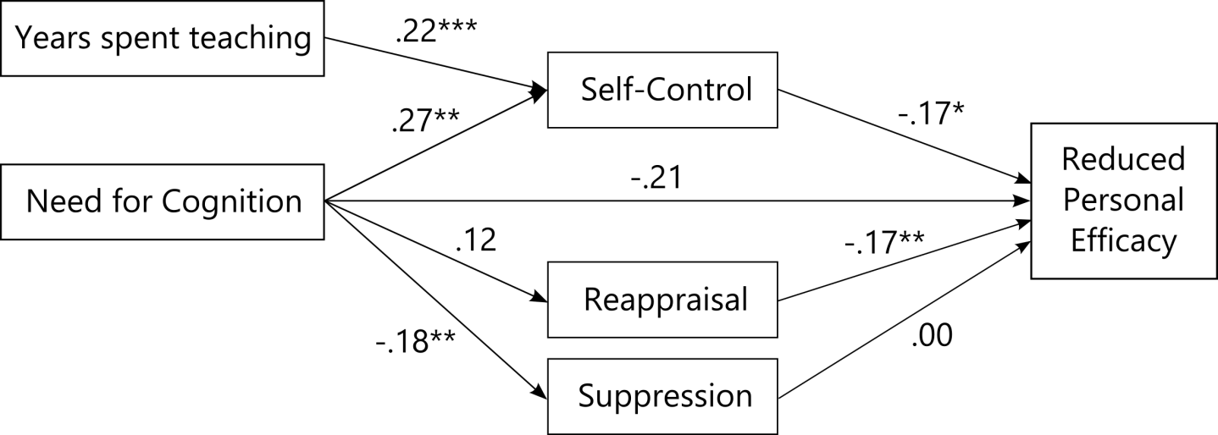

*Figure S3.1*. Standardized regression coefficients in the replication of Grass et al. (2018) when including years spent teaching. *\* p < .*05, \**\* p < .*01, \**\* p < .*001, *N =*180.

Table S3.2

*Results of the replication of Grass et al. (2018) when including years spent teaching.*

|  |  |  |  |  |  |  |  |
| --- | --- | --- | --- | --- | --- | --- | --- |
| Path | *B* | *SE* | *z*-value | *p*-value | CI Lower | CI Upper | *β* |
| Direct Effects | | | | | | | |
| NFC on Self-Control | 0.168 | 0.052 | 3.258 | .001 | 0.064 | 0.267 | 0.280 |
| Years spent teaching on Self-Control | 0.145 | 0.044 | 3.299 | .001 | 0.054 | 0.230 | 0.223 |
| NFC on Reappraisal | 0.055 | 0.036 | 1.519 | .129 | -0.016 | 0.125 | 0.123 |
| NFC on Suppression | -0.063 | 0.024 | -2.602 | .009 | -0.109 | -0.014 | -0.182 |
| Self-Control on RPE | -0.069 | 0.030 | -2.271 | .023 | -0.127 | -0.010 | -0.169 |
| Reappraisal on RPE | -0.094 | 0.036 | -2.618 | .009 | -0.164 | -0.022 | -0.173 |
| Suppression on RPE | 0.002 | 0.049 | 0.044 | .965 | -0.093 | 0.101 | 0.003 |
| NFC on RPE | -0.051 | 0.020 | -2.491 | .013 | -0.089 | -0.010 | -0.208 |
| Indirect Effects | | | | | | | |
| NFC and Years spent teaching on RPE via Self-Control | -0.021 | 0.011 | -1.965 | .049 | -0.045 | -0.002 | -0.085 |
| NFC on RPE via Reappraisal | -0.005 | 0.004 | -1.325 | .185 | -0.014 | 0.002 | -0.021 |
| NFC on RPE via Suppression | 0.000 | 0.003 | -0.041 | .968 | -0.008 | 0.006 | -0.001 |
| Total Effect | | | | | | | |
| Total Effect | -0.078 | 0.025 | -3.164 | .002 | -0.124 | -0.027 | -0.315 |

*Note: B =*unstandardized regression coefficient, *β =*standardized regression coefficient, CI = confidence interval, NFC = Need for Cognition, RPE = reduced personal efficacy subscale of the Maslach Burnout Inventory, *SE =*standard error, *N =*180.

## S4: Demand-resource-ratio model with the MBI subscale reduced personal efficacy

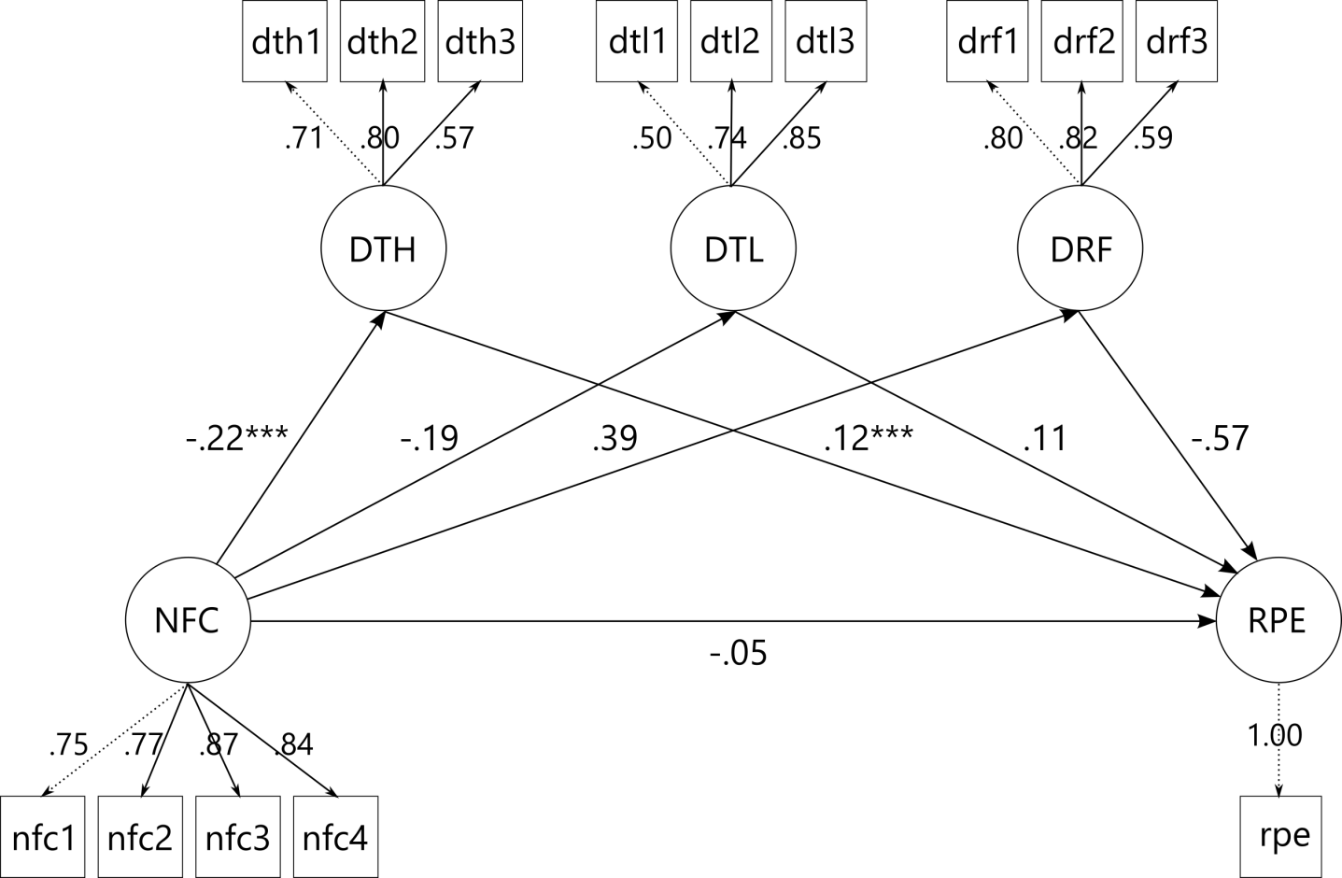

*Figure S4.1*. Standardized path coefficients of the demand-resource-ratio model with the MBI subscale reduced personal efficacy. *\* p < .*05, \**\* p < .*01, \*\**\* p < .*001. NFC = Need for Cognition, DTH = demands too high, DTL = demands too low, DRF = demand resource fit, nfc1-4 = item parcels, dth/dtl/drf1-3 = item indicators, RPE = reduced personal efficacy, *N =*180.

## S5: Exploratory model with all relevant variables

Table S5.1

*Results of the exploratory model with Covid burden.*

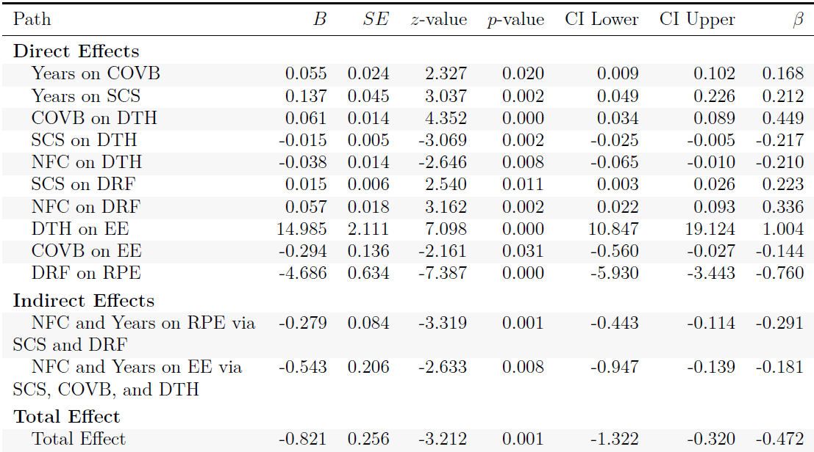

*Note: B =*unstandardized regression coefficient, *beta =*standardized regression coefficient, CI = confidence interval, COVB = Covid Burden, DTH = Demands Too High, DRF = Demand Resource Fit, MBI = Maslach Burnout Inventory, NFC = Need for Cognition, SCS = Self-control Scale, *SE =*standard error, Years = Years spent teaching, *N =*180.