**ISYS3001 – Assignment 1 exercise-VictIBS**

Remember that this is a public repository - your changes could be seen by anyone who looks!

Add some comments about Version management outside this border, or just add some text so there is a change to this file.

Remember that your GitHub user ID must be submitted in your assignment report!

Once you’ve changed follow the next step in your assignment task.

JZgaga

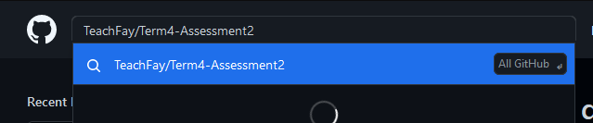

Search for files.

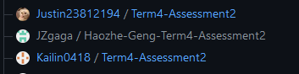

Create a fork.

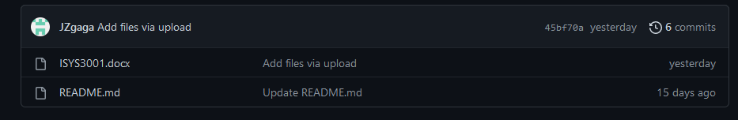

Upload files.