LAN Manager
Architecture/Design Documentation

Table of Contents

- Introduction……………...……………………………………………………..3
- Design Goals…………………………………………………………………………....4
- System Behavior…...…………………………………………………………...4
- Design Models
  - Server Mode…………………………………………………………..9
  - Client Mode………………………………………………………….12
  - Web page install handling……………………………………………14

Change History

Version: 1.0-1
Modifier: Eric Henricks
Date: 06/30/2017
Description of Change: Added documentation of version 1.0-1 of lanManager.

___________________________________________________________

Version:
Modifier:
Date:
Description of Change:

1 Introduction

This document describes the architecture and design for the LAN Manager application being developed for Igolgi. LAN Manager is a local area network auditor that uses master-slave configuration of a server, and it’s clients, to collect information about devices on the network. LAN Manager uses UDP multi-casting, and TCP uni-casting, to communicate over the network, and offers configurable options for the multi-cast IP address, uni-cast IP address, as well as options to change which ports each protocol uses. When launching the LAN Manager program, there are a variety of options for the user call upon at the command line to determine how the program will run, as well as determine if the device will run in server or client mode. All the data collected by the device running LAN Manager in server mode, will be visible on a web page located at <servers IP>/lanman/index.php. From the web page, users will be able to find information about each client device’s CPU, memory, disks, and interfaces through the different provided tables. Users, will also be able to see all devices on their network, as long as the broadcast IP was configured correctly, on the ‘Active IP’ page, and will be able to quickly install LAN Manager on any of the devices listed on the ‘Active IP’ page, as long as the devices are configured with a standard Igolgi user account.

The purpose of this document is to describe the architecture and design of the LAN Manager application in a way that addresses the interests, and concerns, of Igolgi faculty and those whom are interested in uses this program on their LAN.

The architecture and design for the LAN Manager system is complex, and no one model can accurately express all of the aspects of the software. To compensate for the software complexity, the documentation will be broken down into three primary models:

- Server Mode – The server mode model will be used to show the the processes, classes, and architecture the program uses when launched in server mode.
- Client Mode – The client mode model will be used to show the processes, and design used the program uses when launched in client mode.
- Web page install handling – The web page install handling model will show how the software handles sending installs to other systems, and will describe the options for changing the install handling.

2 Design Goals
The design goals for the LAN Manager application were set in accordance to what Igolgi desired from the LAN Manager project.

The priorities for the design are as follows:

- The design should use UDP multi-casting to broadcast request messages over then network, and should use TCP uni-casting to transmit data from client to server in a secure method.
- The design should should allow for configurable options, such as the UDP multi-cast IP, TCP uni-cast IP, multi-cast port, uni-cast port, client polling rate, broadcast ping rate, etc..
- The design should allow the program to run as a daemon, and automatically launch upon system reboot.
- The design should allow override commands to entered in at command line to allow the user to retrieve the program version, set an alternate configuration file path, force the program to run in either server, or client mode, and reset the software’s database if necessary.
- The design should allow for quick, and easy, installation/deployment for all system on the local network.

3 System Behavior

The software uses a master-slave configuration to send and receive data over the network, while keeping the structure of the software organized and easy to understand.

1. The master system sends out a poll request to each slave on the multi-cast port.

2. Each slave system listening on the multi-cast port responds to the server, and attempts to establish a TCP connection
Master
IP: 10.1.10.200
Slave
IP: 10.1.10.101
Slave
IP: 10.1.10.101
Slave
IP: 10.1.10.101
Slave
IP: 10.1.10.101
Master
IP: 10.1.10.200
Slave
IP: 10.1.10.102
Slave
IP: 10.1.10.103
Slave
IP: 10.1.10.101
Slave
IP: 10.1.10.104

Master
IP: 10.1.10.200
Slave
IP: 10.1.10.101
TCP Connection
Data Packet

3. Once the TCP connection has been made, the slave system sends the master the requested data.

4. The server then reads in the slave system’s information, and saves it into a database.
Master
IP: 10.1.10.200
Local Database

Client #1
Client #2
Client #3
...
Client Data
5. The web page, hosted on the server system, then dynamically updates based on the database.
Local Database

Client #1
Client #2
Client #3
...
Database Data
Web page

Overview Table
Client #1
Client #2
...

4 Design Models

4.1 Server Mode:

When run in server mode, the program will act as a master to all of the client systems on the network. Thus, the system running the server will poll each client’s data, ping the configured broadcast IP, manage a local database, and host the software’s web page. The server’s runtime settings are configured before launch in a separate file that can edited. The server system’s configuration file should be edited before launch to ensure the desired setting shave been configured. In which case, the configuration file is the best place to start:

The configuration file, ‘labAuditConfig.ini’, can be found in the /etc/lanManager/ directory of the local system.

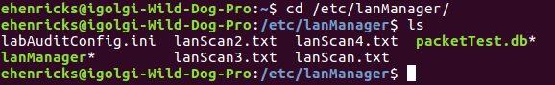
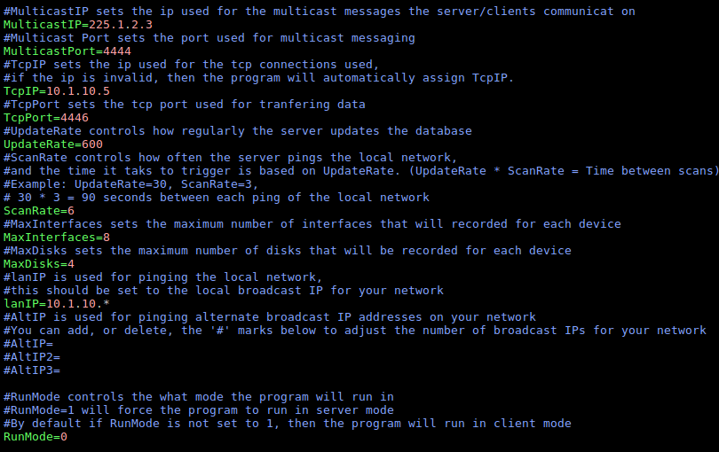
‘/etc/lanManager/labAuditConfig.ini’ is the default configuration file used for lanManager, and any settings should be set using this file, unless another pathname is used via a command at the command line.

Once the configurable settings have been changed accordingly, we can navigate to the /usr/bin/lanManager directory, and launch lanManager in server mode.

**Note** lanManager can be launched from the /etc/lanManager directory as well, and acts as a backup in the event that the /usr/bin/lanManager directory gets deleted or corrupted.

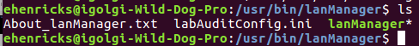
For additional command line options, the user can call ‘-h’ when launching lanManager to see available commands.

**Note** The ‘-h’ command will not launch the program in server or client mode, rather, it will simply output additional commands that can be used.

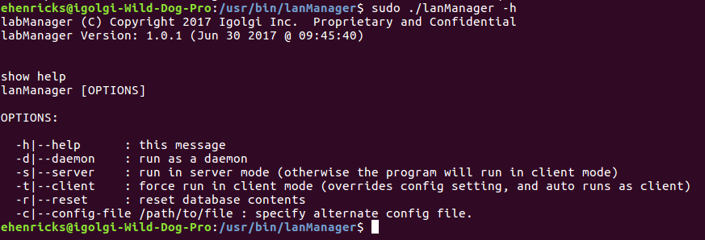

To run the program in server mode, the ‘-s’ command can be used at the command line or the “RunMode” option in the configuration file can be set to ‘1’.

At launch time, the lanManager program will read in the configuration settings bind the local interface to the configured ports/IP addresses.

**Important!!!** lanManager should always be run in “sudo” mode to ensure the device can be properly binded to the set ports, otherwise the program may exit prematurely as it was unable to bind!

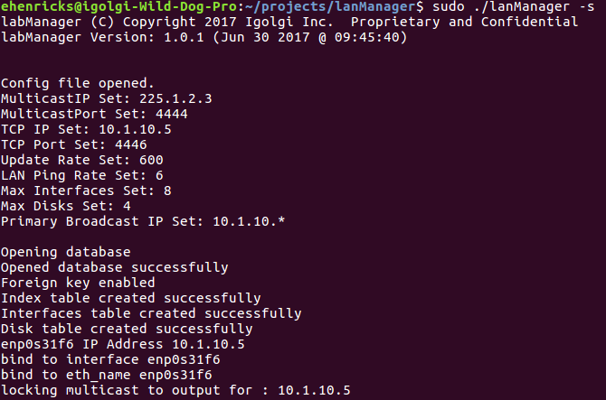

Loop Forever
From this point lanManager will run in server mode, and will follow this design model...
Program Start
$: sudo ./lanManager -s
Read configuration settings
Server mode?
run_client();
Yes
run_server();
No
1. open_database();
Loop # broadcast IPs
Server_Establish_TCP_Connection();
Loop # broadcast IPs
ping_local_network();

2. ping_local_network();

Connector Legend:

Refer to Client Mode, pg 12

Refer to databases, pg 10

Refer to network ping, pg 10

Refer to TCP, pg 11

Return to run_server();
1. enable_foreign_keys();
2. create_table_index();
4. create_table_disks();
3. create_table_interfaces();
Open lanscan.txt
Nmap ping broadcast IP
Write results to lanscan.txt
Return to run_server();

Bind to TCP socket.
Loop until next client poll
Listen for client messages
Accept client data packet
Received client message?
No
Yes
1. update_database_index()
2. update_database_interfaces();
3. update_database_disks();
Return to run_server();

4.2 Client Mode:

When run in client mode, the program will act as a slave system to the server on the network. The primary processes of client mode revolve around waiting for a server poll request, creating a data packet, and transferring the packet to the server system.

Bind to multi-cast port
Listen for server poll
Loop Forever
Client_Establish_TCP_Connection();
Listen for server poll
Connector Legend:

Refer to Server Mode, pg 9

Refer to Client TCP, pg 13

1. getInterfaces();
2. Use shell commands to gather data
3. Call function
PopenDisksCommand();
(Collects data on detected disks)
Send packet to server
Construct data packet
Merge data into packet
Gathered Data
Clear buffer
Return to run_client();

4.3 Web page install handling:

The lanManager application has the functionality to install itself on active devices detected by the network ping, in order to automate the installation, the web page uses a script located in the ‘/var/www/lanman/’ directory named ‘lanManager_install.sh’. The script is designed to only work for specific machine setups, in which, by default the script requires the target device to have an igolgi user account, with the password ‘igolgi’, and has the password requirement for dpkg disabled in their sudoers file.
To begin installing the lanManager application on devices found on the network, the server system must ping the local broadcast IP first (this can be done by configuring the labAuditConfig.ini and run lanManager in server mode).

Once the server has pinged the local broadcast IP, open up an internet browser and navigate to <server IP>/lanman/activeIP.php via the search bar.

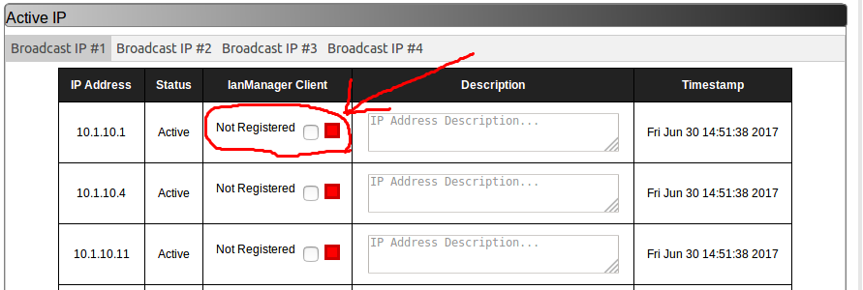
On the ‘Active IP’ page, the user will be able to see which devices on the network currently are not running the lanManager application in client mode by looking in the ‘lanManager Client’ column to see their current status.

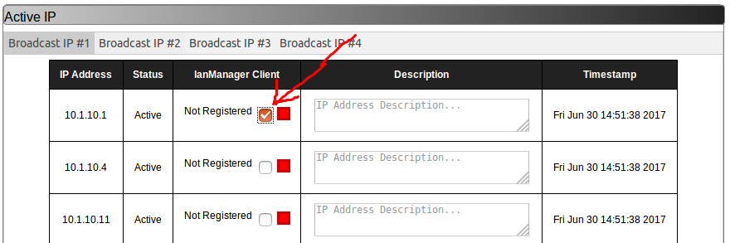
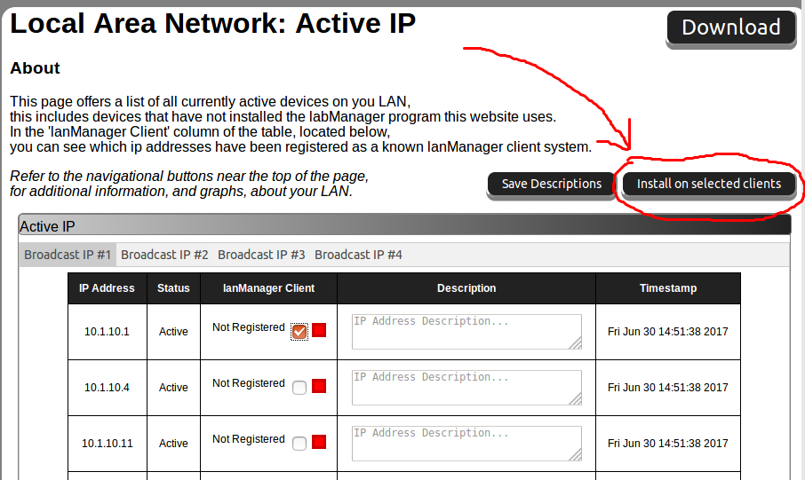
To install the lanManager application on a device, just click the check box on each device you wish to install the application on, and then click the “Install on selected clients” button near the top of the page.
A pop-up window will appear with the results of the install for all of the selected devices, and the devices where lanManager was successfully installed should update into the database on the next client poll from the server system.

Known client systems will be distinguishable from non-client systems, and tell the user that the specific IP is already running the lanManager application.

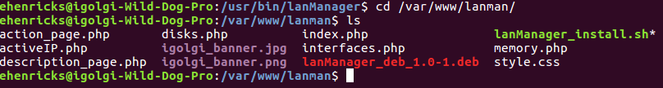
To access, and edit, the script the lanManager application uses, navigate to the file located at ‘/var/www/lanman/lanManager_install.sh’

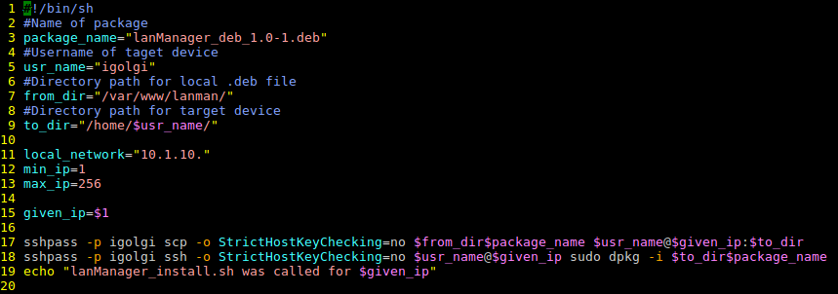
Using a text editor, the user can edit the following install settings…

package_name: *The name of the package to install*
usr_name: *The name of target user account to install to*
from_dir: *The path of the directory to the package*
to_dir: *The path where the package will be sent to on the target system*
local_network: *The LAN IP*

**Important!!!**
After the ‘-p’ in each sshpass command should be the password for the target user account!
If the password is incorrect, then the script will not work!

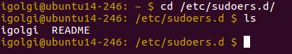
The final aspect of the automated install feature of the lanManager application requires each target system’s sudoers to allow dpkg to require no password. This can easily be achieved on most systems by adding a file to the /etc/sudoers.d/ directory and adding one line to modify the need for a password when using dpkg.

File to add: <username of account>
File line to add: <username of account> ALL=(ALL) NOPASSWD: /usr/bin/dpkg

**Important!!!**
Editing the a system’s sudoers file can mess with an account’s privileges to use sudo, and it is highly recommended that anyone editing the these files should be able to use pkexec or have the ability to switch to root mode (even if that means launching a system in recovery mode) in order to fix any errors made to the sudoers file!

