Plugin execution not covered by lifecycle configuration

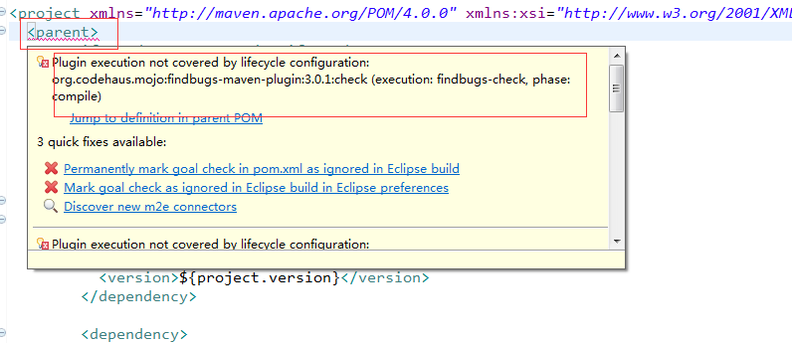

1. use ***quick-fix*** on the error in ***pom.xml*** and select Permanently mark goal run in pom.xml as ignored in Eclipse build - this will generate the required boilerplate code for you.
2. After that just replace the <ignore/> tag with <execute/> tag in the generated configuration and you're done:
3. <action>
4. <execute/>

</action>

<plugin>

<groupId>org.eclipse.m2e</groupId>

<artifactId>lifecycle-mapping</artifactId>

<version>1.0.0</version>

<configuration>

<lifecycleMappingMetadata>

<pluginExecutions>

<pluginExecution>

<pluginExecutionFilter>

<groupId>org.codehaus.mojo</groupId>

<artifactId>aspectj-maven-plugin</artifactId>

<versionRange>[1.0,)</versionRange>

<goals>

<goal>test-compile</goal>

<goal>compile</goal>

</goals>

</pluginExecutionFilter>

<action>

<execute/>

</action>

</pluginExecution>

</pluginExecutions>

</lifecycleMappingMetadata>

</configuration>

</plugin>