形如这样的表结构，需要查询某个 product_id 对应的 product_feature_id 的集合，并且拼接成形如 ‘40xxxxxx’1,’40xxxxxxx2’, ’40xxxxxxx3’, ’40xxxxxxx4’...... 的方式

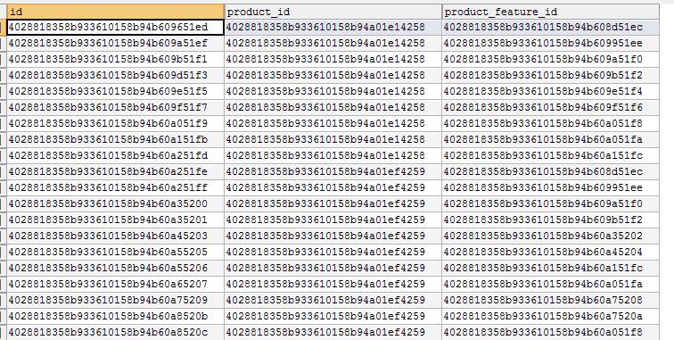

SELECT GROUP_CONCAT(concat("'",a.product_Feature_Id,"'")) as feature_ids FROM Product_Feature_Rel a WHERE a.product_id = ‘4028818358b933610158b94a01e14258’



复制出来为

'4028818358b933610158b94b608d51ec','4028818358b933610158b94b609951ee','4028818358b933610158b94b609a51f0','4028818358b933610158b94b609b51f2','4028818358b933610158b94b609e51f4','4028818358b933610158b94b609f51f6','4028818358b933610158b94b60a051f8','4028818358b933610158b94b60a051fa','4028818358b933610158b94b60a151fc'

select a.id as product_id ,

group_concat(d.feature_name) // 1

from product a where a.model like '%g%'

group by product_id // 2

order by model

行转列函数 group_concat(field_name) 如 1 ,如果不加上另一个字段的group by 如 2 ，那么结果就会只有一条

这样才能保证将希望的所有数据都查出来

# 27 canister 所有的产品与筛选项 rel

select *,GROUP_CONCAT(DISTINCT(a.filter_item_value)) from product_filter_item_rel a where a.product_id in (

select b.id from product b where b.product_category_id = '27' and b.product_type = 1

) group by a.filter_item_id