Jobs Tracker

By using a job tracker, you can track the duration of tasks done by workers and tracking real-time.

Code :

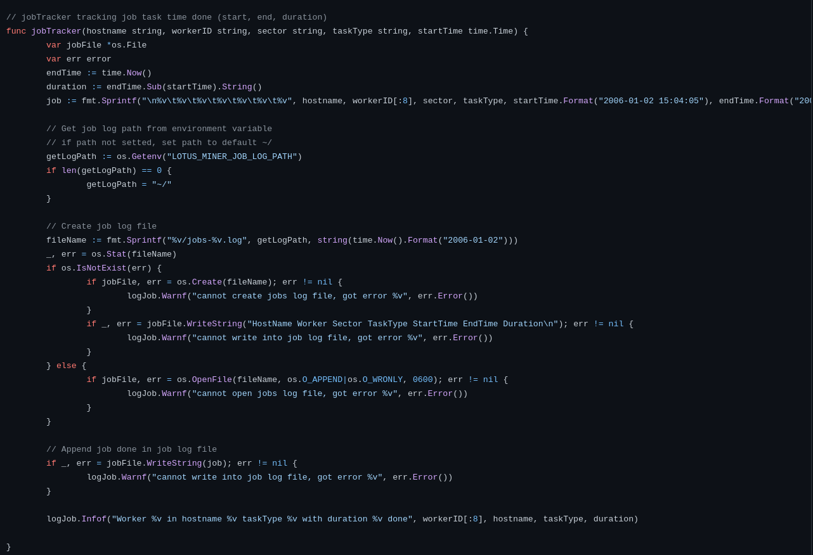

Result in miner log :

Result realtime log :

