RDMA Protocol

In computing, remote direct memory access (RDMA) is a direct memory access from the memory of one computer into that of another without involving either one's operating system. This permits high-throughput, low-latency networking, which is especially useful in massively parallel computer clusters.

RDMA Advantages :

- Data transfer between servers and between server and storage without the involvement of the host CPU in the data path
- Bandwidth 10 ~ 400 GbE/s (DDR, QDR, FDR, EDR, HDR, NDR)
- RDMA provides low latency through stack bypass and copy avoidance
- Reduces CPU utilization
- Reduces memory bandwidth bottlenecks and provides high bandwidth utilization
- Optimized server utilization with high speed networking and CPU offload
- High availability and high reliability for compute, storage, and network
- Increases total SSD utilization to over 90%

CPU Offloads :

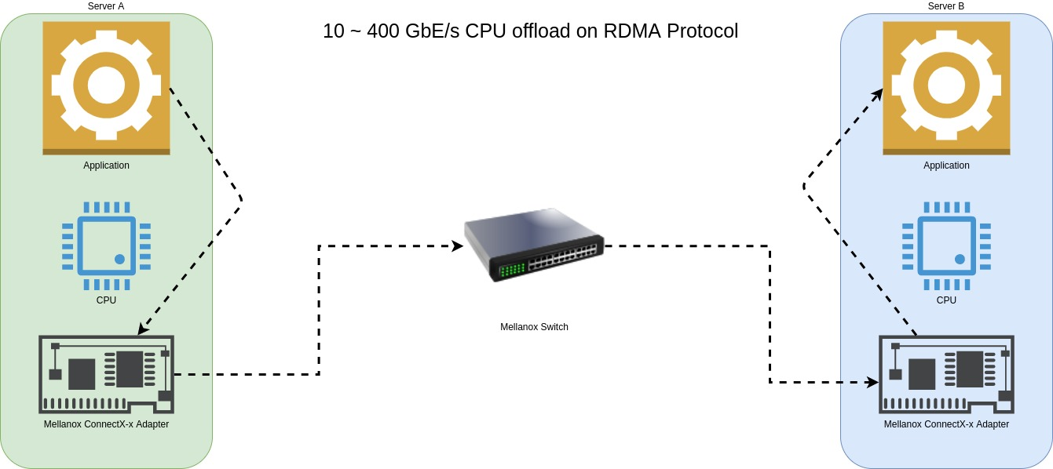
RDMA allows direct memory access from the memory of one node into that of another without involving either one’s CPU.

Low Latency :

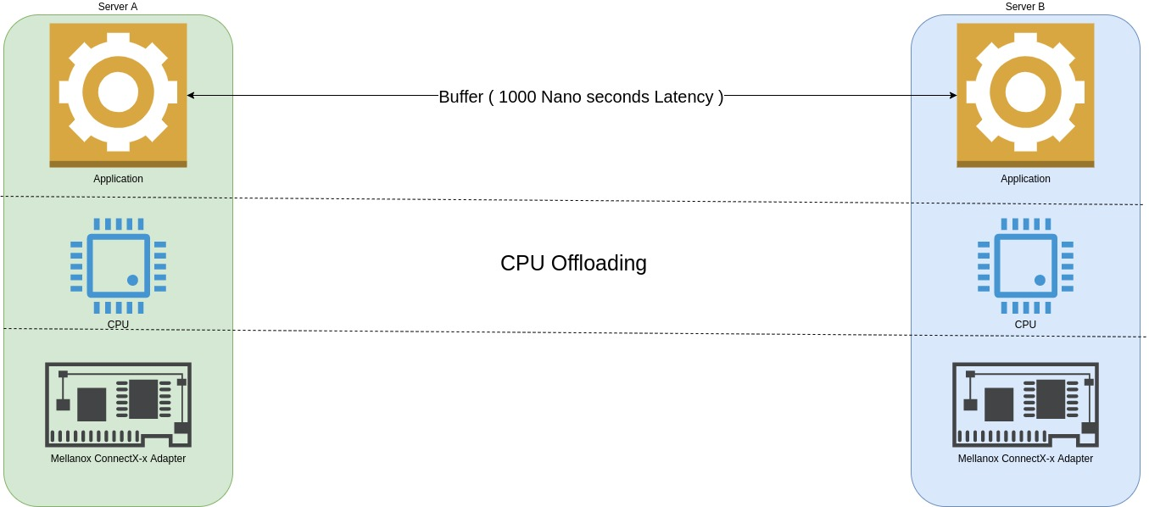

Extreme low latency is achieved by a combination of hardware offloading and accelerating mechanisms. As a result, end-to-end latency of RDMA sessions can be as low as 1000 nano-seconds or 1 micro-second.

Suggestions for hardware :

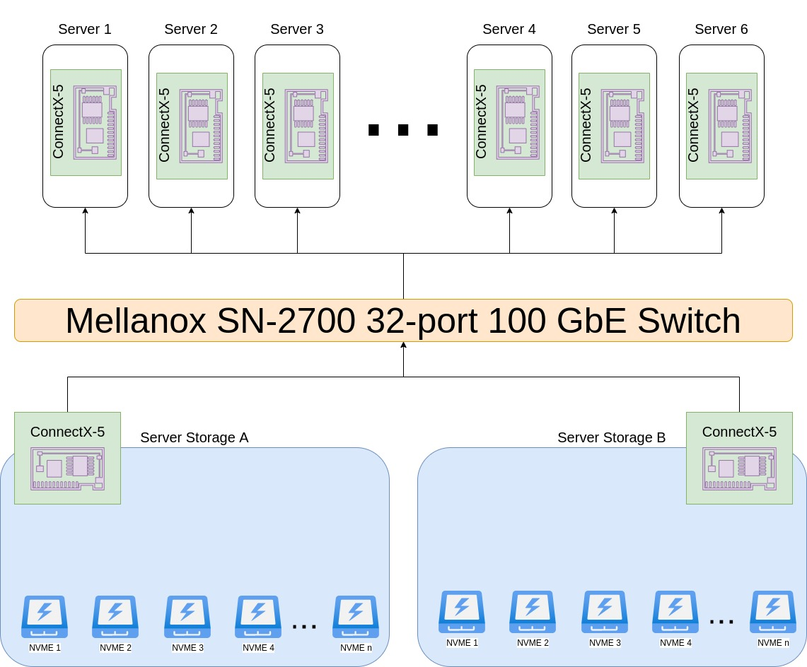

- Switch SN-2700 32-port 100 GbE : https://store.mellanox.com/products/nvidia-msn2700-csbfc-spectrum-based-100gbe-1u-open-ethernet-switch-with-cumulus-linux-32-qsfp28-ports-2-power-supplies-dc-x86-cpu-standard-depth-p2c-airflow-rail-kit.html

- NIC MCX516A-CCAT ConnectX-5 EN : https://store.mellanox.com/products/nvidia-mcx516a-ccat-connectx-5-en-adapter-card-100gbe-dual-port-qsfp28-pcie3-0-x16-tall-bracket-rohs-r6.html

- Cable MCP1600-C003E26N DAC Cable Ethernet 100GbE ( 1to1 ) : https://store.mellanox.com/products/nvidia-mcp1600-c003e26n-passive-copper-cable-ethernet-100gbe-qsfp28-3m-black-26awg-ca-n.html

Software Solutions :

- nfs over RDMA : https://community.mellanox.com/s/article/howto-configure-nfs-over-rdma--roce-x
- RDMA roce solutions : https://community.mellanox.com/s/article/rdma-roce-solutions
- Ethernet Drivers : https://developer.nvidia.com/networking/ethernet-software
- IB Drivers : https://developer.nvidia.com/networking/infiniband-software
- Firmware : https://mellanox.com/support/firmware/firmware-downloads
- RDMA over Converged Ethernet (RoCE) from A to Z : https://academy.mellanox.com/en/course/rdma-over-converged-ethernet-roce-from-a-to-z/?cm=975

