Devnet Environment

Docker Image file
In the Docker image file, we have created an automated script that retrieves the code from the specified repository. The script fetches the source from the repository, compiles and exports it, allowing a developer to test the latest changes.
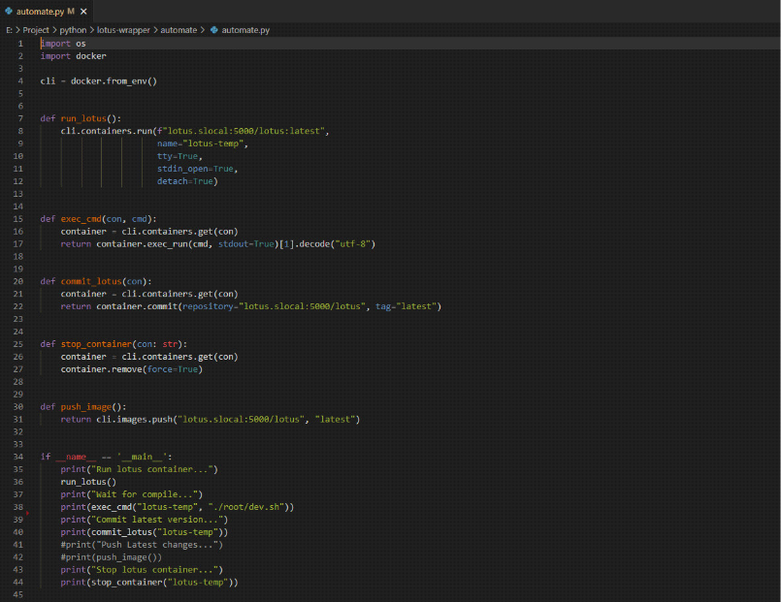An automated script for building lotus devnet new image in Docker

Lotus Devnet Sector Config
As soon as the Docker image can be used, we start lotus daemon and miner with 2k sectors that allow us to use smaller sectors for testing.
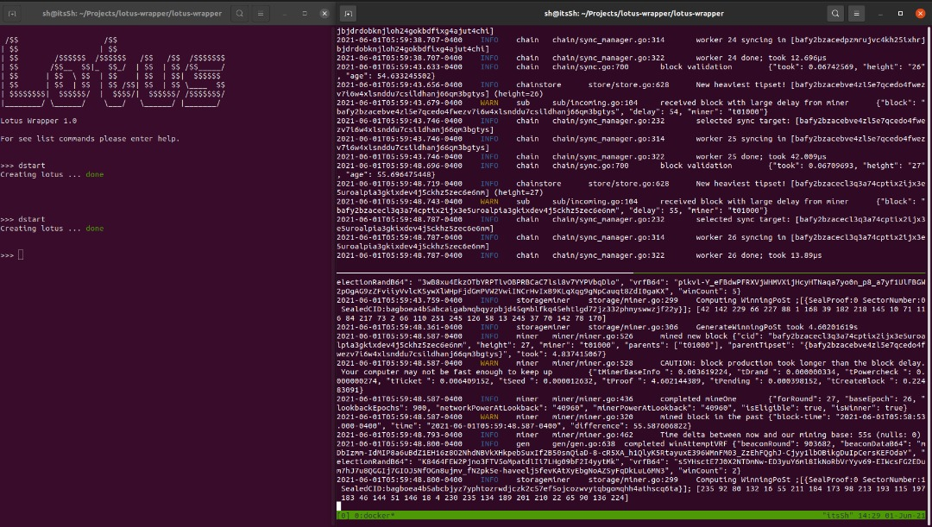Left side : Lotus Wrapper Run the lotus daemon and miner, Right Top side : Daemon Logs, Right Bottom side : Miner Logs

Config Miner Layout
Simulating a large set-up requires running multiple workers in docker containers on separate physical and virtually based servers. they are all part of the same miner.
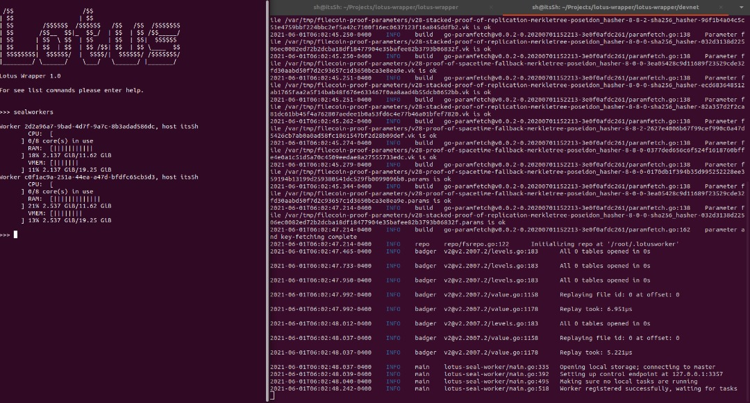Left side : Lotus Wrapper ( List of workers ), Right side : Worker logs

Create deals and task
Scheduler can be used to assign tasks to workers after the environment is ready. Our tool creates multiple deals and makes the miner accept them in order to provide tasks to workers.
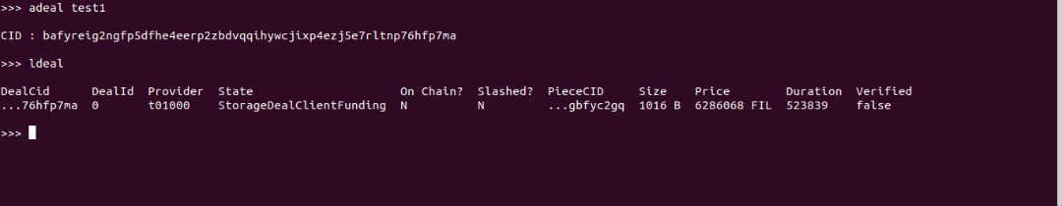Creating a deal using wrapper
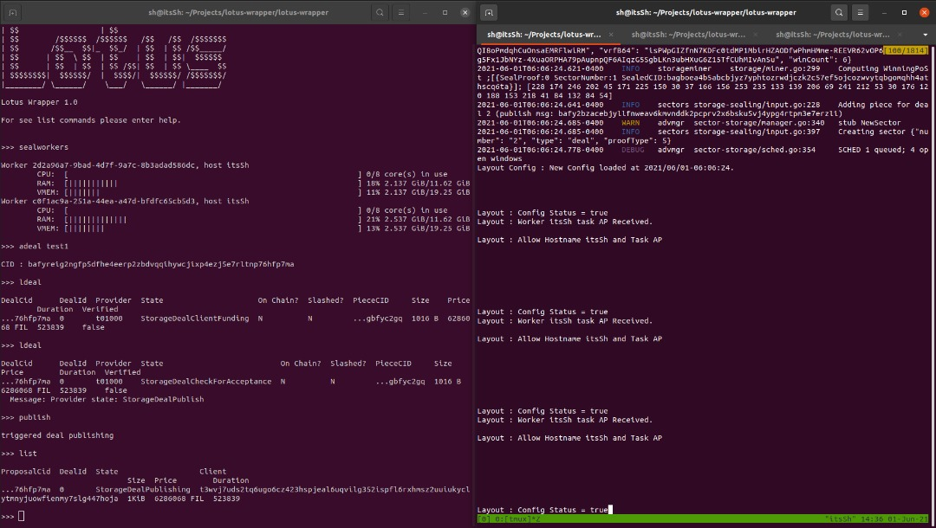The left side shows the deal published and sent to the miner, the right side shows the new layout logic used by the scheduler

