Devnet Environment
In the Docker image file, we have created an automated script that retrieves the code from the specified repository. The script fetches the source from the repository, compiles and exports it, allowing a developer to test the latest changes.
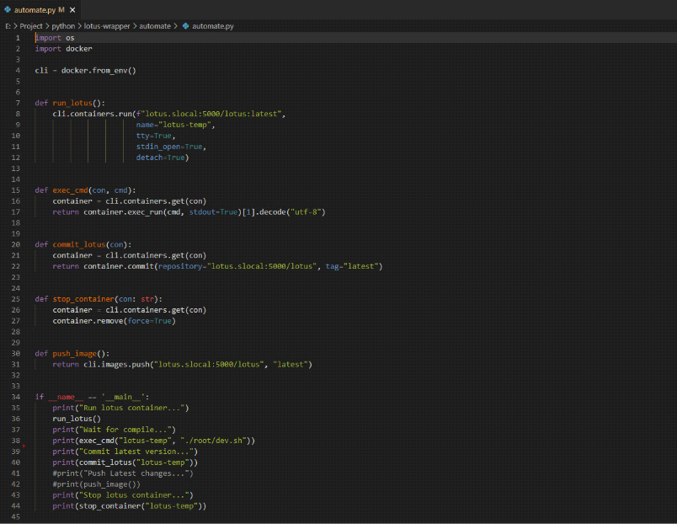

As soon as the Docker image can be used, we start lotus daemon and miner with 2k sectors that allow us to use smaller sectors for testing.
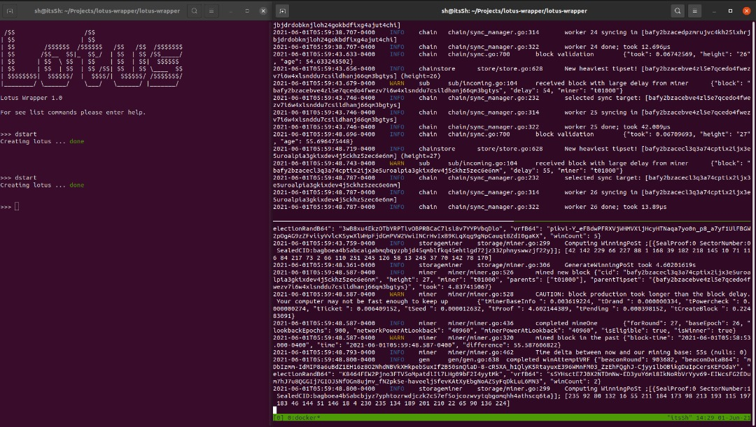
Simulating a large set-up requires running multiple workers in docker containers on separate physical and virtually based servers. they are all part of the same miner.
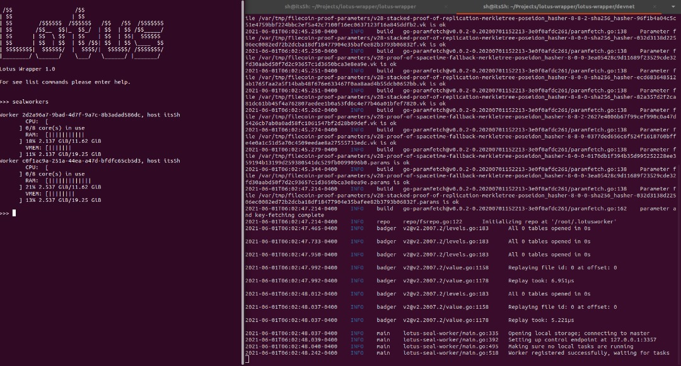
Our scheduler can be used to assign tasks to workers after the environment is ready. Our system creates multiple deals and makes the miner accept them in order to provide tasks to workers.
