CS2302 Data Structures

Fall 2019

Lab Report #7

Due: 9 December 2019

Professor: Olac Fuentes

TA: Amindita Nath

**Introduction**

The problem presented in this involves finding Hamiltonian cycles within graphs within random graphs, as well as demonstrate backtracking to solve the same problem with Hamiltonian cycles. Then we had to implement a modified version of the edit distance between strings to only swap when both are vowels or consonants.

**Proposed Solution Design and Implementation**

Design –

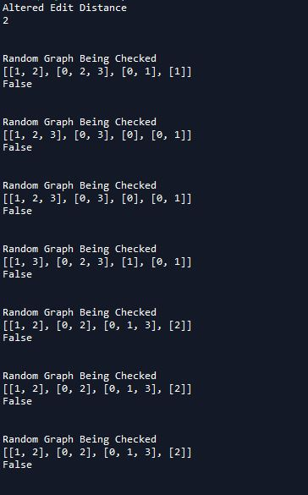

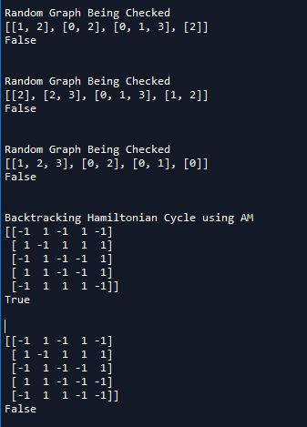

Operation #1: For randomizing finding Hamiltonian cycles with a set number of edges and vertices given it creates random graphs that then get checked after each loop which is determined by how many random graphs the user wants to test.

Operation#2: For backtracking I used adjacency matrix graphs to make the backtracking method. I made 3 methods to test for cycles, one fore adjacency, one to perform the actual backtracking, and then one used as the call that returns whether it is True or False.

Operation #3: For modifying edit distance I created a separate method to check whether they were both vowels or both consonants and put a condition that when they are not the same the swap cannot happen.

**Experimental Result**

**Conclusion**

I learned that randomization can lead to more efficient and robust code since you test functions with many different inputs and I also learned that backtracking usually takes longer then looping does.

**Appendix**

I certify that this project is entirely my own work. I wrote, debugged, and tested the code being presented, performed the experiments, and wrote the report. I also certify that I did not share my code or report or provided inappropriate assistance to any student in the class