

23CSE211
Design and Analysis of Algorithms
Lab-2 04/12/2025

Submitted to Submitted by
Dr SS Chakravarthi Jagapriyan B - CH.SC.U4CSE24216

Lab-2
Sorting Techniques
- Bubble sort
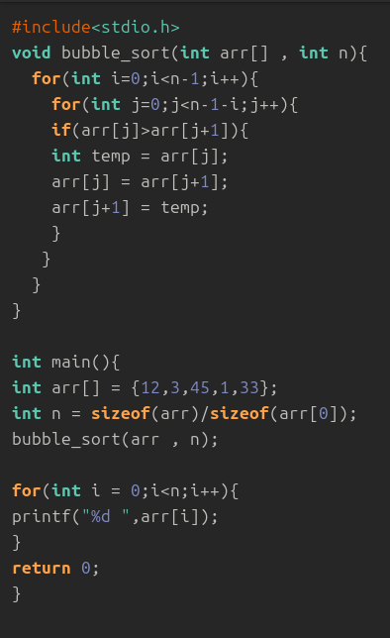

Output:
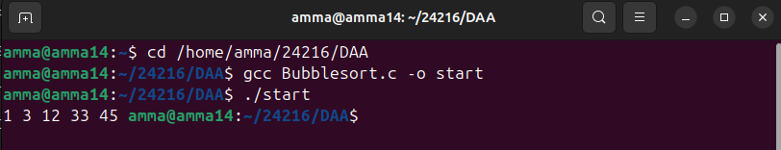

- Insertion sort
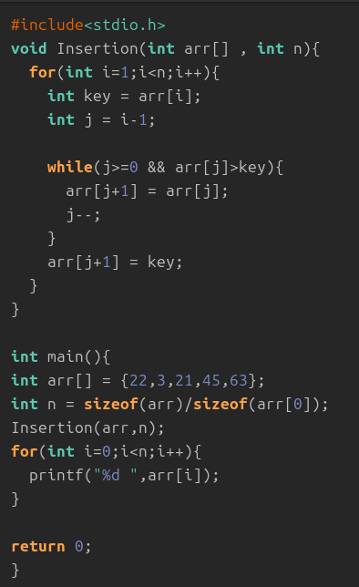

Output:
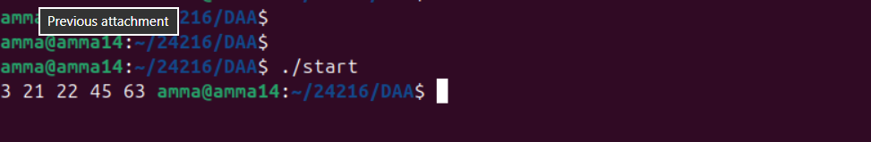

3.Selection Sort
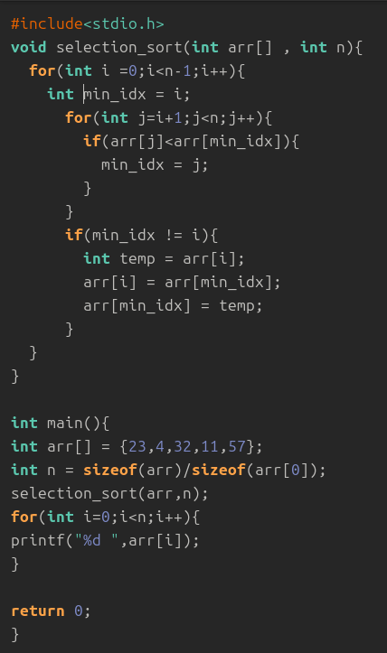

Output:


4.Bucket Sort

#include <stdio.h>
#include <stdlib.h>

#define MAX 100
#define BUCKETS 10

void insertionSort(int arr[], int n) {
for (int i = 1; i < n; i++) {
int key = arr[i];
int j = i - 1;
while (j >= 0 && arr[j] > key) {
arr[j + 1] = arr[j];
j--;
}
arr[j + 1] = key;
}
}

void bucketSort(int arr[], int n) {
int buckets[BUCKETS][MAX];
int count[BUCKETS] = {0};

for (int i = 0; i < n; i++) {
int index = arr[i] / 10;
buckets[index][count[index]++] = arr[i];
}

for (int i = 0; i < BUCKETS; i++) {
insertionSort(buckets[i], count[i]);
}

int k = 0;
for (int i = 0; i < BUCKETS; i++) {
for (int j = 0; j < count[i]; j++) {
arr[k++] = buckets[i][j];
}
}
}

void printArray(int arr[], int n) {
for (int i = 0; i < n; i++)
printf("%d ", arr[i]);
printf("\n");
}

int main() {
int arr[] = {42, 32, 33, 52, 37, 47, 51};
int n = sizeof(arr) / sizeof(arr[0]);

printArray(arr, n);
bucketSort(arr, n);
printArray(arr, n);

return 0;
}

Output:
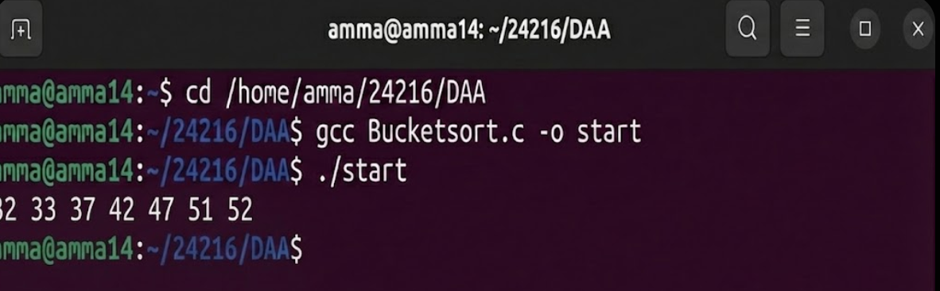

5.Heap sort
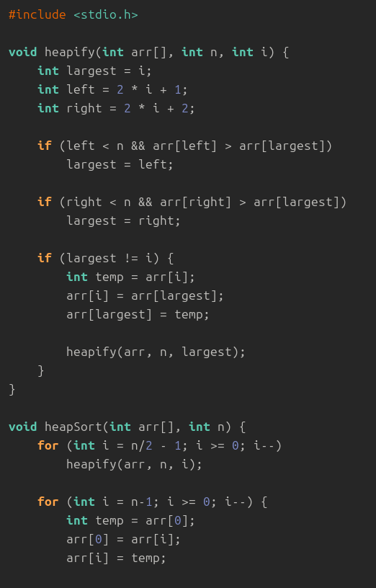
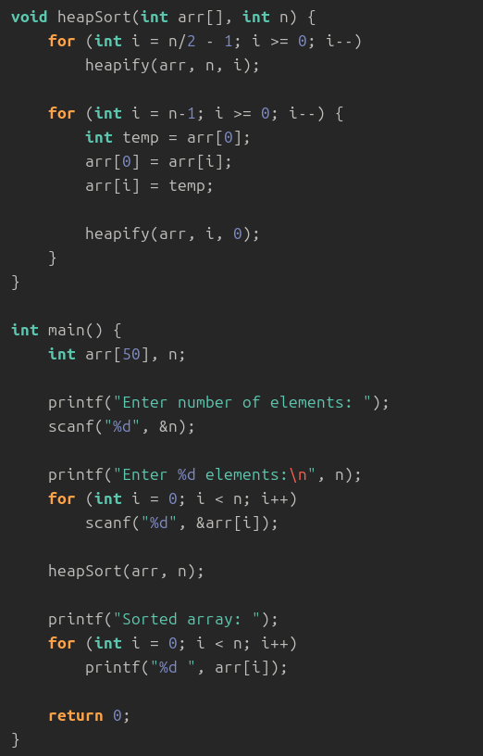

Output:
