

23CSE211
Design and Analysis of Algorithms
Lab-7

Submitted to Submitted by
Dr SS Chakravarthi Jagapriyan B - CH.SC.U4CSE24216

Lab-7

- Huffman coding
”amrita vishwa vidyapeetham chennai campus”

CODE:
#include <stdio.h>
#include <stdlib.h>
#include <string.h>

#define MAX_TREE_HT 100

struct MinHeapNode {
char data;
unsigned freq;
struct MinHeapNode *left, *right;
};

struct MinHeap {
unsigned size;
unsigned capacity;
struct MinHeapNode** array;
};

struct MinHeapNode* newNode(char data, unsigned freq) {
struct MinHeapNode* temp = (struct MinHeapNode*)malloc(sizeof(struct MinHeapNode));
temp->left = temp->right = NULL;
temp->data = data;
temp->freq = freq;
return temp;
}

struct MinHeap* createMinHeap(unsigned capacity) {
struct MinHeap* minHeap = (struct MinHeap*)malloc(sizeof(struct MinHeap));
minHeap->size = 0;
minHeap->capacity = capacity;
minHeap->array = (struct MinHeapNode**)malloc(minHeap->capacity * sizeof(struct MinHeapNode*));
return minHeap;
}

void swapMinHeapNode(struct MinHeapNode** a, struct MinHeapNode** b) {
struct MinHeapNode* t = *a;
*a = *b;
*b = t;
}

void minHeapify(struct MinHeap* minHeap, int idx) {
int smallest = idx;
int left = 2 * idx + 1;
int right = 2 * idx + 2;

if (left < minHeap->size && minHeap->array[left]->freq < minHeap->array[smallest]->freq)
smallest = left;

if (right < minHeap->size && minHeap->array[right]->freq < minHeap->array[smallest]->freq)
smallest = right;

if (smallest != idx) {
swapMinHeapNode(&minHeap->array[smallest], &minHeap->array[idx]);
minHeapify(minHeap, smallest);
}
}

int isSizeOne(struct MinHeap* minHeap) {
return (minHeap->size == 1);
}

struct MinHeapNode* extractMin(struct MinHeap* minHeap) {
struct MinHeapNode* temp = minHeap->array[0];
minHeap->array[0] = minHeap->array[minHeap->size - 1];
--minHeap->size;
minHeapify(minHeap, 0);
return temp;
}

void insertMinHeap(struct MinHeap* minHeap, struct MinHeapNode* minHeapNode) {
++minHeap->size;
int i = minHeap->size - 1;
while (i && minHeapNode->freq < minHeap->array[(i - 1) / 2]->freq) {
minHeap->array[i] = minHeap->array[(i - 1) / 2];
i = (i - 1) / 2;
}
minHeap->array[i] = minHeapNode;
}

void buildMinHeap(struct MinHeap* minHeap) {
int n = minHeap->size - 1;
for (int i = (n - 1) / 2; i >= 0; --i)
minHeapify(minHeap, i);
}

struct MinHeap* createAndBuildMinHeap(char data[], int freq[], int size) {
struct MinHeap* minHeap = createMinHeap(size);
for (int i = 0; i < size; ++i)
minHeap->array[i] = newNode(data[i], freq[i]);
minHeap->size = size;
buildMinHeap(minHeap);
return minHeap;
}

struct MinHeapNode* buildHuffmanTree(char data[], int freq[], int size) {
struct MinHeapNode *left, *right, *top;
struct MinHeap* minHeap = createAndBuildMinHeap(data, freq, size);

while (!isSizeOne(minHeap)) {
left = extractMin(minHeap);
right = extractMin(minHeap);
top = newNode('$', left->freq + right->freq);
top->left = left;
top->right = right;
insertMinHeap(minHeap, top);
}
return extractMin(minHeap);
}

void printCodes(struct MinHeapNode* root, int arr[], int top) {
if (root->left) {
arr[top] = 0;
printCodes(root->left, arr, top + 1);
}
if (root->right) {
arr[top] = 1;
printCodes(root->right, arr, top + 1);
}
if (!(root->left) && !(root->right)) {
printf("'%c': ", root->data);
for (int i = 0; i < top; ++i)
printf("%d", arr[i]);
printf("\n");
}
}

void HuffmanCodes(char data[], int freq[], int size) {
struct MinHeapNode* root = buildHuffmanTree(data, freq, size);
int arr[MAX_TREE_HT], top = 0;
printCodes(root, arr, top);
}

int main() {
char str[] = "amrita vishwa vidyapeetham chennai campus";
int freq[256] = {0};

for (int i = 0; str[i] != '\0'; i++) {
freq[(unsigned char)str[i]]++;
}

int uniqueChars = 0;
for (int i = 0; i < 256; i++) {
if (freq[i] > 0) uniqueChars++;
}

char data[uniqueChars];
int frequencies[uniqueChars];
int j = 0;

for (int i = 0; i < 256; i++) {
if (freq[i] > 0) {
data[j] = (char)i;
frequencies[j] = freq[i];
j++;
}
}

printf("Huffman Codes for:\n\"%s\"\n\n", str);
HuffmanCodes(data, frequencies, uniqueChars);

return 0;
}

OUTPUT:
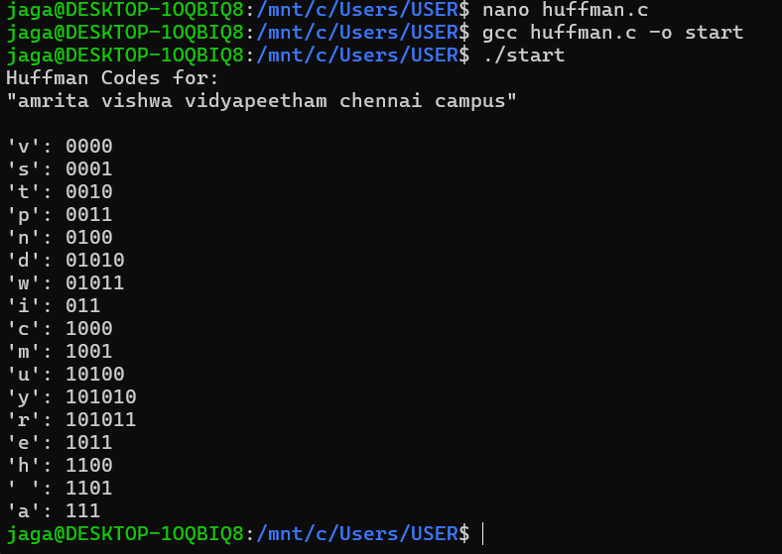

Time Complexity: O(N + C \log C), where N is the total number of characters in the string (to count frequencies) and C is the number of unique characters (to build the min-heap and the tree).

Space Complexity: O(C) to store the min-heap, the resulting Huffman tree, and the recursion stack, which effectively becomes O(1) since the number of unique ASCII characters is bounded by a constant (256).

