

23CSE211
Design and Analysis of Algorithms
Lab-4

Submitted to Submitted by
Dr SS Chakravarthi Jagapriyan B - CH.SC.U4CSE24216

Lab-3

- Merge Sort

CODE:
#include <stdio.h>

void merge(int arr[], int l, int m, int r) {
int i, j, k;
int n1 = m - l + 1;
int n2 = r - m;

int L[n1], R[n2];

for (i = 0; i < n1; i++)
L[i] = arr[l + i];
for (j = 0; j < n2; j++)
R[j] = arr[m + 1 + j];

i = 0;
j = 0;
k = l;
while (i < n1 && j < n2) {
if (L[i] <= R[j]) {
arr[k] = L[i];
i++;
} else {
arr[k] = R[j];
j++;
}
k++;
}

while (i < n1) {
arr[k] = L[i];
i++;
k++;
}

while (j < n2) {
arr[k] = R[j];
j++;
k++;
}
}

void mergeSort(int arr[], int l, int r) {
if (l < r) {
int m = l + (r - l) / 2;

mergeSort(arr, l, m);
mergeSort(arr, m + 1, r);

merge(arr, l, m, r);
}
}

void printArray(int A[], int size) {
int i;
for (i = 0; i < size; i++)
printf("%d ", A[i]);
printf("\n");
}

int main() {
int arr[] = {12, 11, 13, 5, 6, 7};
int arr_size = sizeof(arr) / sizeof(arr[0]);

printf("Given array is \n");
printArray(arr, arr_size);

mergeSort(arr, 0, arr_size - 1);

printf("\nSorted array is \n");
printArray(arr, arr_size);
return 0;
}
OUTPUT:

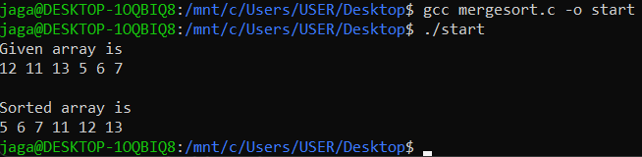

- Quick Sort

CODE:
#include <stdio.h>

int partition(int arr[], int l, int h) {
int pivot = arr[h];
int i = (l - 1);
int temp;

for (int j = l; j < h; j++) {
if (arr[j] <= pivot) {
i++;
temp = arr[i];
arr[i] = arr[j];
arr[j] = temp;
}
}
temp = arr[i + 1];
arr[i + 1] = arr[h];
arr[h] = temp;

return (i + 1);
}

void quickSort(int arr[], int l, int h) {
if (l < h) {
int pi = partition(arr, l, h);

quickSort(arr, l, pi - 1);
quickSort(arr, pi + 1, h);
}
}

int main() {
int arr[] = {10, 7, 8, 9, 1, 5};
int n = sizeof(arr) / sizeof(arr[0]);

quickSort(arr, 0, n - 1);

printf("Sorted array: \n");
for (int i = 0; i < n; i++) {
printf("%d ", arr[i]);
}
printf("\n");

return 0;
}

OUTPUT:
