

23CSE211
Design and Analysis of Algorithms
Lab-8

Submitted to Submitted by
Dr SS Chakravarthi Jagapriyan B - CH.SC.U4CSE24216

Lab-8

- Job sequencing

CODE:

#include <stdio.h>
#include <stdlib.h>
#include <stdbool.h>

typedef struct {
int id;
int profit;
int deadline;
} Job;

int compareJob(const void* a, const void* b) {
Job* temp1 = (Job*)a;
Job* temp2 = (Job*)b;
return (temp2->profit - temp1->profit);
}

int min(int num1, int num2) {
return (num1 > num2) ? num2 : num1;
}

void jobSequencing(Job arr[], int n) {
qsort(arr, n, sizeof(Job), compareJob);

int maxDeadline = 0;
for (int i = 0; i < n; i++) {
if (arr[i].deadline > maxDeadline) {
maxDeadline = arr[i].deadline;
}
}

int result[maxDeadline];
bool slot[maxDeadline];

for (int i = 0; i < maxDeadline; i++) {
slot[i] = false;
}

int totalProfit = 0;
int jobsCount = 0;

for (int i = 0; i < n; i++) {
for (int j = min(maxDeadline, arr[i].deadline) - 1; j >= 0; j--) {
if (slot[j] == false) {
result[j] = i;
slot[j] = true;
totalProfit += arr[i].profit;
jobsCount++;
break;
}
}
}

printf("Time Slots:\t");
for (int i = 1; i <= maxDeadline; i++) {
printf("[%2d] ", i);
}

printf("\nJob Sequence:\t");
for (int i = 0; i < maxDeadline; i++) {
if (slot[i]) {
printf(" J%-2d ", arr[result[i]].id);
} else {
printf(" -- ");
}
}

printf("\n\nTotal Jobs Scheduled: %d out of %d\n", jobsCount, n);
printf("Total Maximum Profit: %d\n", totalProfit);
}

int main() {
int profits[] = {36, 21, 28, 19, 21, 13, 28, 25, 18, 20, 27, 22, 14, 26};
int deadlines[] = {5, 8, 3, 4, 4, 9, 12, 14, 2, 7, 5, 1, 6, 3};
int n = sizeof(profits) / sizeof(profits[0]);

Job arr[n];
for (int i = 0; i < n; i++) {
arr[i].id = i + 1;
arr[i].profit = profits[i];
arr[i].deadline = deadlines[i];
}

printf("--- Job Sequencing with Deadlines ---\n\n");
jobSequencing(arr, n);

return 0;
}

OUTPUT:
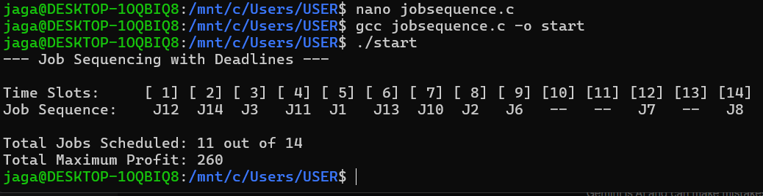

Time Justification:

The O(N \log N) comes from using a sorting algorithm to rank the N jobs by profit first. The O(N \times M) occurs because, in the worst-case scenario, the algorithm must linearly scan backward through up to M time slots for every single one of the N jobs to find an empty space.

Space Justification:

The O(M) memory is strictly required to create the "schedule" array, which needs exactly M slots (the maximum deadline) to keep track of which specific time slots have been filled or remain open.

